**StorageCraft File and folder restore.**

**Steps:**

1. Go to backup target and right click on latest backup image, click on StorageCraft quick mount”. A screenshot of a computer

   Description automatically generated
2. Fill Image password in pop-up window.

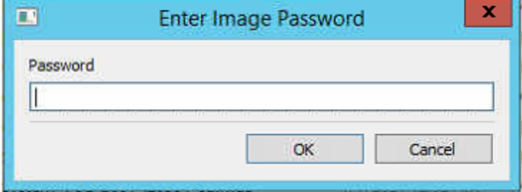

1. A new drive will be mount on machine.

1. Copy any file and folder from Mounted drive.
2. Once file copied tha dismount that drive.

