**Installing the Windows agent**

1. You must log in as a user that has administrator privileges.
2. Download the agent MSI file from <https://helpdesk.kaseya.com/hc/en-gb/articles/4407526882193-Unitrends-Downloads>
3. Double-click the MSI file to launch the installer.

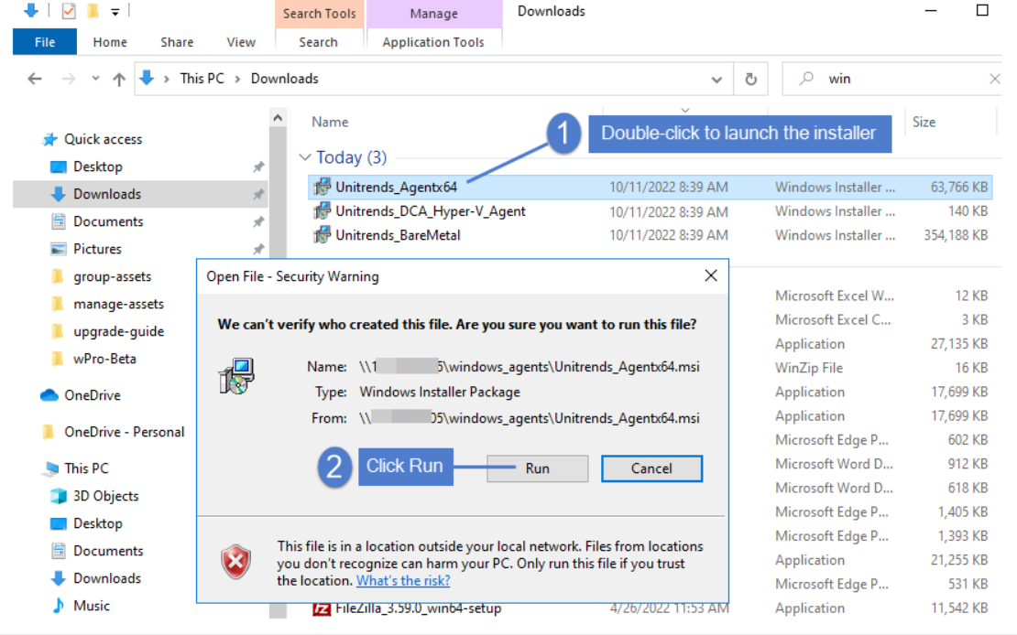

1. Click **Next** to proceed.

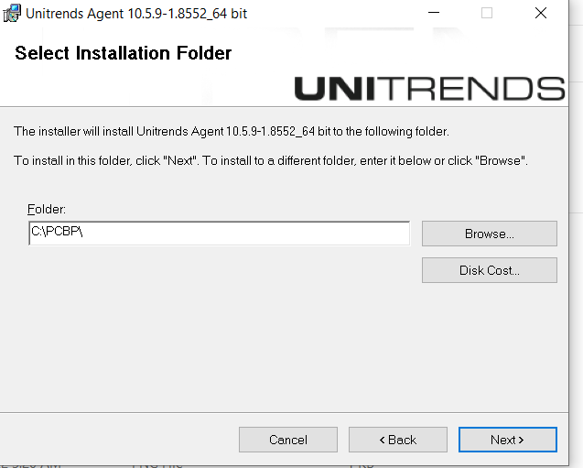

5. Select an installation directory and click **Next**.

The default directory is *C:\PCBP*. To install in another location (folder or volume), click **Browse** or manually enter the directory path.

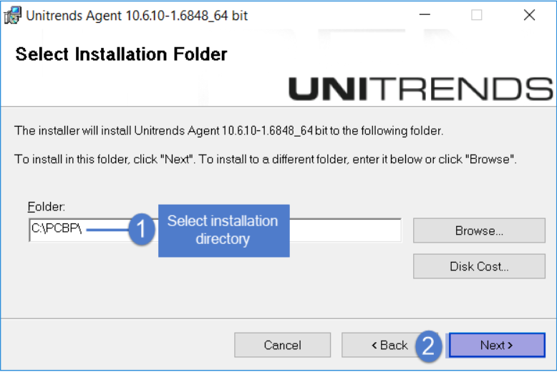

1. Click **Next** to begin the installation process (or click **Back** to review or modify data). The installation can be interrupted at any time by clicking **Cancel**.

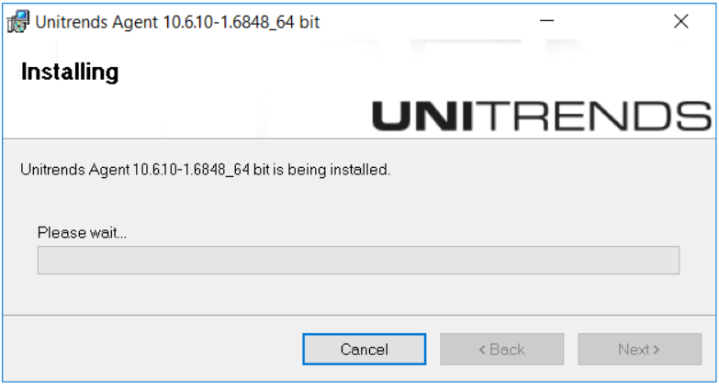

8. (Recommended) Click **Yes** to include the Windows Volume CBT driver. (This driver enables the option to run incremental image-level backups. You can run file-level backups and full image-level backups without installing this driver.)

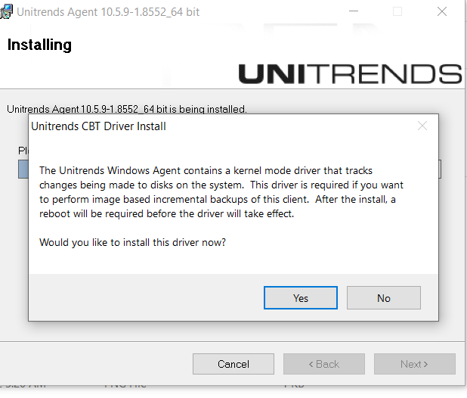

9. After the agent is installed, do one of the following:

install the Volume CBT driver, click **Next** and continue with the next step in this procedure.

Note: If the Volume CBT driver has not been installed or has not been enabled, image-level incrementals are not supported. Any scheduled incremental is automatically promoted to a full backup.

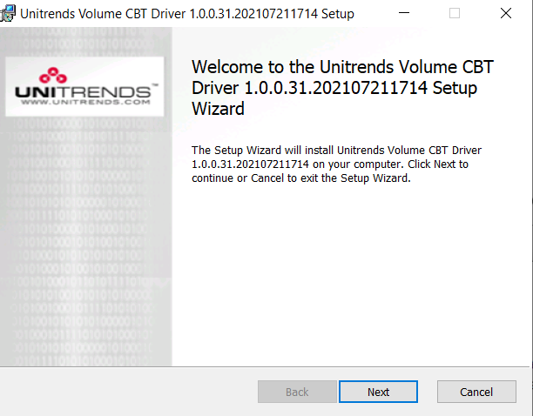

10. Click on Next. Install will start.

11.Click **Finish** to exit the installer.

12. You must reboot the Windows asset to enable the Volume CBT driver. Click **Yes** to reboot now or **No** to reboot at a later time.

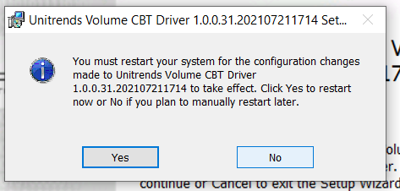

**You must reboot your machine.**

Once come up.

**Connect to Appliance.**

1. **Configure> add> asset.**

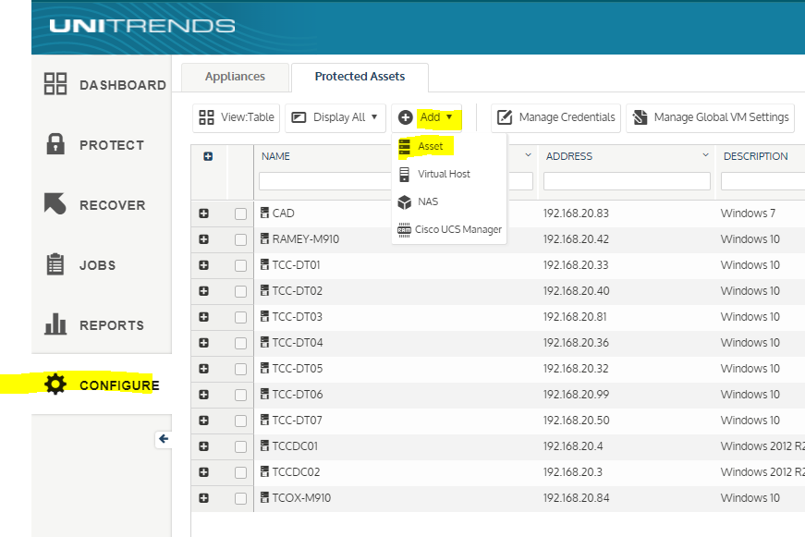

1. **Fill machine name and IP address.**
2. **Do not check any check box.**
3. **Save.**

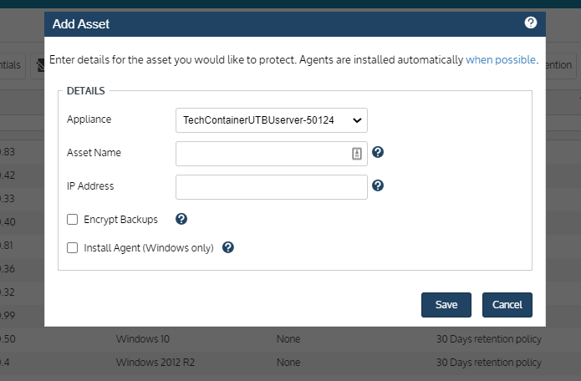

**Once machine connected successfully.**

**Need to setup backup job. – We will setup backup job.**