Disaster Recovery: Starting a Machin on Datto Device.

Datto appliance GUI during a disaster recovery scenario

1. Log into the Datto appliance GUI. Then, click the **Restore** tab. This will display all of the protected machines paired with the Datto device.



2. Under **Choose a System** select the protected machine needed to be restored

3. Under **Choose A Recovery Type**, select **Local Virtualization**

4. Under **Choose A Recovery Point**, select the date to restore.

5. After all settings are selected, click **START RESTORE**

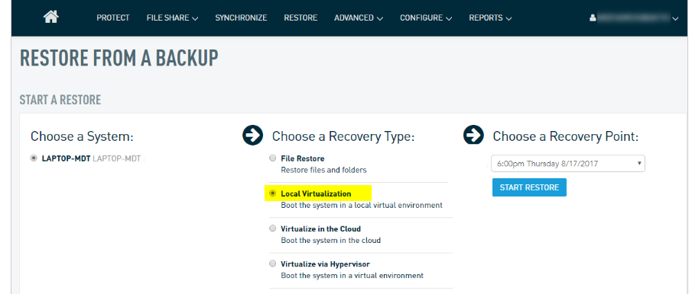

6. On the following page, configure your local virtualization options. To use the local virtualization as your production machine in a disaster recovery scenario, configure its Windows networking options to match those used by the protected server. Make sure that your production machine is no longer on the network before performing this step.

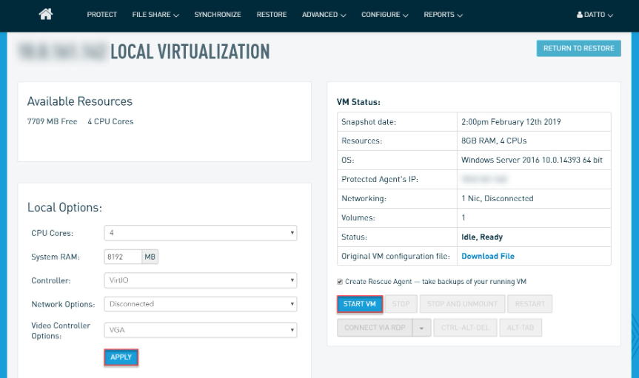

7. Once the settings are checked, select **APPLY** followed by **START VM**.

8. With the Rescue Agent option enabled, you will be prompted to choose whether or not you would like to pause backups on the protected machine. Depending on your recovery scenario, you can choose to either **PAUSE BACKUPS** or **CONTINUE BACKUPS**. Typically, you would pause backups on a system that cannot be reached during a disaster scenario. Once you've made your selection, click **CONFIRM**.

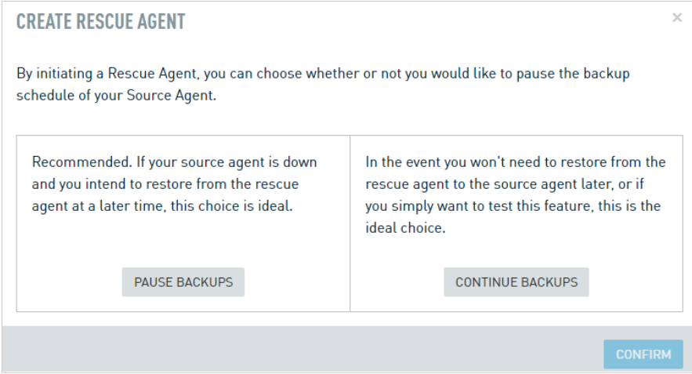

You will be able to see the VM booting in the **Screenshot** window.

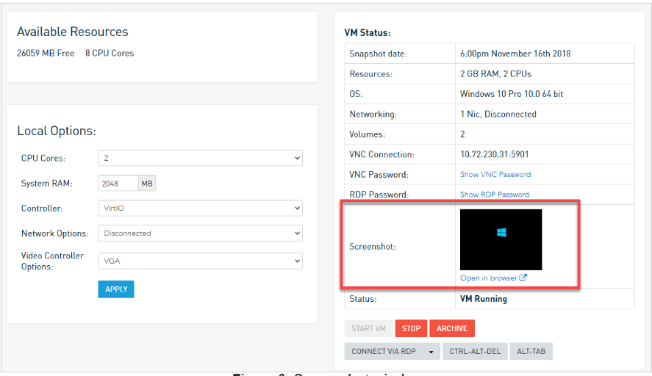

Click is Open in browser to take remote.

To stop the local virtualization, but leave it mounted, click **STOP**. To stop the local virtualization and unmount it, click **STOP AND UNMOUNT**.

Your virtualization will mount and begin running in the **Local Virtualization** screen. On the [Protect](https://help.datto.com/s/article/KB205298080) tab of the Datto appliance GUI, you will now see a new agent with a name comprised of the word 'Rescue' and the protected server's IP address or FQDN. This is the Rescue Agent for your running virtualization. You can manage this agent the same way you would manage any other agent

