**New Unitrends Appliance – Encription and Retention configuration**

1. Log in to your Unitrends Backup Portal:
2. Click on Manage

1. Login with root password and go to configuration and select Appliance and click on Edit

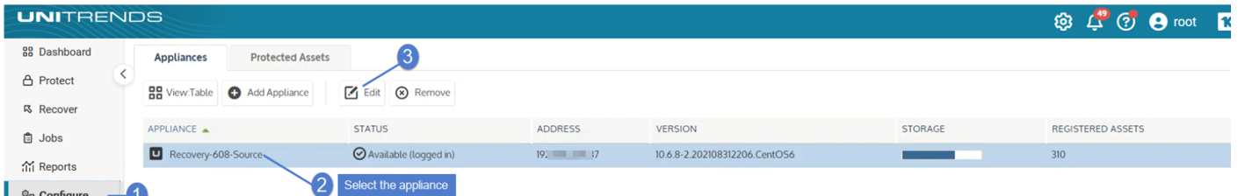

1. **Go to Advance Enable Encryption and Save.**

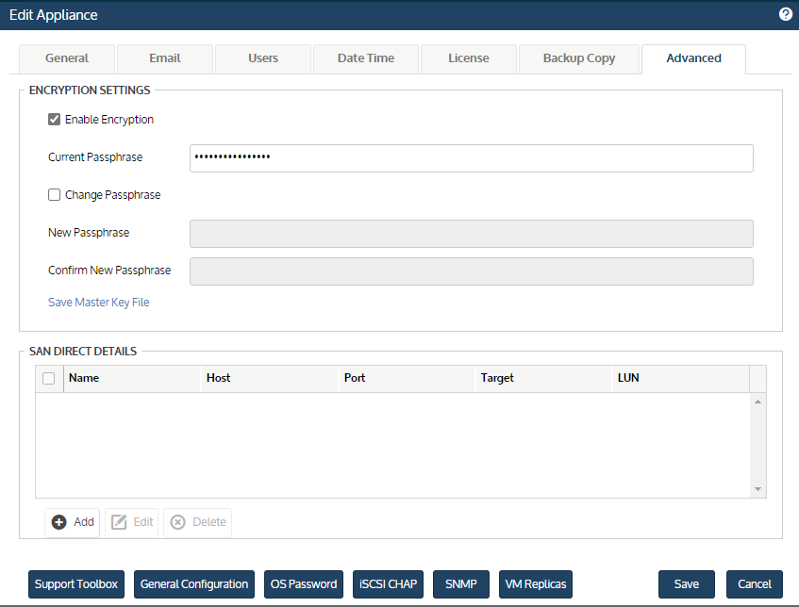

1. Go to configuration and Click on Protected Assets.
2. Manage Retention

1. **Configure Retention as per Client standards**

