**Synology NAS to Qnap NAS Copy SOP**

**Scenario: copying backups from Source NAS(Synology) to destination NAS(Qnap NAS) below is the Steps:**

**Step1:**Open the destination NAS(Qnap) and go to the APP Center.

Download the Hybrid backup sync software as below mentioned Screenshot.

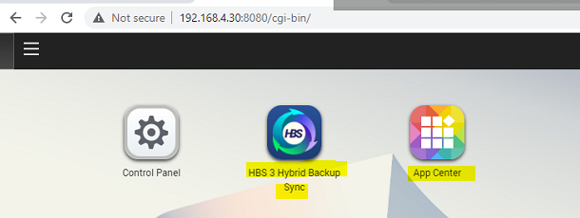

**Steps2:** open the hybrid backup sync and enable the rsync

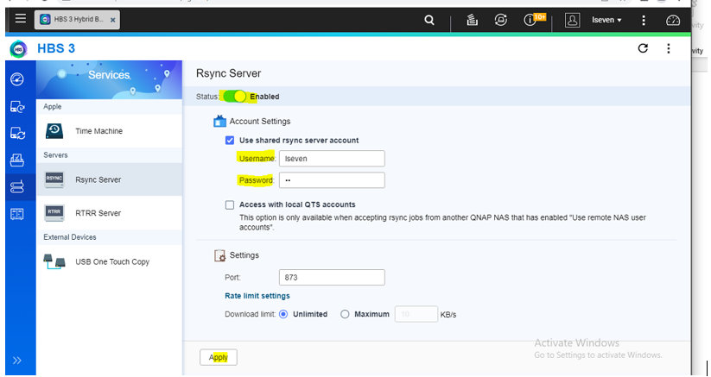

**Step3:** create rsync user name and password then apply**.**

**Step4:** Now go to the Source NAS(synology) and download the Hyper backup software.

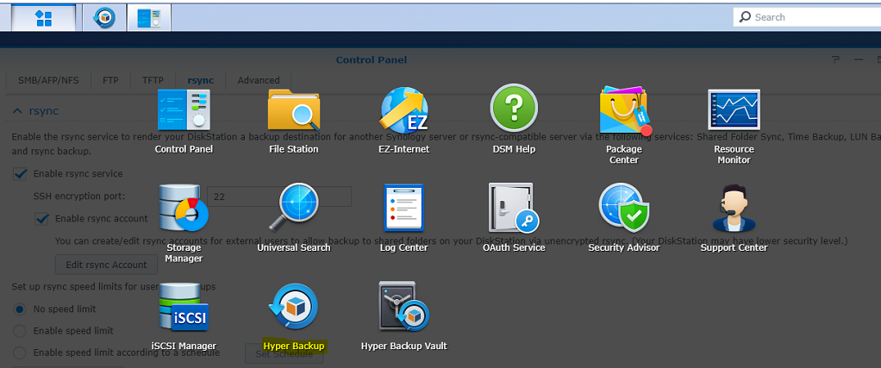

**Step5:**Go to the below location on Source NAS:

**Control panel>file services >rsync**

enable rsync services if not enabled and update the same username and password which was used in the destination rsync credentials(QNAP):

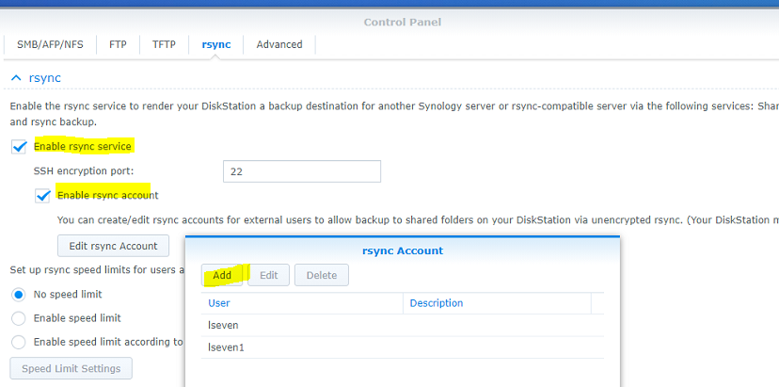

**Step6:** Now open the Hyper backup on Source NAS and in the bottom +button is available to create data backups.

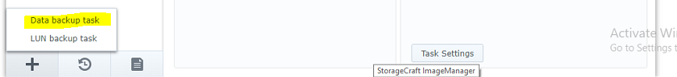

**Step7:**click on the data backup task then it will open a backup wizard,here select rsync copy(single version)s

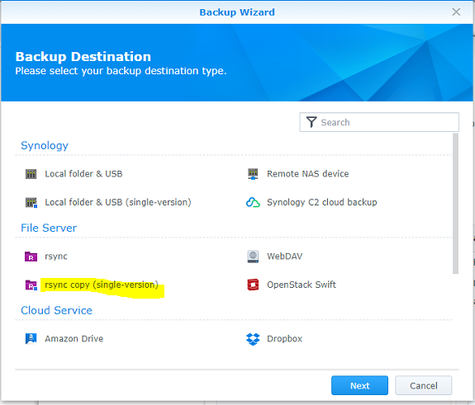

**Step8:**Click next, Here you need to give the below details:

**Server type: rsync-compatible servers**

**Servername or IP : Destination NAS IP address**

**Username :**

**Password:**

**Note: We have created the rsync username and password,so use those credentials.**

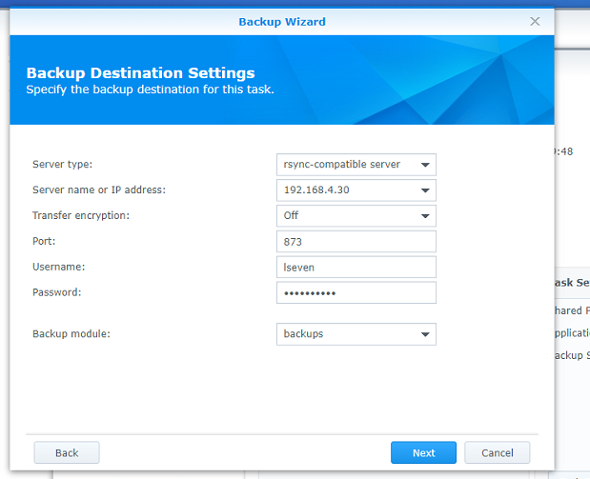

**Step9:** Select what you want copy

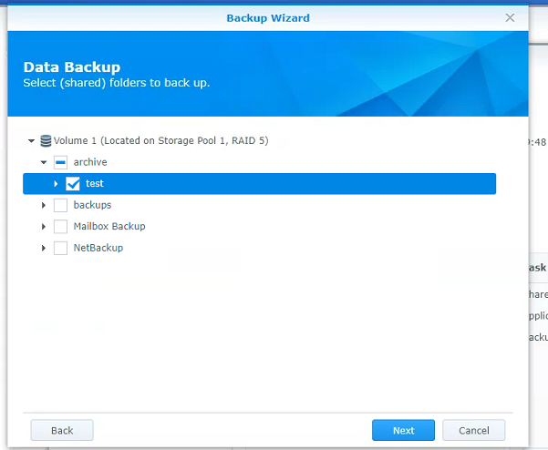

**Step10:** enter the task name and directory name

**Make sure disable the schedule(we are performing one time copy)**

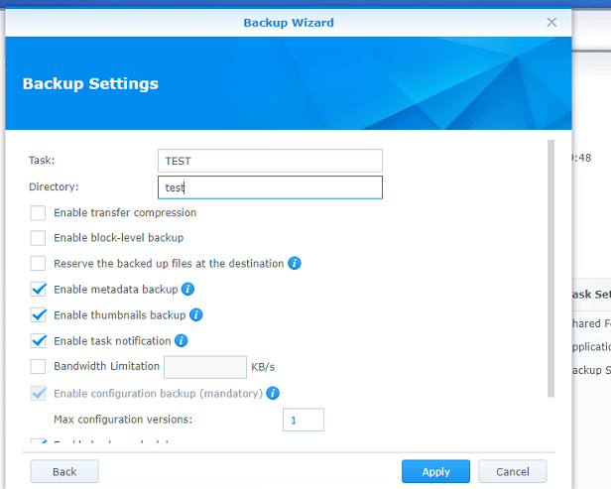

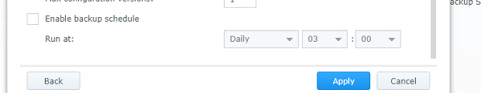

**Step11:** Now trigger the backup manually and monitor the copy status from here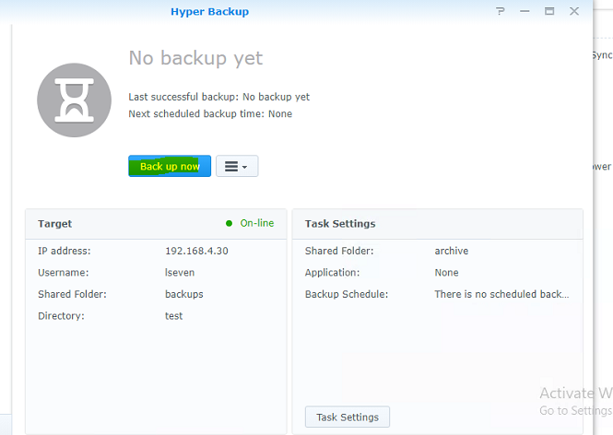

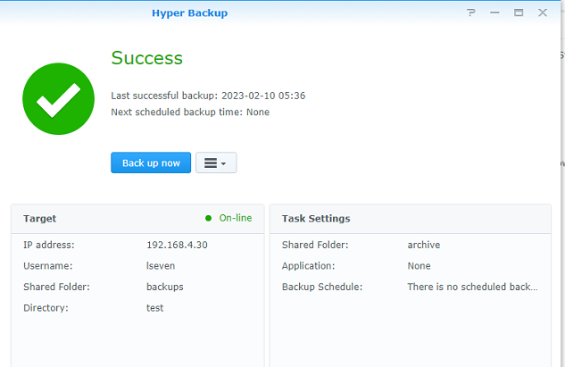

**Step12:** Make Sure before copy the data, test one same file to copy to target and verify file are copy in same format or not.

**Step13:**Once copy task completed then disabled the rsync services on Target NAS.