**Direct-to-Cloud (D2C)**

[Direct-to-Cloud](https://axcient.com/solutions/axcient-direct-to-cloud/) (D2C) provides with the same full-featured, image-based backups of traditional x360Recover, but without the expense of deploying or managing a local appliance.

**STEP 1. Log in to a vault via Single Sign On (SSO)**

1. Log in to the [x360Portal](https://partner.axcient.com/login)and launch x360Recover from the Dashboard.

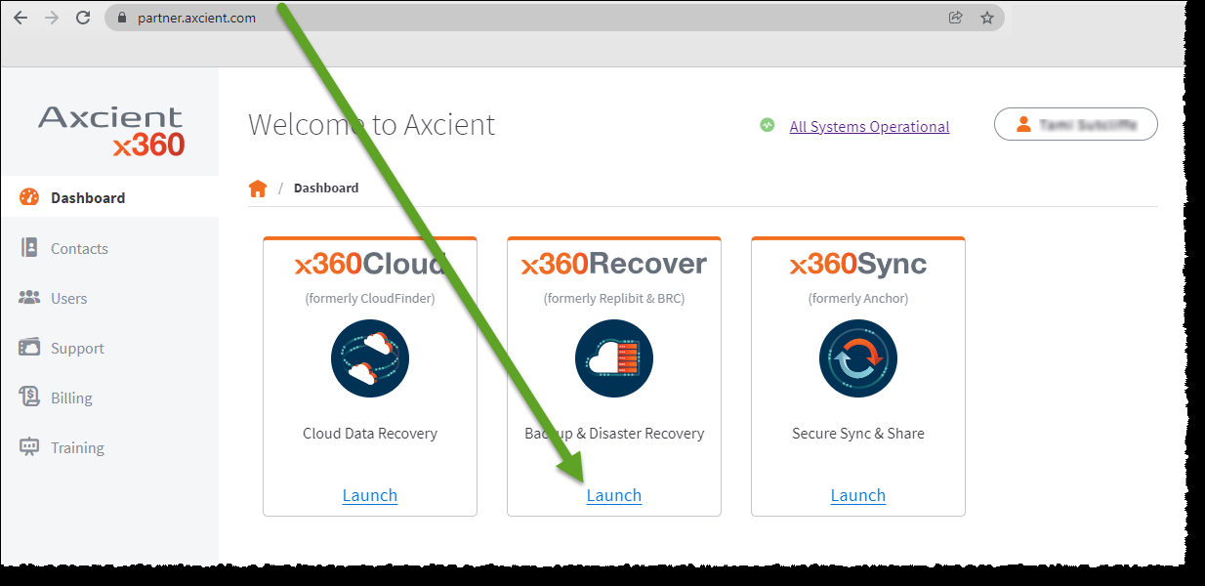

2. Click the **Vaults**tab.  
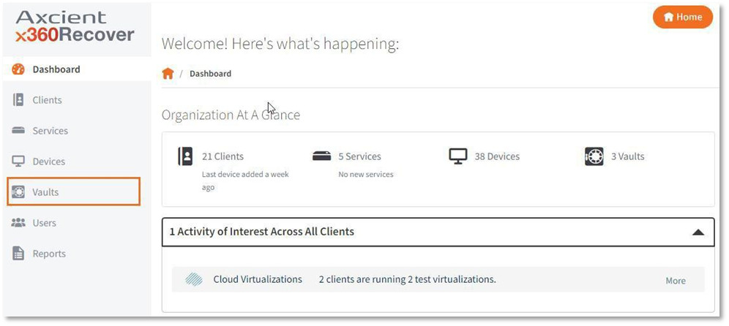

3. Click on the desired vault.

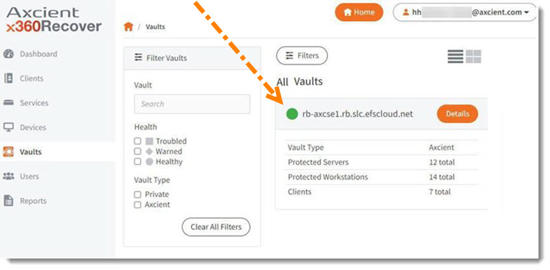

4. Click the **Vault GUI**button.

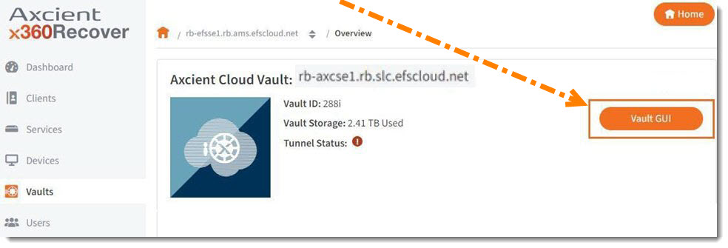

This will log you into the vault directly.

**STEP 2. Download and install the agent**

**2a. Download the client-specific file**

**STEP 1.** **Open the desired vault**(if you have not already done so)

To open a specific vault, log in to the  [x360Portal](https://partner.axcient.com/login) and launch x360Recover from the *Dashboard.*Then, click the **Vaults**tab and then select the desired vault.

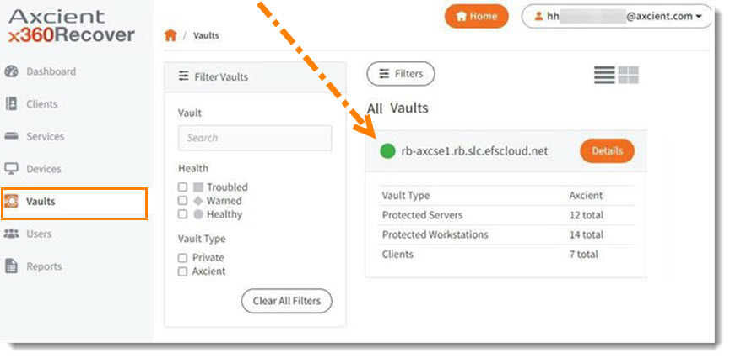

Click the **Vault GUI**button to log into that vault directly.

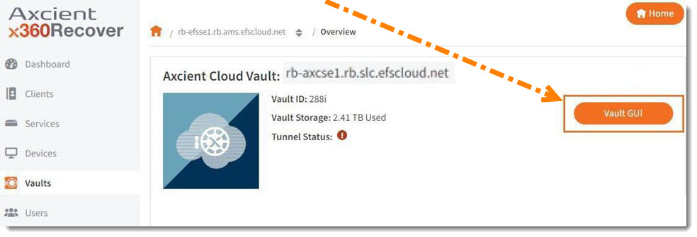

Now that you are logged into the correct vault, click the desired**Clients** tab.

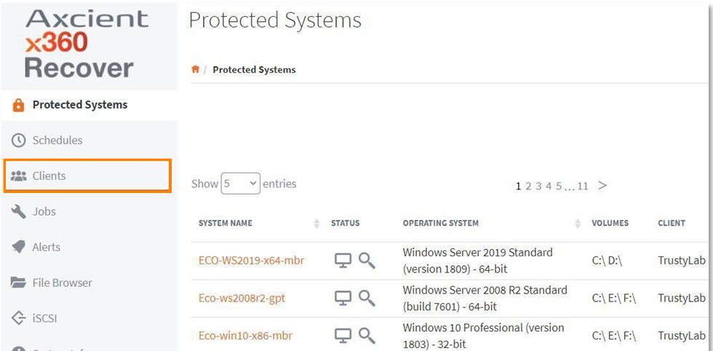

|  |
| --- |
| You can add a new client here.  **To add a new D2C client from the vault:**   * In the vault interface, click the **Clients**tab.      * Click **Add client**      * The **Create New Client User** popup will appear. * Fill in the **Client User Name**and **Company**fields. * Click **Create User**to continue.      * A processing popup displays as the new account is created.      * The new**client**will now appear in your list of clients. |



**STEP 2.**Now that you have all the desired clients in your list,locate the appropriate client and click the accompanying**Download** link.  
  
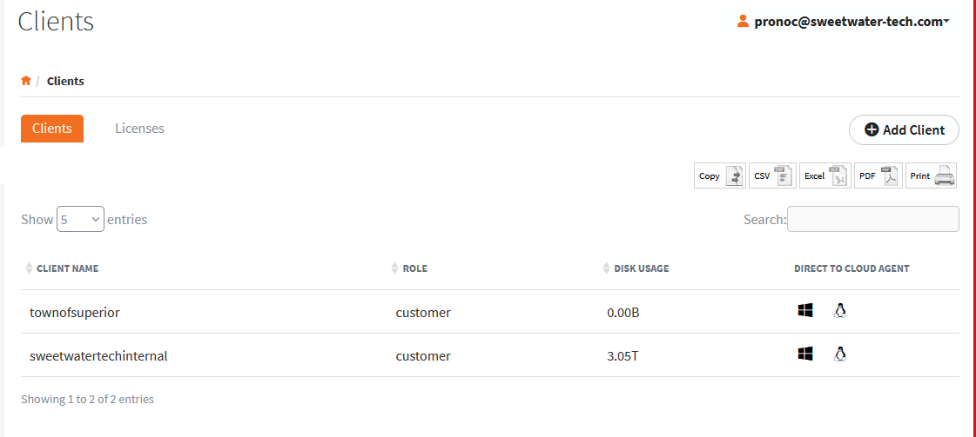



**Notes:**The installation file downloaded from this page contains a temporary token and identifying information embedded in the filename.

* This file is specific to this client.
* **CAUTION: Do not rename this file.**
* This client-specific installation file is valid for 180 days from the time of download. Installing from an expired agent installer file will fail and register invalid token errors within the log file.

**2b. Install using the wizard**

**STEP 1.** After you have logged in to the [x360Portal](https://partner.axcient.com/login), launched x360Recover from the Dashboard, and opened the desired vault, click the desired **Client.**

**STEP 2.** Click the installation file to initiate the installation process.  
  
When the *Setup Wizard*opens, click **Next**to continue.

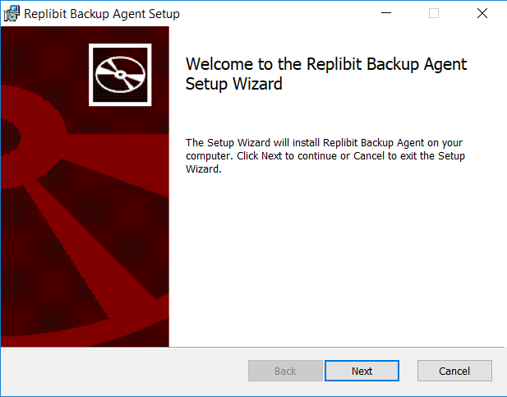

**STEP 3.** After reading the agreement on the *End-User License Agreement* screen, select **I accept the agreement.**  
  
Click **Next** to continue.

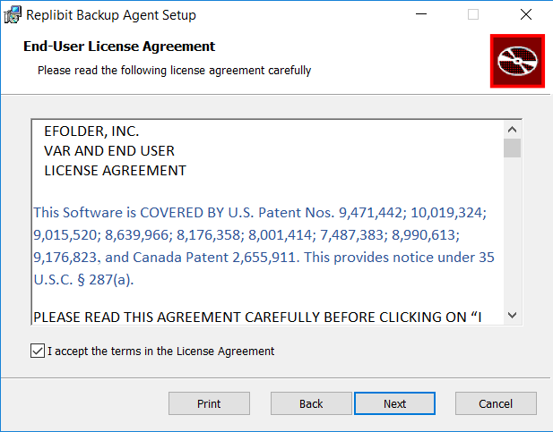

**STEP 4**. On the *Destination Folder*screen, accept the default installation folder.  
  
Click **Nex**t to continue.

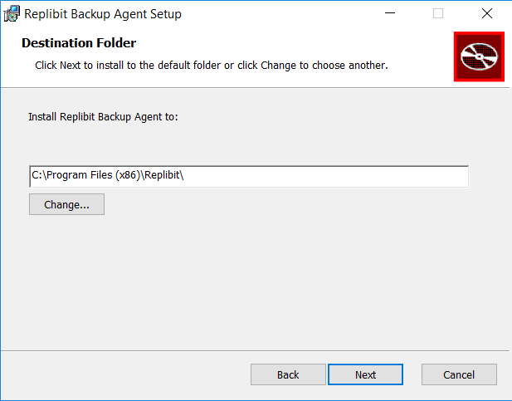

**STEP 5.** On the *Configuration Information* screen, take the following actions:

* Leave the**Appliance IP** field empty. (This field may appear grayed out since an appliance is not needed for D2C.)
* You can choose to add an optional **lock password** here. If you chose to enter an optional lock password, the vault will prompt you for this before you begin a system recovery. If you chose to add an optional lock password, we recommend using a unique setting, to enhance security.
* Enter the desired setting for the **Volumes to back up**field
* Click **Next**to continue.

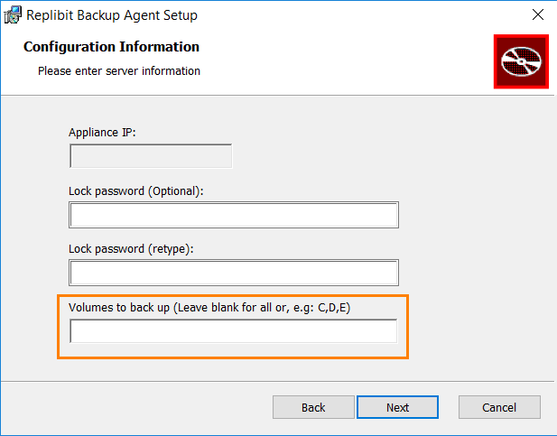

**STEP 6.** When you are ready, click the**Install** button to begin installation.

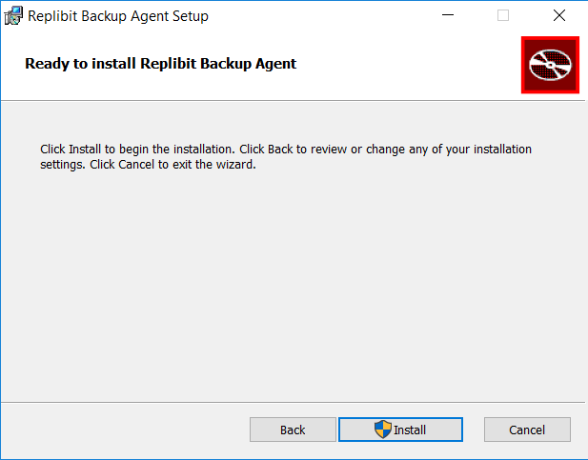

**STEP 7.** When installation completes, click**Finish** to exit.

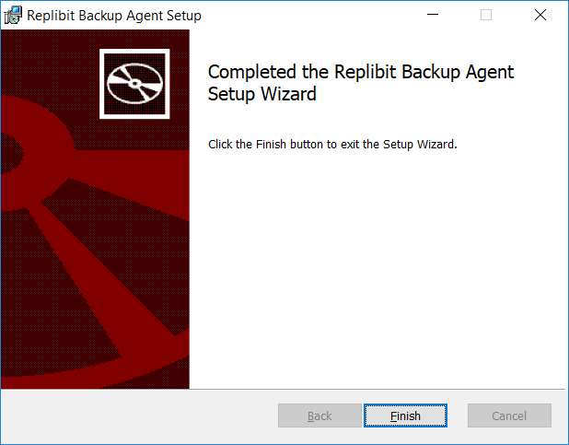

**STEP 8.** After several minutes, the vault web interface will display the newly protected system in the *Protected Systems*tab.

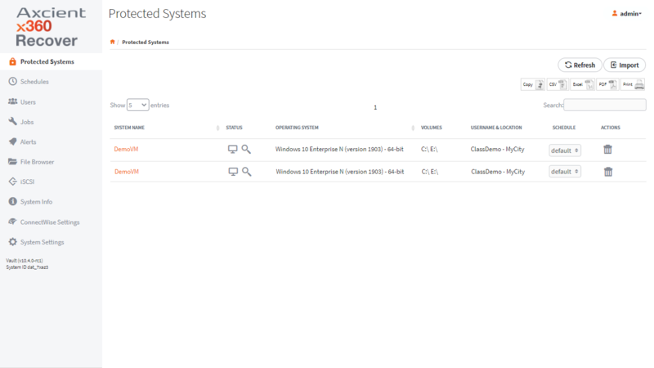  
A full backup will automatically initiate based on your backup policies and schedule settings.

**STEP 3. Create a D2C backup policy (schedule)**

When the agent is installed on a protected system, you can create a backup policy (schedule) and apply that backup policy to a protected system.

All backup policies are created and maintained within the vault.

**To create a backup policy:**

1. Log in to the vault.

2. In the left-hand navigation menu, click the **Backup Policies**tab.

3. In the *Backup Policies page*, click the **Add Policy**button.

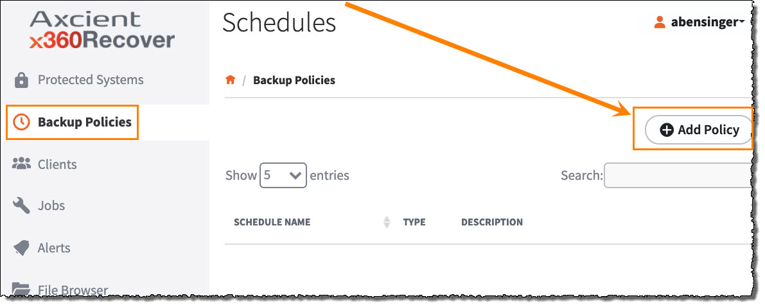

4. In the *Create Schedule*page, enter information about the new backup policy:

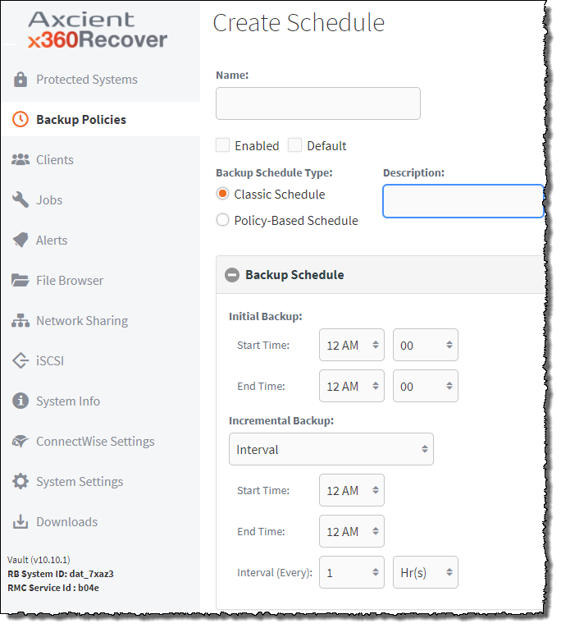

Click the **Save**button when you are finished.

The backup policy is now created and will be listed in the *Backup Policies*page. You can manage and edit schedules in the *Backup Policies*page.