**Backup configuration on Ninja RMM**

1. Login Ninja RMM and click on **Administration > Organizations**

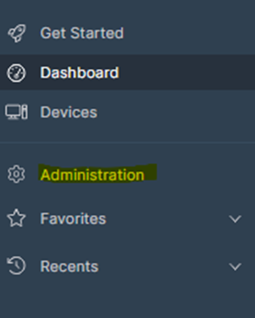

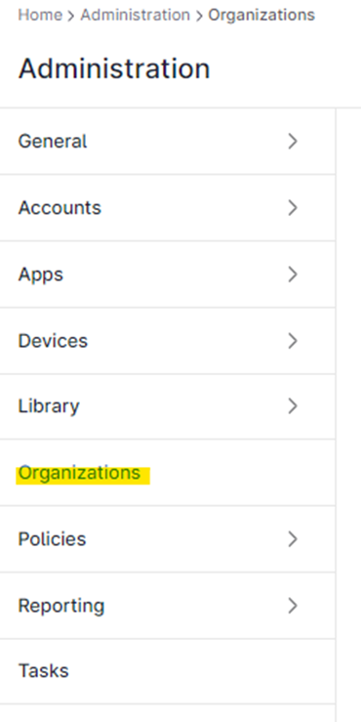

1. Select the Organization of the machine for which you want to set up the backup.
2. Click on **Backups**
3. Under deployment, select **“Selected devices”.**
4. Among the given devices, select the device i.e. the machine for which you want to set up the backup.

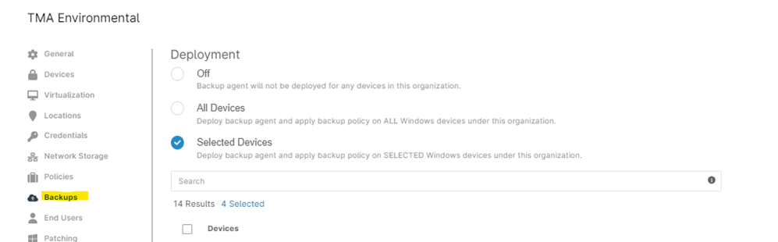

1. Once the device is added in backup, you can see in **Activities** of the machine that the Ninja Backup Module is installed.

1. Click on **Settings** of the Machine and **edit** the **Policy Overrides**

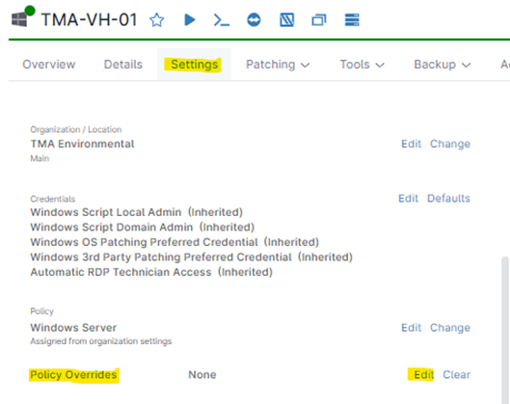

1. Click on **Backups > Add Plan**

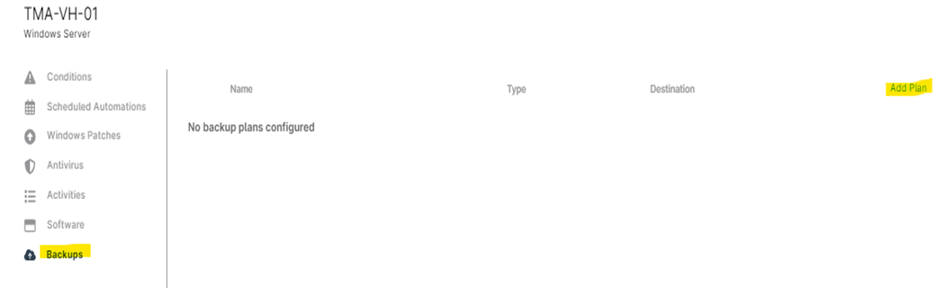

1. Select the type of backup plan you want to create i.e. File level or Image level Backup

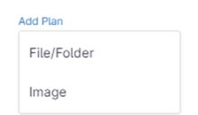

1. Enter the Backup Plan name. Set the schedule, time, backup source as partitions and backup destination.   
   Click on **Save.**