A picture containing clipart

Description generated with high confidence

Veeam Upgrade via VSPC Portal

Asif JIlani

VER No. (ex. Ver. 1.0)

iNITIAL DRAFT / Review Date (14th June 2024)

2024

Contents

Pre-requisites before upgrade: 2

Veeam Upgrade Process: 3

*Veeam Upgrade via VSPC Portal*

# Pre-requisites before upgrade:

* Make sure Veeam Cloud Connect is running to the latest Veeam Version
* Veeam Server should be running on at least Veeam v12.0.0.0
* Veeam server C drive should have at least 25 GB of free space
* Make sure none of the Backup/Restore jobs are in progress
* Validate if we have a successful Veeam Configuration backup

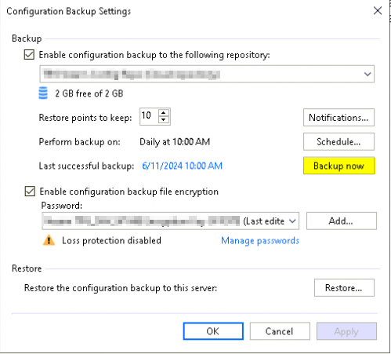

# Veeam Upgrade Process:

1. Log in to the VSPC Portal.
2. Select the Company-> Discovery-> Backup Servers
3. Select the Backup server-> Go to server Actions and click Upgrade

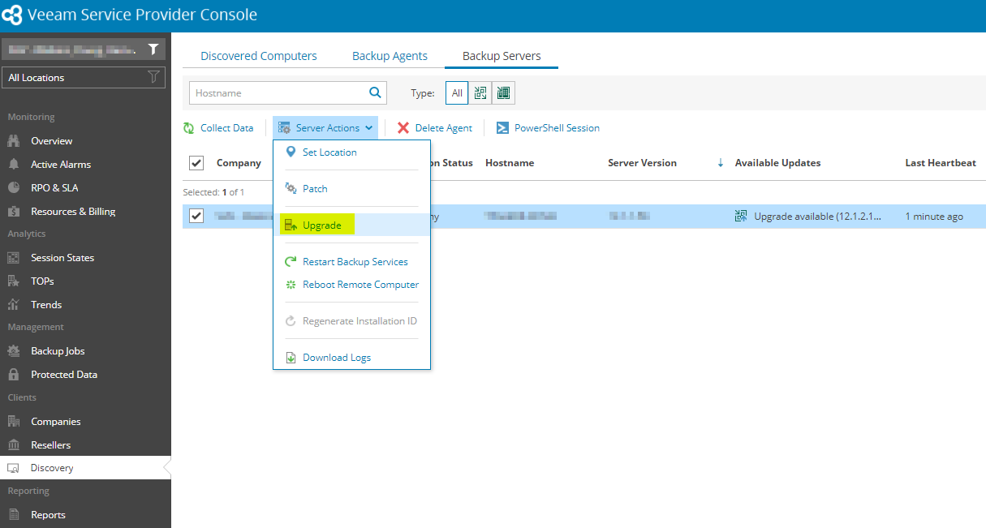

1. In the Source option, select “Download the backup server setup file from a Veeam web server” and click **Next**.

1. In the Account option, Update the credentials of the local administrator account and click **Next (it should have access to the Database)**

1. In the Setup options, Browse and select the “**Veeam Upgrade Setup.xml**” file from your system and click **Next.**

**Note:** Use the attached Unattended Rules checklist.

1. In the Schedule option, Select “Upgrade now” followed by **“Terminate all activities automatically before install”** and click on **Next**.

1. Summary Tab, Review the settings and click on **Finish.**

1. You can monitor the Upgrade process from the VSPC portal.

Company-> Discovery-> Backup Servers-> Update status column -> Click on upgrading.

1. Once the task is completed successfully, all the steps performed will be shown during the upgrade process, and in the available update column, it will show as up-to-date.

