1. Open the Veeam Agent Console from the bottom tray.

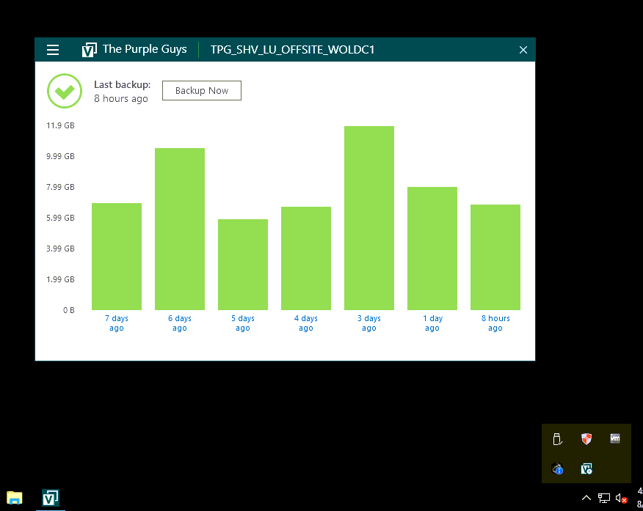

1. Go to the Onsite job options and select “Restore file”

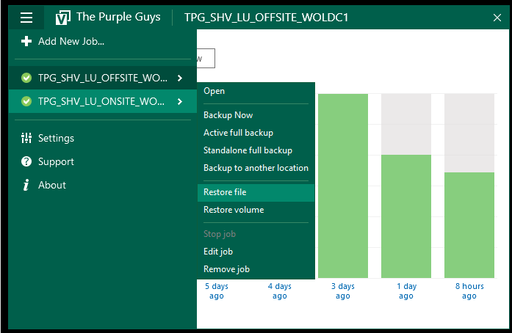

1. Choose any Restore point to Restore.

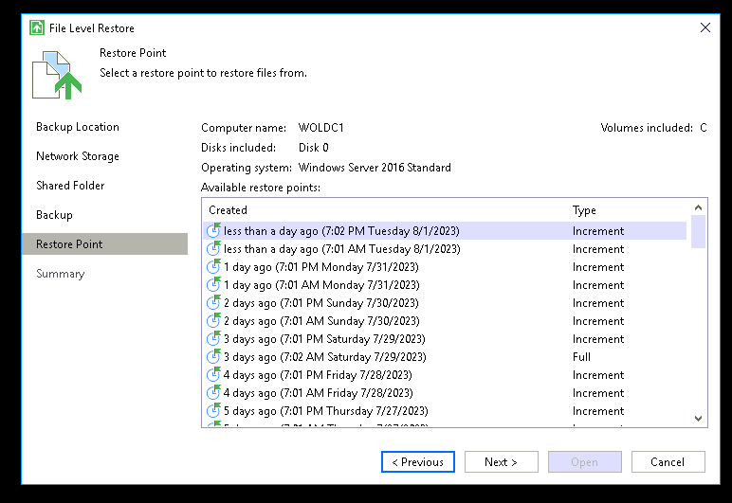

1. Restore Summary

1. You will see all files and folders to copy.

1. Create a “Test folder” on Desktop
2. Right click any file and select “Copy to”

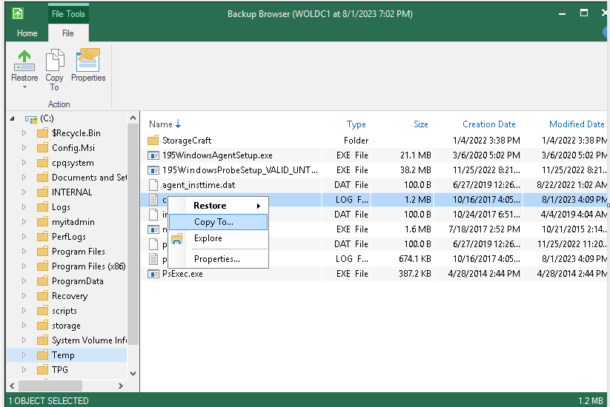

1. Select the Test folder and click okay

1. Open the Test folder on Desktop to cross check whether the selected file has been restored or not.

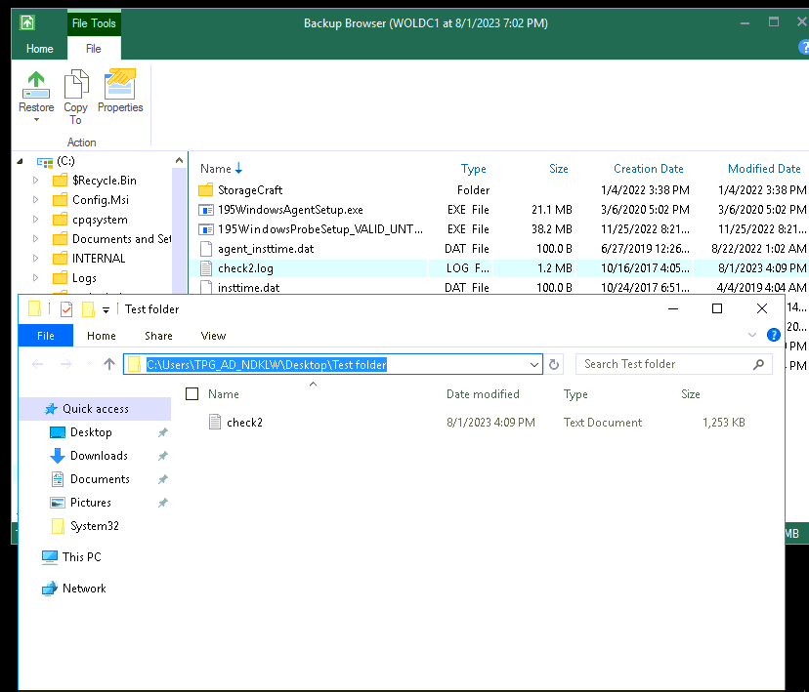

1. Restore Complete.