Veeam Backup & Replication File Level Restore

Step 1. Launch File Restore Wizard

On the **Home** tab, click **Restore** > **Choose Restore form backup \ Replica.**

In this document we have chosen Restore from backup.

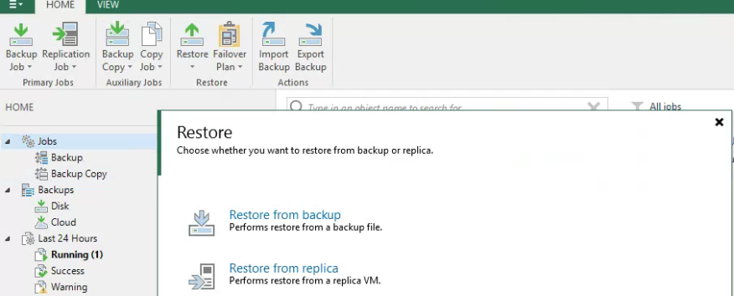

Click on Guest files restore**.**

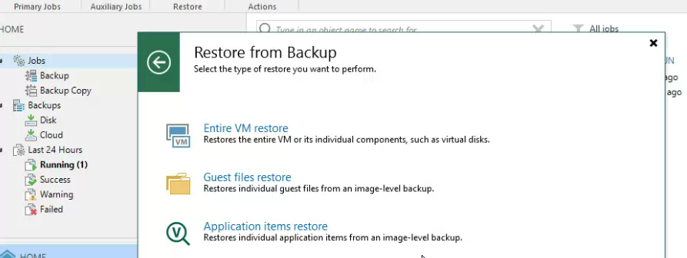

Select machien OS type.

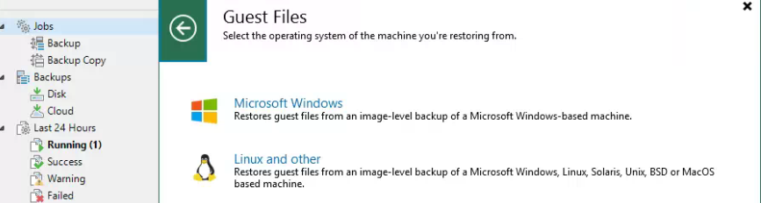

Here is all backup jobs Local \ cloud and select a machine to restore.

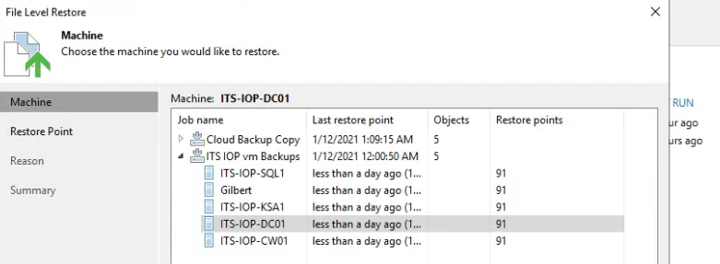

You will see all restore points and choose any restore point to restore.

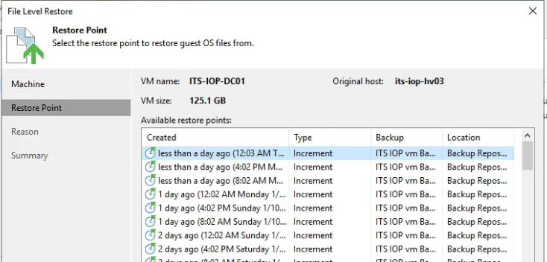

Restore summary.

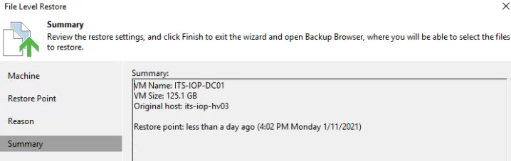

You will see all files and folder to copy.

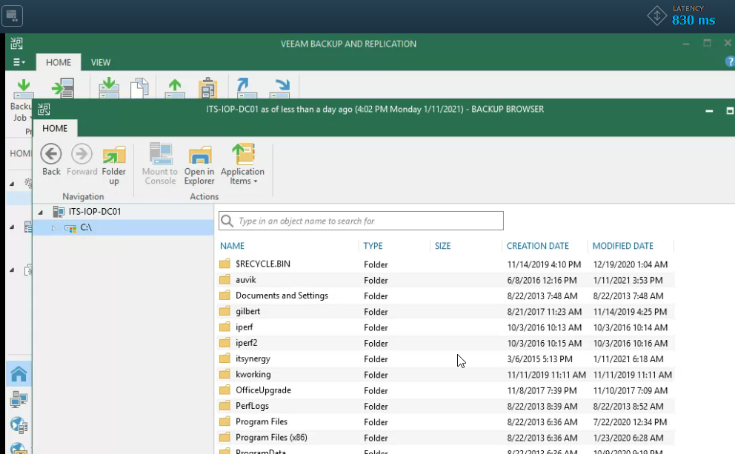

Restore completed.

Step 2. Launch File Restore Wizard

Open the **Home** view. select **Backups** and Choose Disk or Cloud.

* Disk: Local backup
* Cloud: Cloud backup.

Expend backup Job > Right click on server > Restore guest files and Choose OS type.

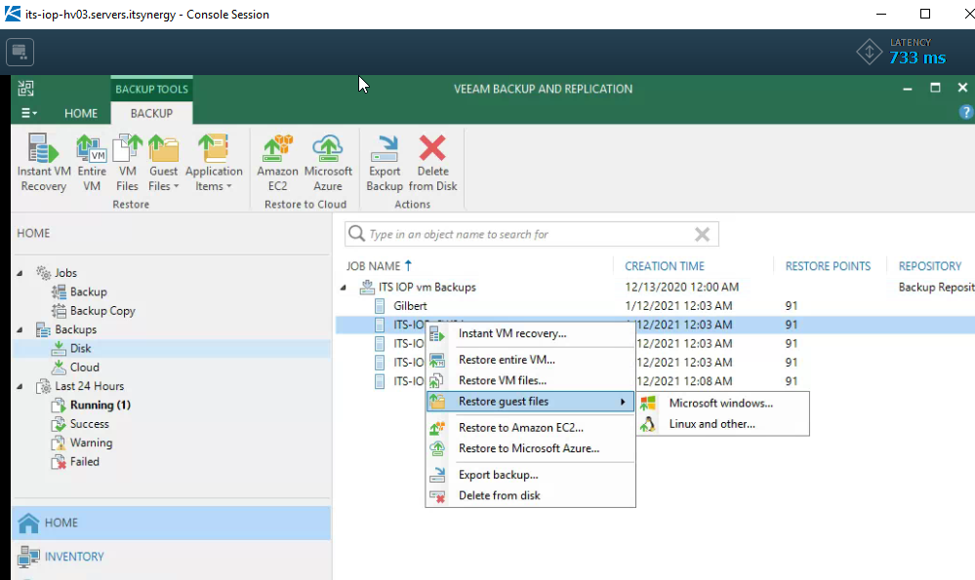

You will see all restore points and choose any restore point to restore.



Restore summary.



You will see all files and folder to copy.



Restore completed.