**Veeam Instant Recovery**

Step 1. Launch Instant Recovery Wizard

To launch the **Instant Recovery to VMware** wizard, do one of the following:

* On the **Home** tab, click **Restore** and select one of the following:
* **VMware vSphere** > **Restore from backup** > **Entire VM restore** >**Instant recovery**> **Instant recovery to VMware vSphere** — if you want to recover VMware vSphere VMs from a VM backup created by Veeam Backup & Replication or you want to recover VMware vSphere VMs from storage snapshots.
* **Microsoft Hyper-V** > **Restore from backup** > **Entire VM restore** > **Instant recovery**> **Instant recovery to VMware vSphere** — if you want to recover Hyper-V VMs from a VM backup created by Veeam Backup & Replication.
* **Agent** > **Entire machine restore** > **Instant recovery**> **Instant recovery to VMware vSphere** — if you want to recover physical machines from a backup created by Veeam Agent for Microsoft Windows or Veeam Agent for Linux.

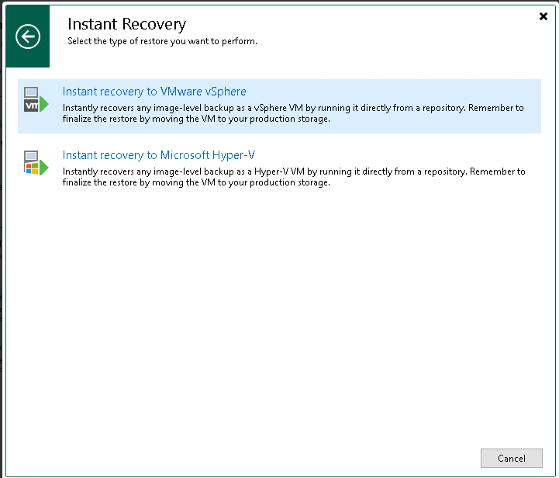

Step 2. Select Workloads

At the **Machines** step of the wizard, select one Machine that you want to recover:

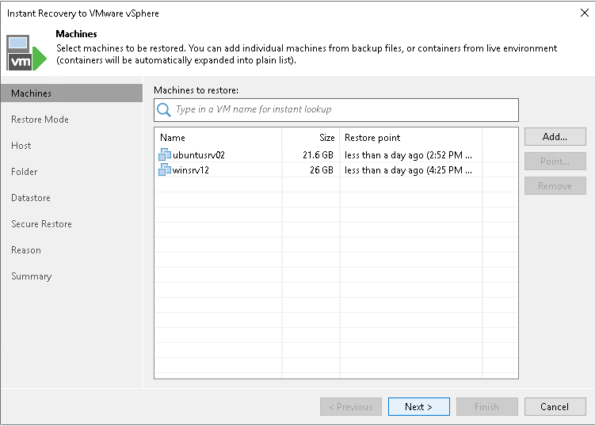

Step 3. Select Restore Point

By default, Veeam Backup & Replication uses the latest valid restore point to recover workloads. You can recover a workload to an earlier state, if necessary:

1. In the **Machines to restore** list, select a workload.
2. Click **Point** on the right. In the **Restore Points** window, select a restore point from which you want to recover the workload.

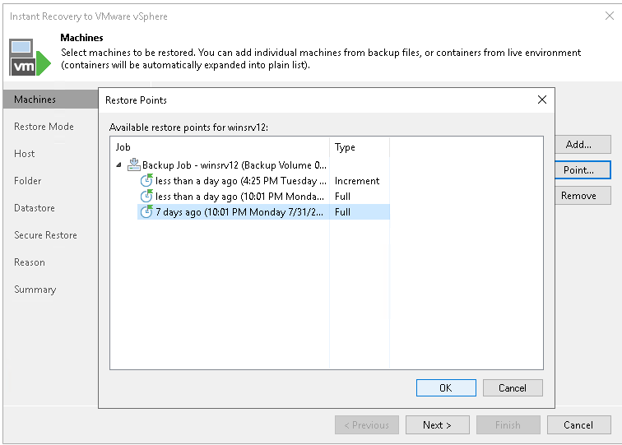

Step 4. Select Restore Mode

At the **Restore Mode** step of the wizard, specify a destination for VM recovery and whether you want to recover VM tags:

* **Restore to a new location, or with different settings** — select this option if you want to recover VMs to a new location, or to any location but with different settings (such as VM location, network settings, format of recovered virtual disks and so on). If this option is selected, the **Instant Recovery to VMware** wizard will include additional steps for customizing VM settings.

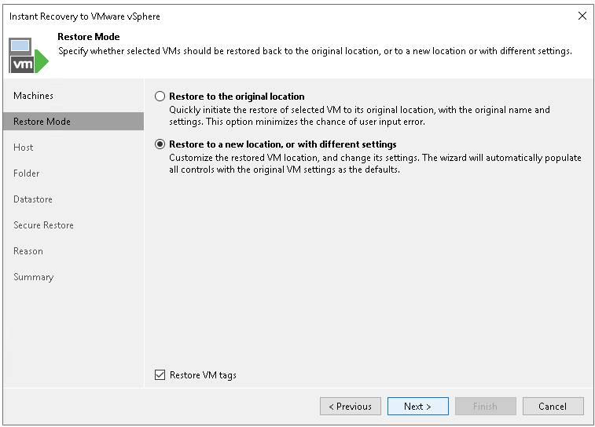

Step 5. Specify Destination for Restored VMs

To specify the destination and network mapping settings for a recovered VM:

1. In the **Restored VM name** field, specify a name under which the workload will be recovered.
2. In the **Host** field, specify a host on which the VM will run.

[For VMware vSphere VM recovery from storage snapshots] Veeam Backup & Replication will create a clone/virtual copy of the storage snapshot, mount it to the selected ESXi host and start the VM on this ESXi host.

1. In the **VM folder** field, specify a folder to which the recovered VM files will be placed.
2. In the Resource pool list, select a resource pool to which the VM will be placed.
3. [For workloads other than VMware vSphere VMs and VMware Cloud Director VMs] In the **Networks** section, configure the network mapping table. To configure one row of the table, select a network in the list and click **Choose**. The **Select Network**window displays all networks to which the target host or cluster is connected. In the list of networks, select a network to which the recovered VM will be connected instead of the original network.
4. Click the **Advanced** button and choose whether to preserve the BIOS UUID or generate a new BIOS UUID. By default, the BIOS UUID is preserved.

***We recommend that you select to generate a new BIOS UUID for the recovered VM to prevent conflicts if the original workload still resides in the production environment. The BIOS UUID change is not required if the original VM no longer exists, for example, it was deleted.***

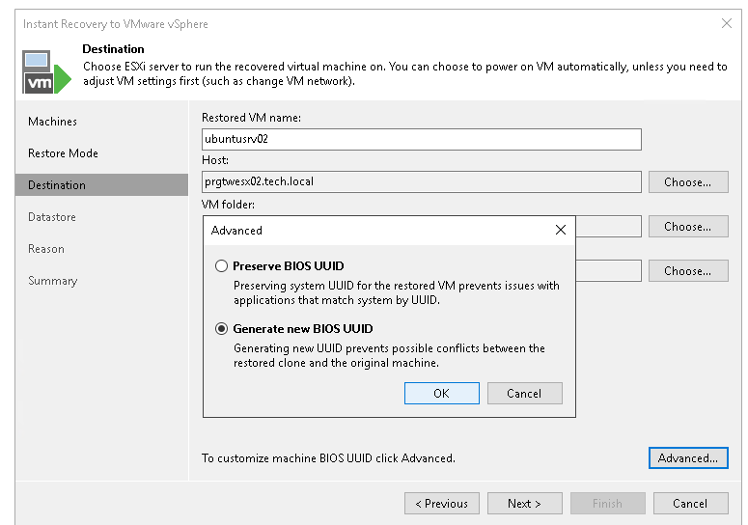

Step 6. Select Destination for Virtual Disk Updates

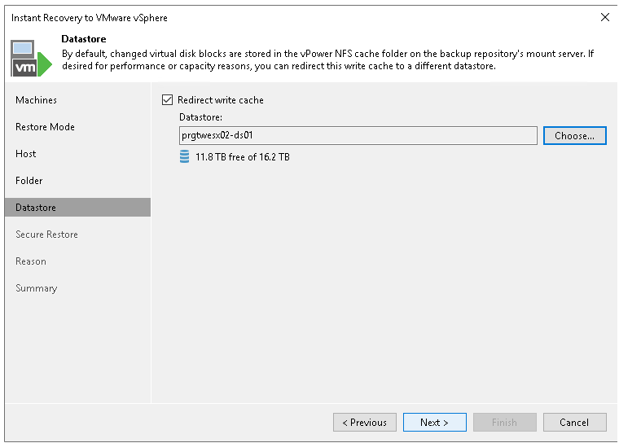

Step 7. Specify Restore Reason

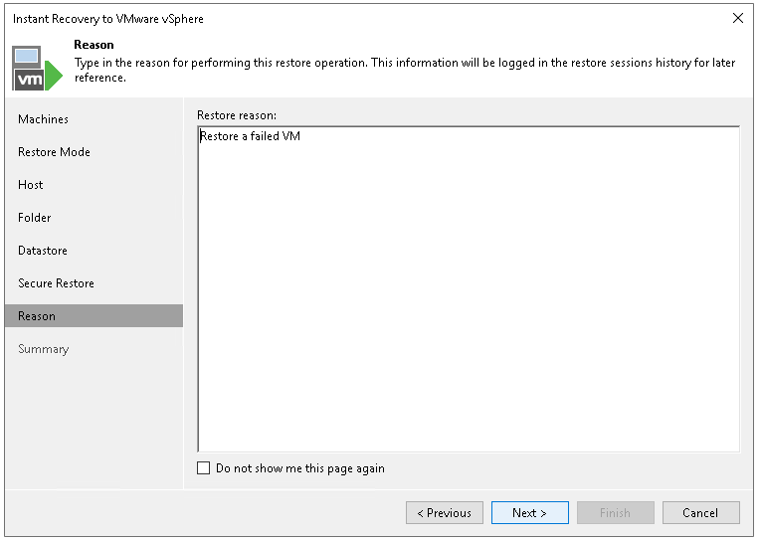

Step 8. Verify Instant Recovery Settings

1. If you recover production workloads that have failed and want to recover them with initial network settings, select the**Connect VMs to network** check box.

***If you recover workloads for testing disaster recovery while the original workloads are still running, leave this check box unselected. Before you power on the recovered VMs, you must disconnect them from the production network and connect to a non-production network to avoid conflicts.***

1. To start the VMs right after recovery, select the **Power on target VMs after restoring** check box. If you recover the workloads to the production network, make sure that the original workloads are powered off.
2. Check settings that you have specified for Instant Recovery and click **Finish**.
3. Check that the publishing process has started and click **Close**.

