A picture containing clipart

Description generated with high confidence

**Process documentation for VM recovery of VMware**

Kuldeep Kumar

iNITIAL DRAFT / Review Date (4th July 2024)

2024

Contents

Step 1. Launch the Veeam Backup Replication Console………………………………………………………. 2

Step 2. Select VM…………………………………………………………………………………………….…………………. 2

Step 3. Select Restore Point……………………………………………………………………………………….………. 3

Step 4. Select Restore Mode……………………………………………………………………………………………… 3-4

Step 5. Select Target Host…………………………………………………………………………………………………… 4

Step 6. Select Target Resource Pool……………………………………………………………………………………. 5

Step 7. Select Target Datastore and Disk Type……………………………………………………………………. 5-6

Step 8. Select Target Folder and Change VM Settings…………………………………………………………. 6-7

Step 9. Specify Network Mapping………………………………………………………………………………………. 7-8

Step 10. Specify Secure Restore Settings……………………………………………………………………………… 8

Step 11. Specify Restore Reason…………………………………………………………………………………………... 9

Step 12. Verify Restore Settings……………………………………………………………………………………………. 9

No table of contents entries found.

**Veeam Entire VM recovery of VMware**

**Step 1.** Launch the Veeam Backup Replication Console.

* On the **Home** tab, click **Disk** > **Select VM** > **Entire VM restore**.

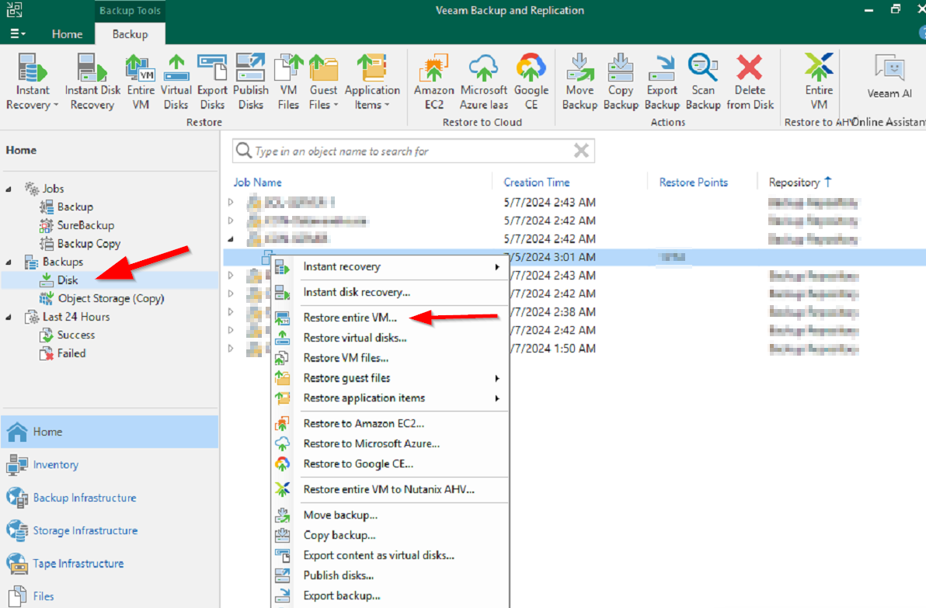

**Step 2. Select VM**

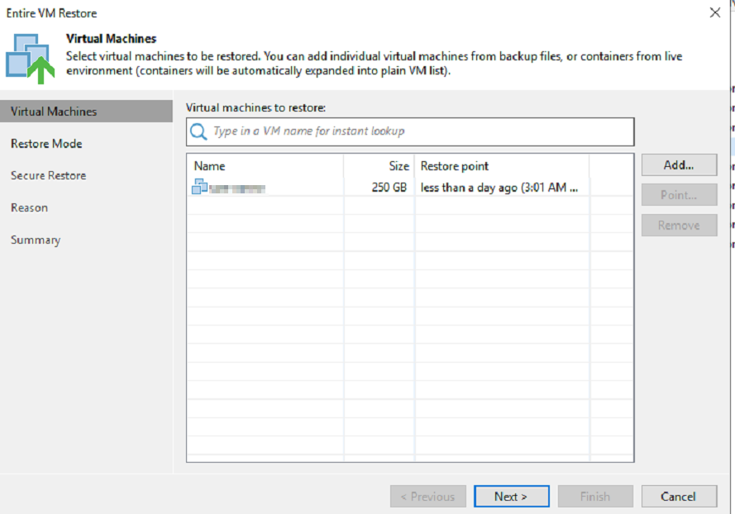

**Step 3. Select Restore Point**

By default, Veeam Backup & Replication uses the latest valid restore point. However, you can restore the VM to an earlier state. If you have chosen to restore several VMs, you can select the necessary restore point for each VM in the list.

To select a restore point for a VM:

1. In the **Virtual machines to restore** list, select a VM.
2. Click **Point** on the right.
3. In the **Restore Points** window, select a restore point from which you want to restore the VM.

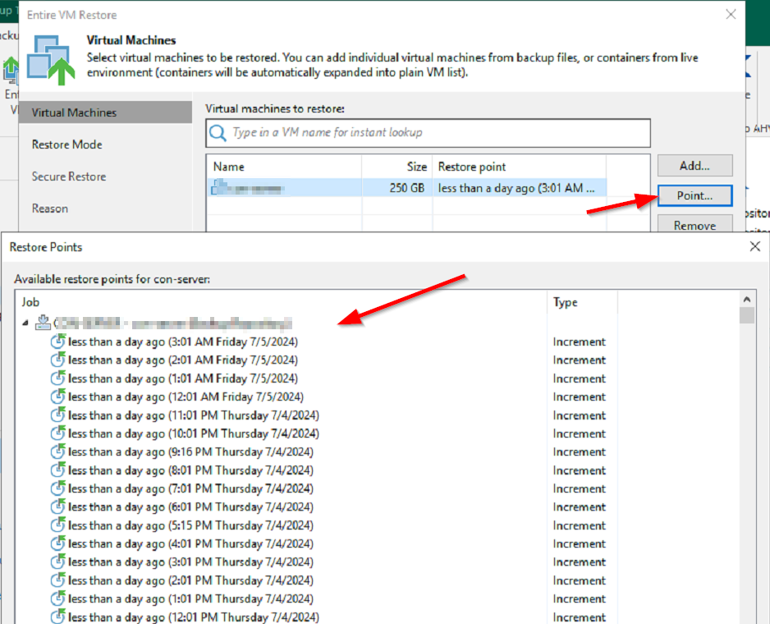

**Step 4. Select Restore Mode**

Choose a restore mode:

* Select **Restore to a new location**, or with different settings to restore VMs to a different location or with different settings (such as VM location, network settings, format of restored virtual disks and so on). If this option is selected, the Full VM Restore wizard will include additional steps for customizing VMs settings.

During restore to a new location, Veeam Backup & Replication creates new VMs. If you want to process the restored VMs, you must edit existing jobs or create new jobs to process the restored VMs. If you restore VMs with the same name and to the same folder as the original VMs, Veeam Backup & Replication deletes the original VMs. In this case, you must edit existing jobs to exclude original VMs from them.

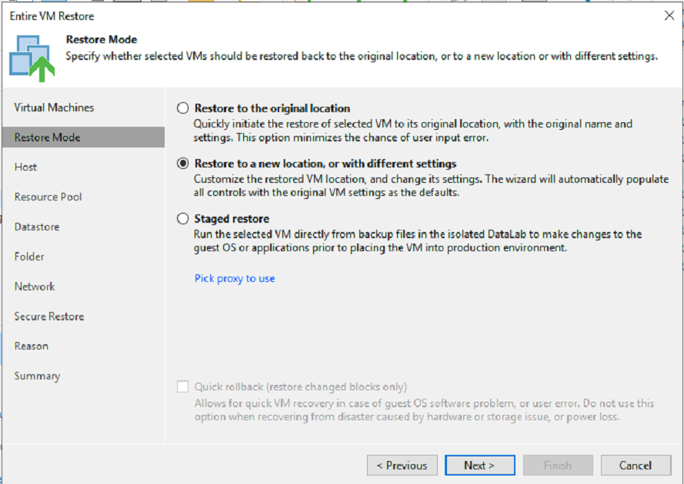

**Step 5. Select Target Host**

To specify a target host:

1. Select the necessary VMs in the list and click **Host**.
2. Choose a host or cluster where the selected VMs must be registered.

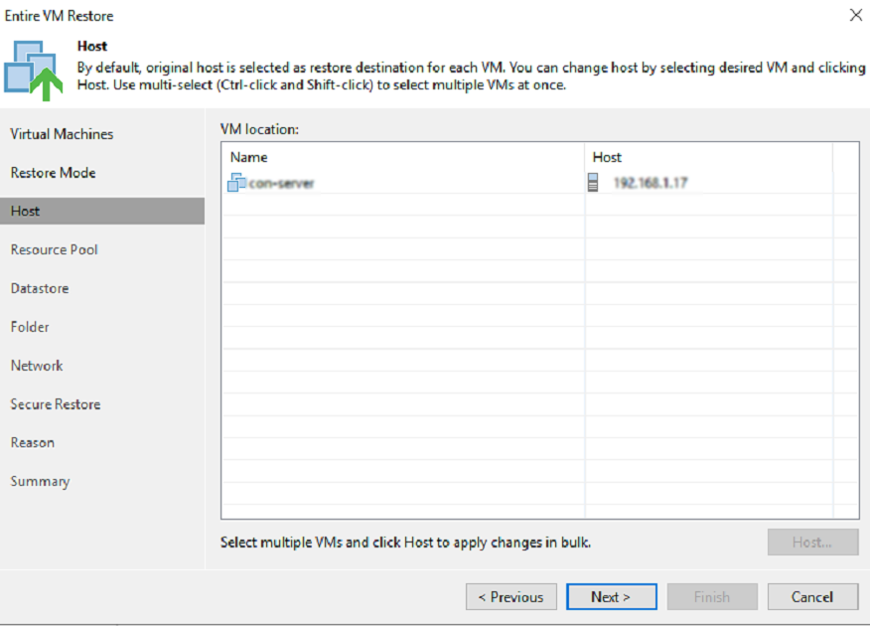

**Step 6. Select Target Resource Pool**

To specify a destination resource pool:

1. Select the necessary VMs in the list and click **Pool**.
2. Select a resource pool to which the VMs must be placed.
3. If necessary, select a vApp in which the VMs must be included.

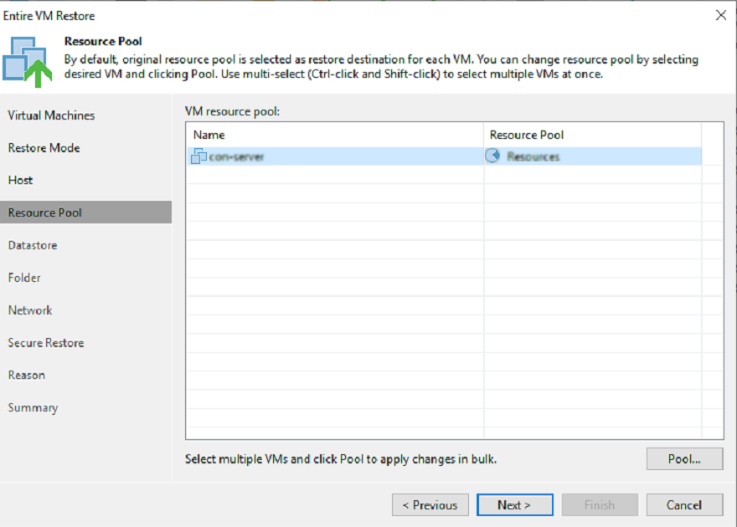

**Step 7. Select Target Datastore and Disk Type**

You can place an entire VM to a particular datastore or choose to store configuration files and disk files of the restored VM in different locations.

1. To place VMs to a datastore, select the necessary VMs in the **Files location** list and click **Datastore**. In the **Disk Type** **Settings** window, select a datastore and click **OK**.

If you want to place configuration and disk files to different datastores, expand the VM in the File location list and select individual files. Then specify the necessary datastore.

1. By default, Veeam Backup & Replication preserves the format of restored VM disks. To change the disk format, expand a VM in the **Files location** list, select the necessary disks and click **Disk Type**. In the **Disk Type Settings** section, choose the format that will be used to restore virtual disks of the VM: same as source, thin, thick lazy zeroed or thick eager zeroed.

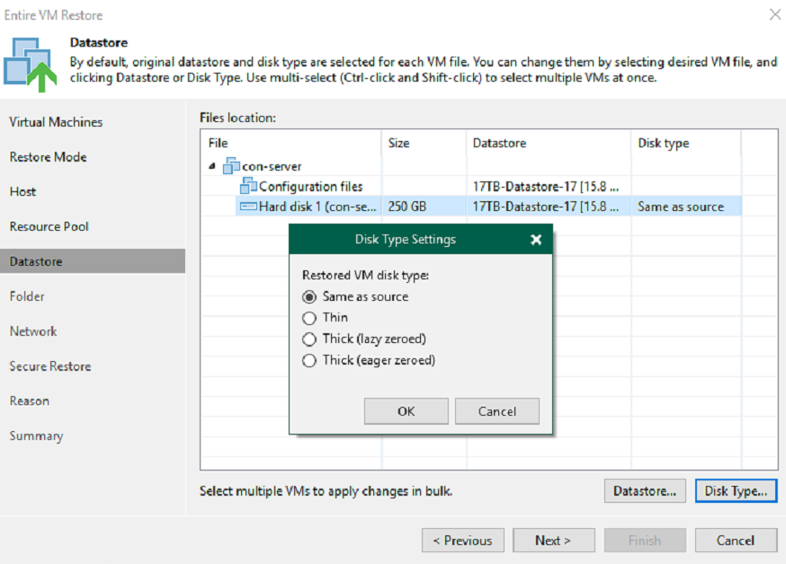

**Step 8. Select Target Folder and Change VM Settings**

To specify a destination VM folder:

1. Select a VM in the list and click **Folder**.
2. Choose a folder to which the VM will be placed.

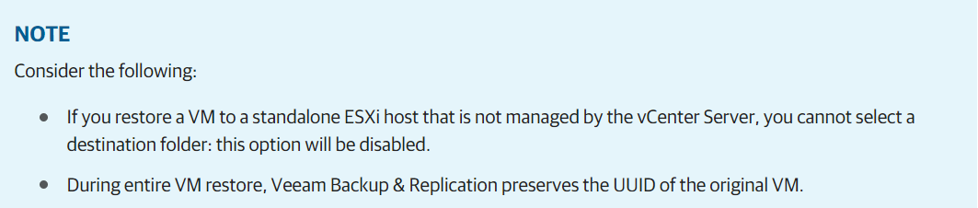

* **Changing Names**

To change a VM name:

1. Select a VM in the **VM folder** list and click **Name**.
2. In the **Change Name** section, enter a new name explicitly or specify a change name rule by adding a prefix or suffix to the original VM name.

Alternatively, you can change a VM name directly in the **VM folder** list. To do this, click the **New Name** field and enter the name to be assigned to the recovered VM.

* **Restoring VM Tags**

Select the **Restore VM** **tags** check box if you want to restore tags that were assigned to the original VM and to assign them to the restored VM. Veeam Backup & Replication will restore the VM with original tags if the following conditions are met:

1. The VM is restored to its original location.
2. The original VM tag is still available on the source vCenter Server.

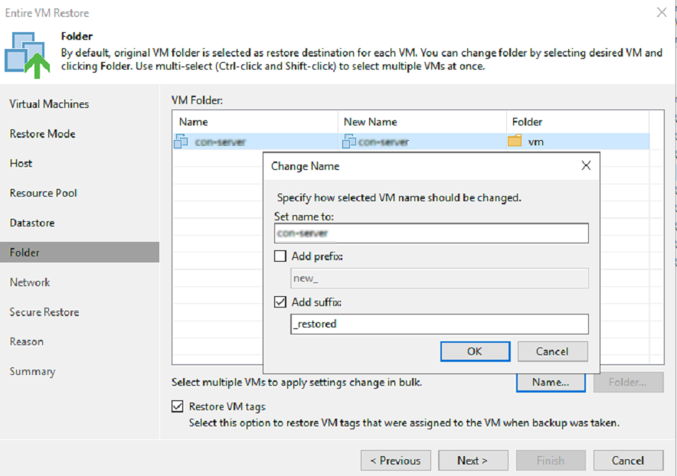

**Step 9. Specify Network Mapping**

If you plan to restore a VM to a new location, for example, another site with a different set of networks, you can map source site networks to target site networks. Veeam Backup & Replication will use the network mapping table to update configuration files of the VM on the fly, during the restore process.

To change networks to which the restored VM will be connected:

1. Select a VM in the list and click **Network**. To apply changes in bulk, select several VMs in the list and click **Network**.

If a VM is connected to multiple networks, expand the VM, select the network to map and click **Network**. The **Select Network** section displays all networks to which the target host or cluster is connected.

1. From the list of available networks, choose a network to which the VM must have access upon restore.

If you do not want to connect a restored VM to your virtual networks, select the VM in the list and click **Disconnected**.

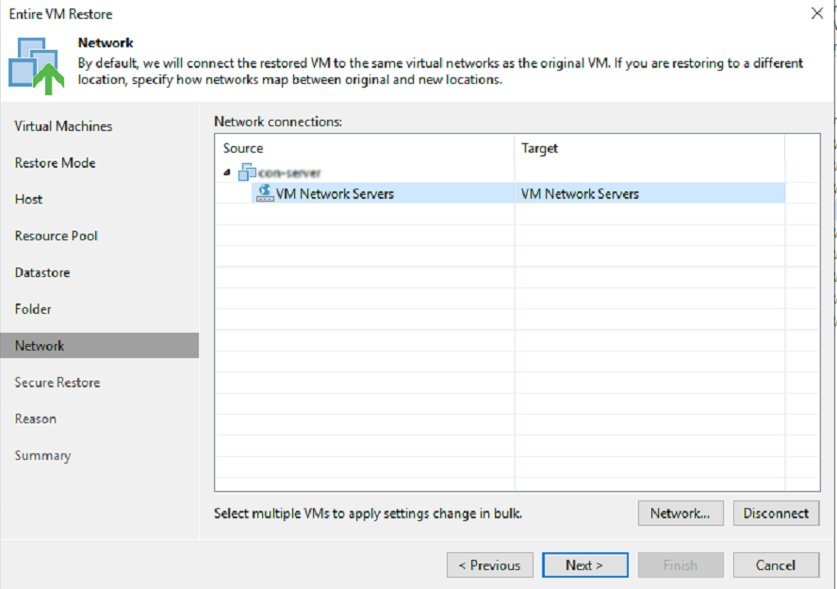

**Step 10. Specify Secure Restore Settings**

**Note: Enabling this check box will increase your restore time, so enable it only when necessary else it can be skipped, uncheck both check boxes and click next.**

Before restoring the machine to the production environment, you can instruct Veeam Backup & Replication to scan machine data with antivirus software and YARA rules.

To specify secure, restore settings:

1. select the Scan the restore point with an antivirus engine check box to use antivirus software as a scan engine.
2. For Veeam Backup & Replication version [12.1 (build 12.1.0.2131) and later] To use a YARA rule as a scan engine, select the **Scan the restore point with the following YARA rule** check box and choose a YARA rule from the drop-down list.

For a YARA rule to appear in the drop-down list, it must be placed in the YaraRules folder in the Veeam Backup & Replication product folder.

To copy the path to the folder with YARA rules, click **Copy YARA rule’s location to clipboard**.

1. Select which action Veeam Backup & Replication will take if scan finds a virus threat:

* **Proceed with recovery but disable network adapters**. Select this action if you want to restore the machine with disabled network adapters (NICs).
* **Abort VM recovery**. Select this action if you want to cancel the restore session.

1. Select the **Continue scanning all remaining files after the first occurrence**(**Scan the entire image** – for version 12 (build 12.0.0.1420)) check box if you want to continue machine scan after the first malware is found.

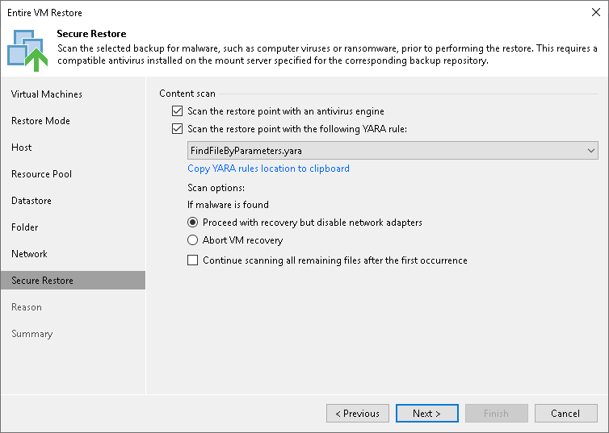

**Step 11. Specify Restore Reason**

At the **Reason** step of the wizard, enter a reason for restoring the selected VMs. The information you provide will be saved in the session history and you can reference it later.

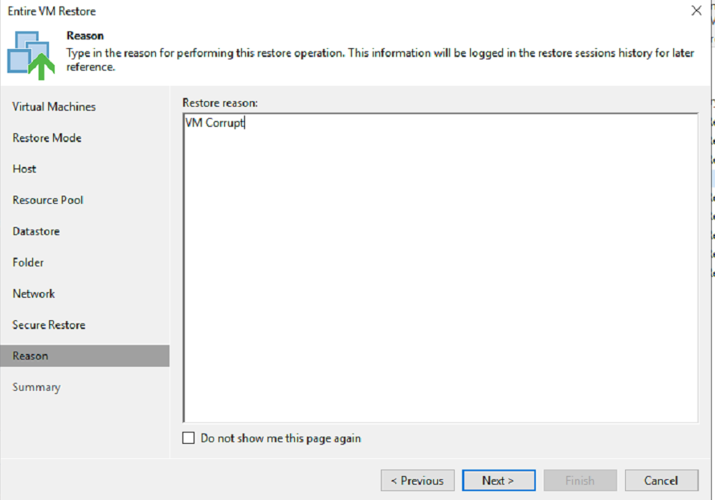

**Step 12. Verify Restore Settings**

At the **Summary** step of the wizard, check restore settings and click **Finish**. If you want to start the recovered VMs on the target host, select the **Power on target VM after restoring** check box.