# SLA Documentation

**What is SLA?**

A service level agreement (SLA) is a minimum set of service levels, that is, performance standards, that your company defines to meet the service needs of one or more customers. We can have one SLA that you apply to all customers, or multiple SLAs to meet different customer needs.

**The objective of SLA.**

SLA's main objective is to define each SLA event's anticipated duration and the business hours during which the SLA clock should record SLA data. Each SLA contains a default objective that can be edited, but not deleted. We can add/edit objectives as per our requirements.

We used to have ‘Standard SLA’ for all the ticket categories. But now, we have created separate SLAs for each ticket category, and we have made an automated process that will keep assigning the SLAs according to the ticket categories.

**Mapped SLA Events to Ticket Status**

* **In Progress > First Response**
* **Scheduled > Resolution Plan**
* **Resolved/Complete > Resolution/Resolved**

**Process**

Below are the steps, that explains how this process works:

1. **Assigning SLA:** Whenever a ticket is created a WFR will be triggered, and SLA will be assigned according to the ticket category.Graphical user interface, text, application

   Description automatically generated
2. **Ticket Categories & their SLAs:**
   1. Below are the Ticket categories and their respective SLAs

|  |  |
| --- | --- |
| **Ticket Category** | **SLA** |
| Automation | Automation |
| Monitoring | Monitoring |
| Backups | Backups |
| Triage | Triage |
| Internal IT | Internal IT |
| Service Operations | Service Operations |

* 1. There are 4 ticket priorities under each ticket category and the SLA Objective has been set according to the priority of the Ticket.

**Like above ticket category (service Operations) and its priorities, SLA objective have been set for all ticket categories (Triage, Automation, Backups, Monitoring & Internal IT) priorities (Critical, High, Medium & Low).**

1. **SLA Start Time:** SLA will start according to the timeframe set in the SLA Objective:

* 1. **All (24x7):** In this time frame, SLA will start as soon as the ticket is created.
  2. **Extended Hours:** In this Time frame: SLA will start as per the extended hours set (before & after business hours)
  3. **Business Hours:** In this time frame, SLA will only work during the set Business Hours.

1. **Workflow Rules & Notification Templates:** We have created the Workflow Rules & Notification Templates that will notify the Primary Resource for ‘Approaching’ & ‘Missing’ the SLA events for the ticket:

|  |  |
| --- | --- |
| Approaching | Overdue/Missed |
| First Response | |
| Resolution Plan | |
| Resolved | |

* These Workflow Rules & Notification templates are created for all the ticket priorities.
* Primary resource will get notified through an automated response if the resource misses to respond on the ticket for the mentioned SLA Events.
* Service Operations will also get notified if the resource misses to respond on the ticket after first ‘Overdue’ notification.

1. **Workflow Rules and Notification Templates:**

Workflow rules & Notification templates are created for all the ticket priorities and events. So, for example, if a ticket is created, assigned, and not worked. The Primary resource will get 6 notifications as per the set time frames. Below are the time frames set for sending out the notifications:

|  |  |  |  |  |  |  |
| --- | --- | --- | --- | --- | --- | --- |
| **Priority** | **First Response** | | **Resolution Plan** | | **Resolved** | |
| **Approaching** | **Overdue** | **Approaching** | **Overdue** | **Approaching** | **Overdue** |
| Critical | 15 Mins | 15 Mins | 1 Hour | 1 Hour | 2 Hours | 2 Hours |
| High | 2 Hours | 2 Hours | 1 Hour | 1 Hour | 2 Hours | 2 Hours |
| Medium | 2 Hours | 2 Hours | 2 Hours | 2 Hours | 2 Hours | 2 Hours |
| Low | 2 Hours | 2 Hours | 2 Hours | 2 Hours | 2 Hours | 2 Hours |

So, if a ticket with **critical priority** is created at 10 AM EST and its first response due in 30 mins (10:30 AM EST), the Primary Resource will get the notification for **approaching First Response** and **Overdue First response**, at 10:15 AM and 10:45 AM respectively.

Below are the snippets of Workflow Rules and the associated ‘Notification Templates’ that will be triggered on the conditions mentioned above:

1. **First Response**

**Approaching**

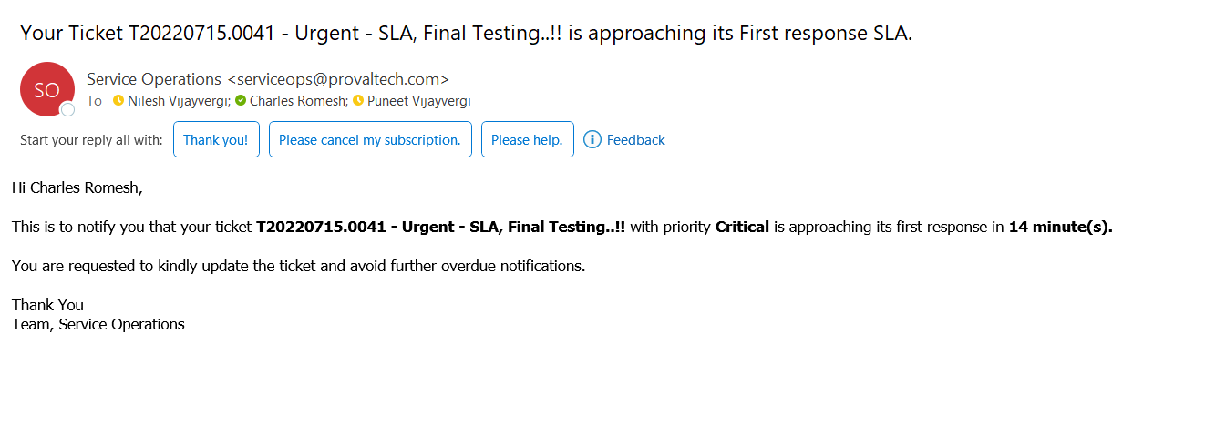

**Overdue/Missed**

**Notification to the resource (This will include the Service Ops Team)**

1. **Resolution Plan**

**Approaching**

**Overdue/Missed**

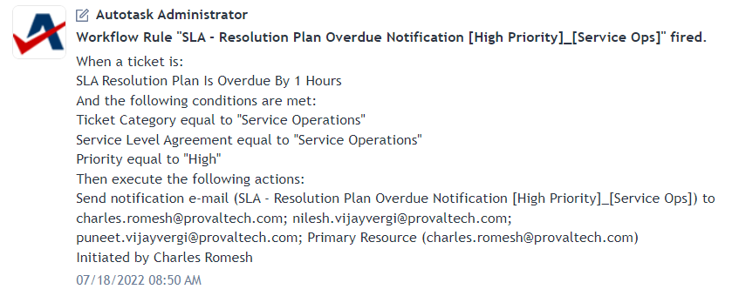

1. **Resolution (due date)**

**Approaching**

**Overdue**

I have tried to cover all the aspects on SLA implementation in this document and have taken this step by step. Still in case of any confusion, please feel free to reach out to Service Ops team. We are already happy to Help...!!