**New Altaro Setup:**

1. Open the Altaro VM Backup console and Connect After the initial installation completes, launch the "Altaro VM Backup" shortcut from the Windows Start Menu, and you will be presented with the following options:

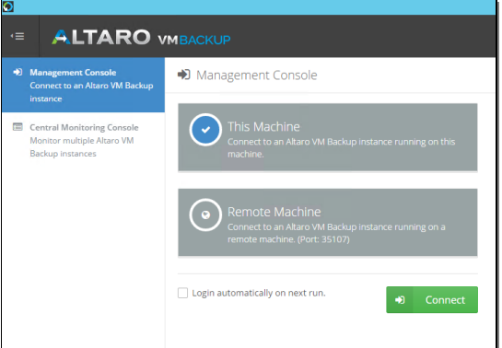

1. Go to Setup > Hosts and click the "Add Host" button. You'll then be prompted with the Host Setup wizard as shown below:

1. Select the type of host you wish to add and click Next.

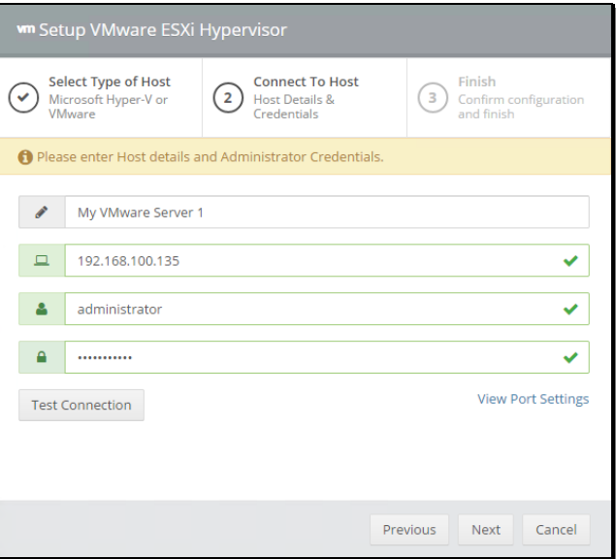

1. Enter the details of your host and click Next. Altaro will test the connection and then deploy the Altaro Host Agent to your host. Once completed, click Finish.
2. Select your Backup Location. To choose where to store your backup data, go to Setup > Backup Locations and click the "Add Backup Location" button:

1. You'll then be prompted with the Add Backup Location wizard as shown below:

1. Choose to add a Physical Drive or a Network Path, then click Next.
2. If selecting a Physical Drive, then simply select the Drive Letter and subfolder (optional) where you want to place your backup data, then click Finish.

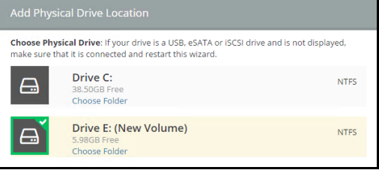

1. If selecting a Network Path, enter the UNC path to your share, and the credentials to be used to connect, then click Finish.

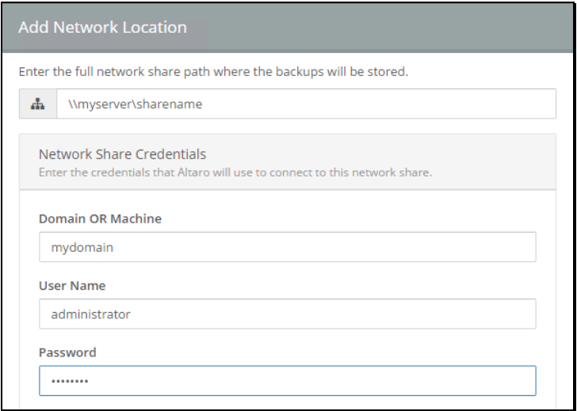

1. To assign VM(s) to your desired backup location, drag and drop the VM(s) from the list on the left hand side into the backup location you would like them to use:

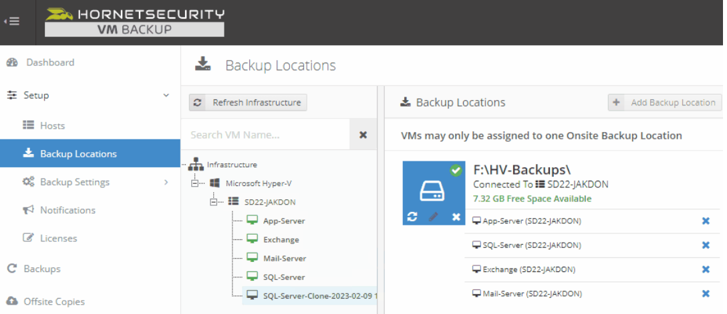

Then click Save Changes to apply your new configuration.

**Note: Each VM can be assigned to only one Backup location at any one time, but different VMs can be configured to go to different Backup Locations**

1. To schedule your VM backups, go to Setup > Backup Schedules and drag & drop the VM(s) into the desired Backup Schedule.

Two Backup Schedules will be created for you by default, however you can Add/Edit/Remove Backup Schedules according to your requirements.

To add a new schedule, click the "Add Backup Schedule" button:

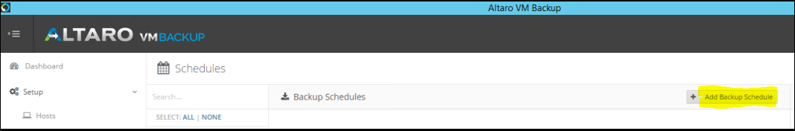

1. You'll then be prompted with the Backup Schedule settings as shown below:

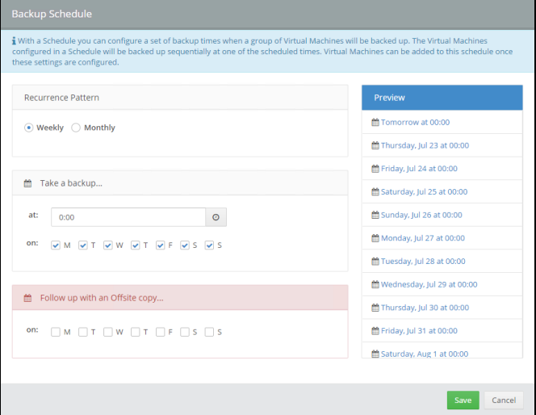

When ready, click Save and the new Schedule will show up in the Backup Schedules configuration screen.

1. Drag and drop the VM(s) from the list on the left hand side into the desired backup schedule:

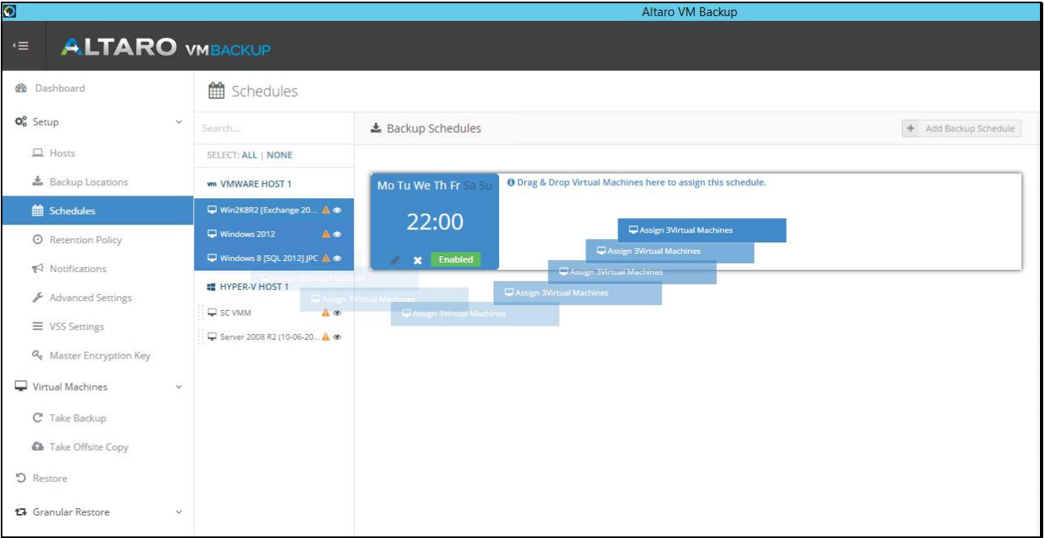

Then click Save Changes to apply your new configuration.

**Note: VMs can be assigned to multiple Backup Schedules if required**

1. Either wait for your backup schedule to kick off at the pre-configured time, or go ahead and start a backup manually by going to **[Backups]**. Select the checkboxes next to the VM(s) you want to backup, then click **[Take Backup]**. Backup progress can then be monitored in the Dashboard.

