To install MSP360 (CloudBerry) Backup on your computer using the Setup Wizard, proceed as follows:

1. Download the installation file from the [MSP360 (CloudBerry) Management](https://www.msp360.com/backup/windows/ultimate.aspx) Portal.

2. Navigate to a folder containing the installation package, then run it.

3. open Online Backup

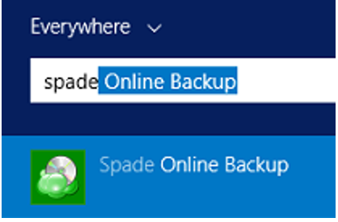

4. Update Account name and Password.

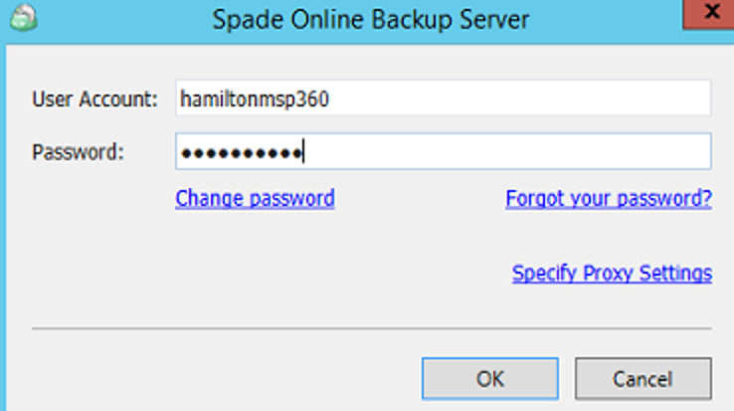

5. Click backup plan **File or Image Based**

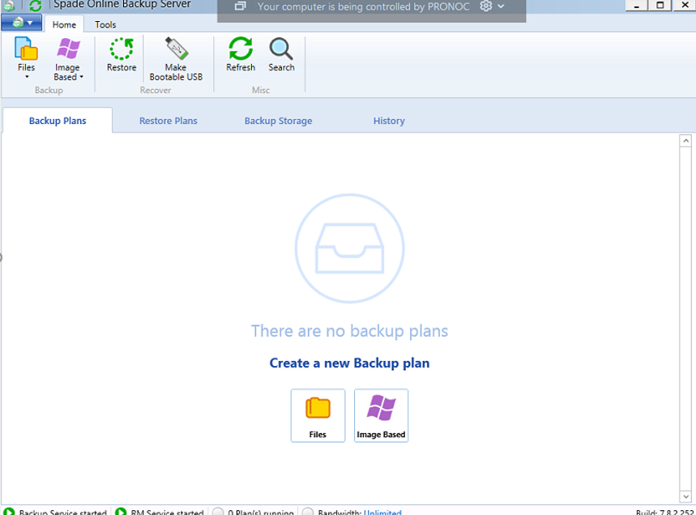

6. Specify the name for the backup plan

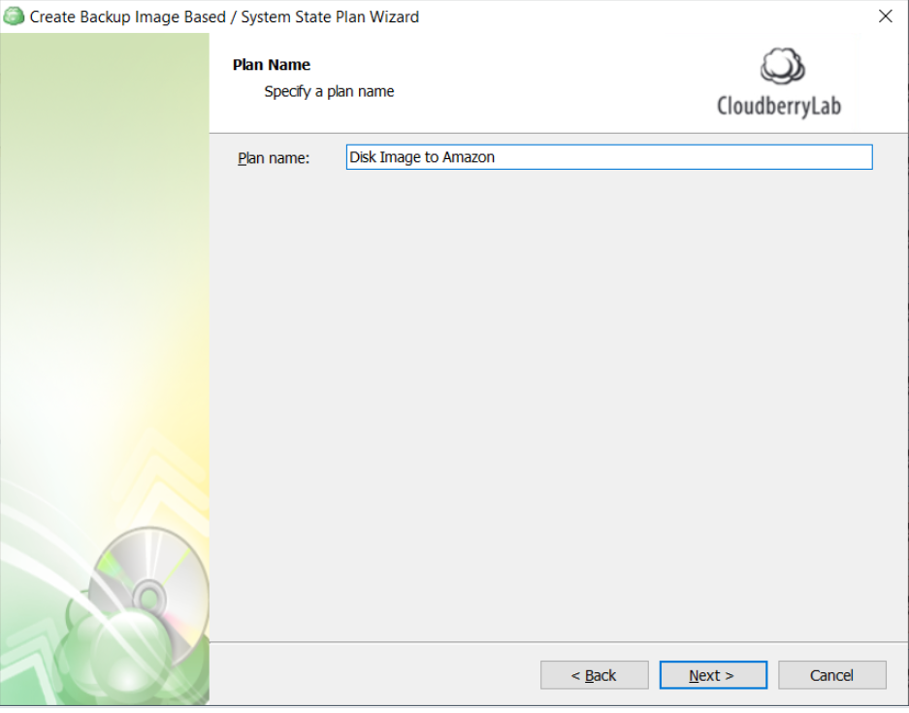

7. Select partitions to back up

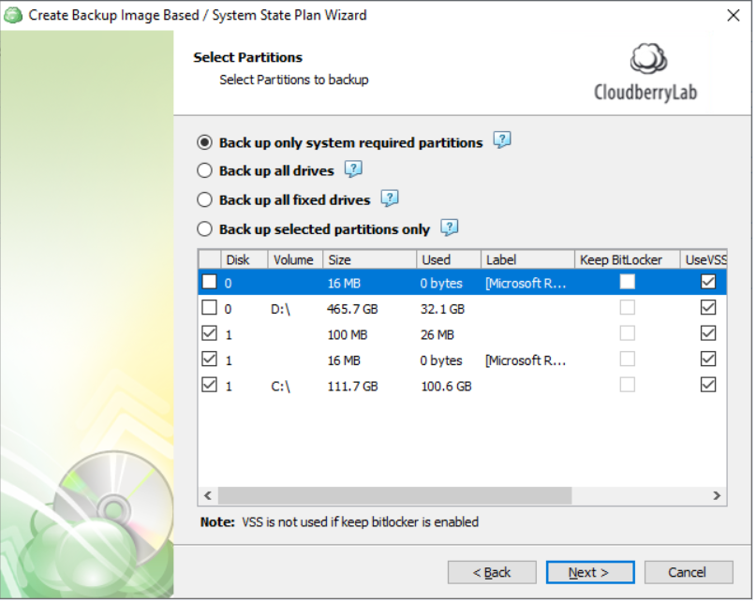

8. Configure advanced options for the backup plan

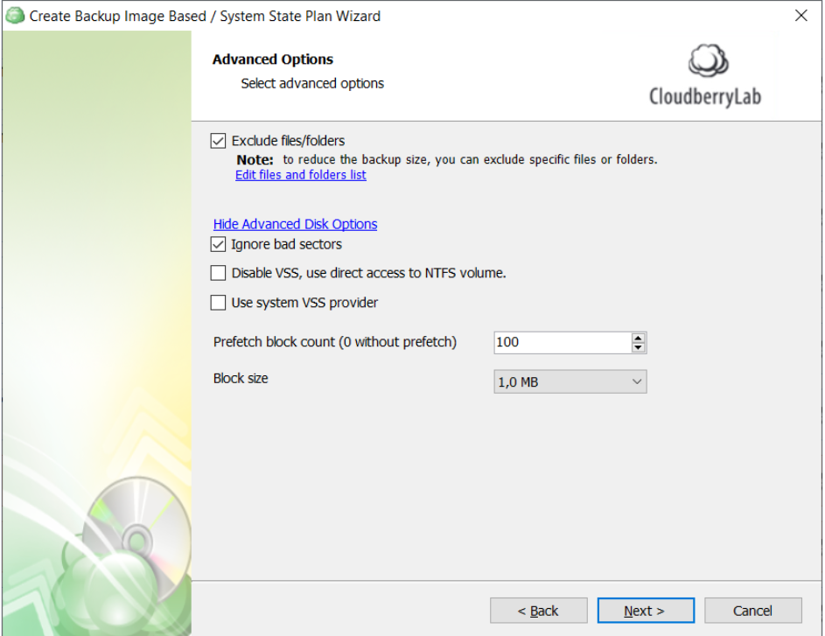

9. Specify compression and encryption options for the backup plan.

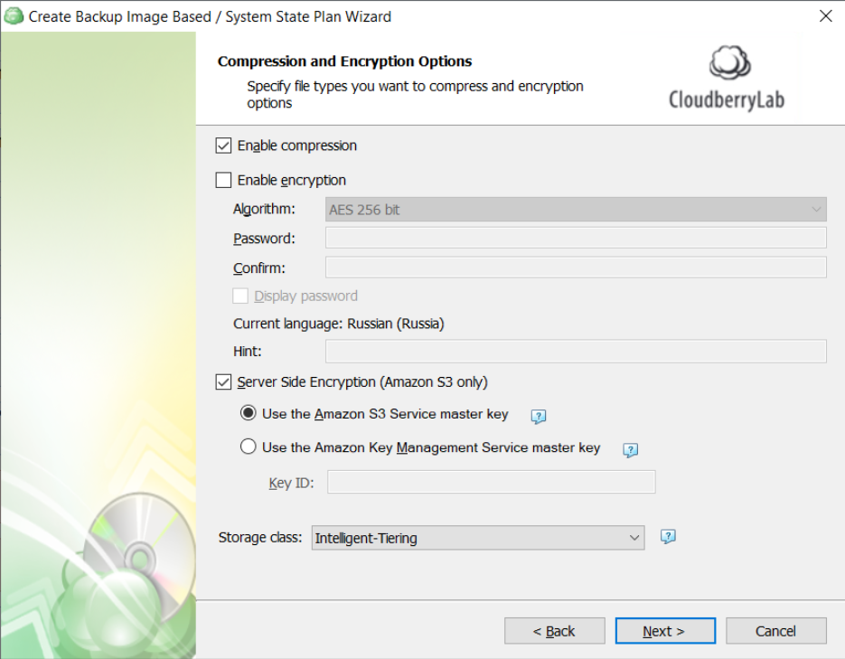

10. Specify the full consistency check and restore verification options.

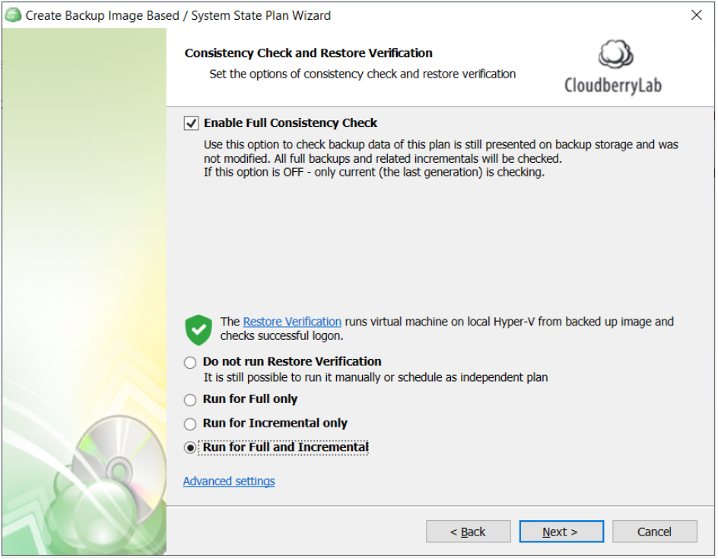

11. Schedule: Specify the backup plan schedule settings.

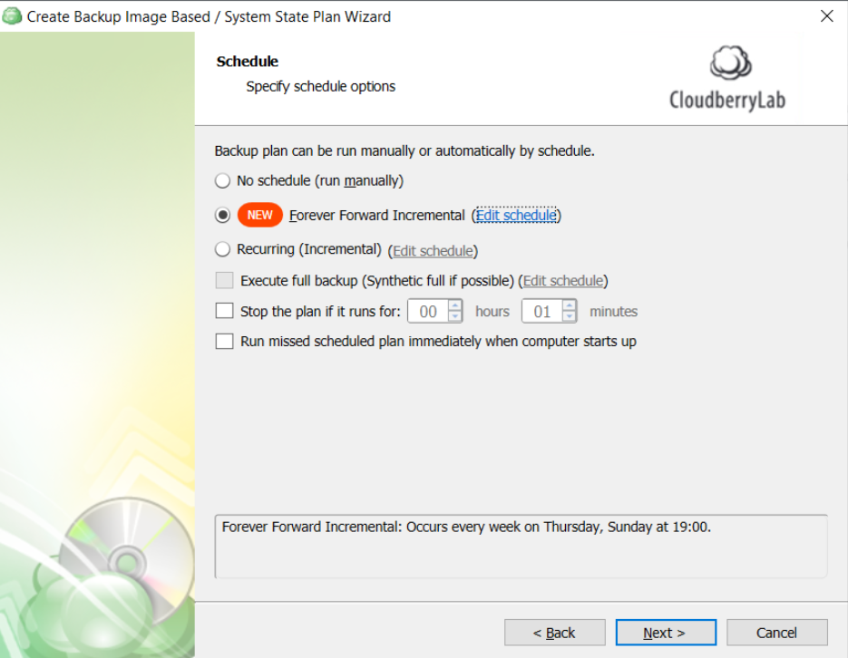

12. Retention Policy and GFS Settings: Specify the retention policy and GFS retention policy for the backup plan. The GFS retention policy delays purge for specific restore points that are stored for archive purposes.

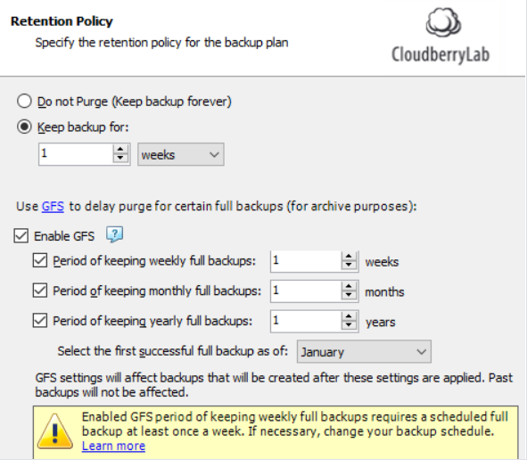

13. Review the configuration of the backup plan.

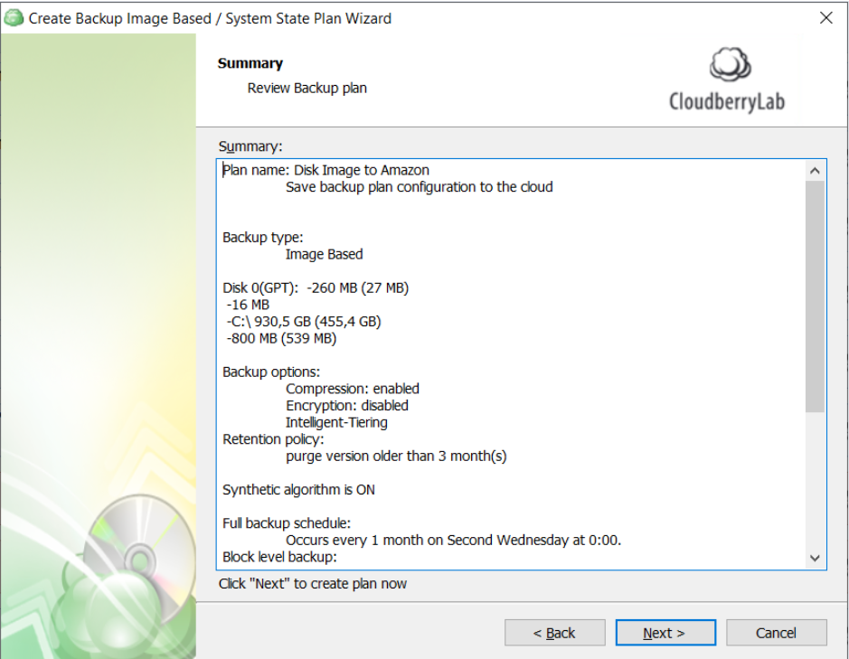

Backup Plan created.

