**Altaro Backup Test restore.**

The Boot from Backup feature allows you to instantly boot any VM version directly from the backup location.

There are two options available when Booting a VM from your Backups:

**Verification mode** - Instantly boots up your backed up VMs in read only mode for verification purposes. Changes made to the booted VM will be discarded when done.

**Recovery mode** - If disaster strikes, the VM can be booted up instantly from the backup drive with minimal downtime, while the VM is restored back to the Hypervisor in the background. A simple VM reboot completes the recovery process and preserves any changes done while the VM was booted.

**To Boot a VM from your backup, open the Management Console**

1. Go to **[Restore]**> **[Boot From Backup] > [Boot a VM from Backup...]**

1. Next choose whether you would like to boot using**[Verification Mode]** or**[Recovery Mode]**:

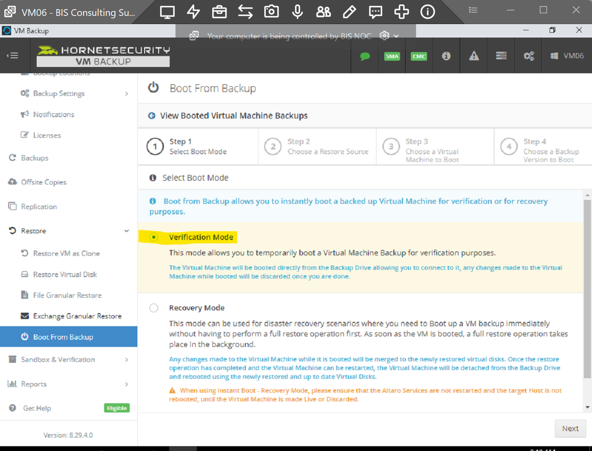

1. The next step after that is selecting the Restore Source.

1. Select the VM you would like to Boot From Backup and click **[Next]**

1. At this point you will be presented with the Backup Version, Name, the Host you'd like to Boot to and the Boot Location

You also have the option to leave the network card disabled.

click **[Boot]**

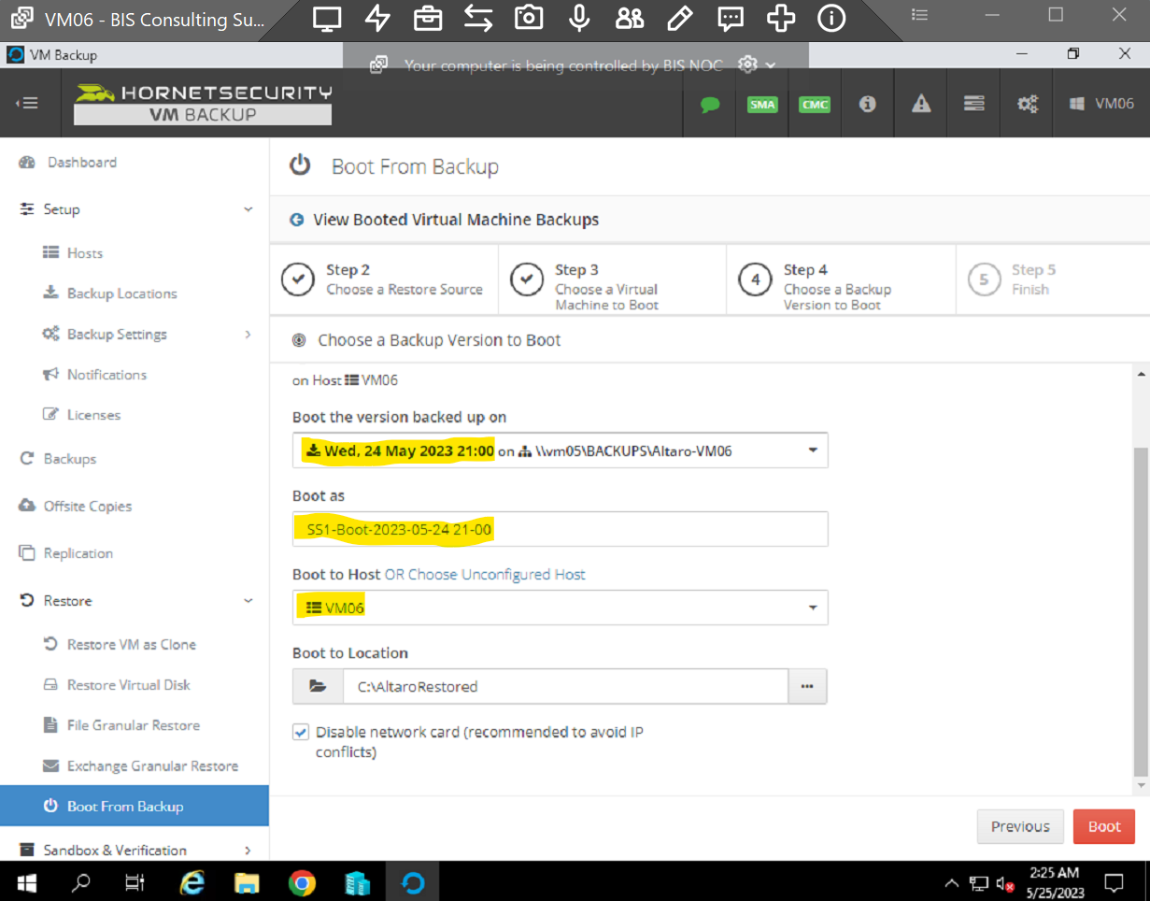

1. Now the test machine created click on Hyper -V too. Click [Connect]

1. Here is a test machine Booted successfully.

1. Once machine Booted successfully. Discard VM from console.

It will remove test vm from Console and Hyper-V host.

Test completed.