**MSP360 Test Restore Process Document**

1. Login to the machine and open backup agent.
2. Go to Backup Storage tab.
3. Expand the Local/Cloud backup and select the latest backup on which you want to test the restore.



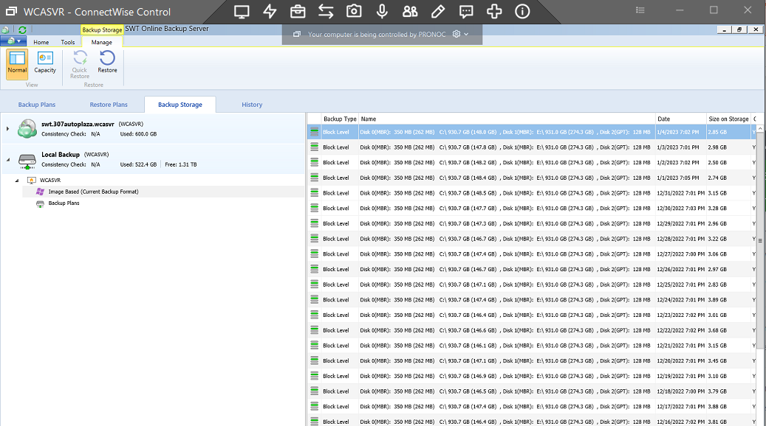



1. Right click on the backup and select File Level Restore.

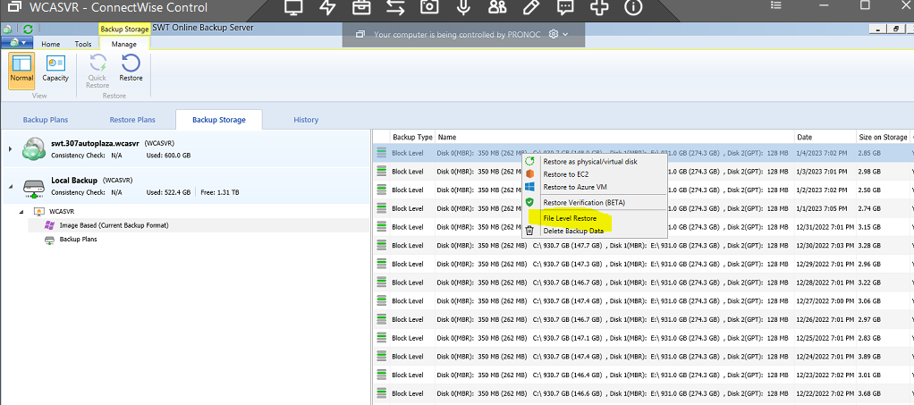

1. You will get a prompt to enter the encryption password as the backup files are encrypted.

1. Expand the drives and the folder.
2. Right click on any small file.

It can be image/document/pdf/html etc. and click on “Restore to”

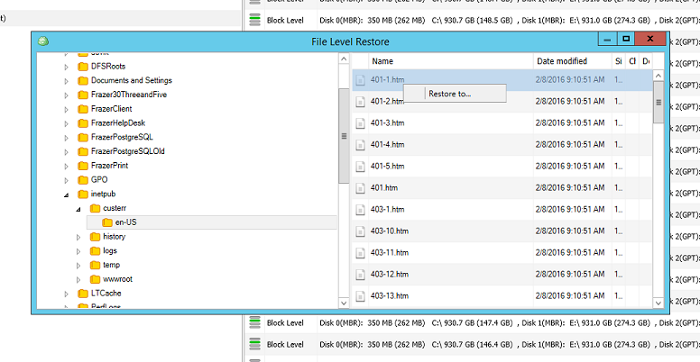

1. Create a folder named Test Restore in Documents or any other location on which you want to restore.

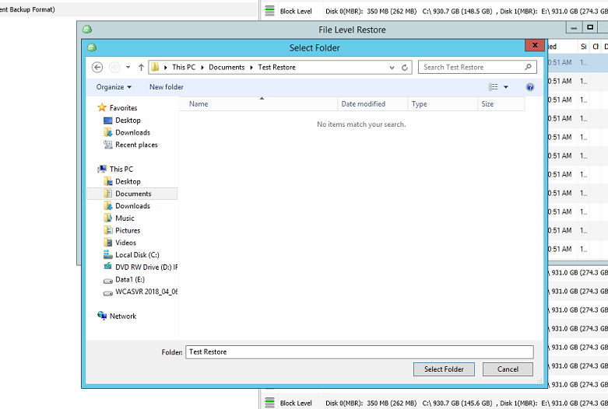



1. After selecting the Test restore folder, a message will appear that the Restore plan is created.



1. You can view the restore progress in Restore plans tab.
2. Once the restore will be completed, the restore plan will disappear from Restore plans tab since it’s a one-time restore.
3. Go to History Tab to view the completed restore.  
   Click on View> All
4. You can verify restore on the restore destination.

1. Delete the test restore folder after the restore is completed.