**Cleanup of Appliance for Repurpose.**

An old Unitrends Appliance setup on New location or Client.

Before deployment of Appliance, we need to perform Cleanup which will remove all old Protected asset, Remove backup/Copy/DCA jobs and Protect data as well.

And Change Appliance host name as per site.

1. **Removed all backup jobs**: Remove all backup, Cloud copy and DCA jobs from Job manager.

Before: There are backup jobs are present.

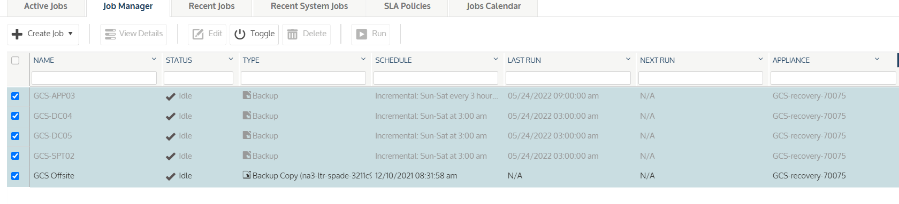

After: There are no job present.

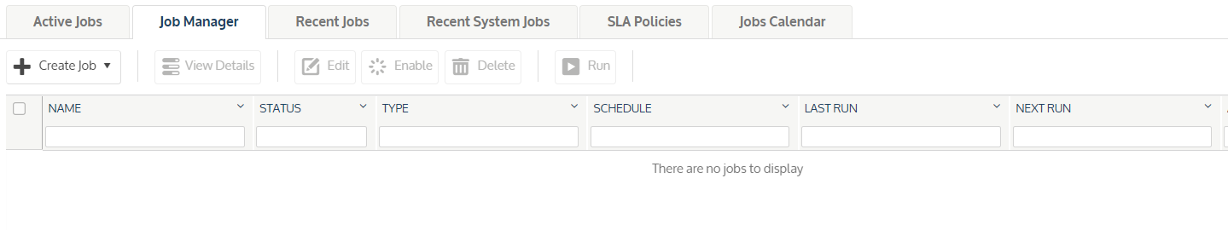

1. **Removed Asset:** Remove All protected Assets Like: Servers, Workstation, Hyper-V and Esxi hots.

Go to 🡪 Configure 🡪 Protected Assets

Before: There are Some servers are protected.

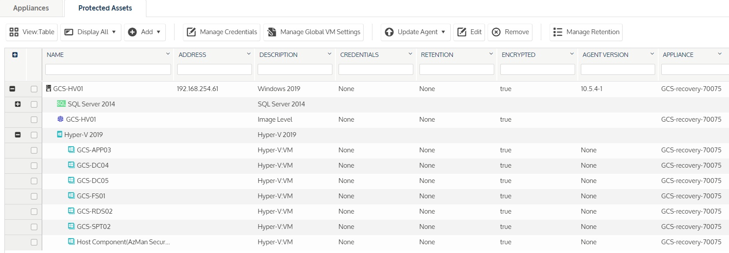

After: Removed all protected assets.

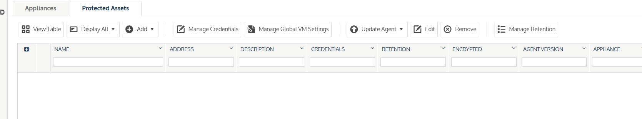

1. **Removed Local backup from Appliance:** Remove backup from Appliance.

Go to -> Recover-> Backup catalog. Use filter while. It will show all protected data on Appliance. Select and delete. Also review File Level Recovery, Instant Recovery and Replicas Tab if any restore if any thing is there we will remove.

Before: There are some protected data on appliance.

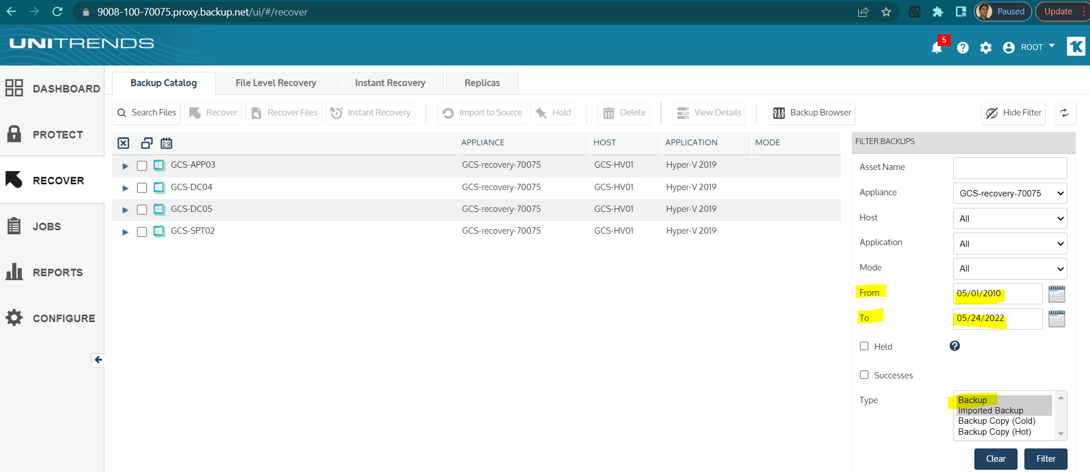

After: All data removed.

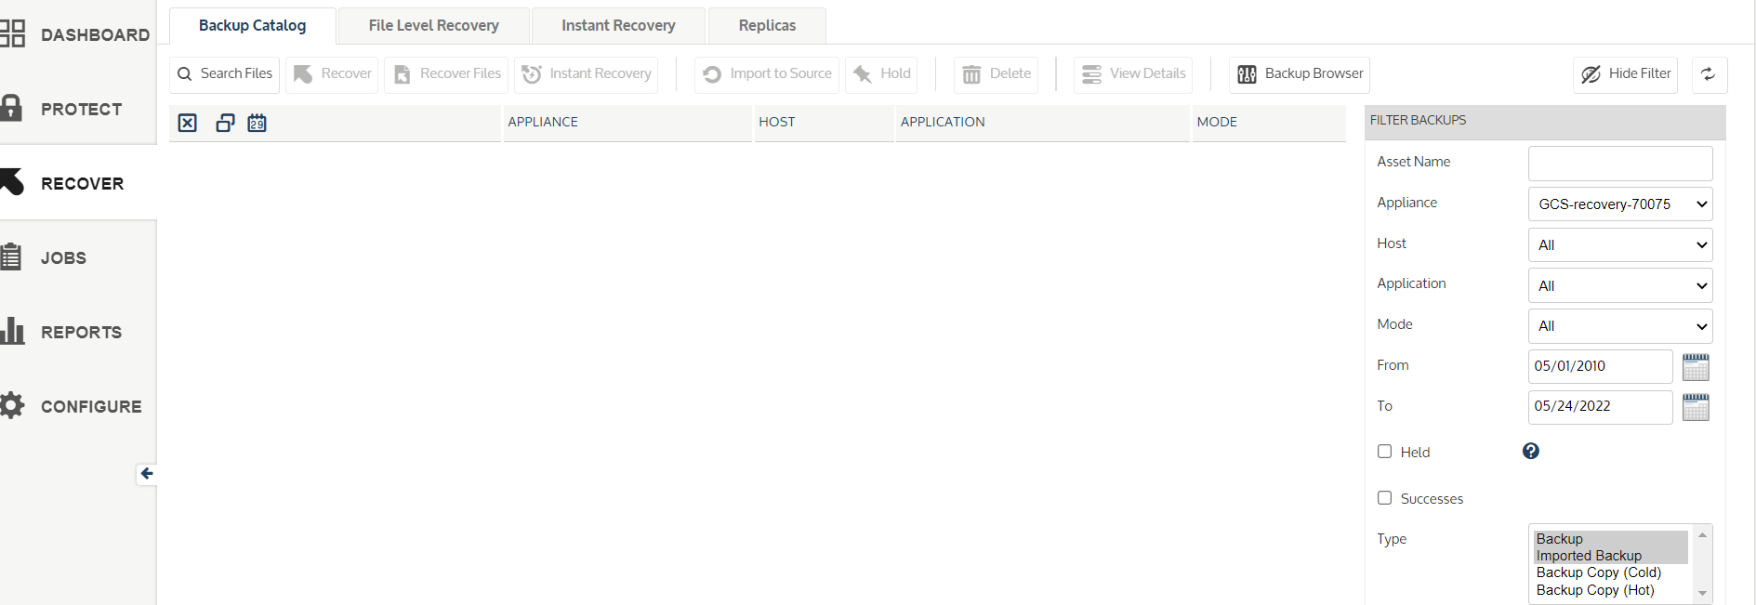.

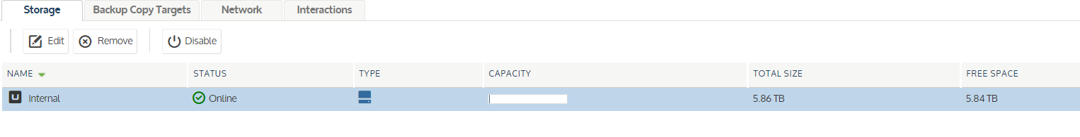

All data removed from Local device.

1. Removed Cloud Target and Backups on it.

Before:

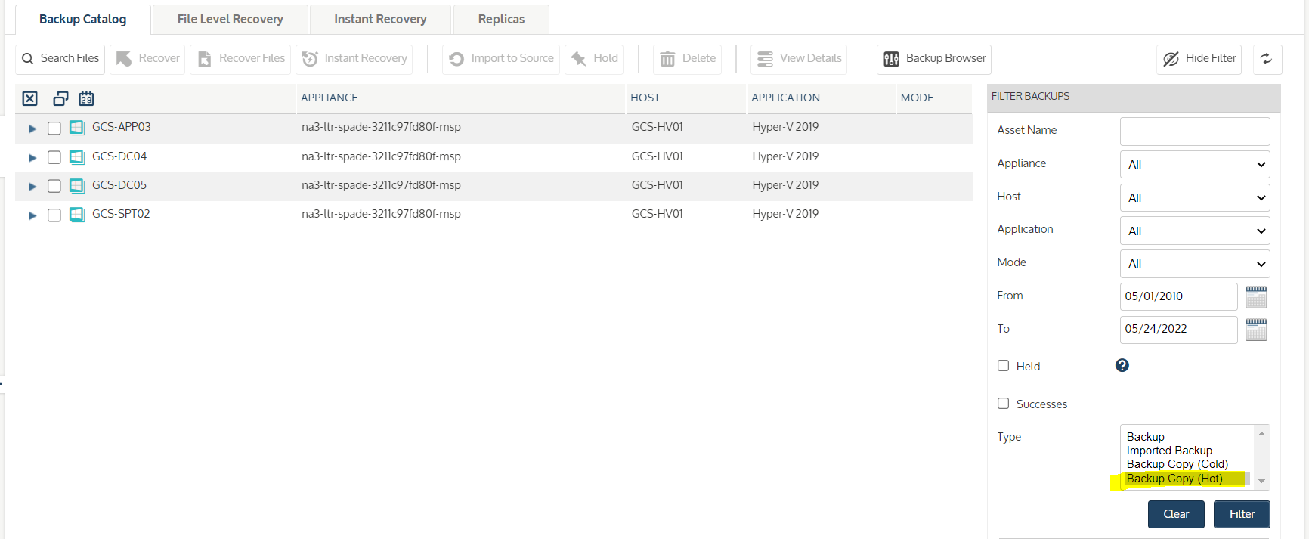

After:

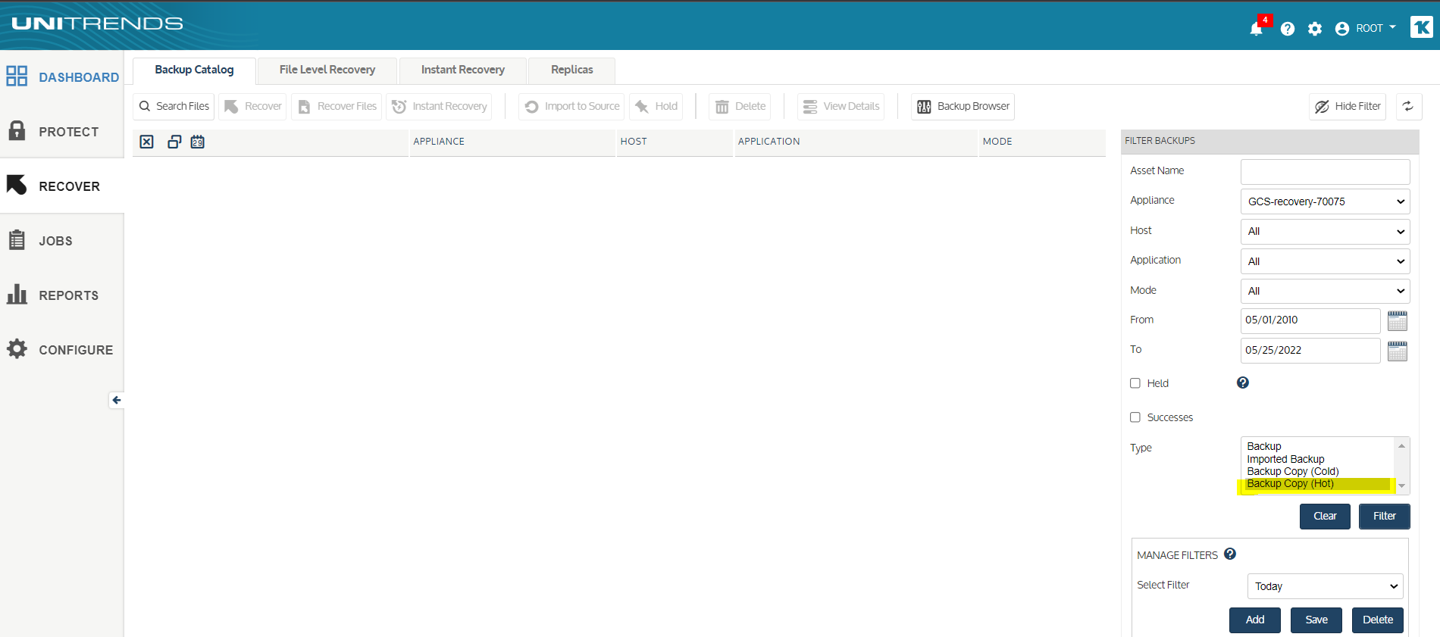

1. Update Appliance Name : Change Appliance name as per site name.

Go to -> Configure-> Appliance -> Edit Appliance setting.

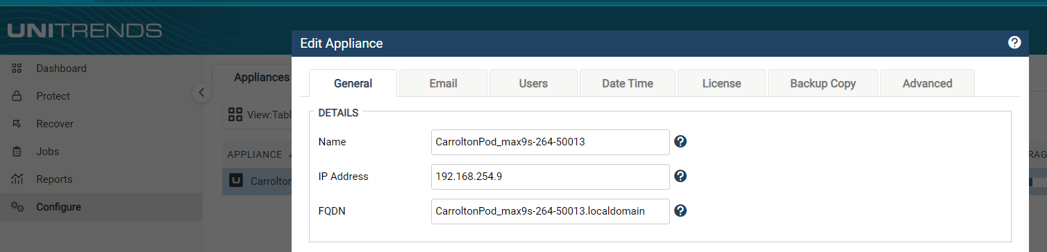

Now Appliance is ready to shift client location.