**MSP 360 File-Level Restore**

1. Launch MSP360 Backup, navigate on Backup Storage

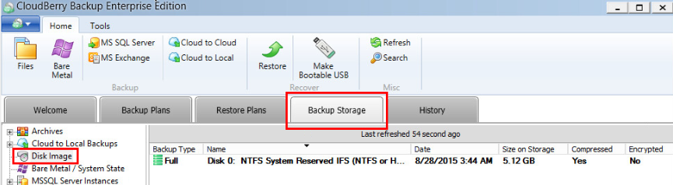

**2.** Select a cloud or physical storage from which to restore your backup.

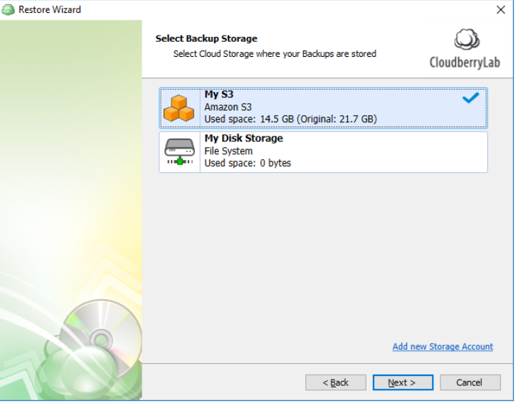

**2.** You will need to specify the plan name to be able to save your restore configuration later on.

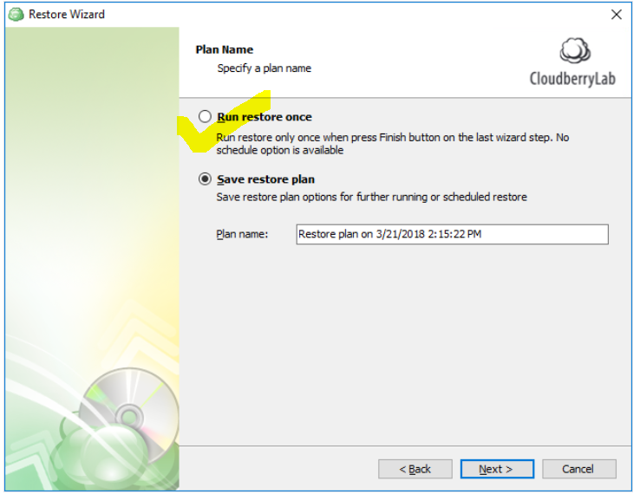

**4.** Choose what kind of data you need to restore.

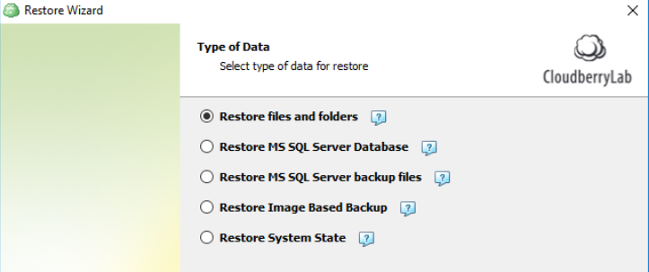

**5.** Select a Restore Point: you need to select whether to restore specific file versions and Restore specific versions

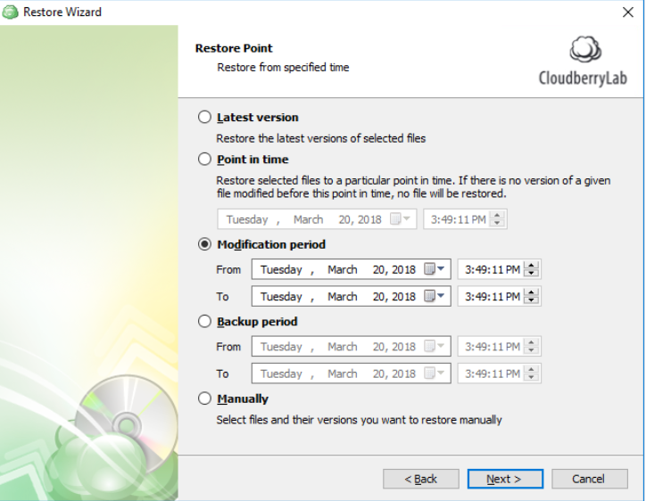

**6. Select Files to Restore :** you need to specify which files and/or folders to restore.

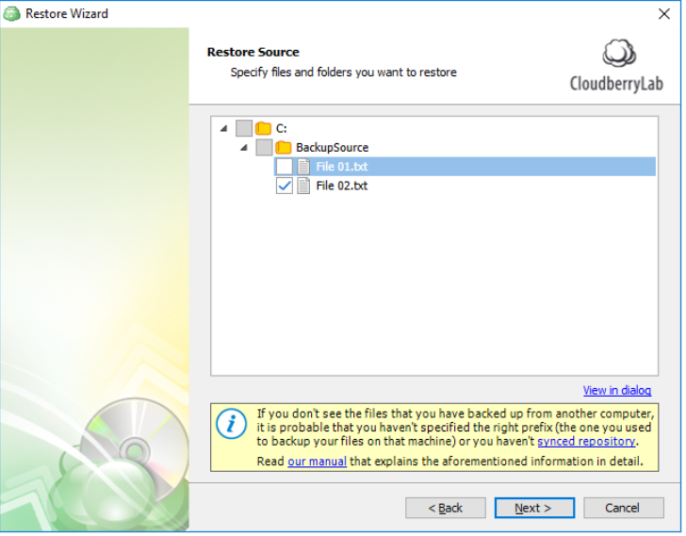

**7.** Select where to restore the selected files.

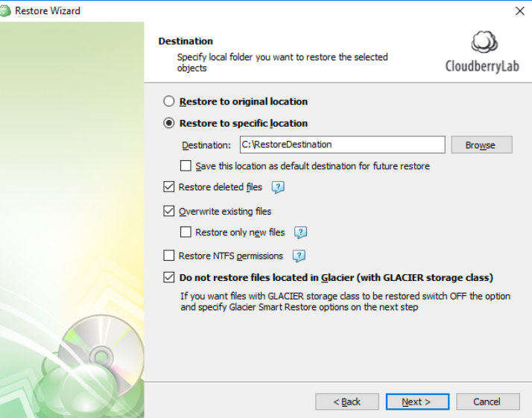

* **Restore to the original location** This will restore the selected files to the same directory where the source files were located.
* **Restore to a specific location** This will restore the selected files to a custom directory. You can make the Restore Wizard use this location as a default destination for newly created restore plans by enabling a corresponding option.

8. **Specify the Encryption Password**

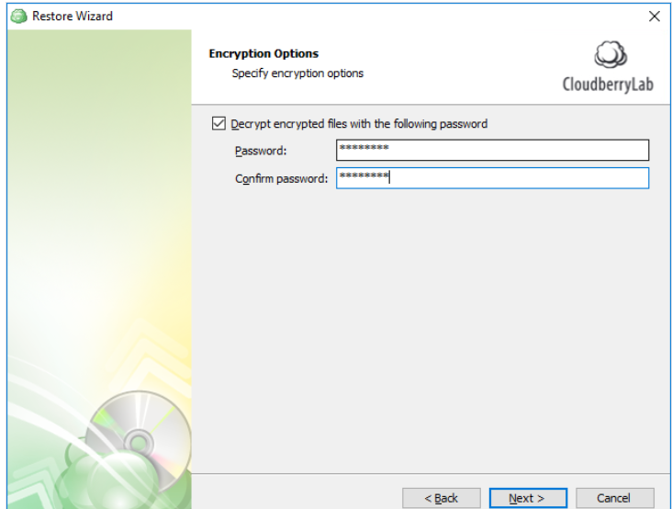

**9. Schedule Your Restore Plan/ Run Manually**

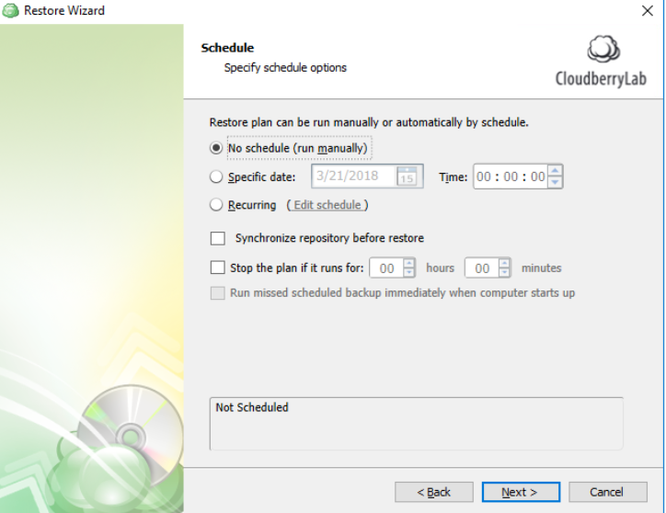

**10. Save and Run Your Restore Plan**

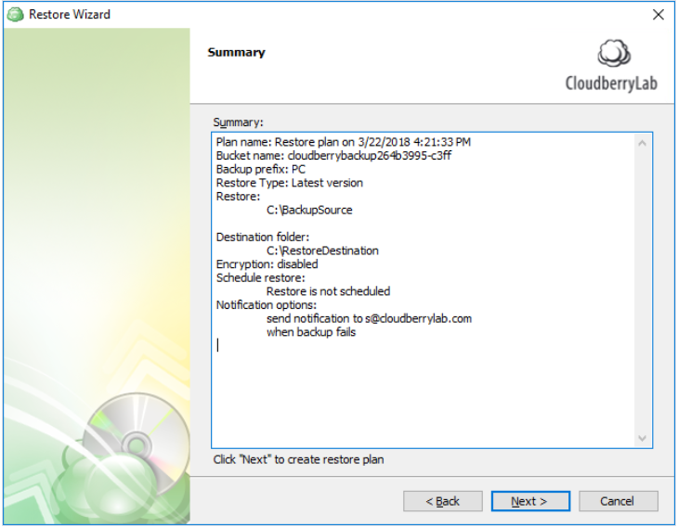

Click **Next** to proceed to the last wizard page, choose whether you need to start the restore process after closing the wizard (this option is available if you chose to save the restore plan previously in this wizard), and click **Finish** to apply the changes.

