**New Unitrends Appliance add to the Unitrends Backup Portal**

1. Log in to your Unitrends Backup Portal:

Open a Firefox or Chrome browser and enter ***https://login.backup.net/*** to access the login page.

In the Appliances view, click **New +**.

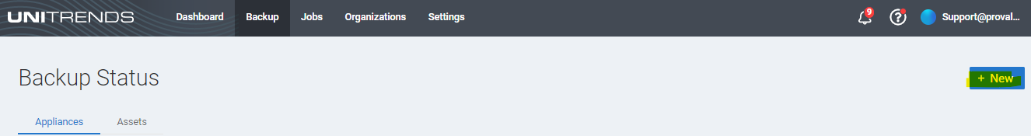

2. Do one of the following:

Select an organization from the Name list.

Or Click **Add New Organization** and do one of the following:

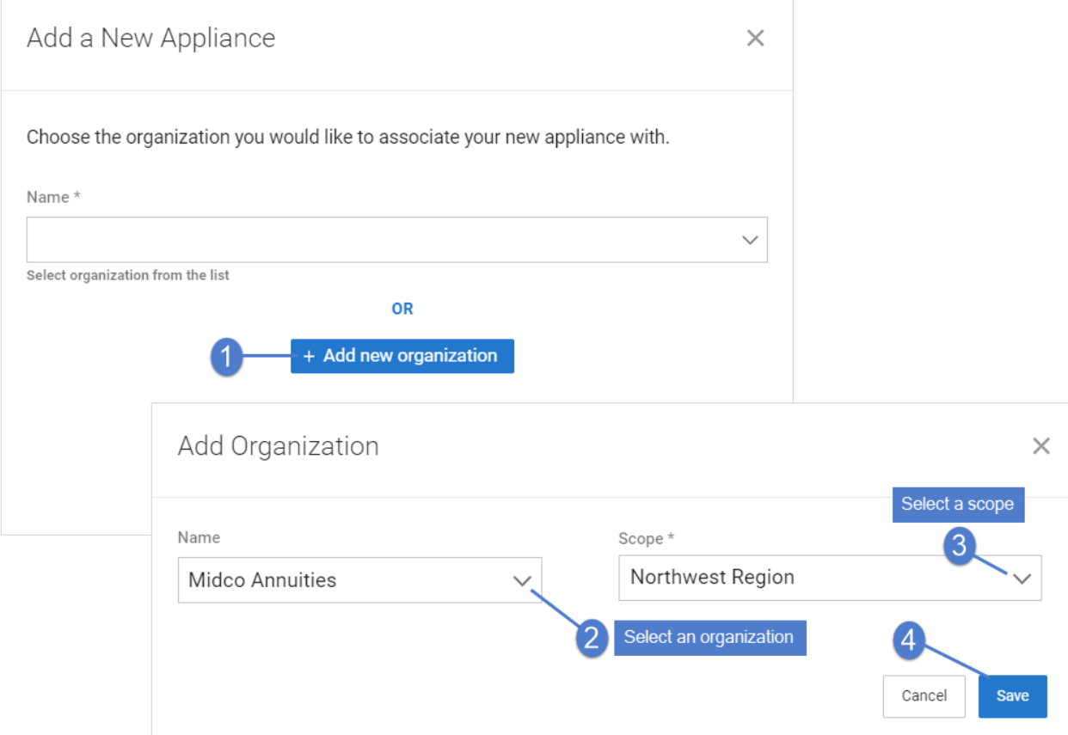

3. Click **Next**.

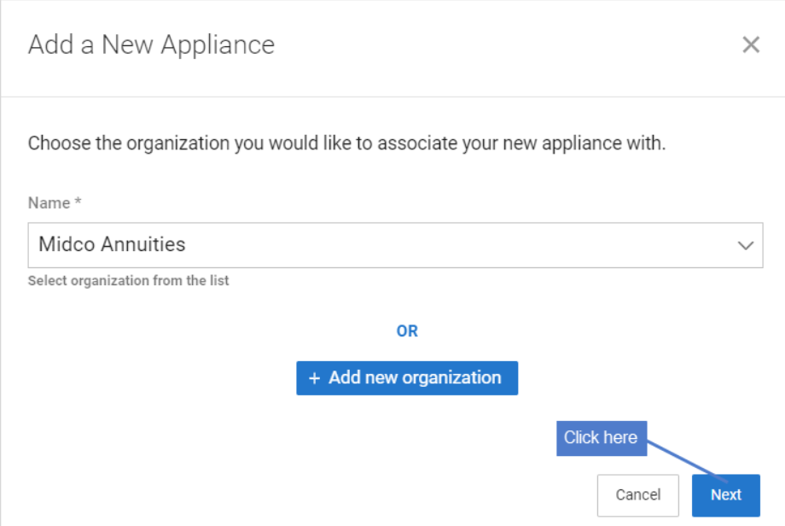



4. Copy the backup.net ID that displays.

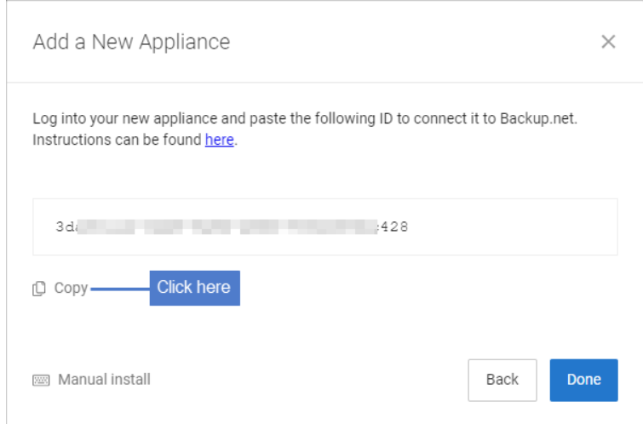

5. Log in to the Unitrends appliance. In the Edit Appliance dialog, click **Backup.net Config**, then paste the ID into the Backup.net ID field. Click **Save**. Click **OK**.

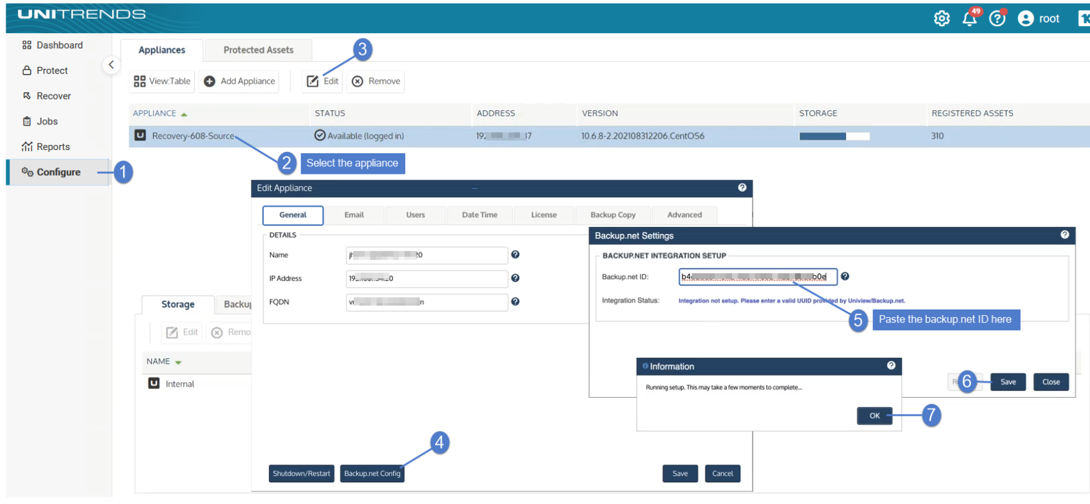

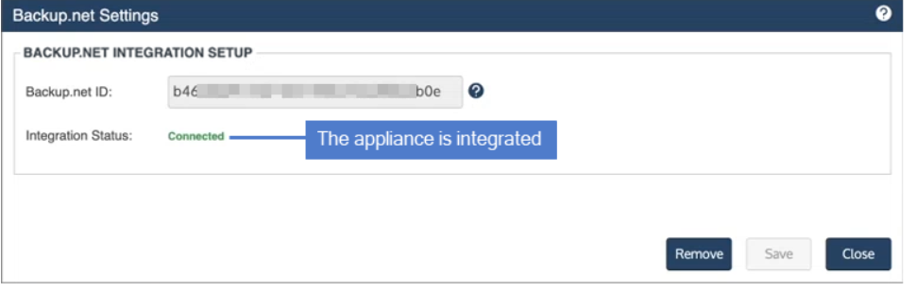

Return to the Unitrends Backup Portal. Click **Done**.

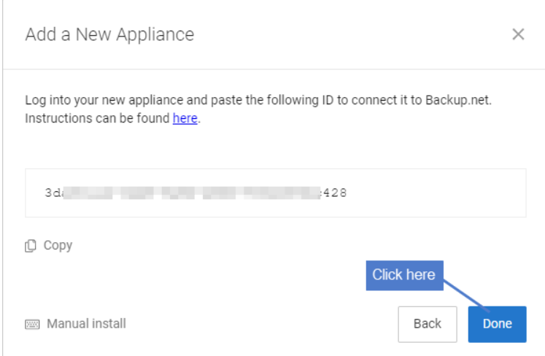

Now Appliance available on Portal.