**Cove File and folder Restore Process.**

File restore step- by - step.

1. Identify machine and Launch Backup client.

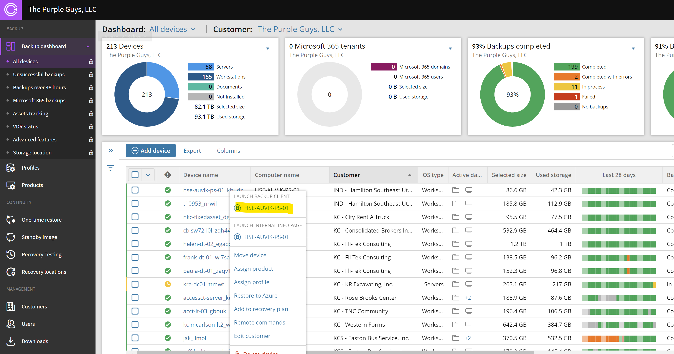

1. Go to Restore Tab
2. Select backup and Time.

1. Expand drive and select file for restore.
2. Restore location
3. Restore to original location.
4. Restore to new location.

1. Once location selected click on restore.
2. File Retore will start