**Files/Folder Restore**

1. On the appliance go to Recover Tab > under the Backup Catalog Tab > Select the Date and click on filter.

It will provide all the backup points for the same date.

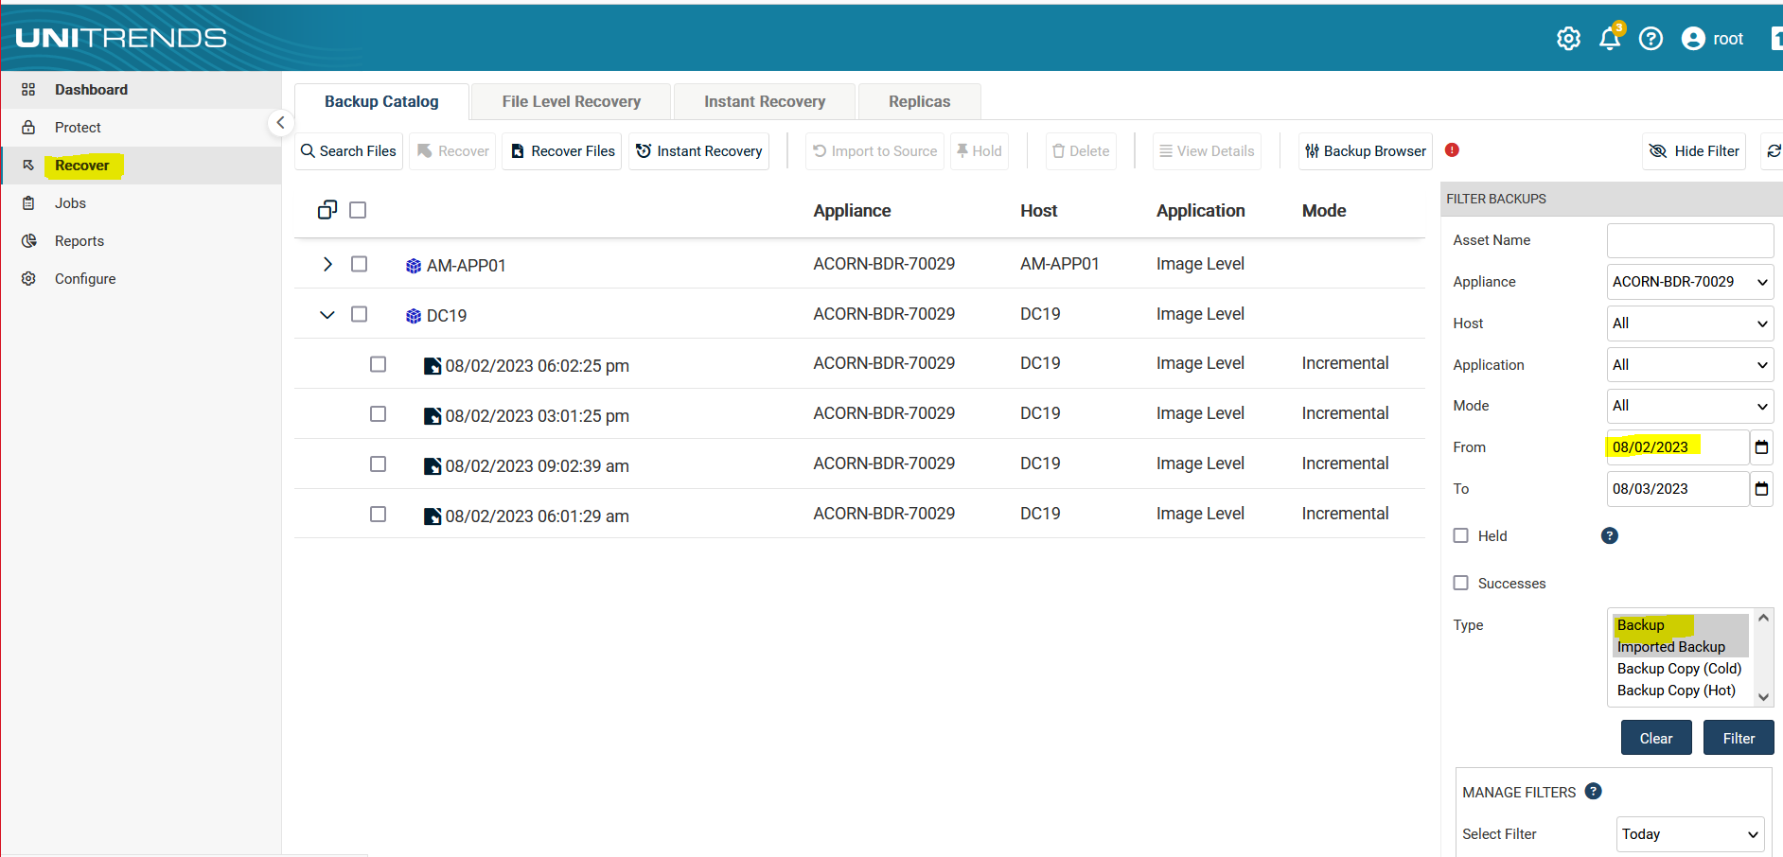

1. Expand the server > Select the backup point > Click on Recover Files.

This will create a File Level Recovery of the backup point on the appliance.

3. Once the recovery is completed, it will show under the File Level Recovery Tab.

1. Select the Recovery Point > Click on Browse/Download tab.

It will show all the Files and Folders.

1. Select the required files or folder on the left-side box and then click on “>” sign. It will show the selected file or folder on the right-side box.
2. Click on the Download option.
3. It will download the file or folder directly on the server (where the appliance is logged in).

