**Creating data copy access jobs (DCA)**

1. Select Jobs > Create Job > Data Copy Access.   
2. Enter a job name.

3. Select Unitrends Appliance from the What do you want to certify list

4. Check boxes to select assets to include in the job. Click Next.

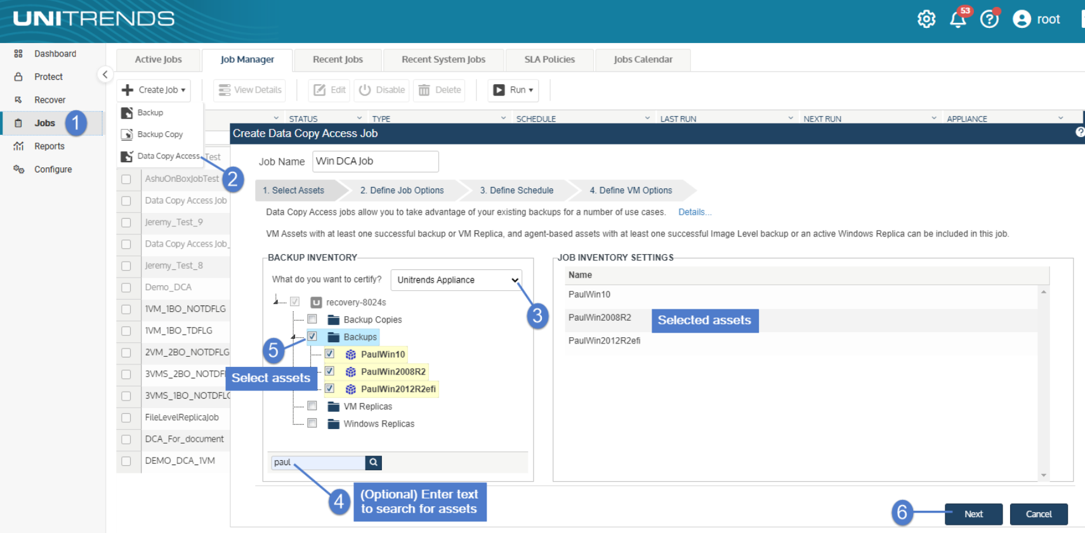

5. Enter job options. Click Next.

|  |  |  |
| --- | --- | --- |
|  | • | Enable RPO/RTO tracking – Check this box. RPO/RTO tracking must be enabled to certify backups as RPO/RTO compliant recovery points. |

|  |  |  |
| --- | --- | --- |
|  | • | Recovery Point Objective (RPO) – The maximum amount of data loss, measured in time, that your business continuity plan can tolerate. |

|  |  |  |
| --- | --- | --- |
|  | • | Recover Time Objective (RTO) – The maximum amount of downtime that your business continuity plan can tolerate. |

|  |  |  |
| --- | --- | --- |
|  | • | Power On Timeout – If a VM fails to power on in this amount of time, it is omitted from the data copy access job. |

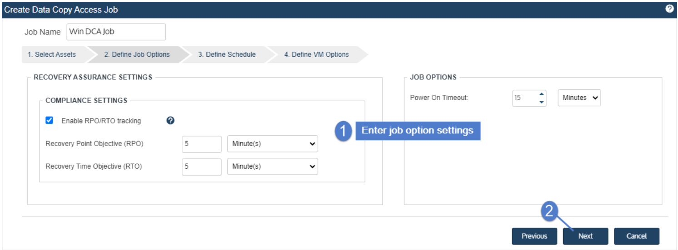

6. Define the test schedule. Click Next.

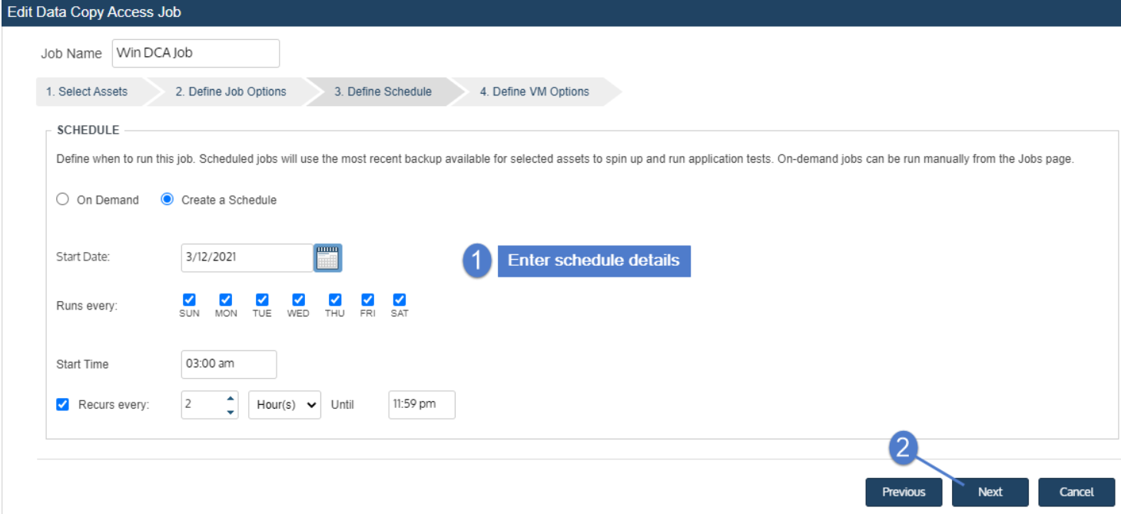

7. Review VM settings. If needed, click the pencil icon to edit a VM's settings. After editing and saving settings for all VMs, click Save to create the job.

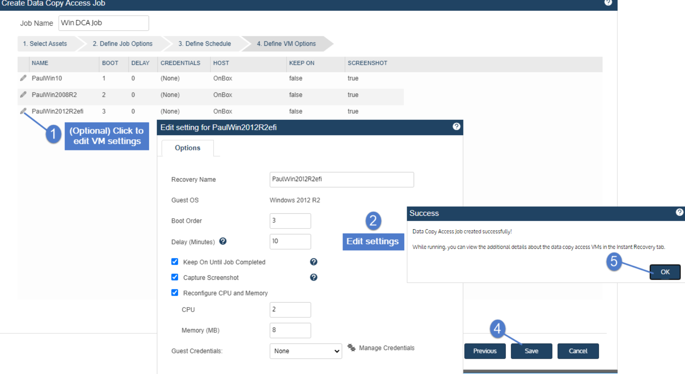

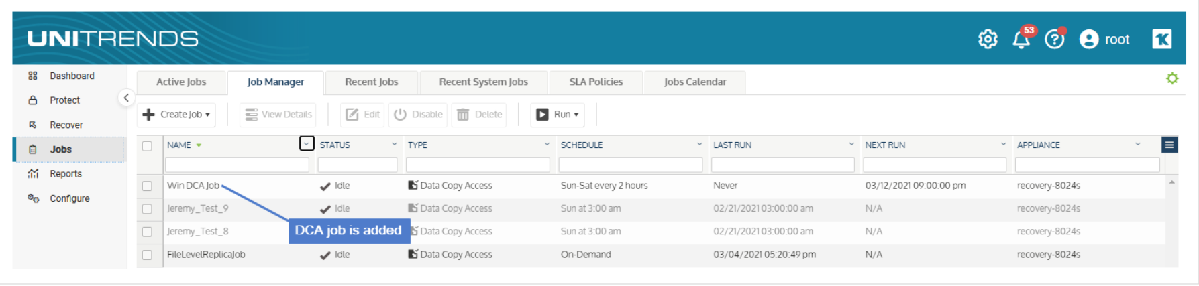

If you created a schedule for your data copy access job, it will run in Run Test mode at the times specified. This job displays on the **Job Manager** tab, where you can select the job to view details, edit settings, or run it on-demand.

