**ShadowProtect SPX installation and Job configration.**

Download latest ShadowProtect SPX.

Dubble click on setup.

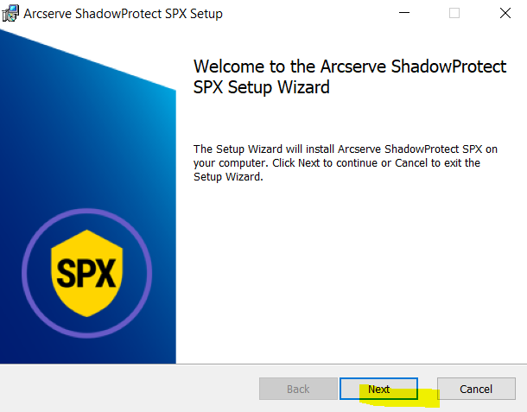

Click on Next

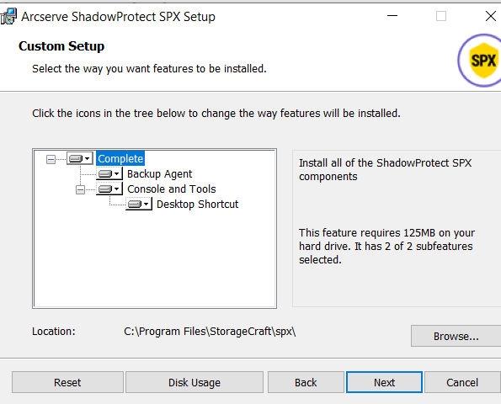

Click on Next

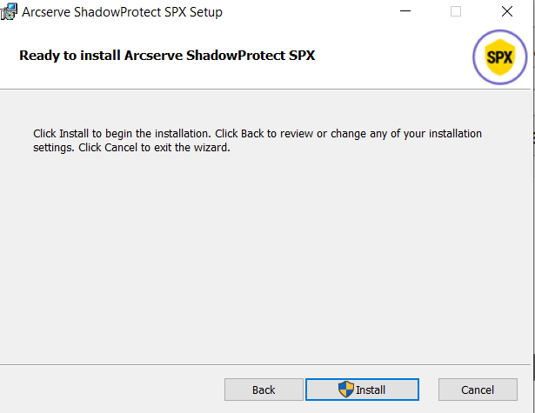

Click on Install.

Installation will start.

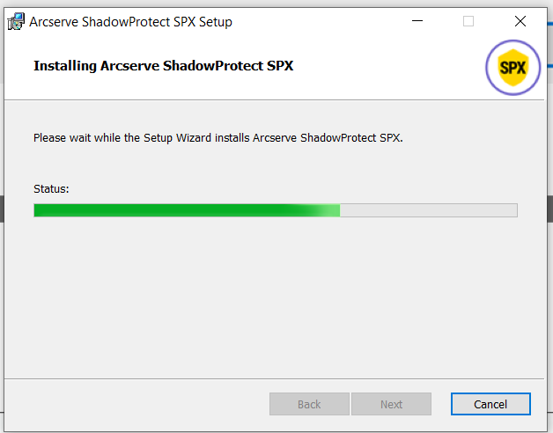

Click on Finsh.

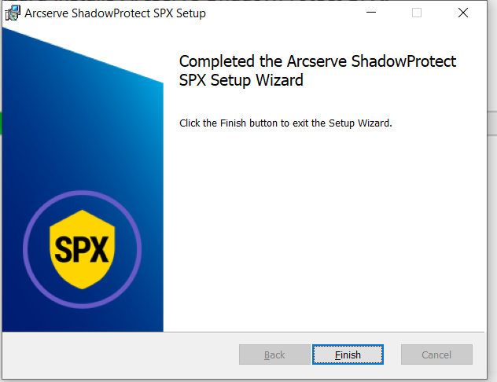

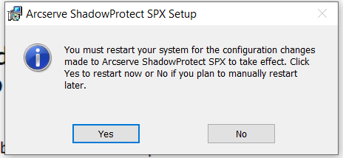

You must reboot server.

Post reboot click on SPX icon

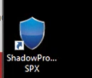

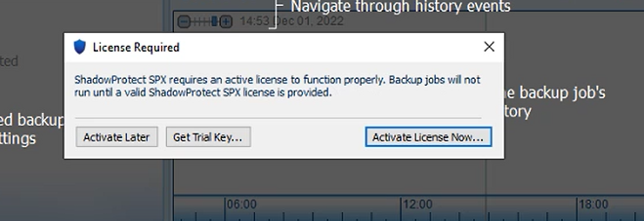

It will ask for activation.

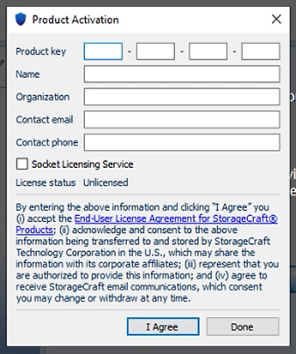

Update Key.

*It will generate from MSP portal or given by Client.

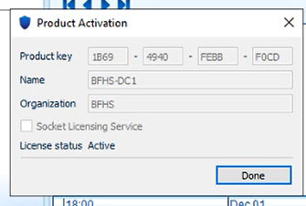

SPX installation completed,Activated and ready to use.

**Backup Job configuration.**

First of all need to setup backup target.

Click on backup destination and updated target access details.

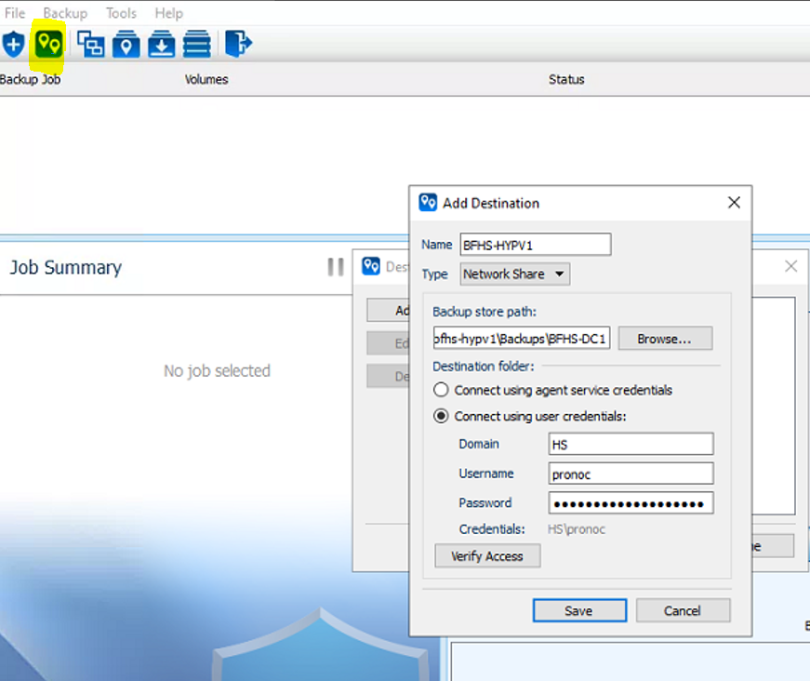

**Setting** : Salect drives which need to backup and Encription.

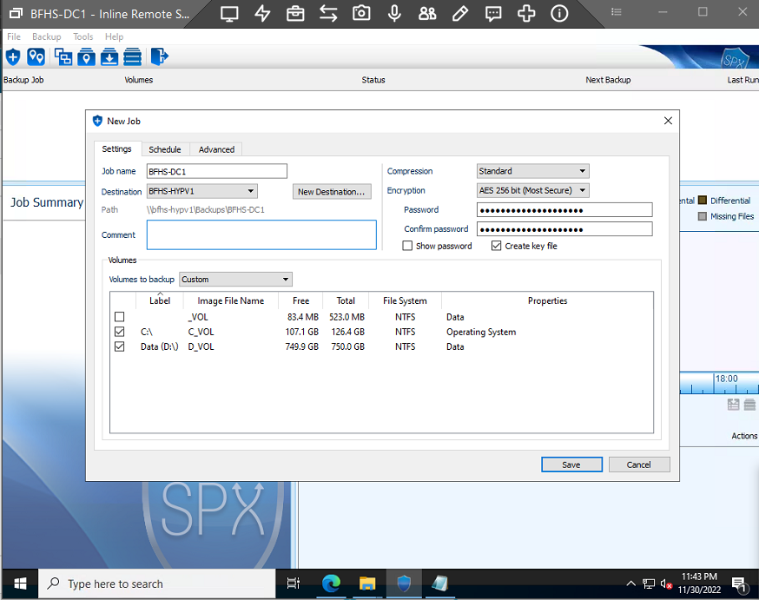

**Schedule:** Set day and time.

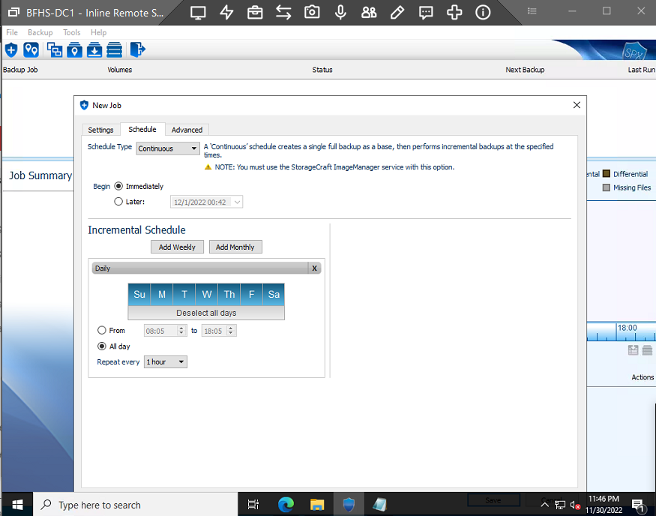

Now job created successfully, and backup will start itself.

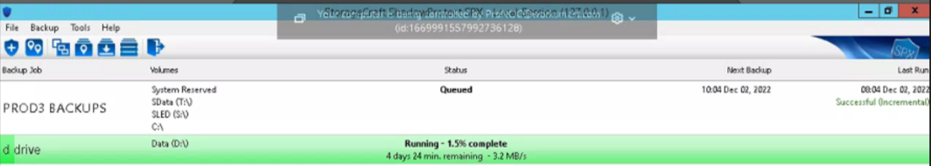

First backup will be a full backup.

**Backup Job configuration completed.**