How to Disable/Delete a tenant in Acronis Cyber Protect Cloud

Disabling a tenant (client)

By disabling a tenant:

* the tenant and all its sub-tenants will be disabled, their services will be stopped.
* notifications will not be sent to any of the user in this tenant.
* credentials for all users in this tenant will not be accepted for logging in to the Cyber Protection console.
* billing of the tenant and its sub-tenants will be continued as their data will be preserved and stored in Acronis Cyber Protect Cloud
* all API clients within the tenant and its sub-tenants will be disabled and all integrations using these clients will stop working.

To disable a tenant:

1. In the management portal, navigate to **Clients**.
2. Hover over the tenant you want to disable and click the menu icon:

[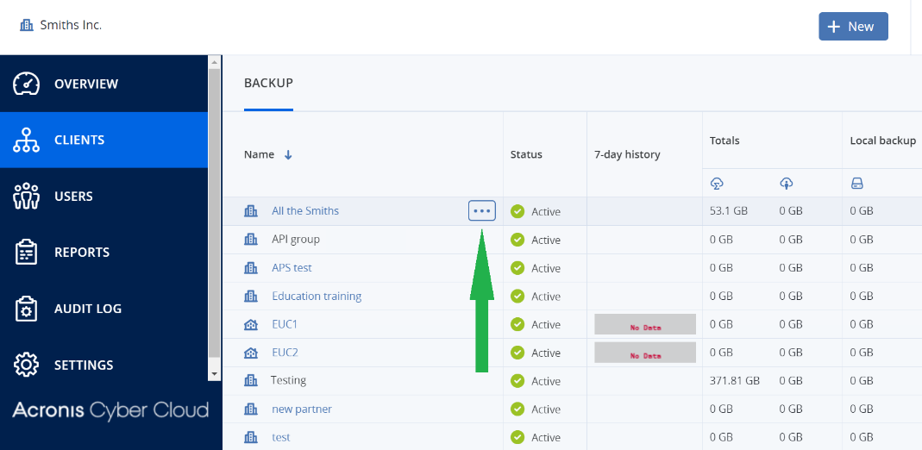](https://kb.acronis.com/system/files/content/2019/12/59556/59566-016.png)

1. Click **Disable**:

* 1. Confirm your choice by clicking **Disable** once again.

Deleting a tenant

By deleting a tenant:

* the tenant and its sub-tenants will be deleted.
* all administrators available in this tenant and all its sub-tenants will be deleted.
* all users available in this tenant and all its sub-tenants will be deleted.
* all machines available in this tenant and all its sub-tenants will be unregistered.
* all services that were enabled within the tenant and its sub-tenants will be stopped.
* all backup plans under this tenant and all its sub-tenants will be revoked from machines available in this tenant and all its sub-tenants
* all backup files available in cloud for machines under this tenant and all its sub-tenant will be deleted. Local backups will remain on local storage.
* all API clients within the tenant and its sub-tenants will be deleted and all integrations using these clients will stop working

To delete a tenant, it must be disabled first.

1. In the management portal, navigate to **Clients**.
2. Hover over the tenant you want to delete and click the menu icon.
3. Click **Delete**: once you click the delete it will ask for login provide the user name from which take login for management portal.

