**File-level restore - SOP**

There are several types of available file and folder recovery, including methods from the appliance UI, methods from the vault UI, or methods using an FTPS client.

|  |  |
| --- | --- |
| METHOD | **DESCRIPTION** |
| 1.[**Recovery Center**](https://help.axcient.com/5-recover-with-x360recover/recovery-center) | Use stand-alone application to recover directly from the Axcient cloud or a private cloud, with options ideal for Direct-to-Cloud users and those with a local cache repository. |
| **2.**[**Mount a snapshot**](https://help.axcient.com/5-recover-with-x360recover/x360recover-file-and-folder-recovery#mount) | Select a snapshot and browse the file system.   * Best for quick restore of a few files/folders. * Use from appliance UI |
| **3.**[**Use FTPS**](https://help.axcient.com/5-recover-with-x360recover/x360recover-file-and-folder-recovery#FTPS) | Quickly browse and transfer files.   * Requires an FTP client. * Requires FTPS to be enabled in the appliance/vault. * Use from either appliance UI or vault UI |
| **4.**[**Start iSCSI**](https://help.axcient.com/5-recover-with-x360recover/x360recover-file-and-folder-recovery#ISCSI) | * Launch an iSCSI initiator application. * Best for restoring larger files/folders or searching for missing files. * Use **only** with appliance **or** private vault |
| **5.**[**Manual partition**](https://help.axcient.com/5-recover-with-x360recover/x360recover-file-and-folder-recovery#manual)  **Only for BDR: NOT for D2C** | * After starting iSCSI, download the iSCSI Manager from x360Recovery Bare Metal Restore Utility and perform a partition-by-partition recovery. * **NOT applicable for Direct-to-Cloud (D2C)** |

**We would prefer “mount a snapshot” option to restore small files and “Start iSCSI” to restore large files.**

**Method #1. Mount a snapshot.**

**Mount** a protected system's point-in-time snapshot from an appliance. (Do not use the file browser to download from a vault.) Once a snapshot is mounted, use the **File Browser** tab to browse and download files and folders.

**Pros of the Mount + File Browser tools**

* Easy to use.
* Available on appliances
* Works with any standard web browser

**Cons of the Mount + File Browser tools**

* Doesn't preserve original file and folder permissions.
* Not suitable for very large files
* Limited to a few hundred files per download
* Folders are retrieved as zipped files - it may take a long time to create an archive.

**Recover with the Mount tool.**

1. Log into an appliance or vault through x360Recover Manager. From the *Protected Systems* page, click into a **protected system** and scroll to the bottom of the page to view its **snapshots**.

Locate a snapshot from the point-in-time you wish to recover and click the **Mount** button.

2. Navigate to the **File Browser**page. Browse to locate the file or folder.

Right-click on the file or folder and **select** Download. When it finishes downloading, you can optionally move the file or folder back to its original location.   
  
3. When you are done recovering, scroll to the bottom of the *File Browser* page to view *Mounted volumes*. Click **Dismount** for the appropriate snapshot.

You have successfully recovered using the Mount tool!

**Method #2. Start iSCSI**

Start **iSCSI** from a protected system's point-in-time snapshot from an appliance or vault, then use native Windows tools to connect and recover from the snapshot.   
  
iSCSI is a standard TCP/IP protocol for connecting block storage devices (like hard disks) from a storage server to an application host over a network layer.  Commonly used in datacenter environments, x360Recover implements the ability to export protected system disk volumes as iSCSI targets as a robust means to perform data recovery.

**Pros of iSCSI**

* Preserves original Windows file and folder permissions.
* Suitable for very large files or many folders
* Supports Smart-Recovery (returns original disk architecture)
* Mounted iSCSI volumes can be searched within Windows.

**Cons of iSCSI**

* Moderately complicated to use.
* Not inherently secure for use over WAN connections

**Recover with iSCSI-**

1. Log into an appliance or private vault through x360Recover Manager. From the *Protected Systems* page, click into a **protected system** and scroll to the bottom of the page to view its **snapshots**.

Locate a snapshot from the point-in-time you wish to recover, and click the **iSCSI Start** button.

2. Select **Test Mode** or **Live Mode**.

* If recovering from a recent backup, **Test Mode is recommended**.
* If recovering from a snapshot that was previously used to boot a virtual machine (VM) in live mode, select **Live Mode** to attach to the persistent snapshot clone containing the data changes made while the VM was running.
* The **Use Smart Recovery** option is **not** recommended for file and folder recovery. Smart Recovery restores the original disk identity and UUID headers. Older versions of Windows will refuse to mount two disks with identical UUID identity, while newer versions of Windows will silently change the UUID identity of the new disks. Neither of these outcomes are likely desired!

Click **Start**.

3. Once the snapshot has been exported, you can mount the virtual disk target to your Windows recovery system. For a system running Windows 7 or newer, or Windows Server 2008 or newer, navigate to the Control Panel's **Administrative Tools**.

Open the **iSCSI Initiator** applet.

If prompted to start the service, click **Yes**.

4. In the *Target* field, enter the **IP address** of the appliance or vault, then click **Quick Connect**.

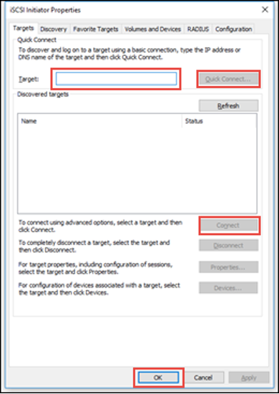

Available disks will populate. Reference the *iSCSI menu pane* of the appliance or vault for the **IQN Name** of the disk volume you would like to search.

Select the desired disk in the *Discovered targets* field and click **Connect**.

5. Once the disk has been connected, navigate to the Control Panel's **Administrative Tools and**open the **Computer Management**applet. Expand **Storage** and click **Disk Management**.

6. Locate the newly attached system disk and verify it is online. If not, right-click the disk name and select **Online**.

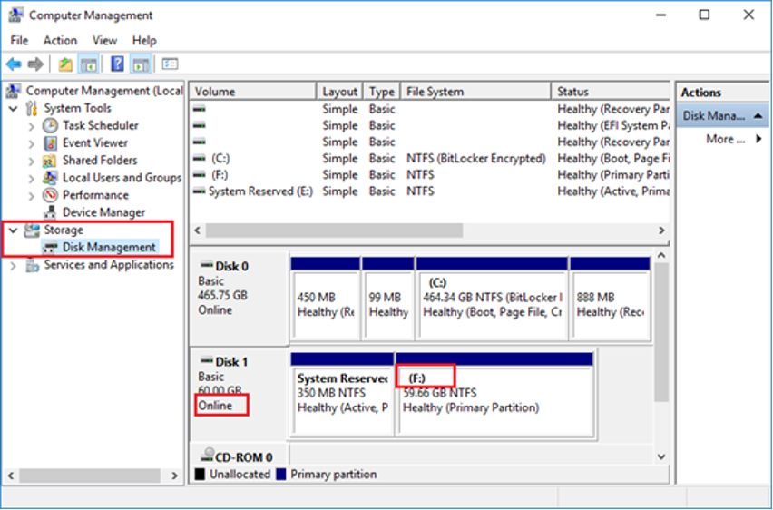

Find the drive letter that has been assigned to the disk volume(s). In the example above, it's the **F:** drive.

7. Use Windows Explorer or your preferred file management utility to search or browse for the file and folders you want to recover. Copy and paste them back to their original server locations.

8. Once recovery is complete, you must remove your disk connections.

* Close any Windows Explorer windows open to the recovery disk volumes.
* From the **Disk Management** applet, right-click the disk name and select **Offline**.
* From the**iSCSI Initiator**applet, select the connected disk(s) and select **Disconnect**. If you receive an error, try again after stopping iSCSI on the appliance or vault (described below).
  + Remove any entries referencing the appliance or iSCSI LUNs from Discovery and **Favorites**.
* In the appliance or vault, click the**Stop**button from the **iSCSI** page.

You can also click **iSCSI Stop** from the protected system's **Details** page. Be sure to change the snapshots filter from All to **In Use**.

You have successfully recovered using iSCSI!

**Here the KB Articles for more details:**

**File and folder recovery**

<https://help.axcient.com/5-recover-with-x360recover/x360recover-file-and-folder-recovery>  
  
**Recovery playbook**  
<https://help.axcient.com/x360recover-essential-user-guide/recovery-playbook>