**How to Activate Veeam Backup Radar Policies**

**Step 1:**

Log in to the Backup Radar <https://us.backupradar.com/>

**Step 2:**

Go to Manage and click on Activate Backups

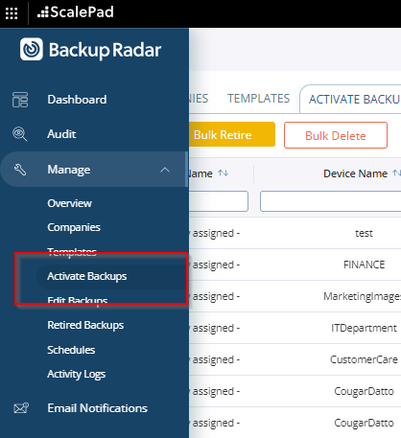

**Step 3:**

Use the Filters under Backup Method and Backup Client ID

1. Backup Method = Veeam API
2. Backup Client ID = Name of the MSP

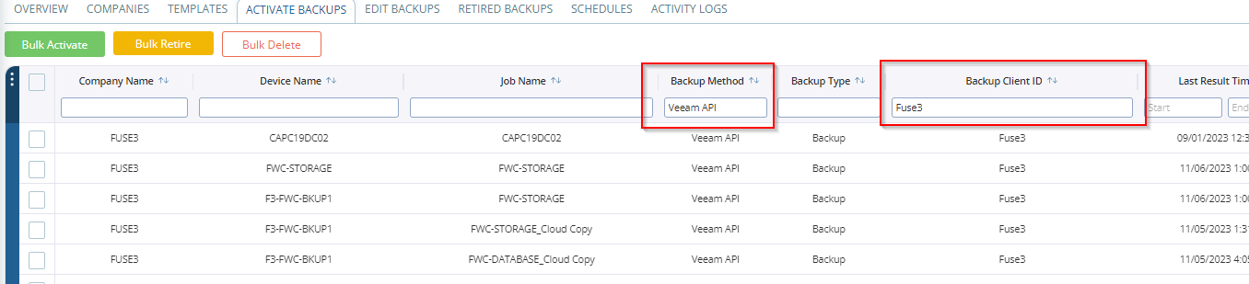

**Step 4:**

Update the mentioned filled Marked on the below screenshots

1. **Device Information**
2. Device Company = **MSP Name**
3. Notes: **End Client Name**

1. **Configuration**
2. Schedule: Select the Backup Schedule as per the job (Daily/Weekly/Weekdays/Monthly)
3. Device Type: Server/Workstation
4. Tag: End Client Name, Backup Method, Backup Type (Local/Offsite)
5. Status Calculation: Last Status received.
6. Start of Business Day: 12 AM
7. No Result Threshold: as per the Schedule (Daily = 1, Weekly =7, Monthly = 31)

**Once done hit save and the policy will start reflecting under Edit Backups**