Tech Tuesday SOP

* Create Tech Tuesday Calendar (rotate videos every week)
  + ConnectWise Automate
  + ConnectWise RMM
  + Kaseya VSA
  + Datto RMM
  + ConnectWise PSA
  + Backup Management
* Create and assign a ticket in Autotask to consultant

* Go to Sales and Marketing Folder in Sharepoint
* Click on the YouTube folder for YouTube Video / Consultant Scheduled for that week
* Choose the folder of the video you want to use and drag the mp4 file into the Movavi program
  + If they have an intro/outro sound bite drag that those into the file bin of Movavi as well
* Create YouTube Thumbnail
  + Go back to the YouTube folder and click on the splash page ppt
  + Change the title to match the title of the folder that the consultant provided. When saving go to file, export, change file type, choose png, then click save as. You can save it anywhere in the YouTube folder (you should just delete it once you are done making the video). Click save and a pop up will come up and you will choose “just this one.”
  + Drag the splash page png file into the media bin of Movavi program
* Movavi editing
  + Drag the splash page, intro (if provided), mp4 video, outro (if provided) and splash page again into the editing bar—must be in this order!
  + If there is an intro/outro you will need to right click on it and detach the audio-this will allow you to drag the audio to the splash page and delete the black portion of the video.

If there is not an outro and it is included in the consultants mp4 video, you will need to listen to the video and pause as soon as they finish their intro (right before they start talking about the video content). When you right click, click detach audio and then delete the screen that goes with their intro and drag the splash page over the audio. Do the same thing at the end of the video when they begin their outro.

* + Click on the import icon on the top left and select music. Click and drag sound ‘awakening’ to the front of the video and drag the splash page over it. Cut the music to be 6 seconds long (simply right click at 6 seconds and click split and delete the rest of the sound bite). Right click to add 5 volume points to look like the following: 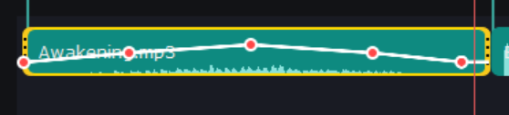

This will allow the music to gradually get louder and then fade out before the consultant begins their intro.

Now control c to copy the music and place it at the end of the video-either after the mp4 or after the consultants outro. Drag the splash page to cover this.

* + Click on the transitions icon and find the “fade to black” transition-click the heart icon in the top left to favorite this transition for the future. Drag this icon in between the splash page and the mp4 video, as well as in between the video and the splash page at the end.

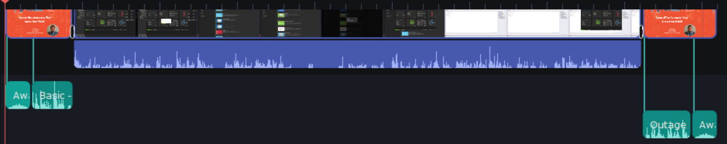

As you can see above, the splash page has the awakening music attached to it, as well as the intro that was provided (some consultants include the intro in their mp4 video). There is a fade to black transition in between the splash page and the mp4 video (beginning and end of video). Then there is an outage and the awakening music at the end with the splash page attached to both.

**How to Save in Movavi**

* Once video editing is complete you will save 2 different files (MUST DO BOTH FILES)
  + Click File in top left corner 🡪 Save Movie as a Media File’
    - Title the Project
    - Save To🡪 Browse the folder you want it in
    - Change quality to highest and Save
  + Next Click File again 🡪 go down to Save Project As
    - Browse folder you want it in (should be the same folder as the process above)
    - Click save

Schedule video to social media platforms after posting to YouTube (LinkedIn, Facebook, X, Instagram)

Once posted close out ticket in Autotask for the consultant

Add Video Title, Date, Consultant who created it, and YouTube Link to the Complied List of Videos (link here) [Compiled list of videos.xlsx](https://provaltech.sharepoint.com/:x:/s/SalesMarketing/ESPvQj1ILHtAur6C1IaBeJoBjlhHfNmttrR4A9bQSR0Asw?email=Kaitlin.Jones%40provaltech.com&e=8747eP)