**SOP for Website Backups**

**Objective:**

To ensure the regular and systematic backup of the WordPress website, maintaining a secure and organized repository of essential files and data.

**Procedure:**

1. Log into the Admin / Backend of WordPress using your credentials
2. In the left-hand column of the WordPress Dashboard:

* Scroll down and select "Settings."

1. Hover over the "Settings" option, then click on "UpdraftPlus Backups."

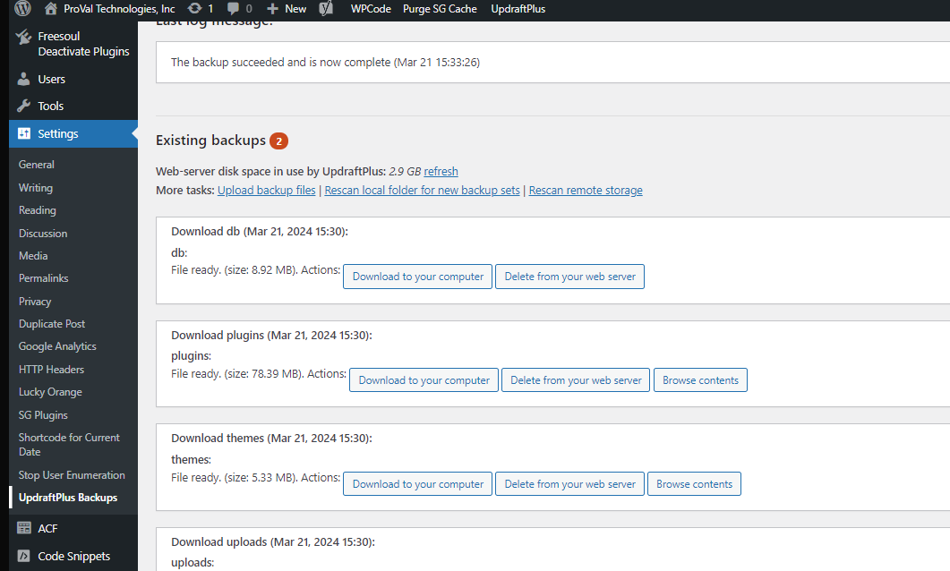

1. On the UpdraftPlus Backups page, locate and click the "Backup Now" button (will be in a big blue box)

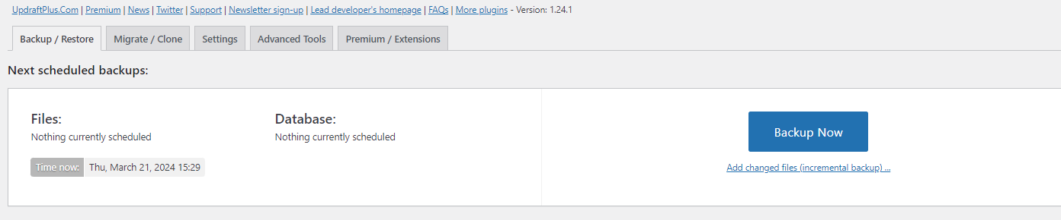

5. Ensure the following options are selected:

1. Include your database in the backup

2. Include your files in the backup

6. Click "Backup Now" to initiate the backup process.

* Wait patiently as this may take a few minutes to complete.

7. Once the backup is finished, proceed to download the following files:

* Database
* Plugins
* Themes
* Uploads (specific number may vary, for example, 8 as of 3/21/2024)

8. For each file type, click on it to download:

* Select 'Download to computer' option.

9. Create a folder labeled "Backups" followed by the date of the backups (e.g., March 21 2024 Backups).

10. Place all downloaded files into this folder from the current backup session.

11. Move the entire folder to the main backups directory for organization in sharepoint.

12. Once the backup is securely saved and verified in a safe location, you may proceed to delete the older backup from UpdraftPlus on the site to save space.

* For example, delete the "March 12th Backup" since the new "March 21, 2024" backup is secured.

13. Perform this backup activity on a monthly basis, unless significant changes have been made to the website.

* Examples of such changes include:
  + New pages added
  + New "Tech Tuesday" videos uploaded
  + New blog posts created
  + Major plugin or theme updates

Note: If there are any issues during the backup process or questions about the backup status, please refer to the backup documentation.

Sales and Marketing 🡪 Marketing 🡪 Website 🡪 Add folder to Website Backups Folder

[Website Backups](https://provaltech.sharepoint.com/:f:/s/SalesMarketing/En9iGpZ1xvVFt_wwsd1EBg8BdxHenhfZJuNvXCLe0twT9Q?email=Kaitlin.Jones%40provaltech.com&e=WUccBB)