**How to create Bucket in the Wasabi Console**

1. Log into the wasabi Console <https://console.wasabisys.com/login>
2. Create the bucket by clicking on Create New Bucket Button
3. 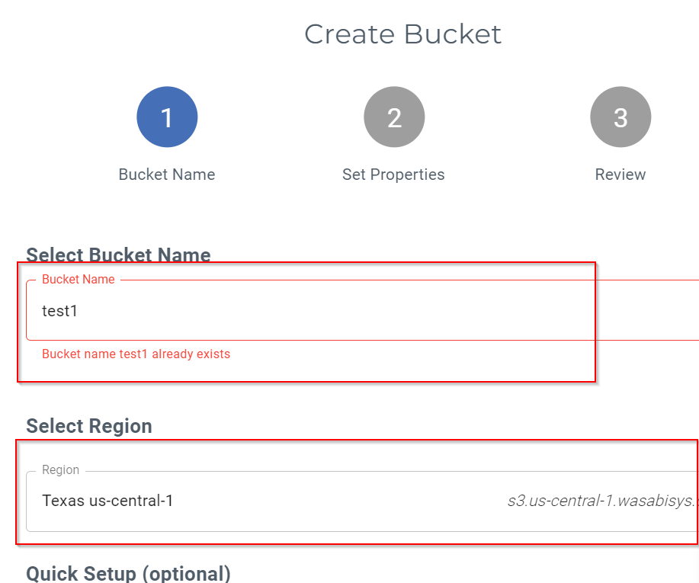Define bucket Name and region (make sure the name is in lowercase)
4. To use the Backup Immutability feature, make sure the below mentioned options are enabled. (Do not enable if client is not willing since it may add some additional cost)

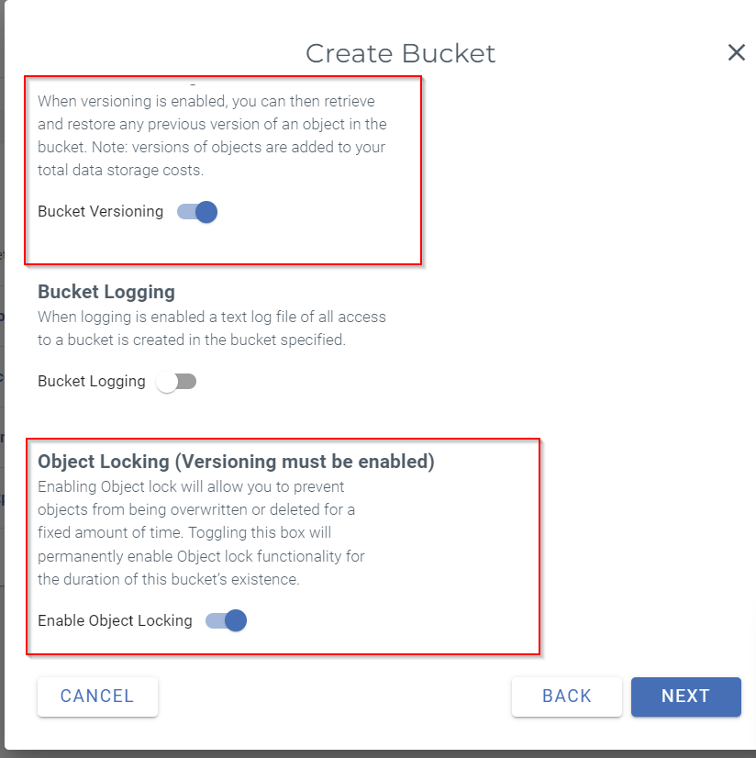

**How to add object storage Repository in Veeam**

<https://knowledgebase.wasabi.com/hc/en-us/articles/11914197710747-How-do-I-create-a-Backup-Job-in-Veeam-v12-to-Backup-to-Wasabi->

https://knowledgebase.wasabi.com/hc/en-us/articles/11914581509915-How-do-I-create-a-Backup-Copy-Job-in-Veeam-v12-with-Wasabi-

1. On the "Backup Infrastructure" tab, click on "Backup Repositories" and then click "Add Repository" to open the Add Backup Repository wizard.

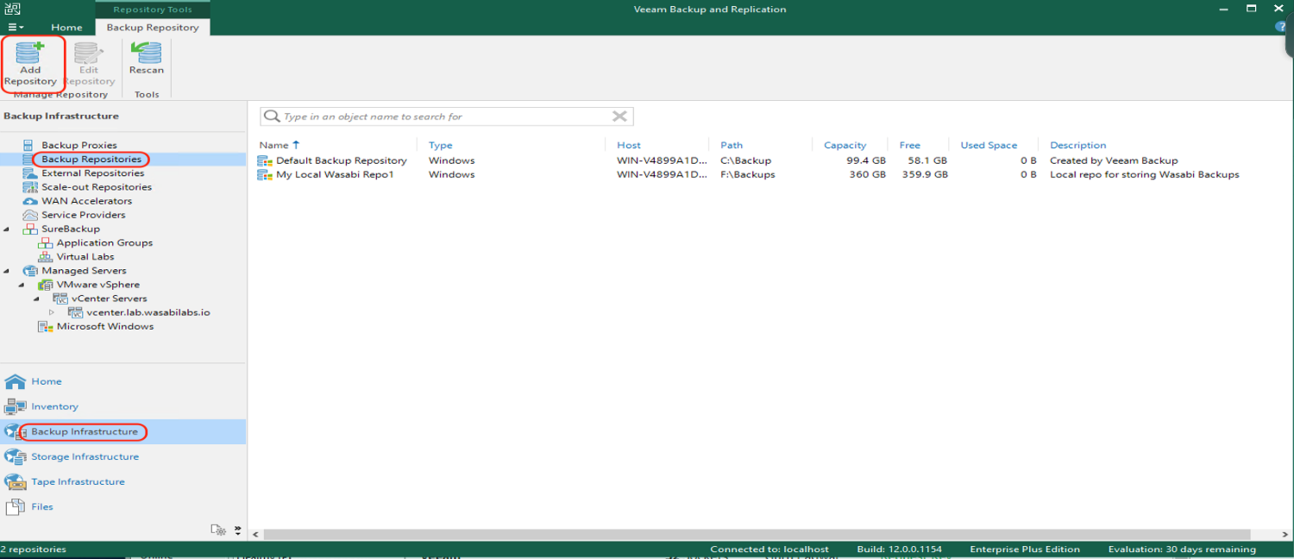

1. Click on "Object storage" to select the type of backup repository.

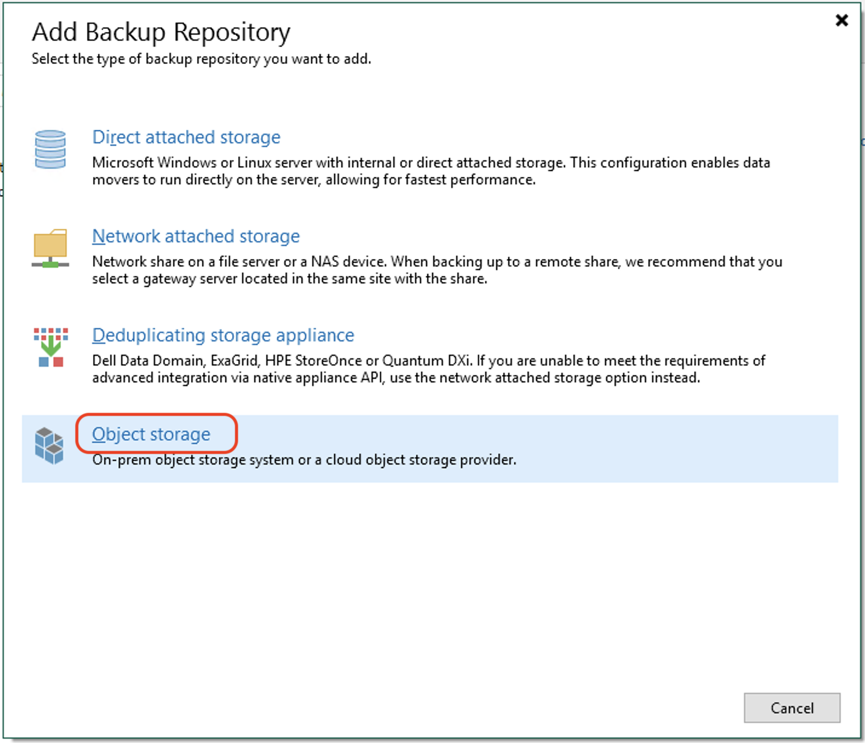

1. Click on "Wasabi Cloud Storage" to select Wasabi as the object storage.

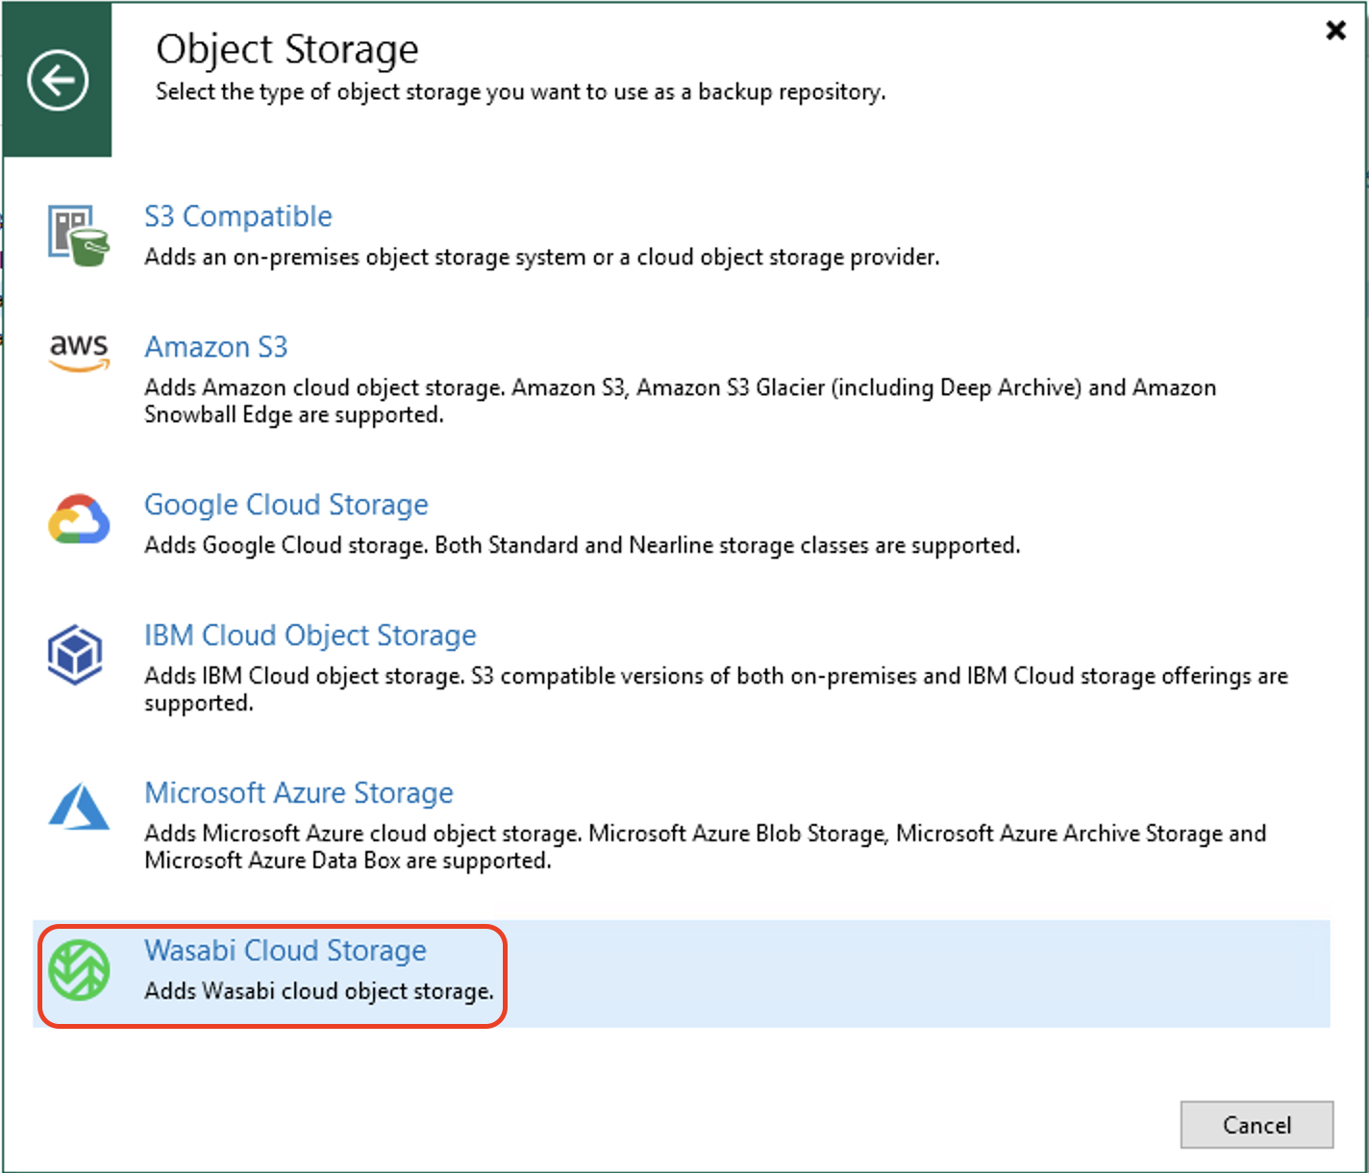

1. Input a Name and an optional description for the object storage repository. Then click "Next".

1. Input the Region, then click "Add" to input the access and secret keys.

**Note:** This configuration example discusses the use of Wasabi's US-east-1 storage region. To use other Wasabi storage regions, please use the appropriate Wasabi service URL as described in our Wasabi Service URLs article.

<https://knowledgebase.wasabi.com/hc/en-us/articles/360015106031>

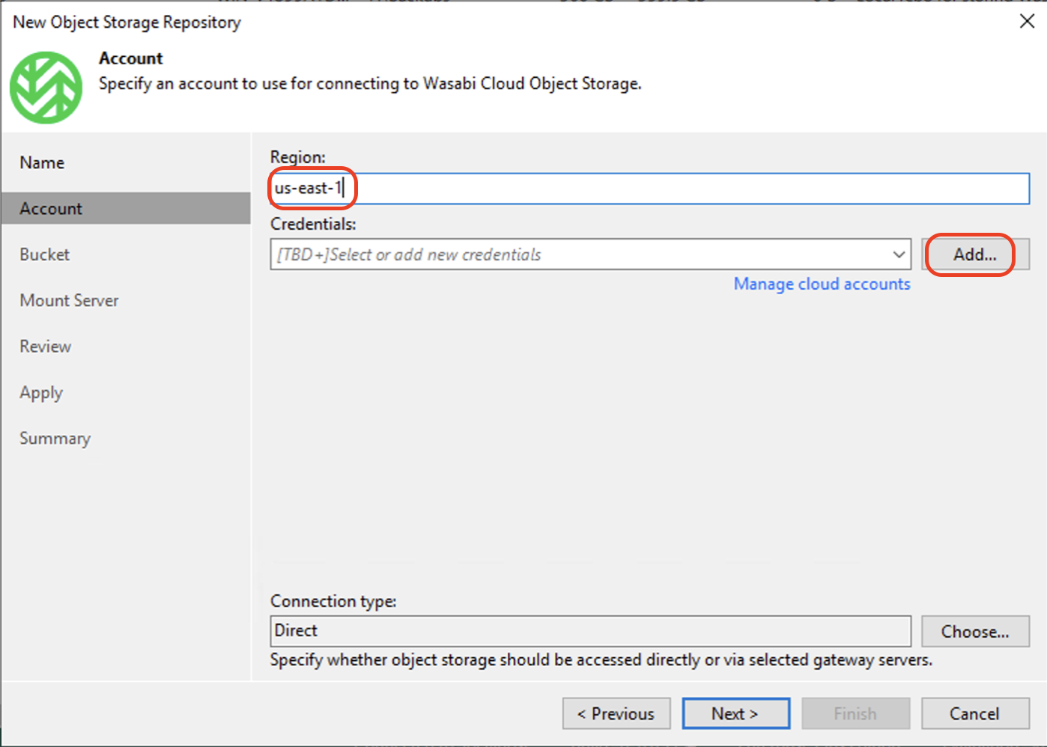

1. Click "Next" to continue.
2. 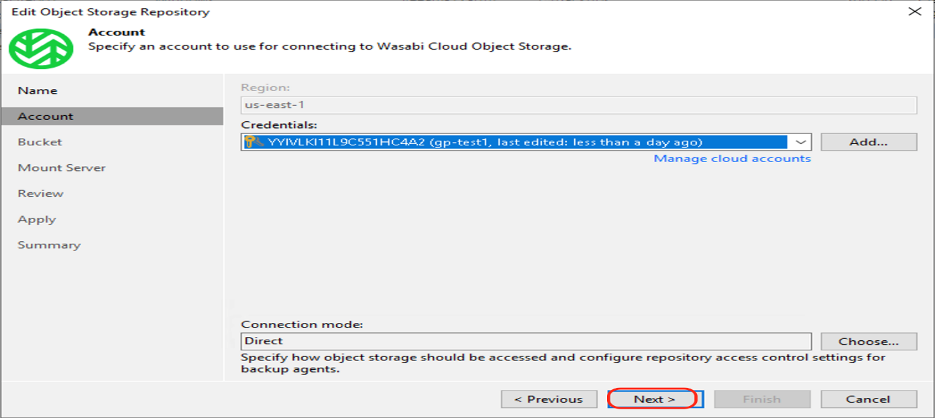 Click "Browse" beside the "Bucket" to choose an existing Wasabi bucket. Then click "Browse" beside the "Folder" and create a new folder by clicking "New Folder" in the folder window. Input a name for the folder and click "OK". Then click "Next".
   1. **Limit object storage consumption:** Defines a soft limit that can be exceeded temporarily for your object storage consumption. Provide the value in TB or PB.
   2. **Immutable Backups:** To create immutable backups click the radio button to check the "Make recent backups immutable for" and configure the number of days to make backups immutable

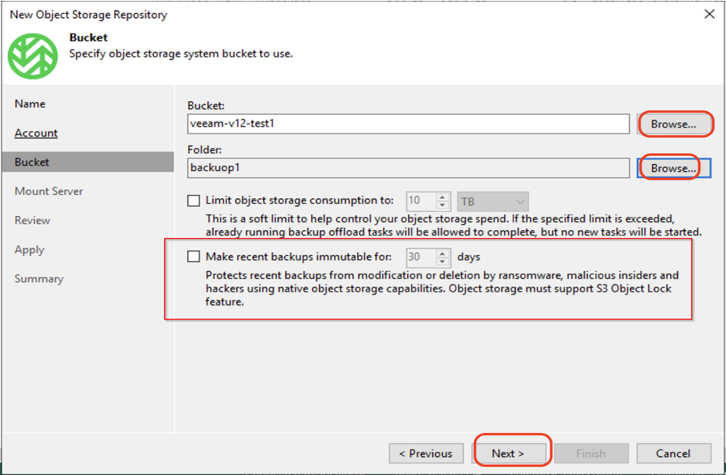

1. In the Mount server tab, keep the default values and click "Next".

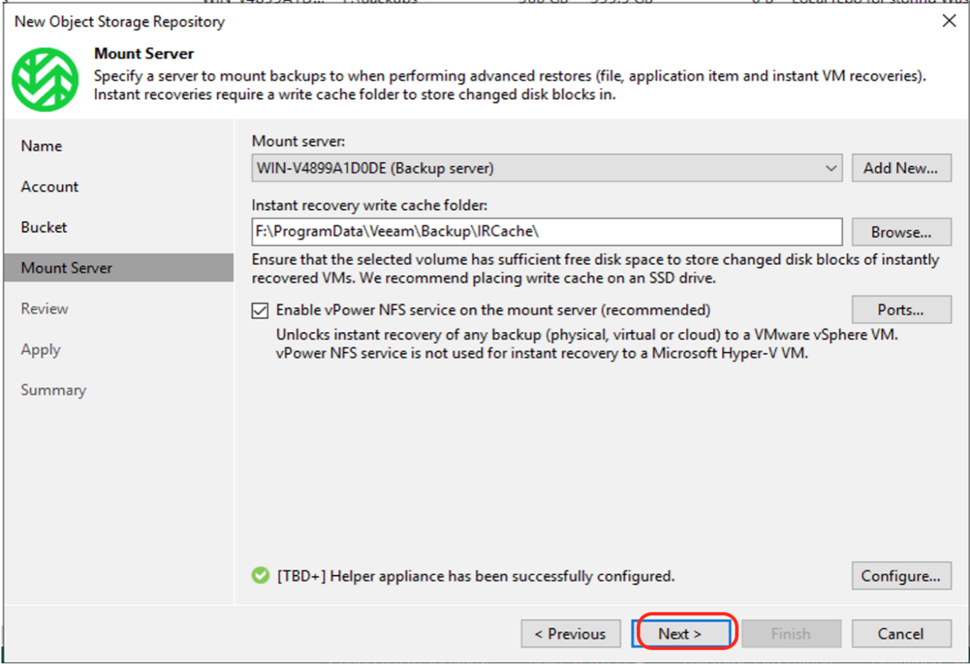

1. Click "Apply" in the Review tab.

1. Click "Next" in the Apply tab to continue.
2. Review the Summary and click "Finish" to create the Wasabi repository

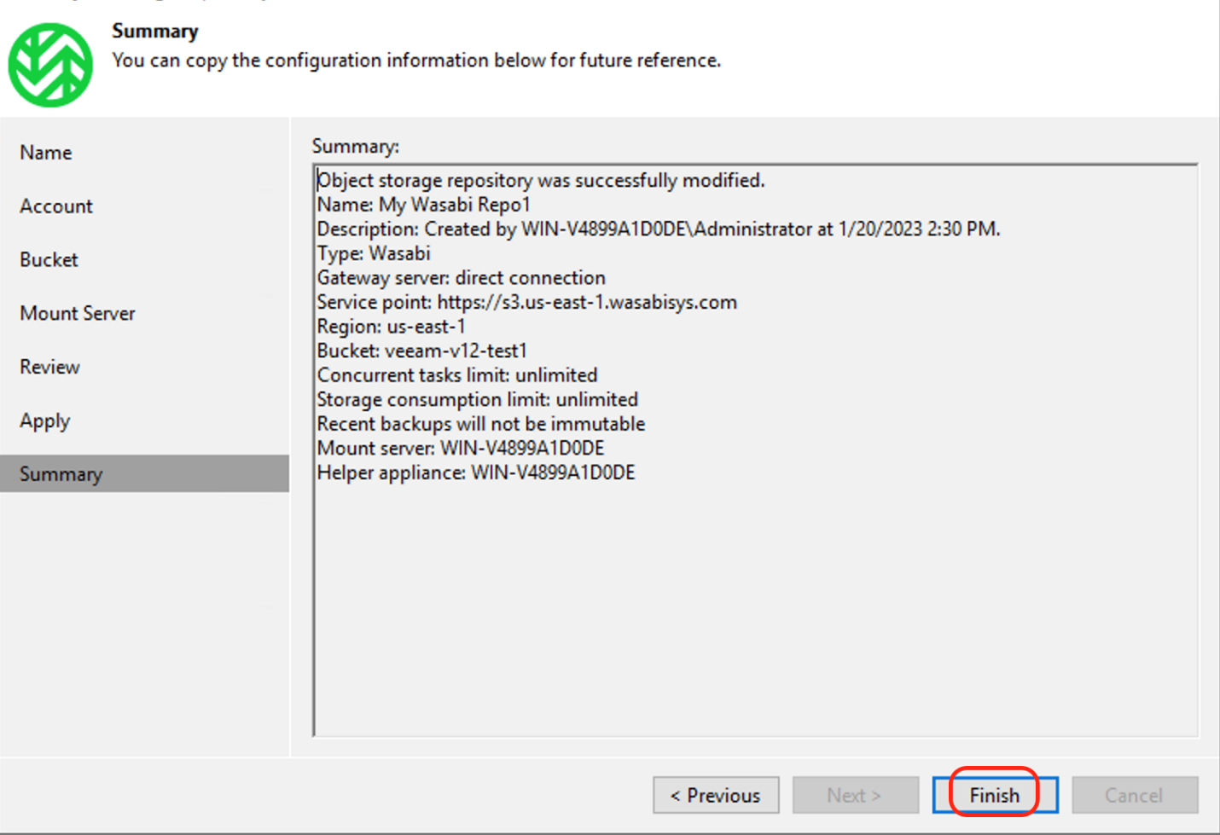

**How to Configure Backups to Wasabi**

1. Right on the Backup/Backup Copy and create the backup Job

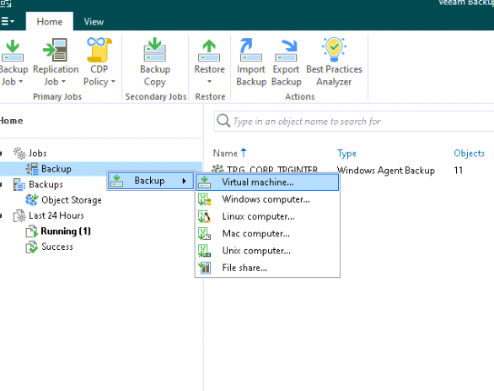

1. Name the backup job as per the standards and use the wasabi repo as the target. Complete the backup configurations as per the standards

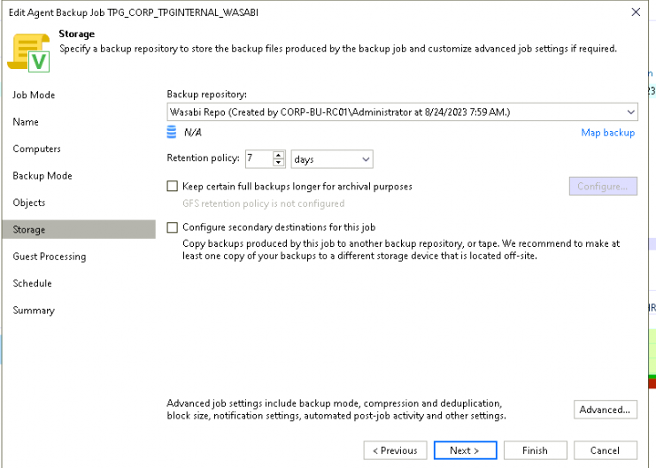

**How to restore a File from the Wasabi Object Storage Repository**

1. Login to the Veeam Console
2. Expand the Restore points from the object storage section.
3. Right-click on the machine name and select the type of restore you need to perform.
4. Select the restore point and proceed with the restore.

