Standard Process to Configuration SureBackup.

**To configure SureBackup we need to create Virtual Lab.**

**Follow the Below Mentioned Steps for creating Virtual Lab:-**

-Launch the Veeam Console

-Go to Backup infrastructure

-Select Virtual Lab and right click and create add Virtual lab option. 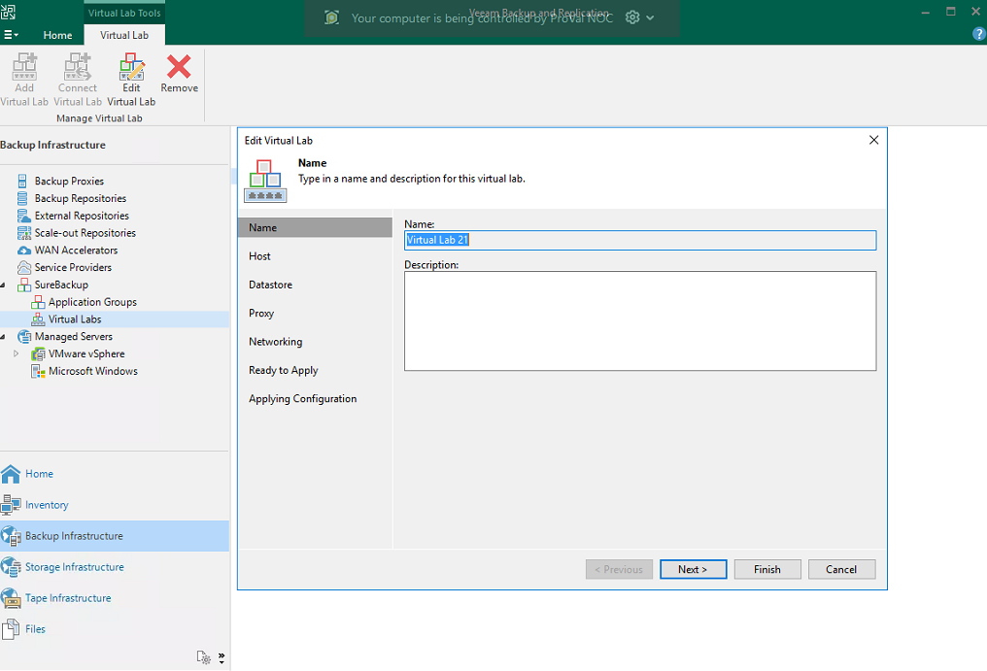

**-**Name the Virtual Lab.

-Assign Host.

-Then Next, Next and Finish.

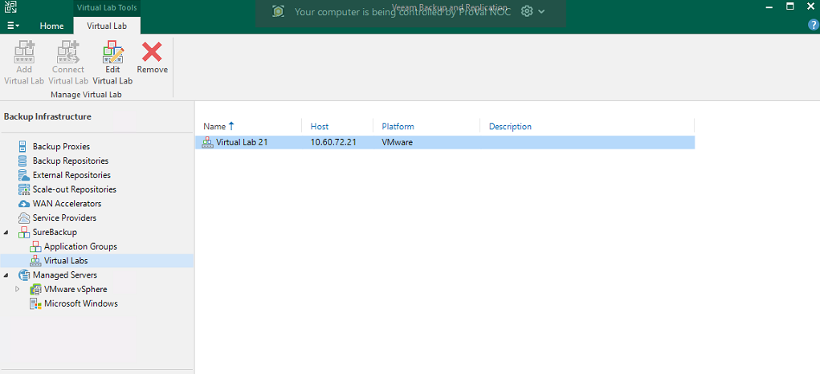

Now create SureBackup Job.

-Go to Home

-Right click on Jobs and select SureBackup Job.

-Name the Surebackup Job.

-Select Virtual Lab which you created. 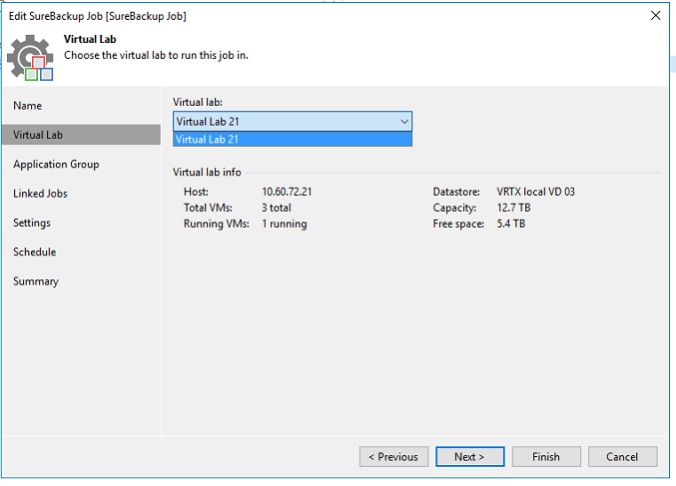

-Select Application group if you have created any, if not then just click next.

-Select Job Backup Job (for you want to perform testing) then click next.

-Schedule it accordingly, then next and finish.

**SureBackup Job is created.**

Now you can start the SureBackup job and start the testing. 