* **Download and install Veeam Backup & Replication v12.**

Download and install the latest version of the Veeam Backup & Replication installation image from the below link:

<https://download2.veeam.com/VBR/v12/VeeamBackup&Replication_12.0.0.1420_P20230718.iso>

Mount the installation image to the machine on which you want to install Veeam Backup & Replication and complete the installation process.

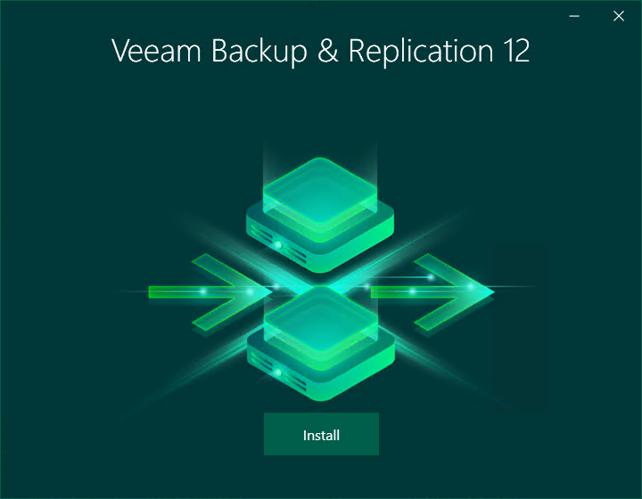

***Virtualization Servers and Hosts:***

1. Adding the hosts to the backup infrastructure. In the inventory pane, select the **Managed Servers** node and click **Add Server.**

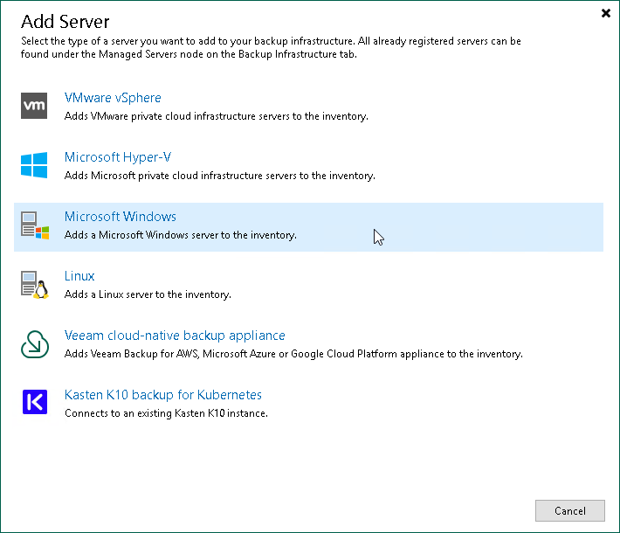

1. At the **Name** step of the wizard, specify an address and description for the Host server.

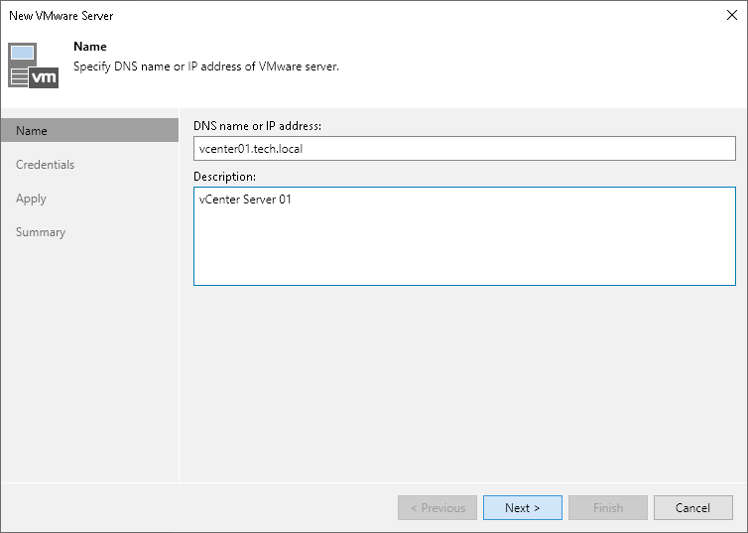

1. At the **Credentials** step of the wizard, specify\Add credentials and port settings for the Host server.

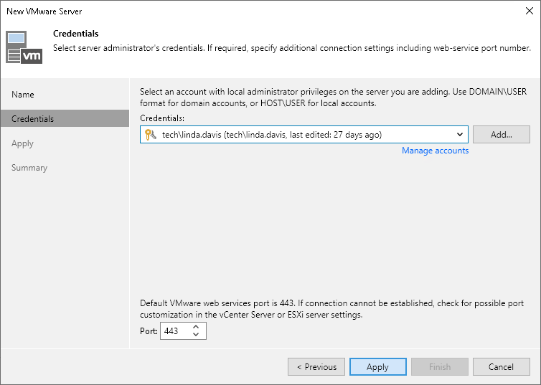

1. At the **Apply** step of the wizard, wait till Veeam Backup & Replication installs and configures all the required components. Click **Next** to complete the adding of the Host server.

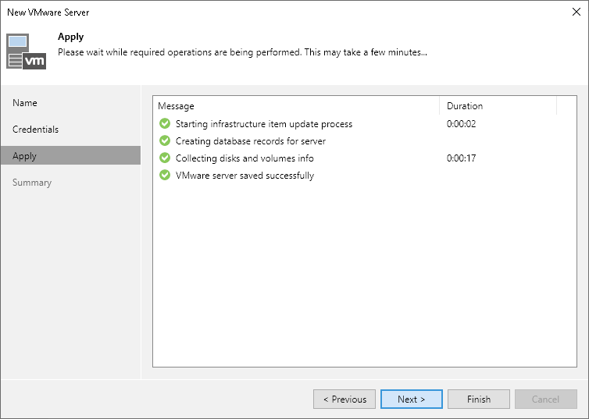

1. At the **Summary** step of the wizard, review details of the VMware vSphere server and click **Finish** to exit the wizard.

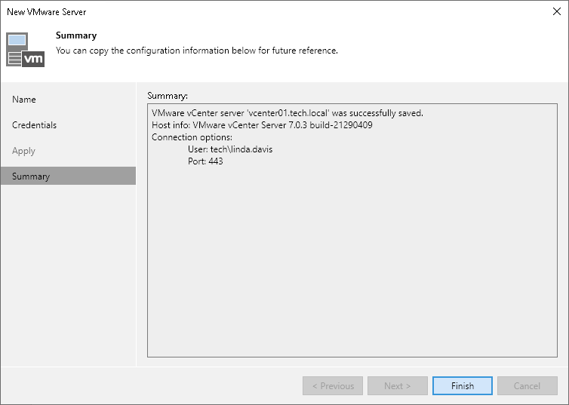

***Backup Repositories***

1. To add a backup repository, use the **New Backup Repository** wizard and select**Add Backup Repository**.

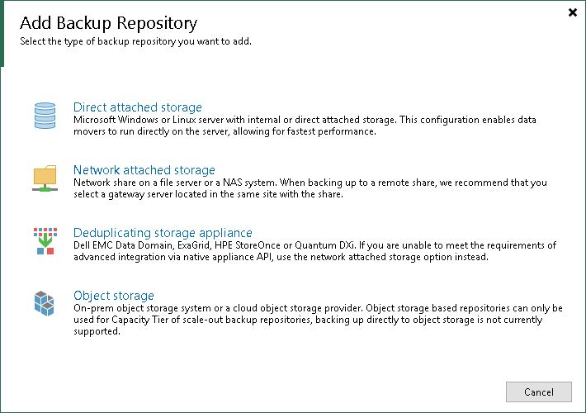

1. At the **Name** step of the wizard, specify a name and description for the backup repository.

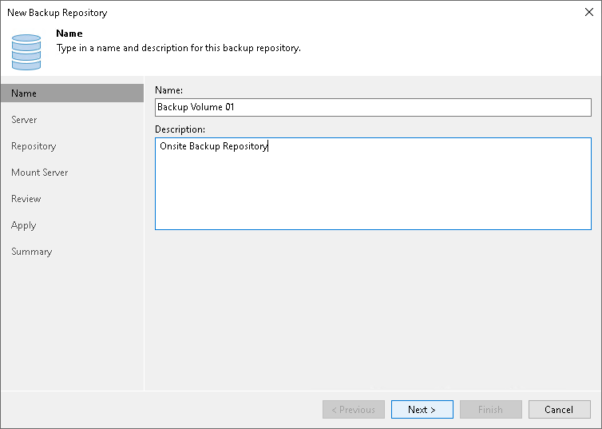

1. At the **Server** step of the wizard, Click **Populate** to see a list of disks connected to the server, their capacity, and free space.

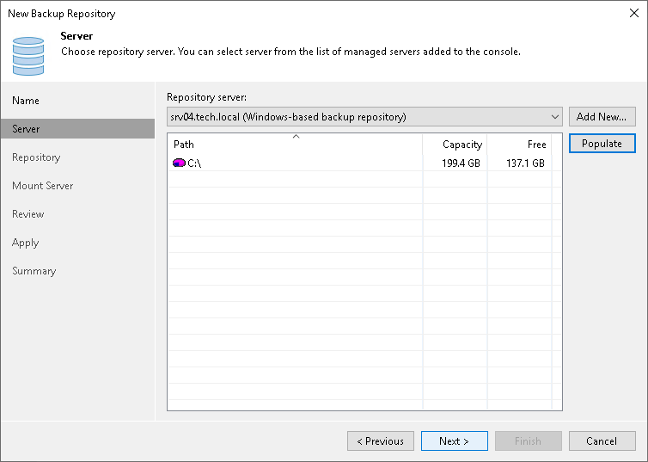

1. At the **Repository** step of the wizard, configure general repository settings including path to the repository folder and load control, and also advanced repository settings.

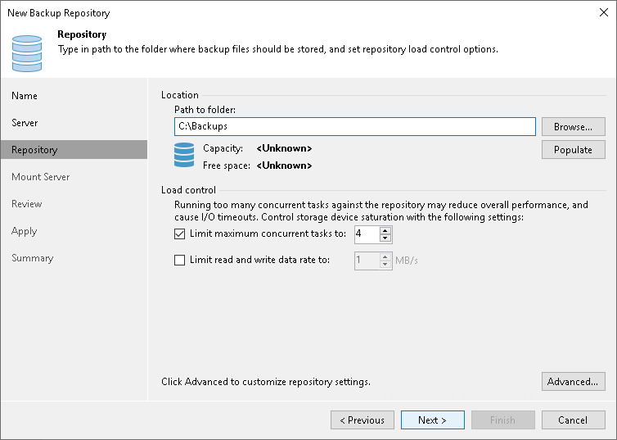

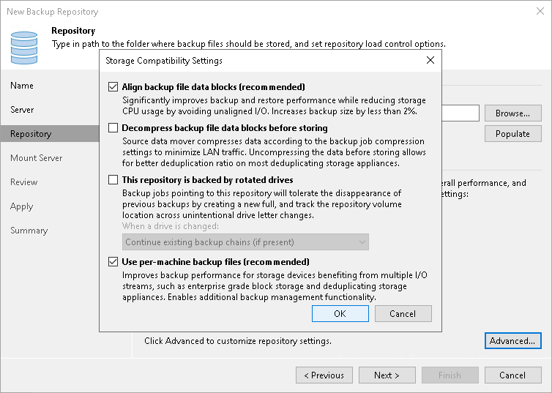

1. At the **Mount Server** step of the wizard, specify settings for the mount server that you plan to use for file-level and application items restore.

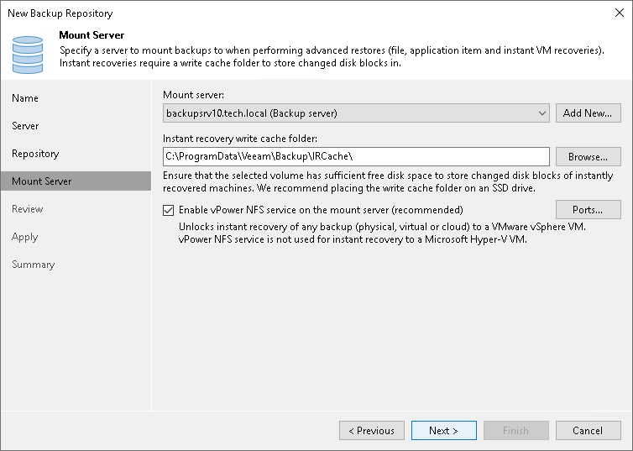

1. At the **Review** step of the wizard, review details of the backup repository and specify importing settings.

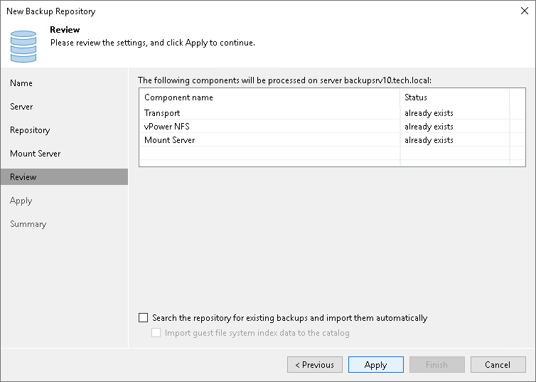

1. At the **Apply** step of the wizard, wait for Veeam Backup & Replication to install and configure all required components. Then click **Next** to complete the procedure of adding the backup repository to the backup infrastructure.

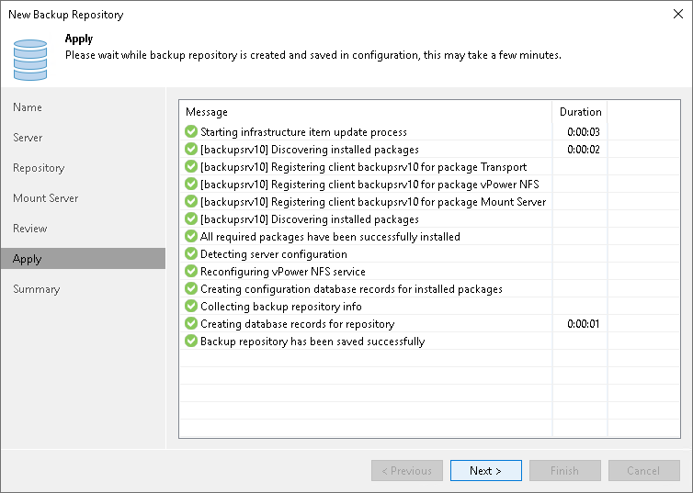

1. At the **Summary** step of the wizard, review details of the added backup repository. Then click **Finish** to exit the wizard.

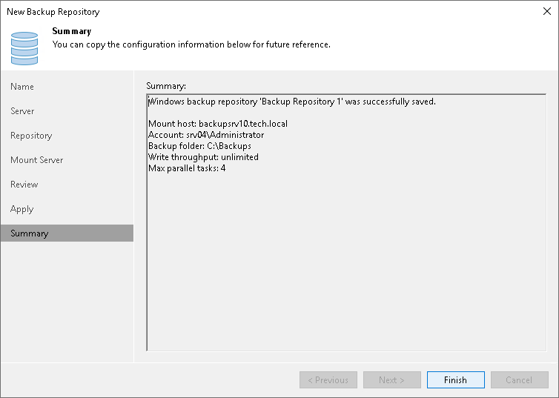

***Adding Service Provider.***

1. To launch the **Service Provider** wizard, Open the Backup Infrastructure view. Select the Service Providers node in the inventory pane and click Add Provider on the ribbon.

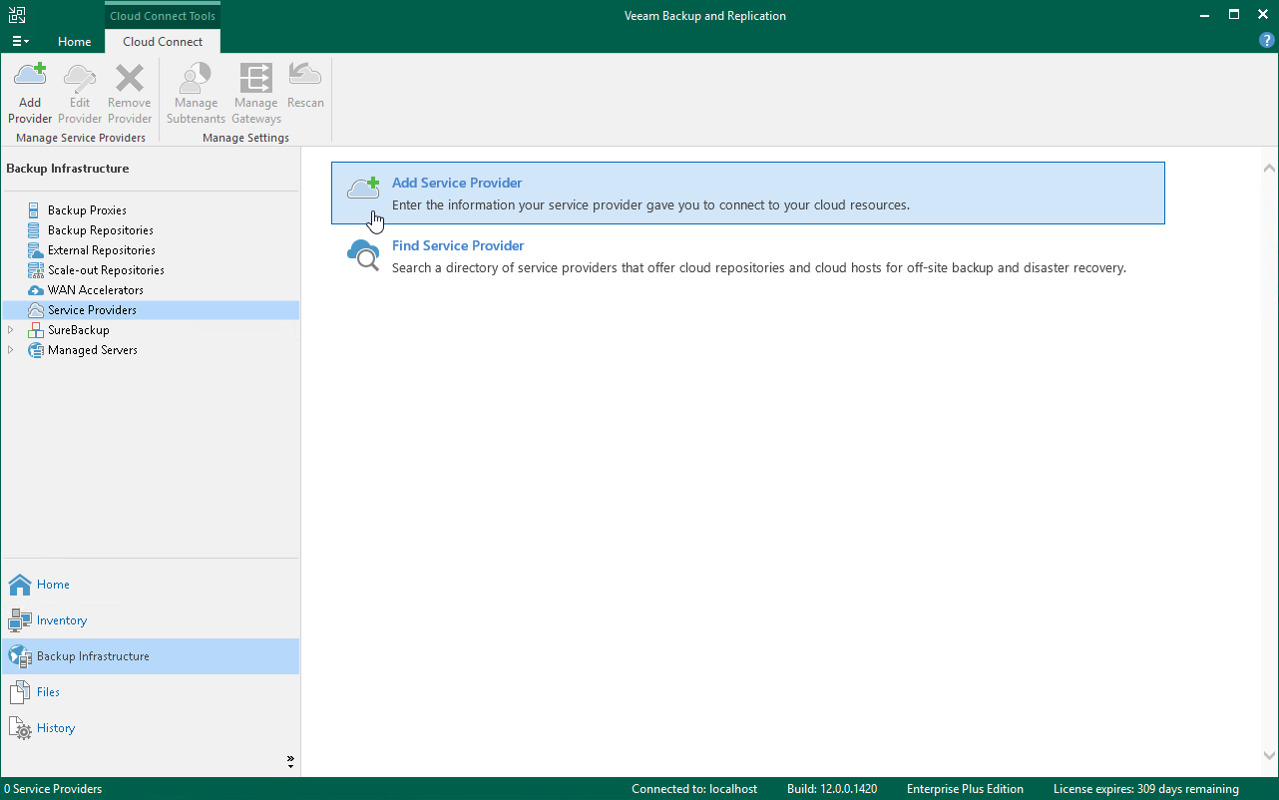

1. At the **Service Provider** step of the wizard, specify the settings for the cloud gateway that the service provider has provided to you.

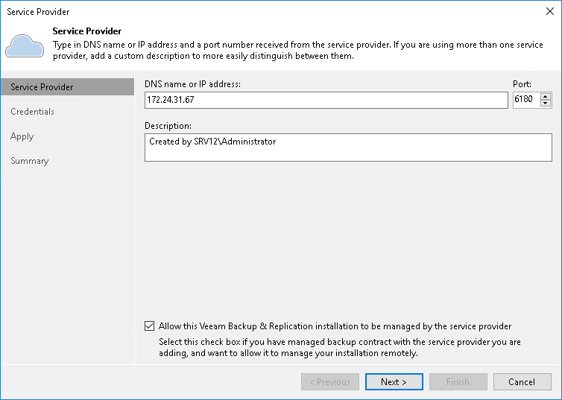

1. At the **Credentials** step of the wizard, verify TLS certificate settings and specify credentials for the tenant account.

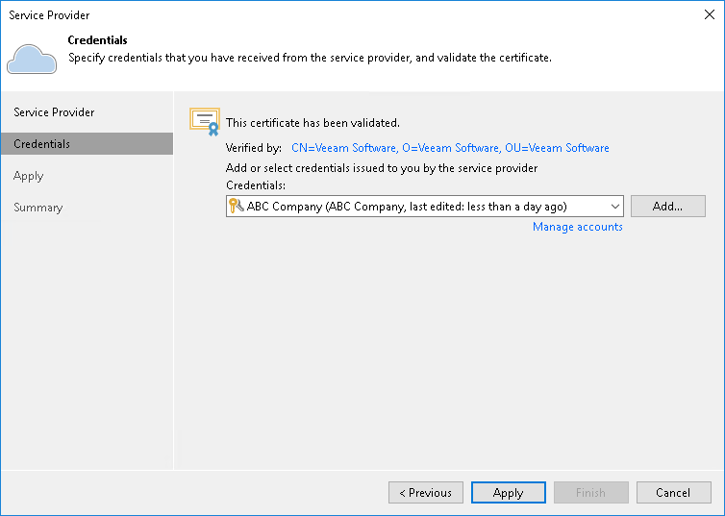

1. At the **Resources** step of the wizard, Veeam Backup & Replication will automatically enumerate resources provided to the tenant on the cloud repository and display the results in the wizard window.

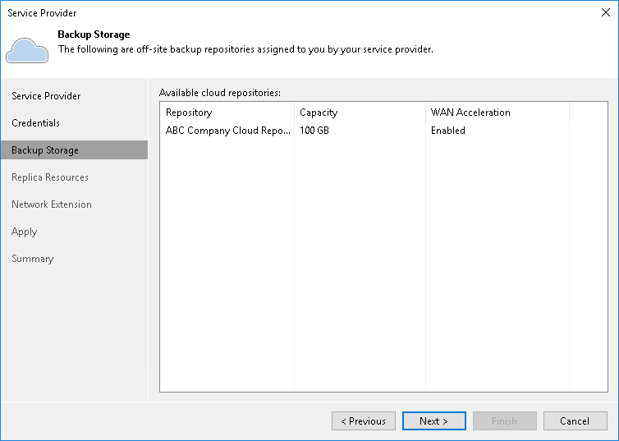

1. At the **Apply** step of the wizard, Veeam Backup & Replication will save information about resources available from your Service Provider and deploy the specified number of network extension appliances on your production host. Wait for the required operations to complete and click **Next** to continue.

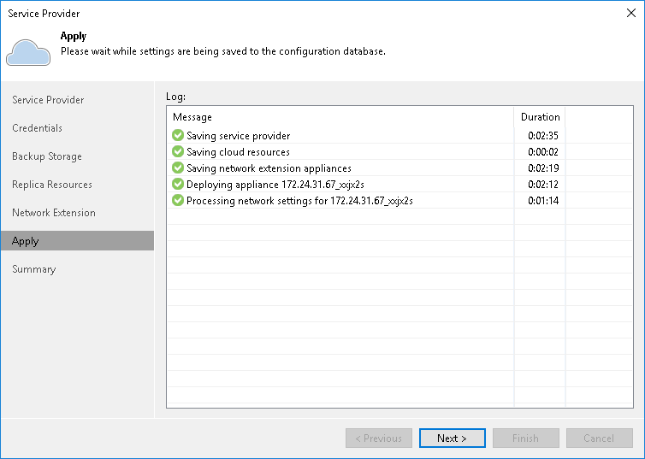

1. At the **Summary** step of the wizard, Click Finish to exit the wizard.

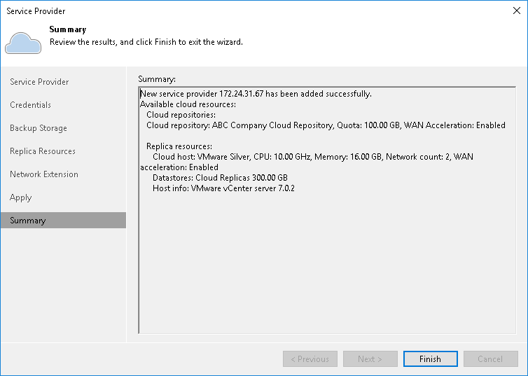

***New Backup Job wizard to configure the backup job.***

1. Launch the New Backup Job wizard On the Home tab, click Backup Job > Virtual machine > VMware vSphere.

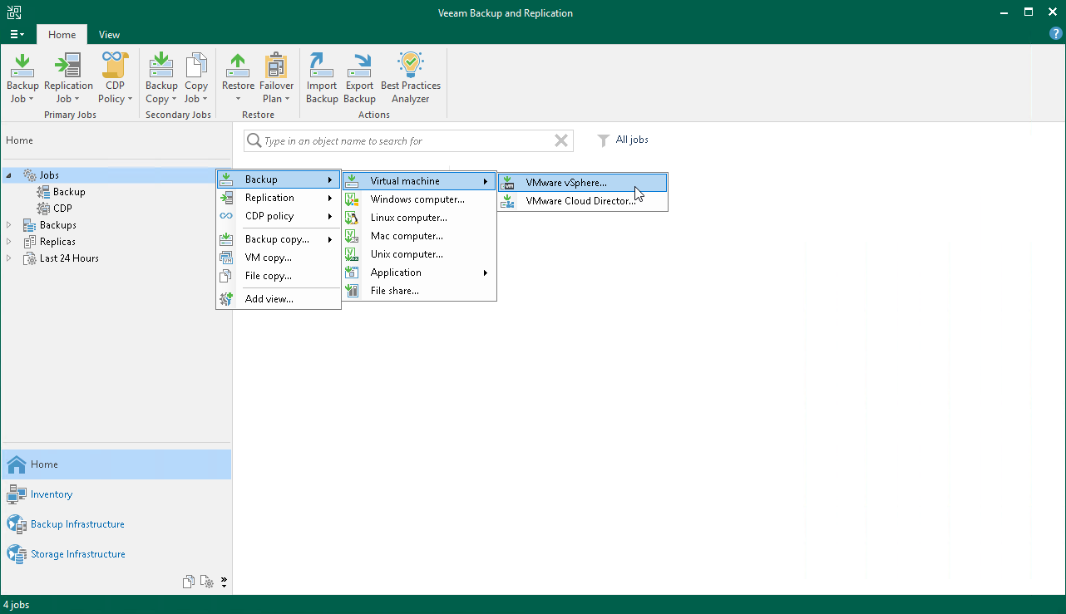

1. At the **Name** step of the wizard, specify a name and description for the backup job.

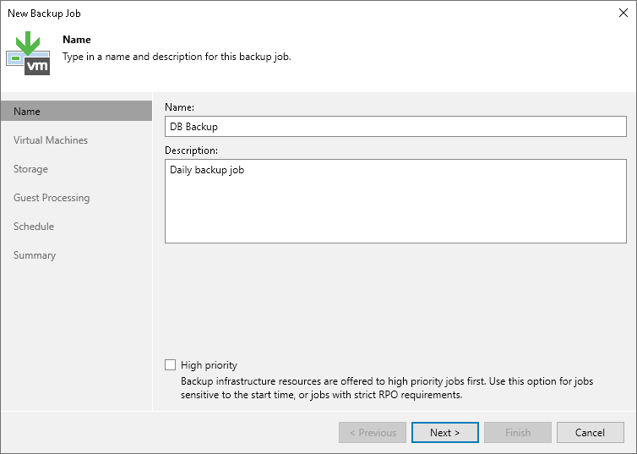

1. At the **Virtual Machines** step of the wizard, select VMs and VM containers (hosts, clusters, folders, resource pools, VirtualApps, datastores, or tags) that you want to back up by clicking on **Add**.

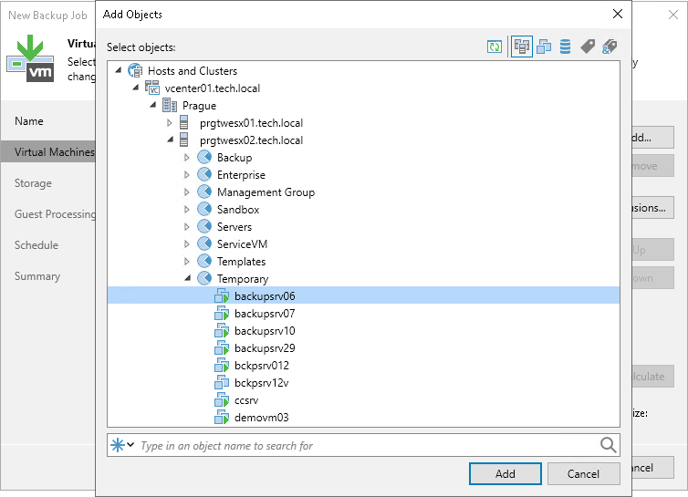

1. At the **Storage** step of the wizard, select backup infrastructure components for the job — backup proxy and backup repository, and specify retention policy settings.

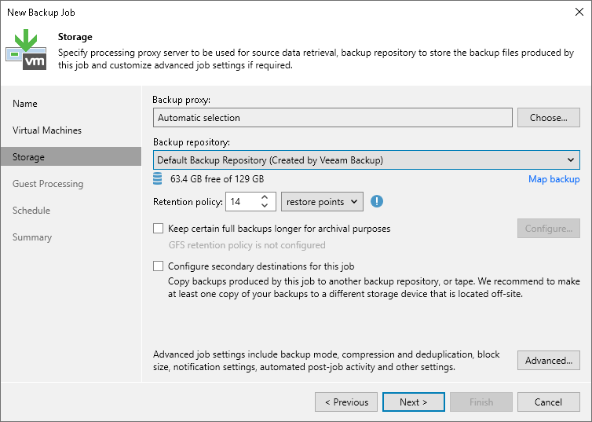

1. Select the **Keep certain full backups longer for archival purposes** check box and click **Configure** to configure the GFS setting.

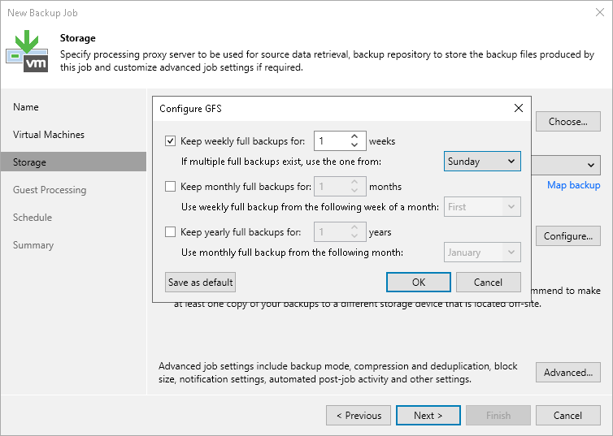

1. At the **Storage** step of the wizard, specify advanced settings like **Create synthetic full backups,** **backup files health check, and Enable backup file encryption** for the backup job.

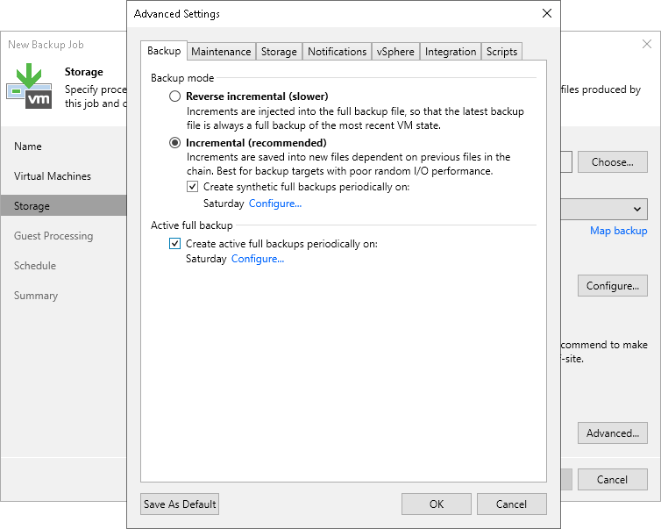

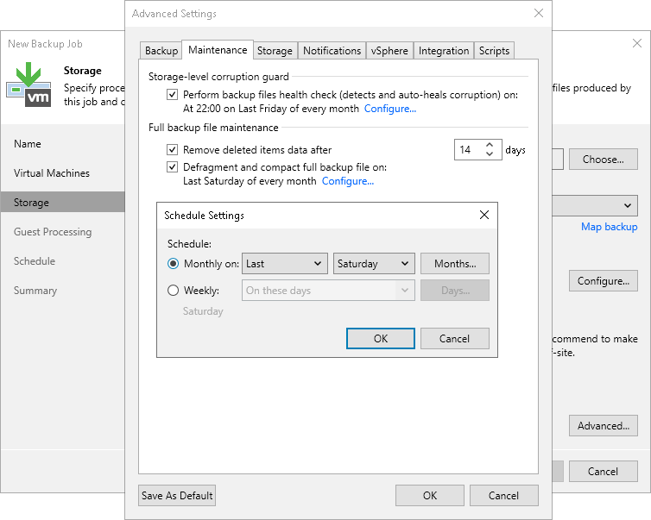

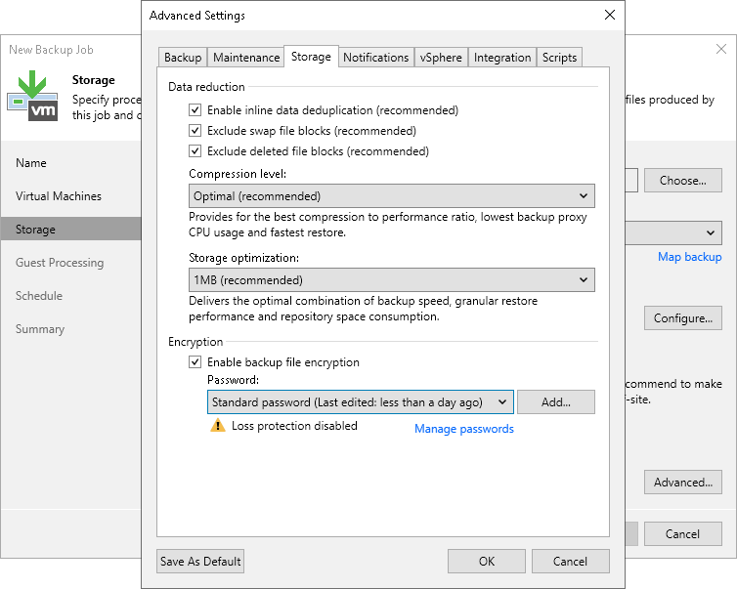

1. At the **Guest Processing** step of the wizard, **Enable application-aware processing** and specify a user account that will be used to connect to the VM guest OS, from the **Guest OS credentials** drop-down list or Add a new user account that has all required permissions.

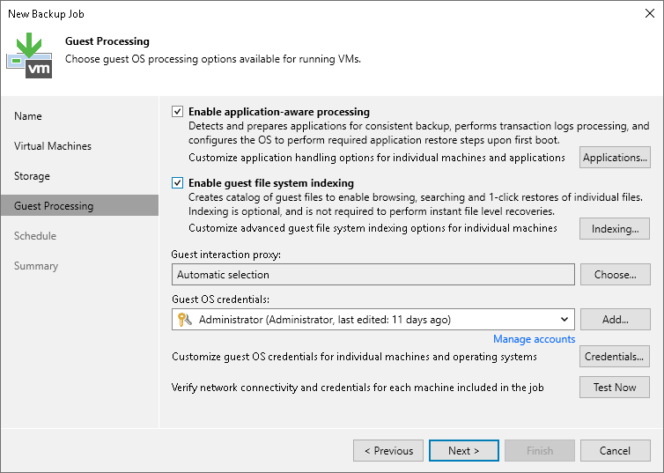

1. At the **Schedule** step of the wizard, select to run the backup job manually or schedule the job to run on a regular basis.

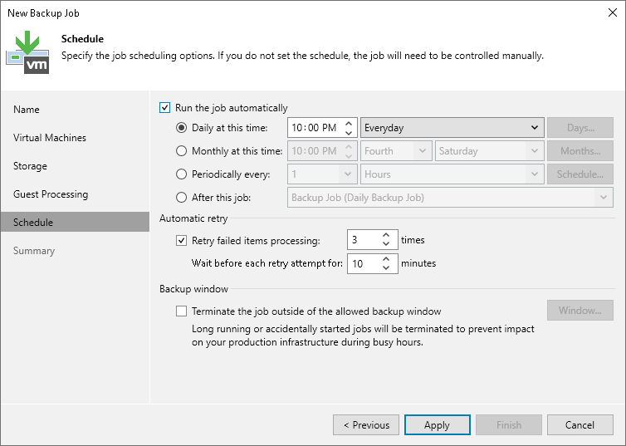

1. At the **Summary** step of the wizard, complete the procedure of backup job configuration.

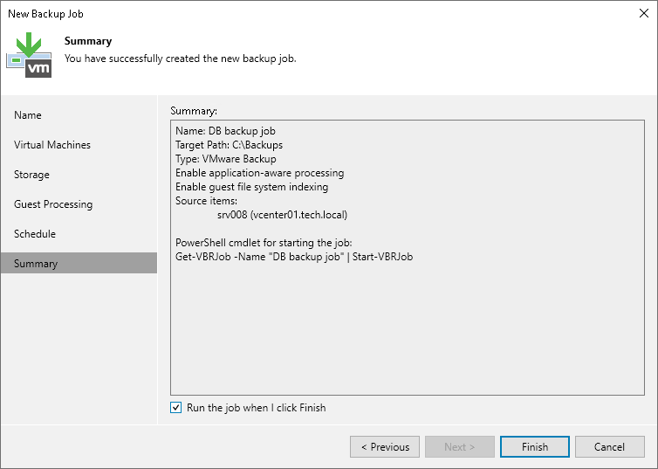

**Monitor the Backup Status under History Tab**

1. Click on the History Tab  
2. Type the backup job name and Validate the backup status

