1. Power off target vm and edit properties.
2. Connect CD drive to machine and select recovery environment cd.

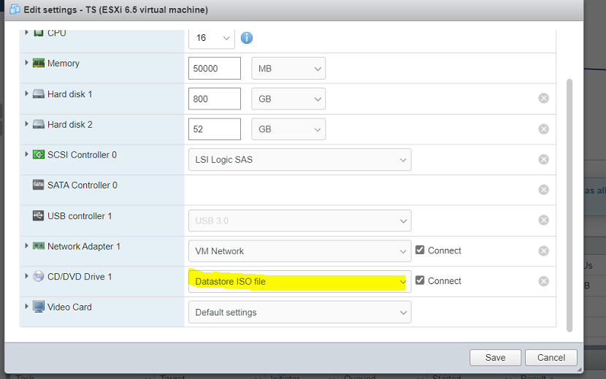

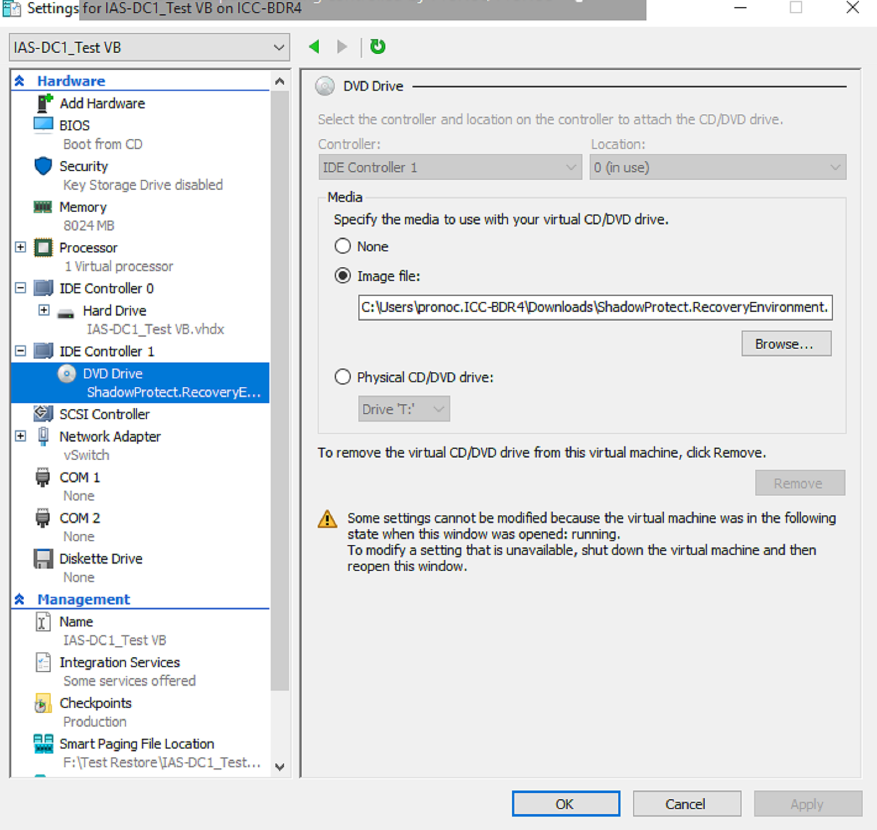

1. Restart the computer.
2. Machine will boot with Recovery Environment.
3. Click on Restore tab.

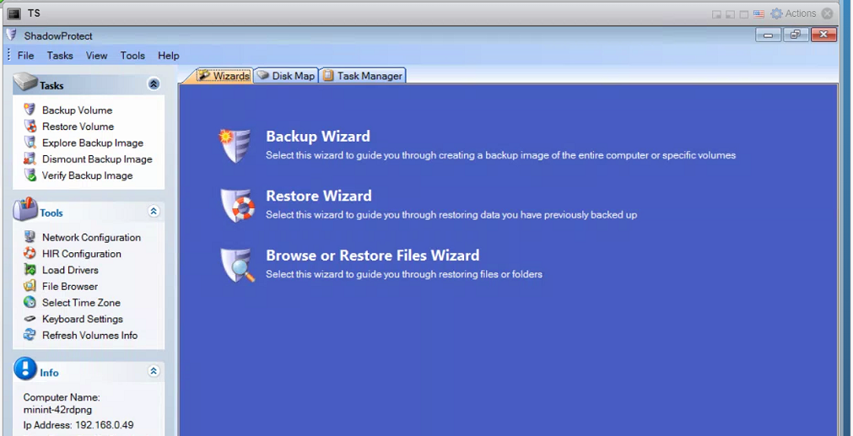

1. Provide SPX Image to restore.

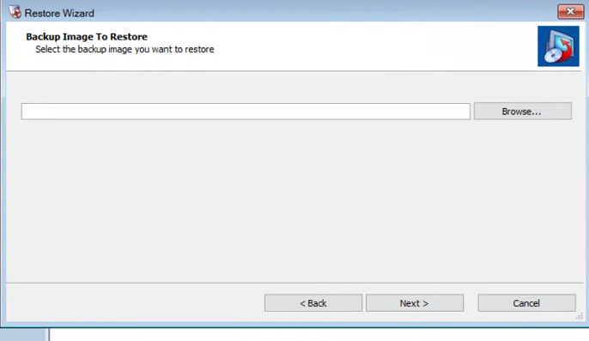

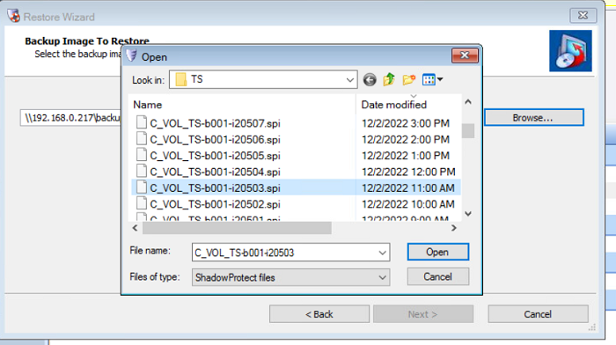

1. Provide SPX encryption Password.

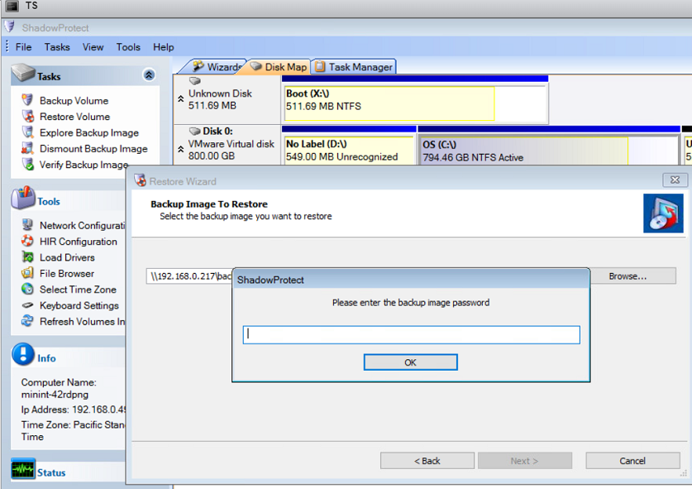

1. Click Next

It will show backup chain information

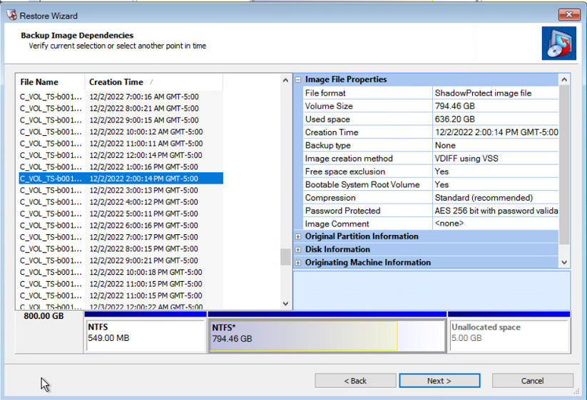

1. Select drive for restore.

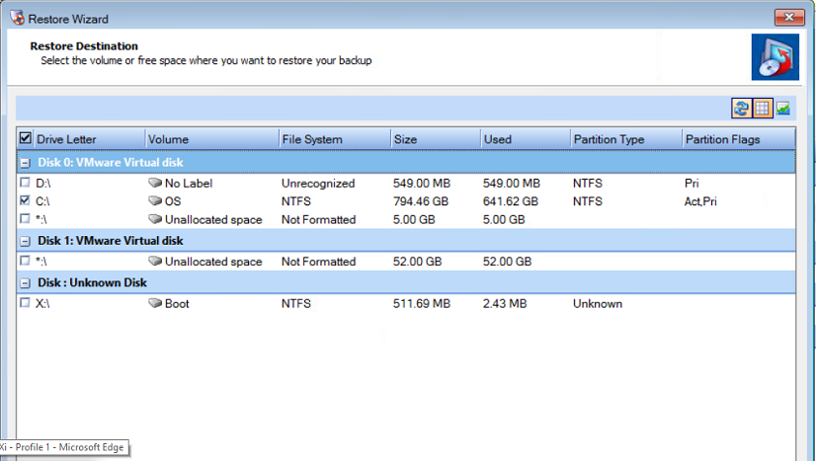

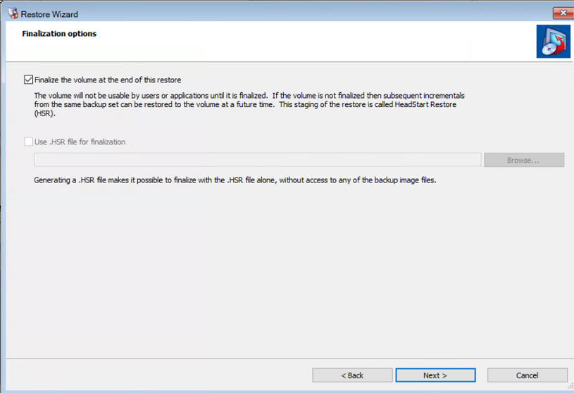

1. Click Next

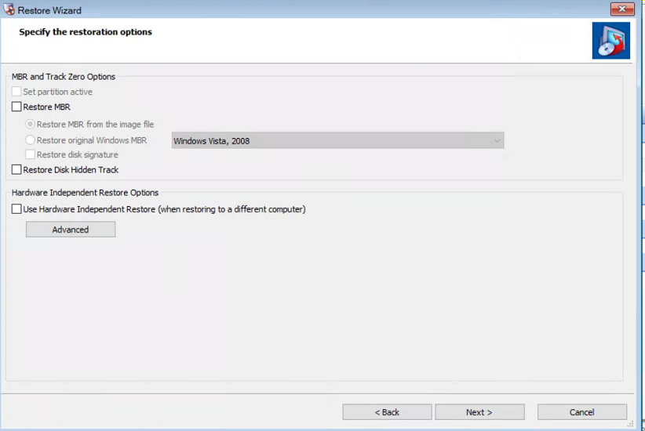

1. Click next.

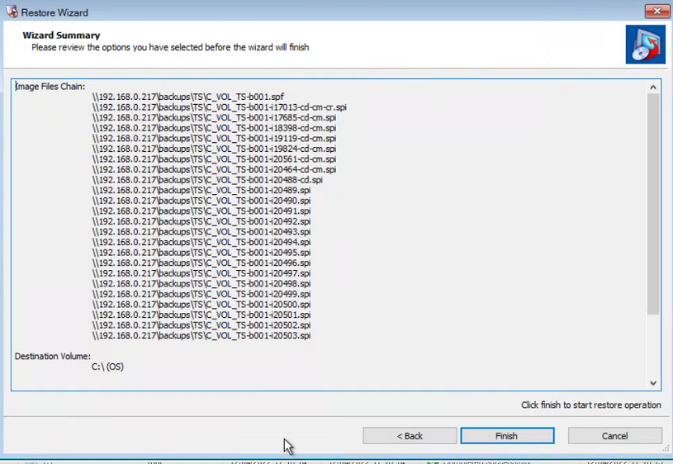

1. Click Finish.
2. Restore will start.
3. Do same for other drive if needed

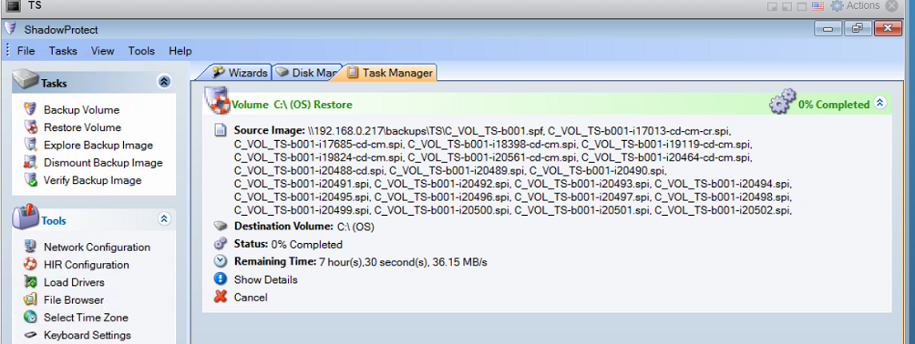

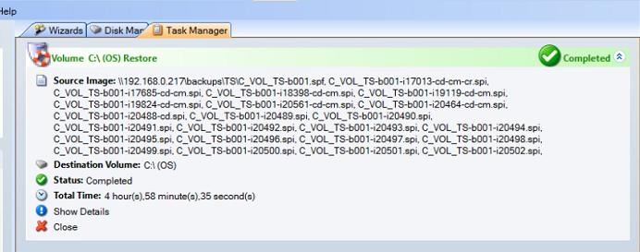

1. Once restore completed.

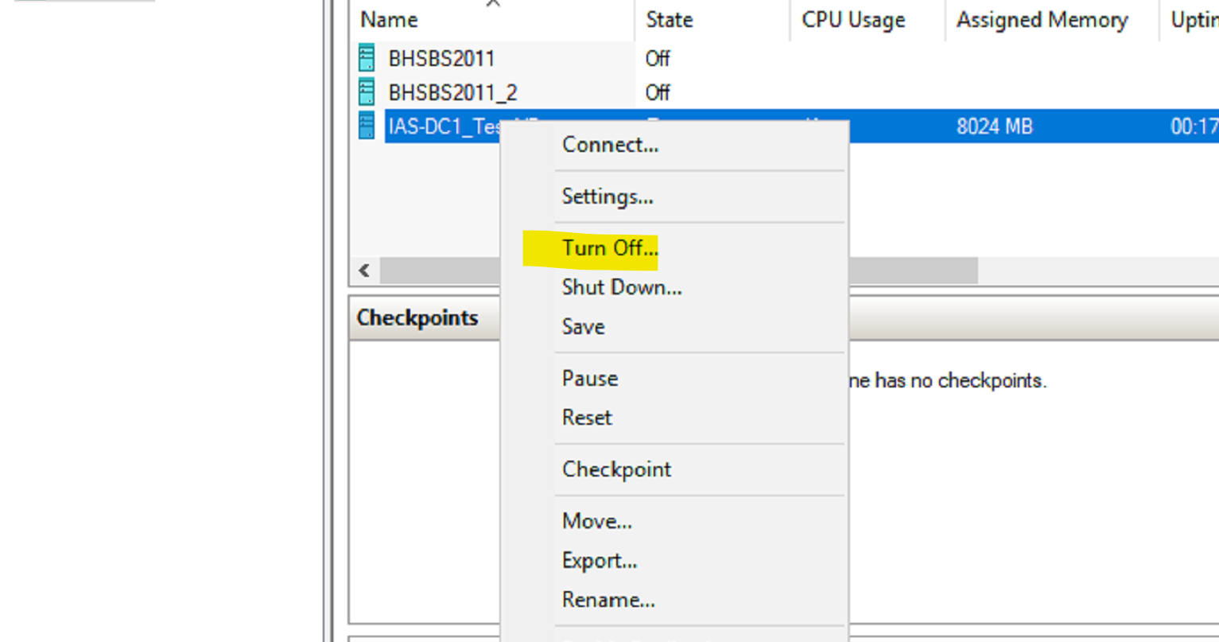

1. Remove the Recovery ISO and Select the None option

1. Reboot server, Machine will come online.