1.Go to the Acronis portal and select the site for which recovery needs to be done.

2. Select the machine for which recovery needs to be done

3. Go the recovery option shown in snap.

APPS01

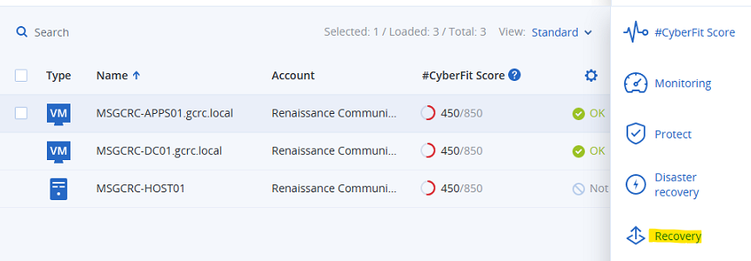

4. Choose the location local/cloud

5. Choose the option more ways to recover as shown in snap

6. Click on the download button and download the ISO file on the Host

7. Copy the code if recovery location is selected form cloud and provide the code when initiating the recovery

8. Select the VM and click right to connect to VM

9. Once connected click on the green button to turn on the VM

10. Choose the option Manage this machine locally

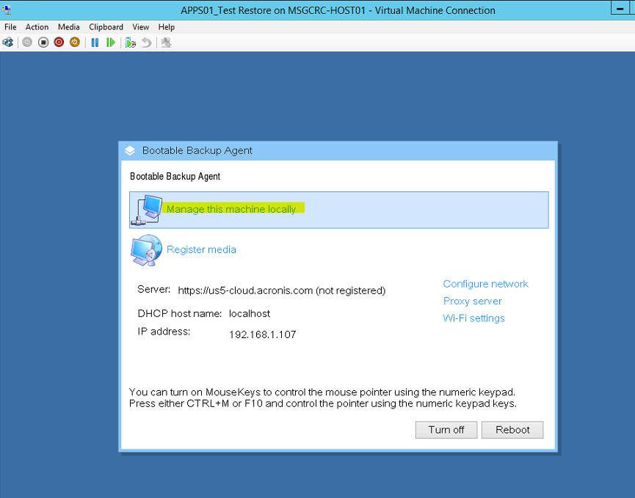

10. Then Select the recover option.

11. Click on the Required option as shown in snap.

12. Click on browse option to provide the recovery location path.

13. Provide the path

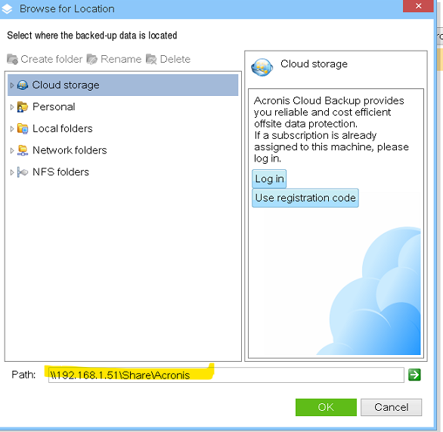

14. Provide the credentials to access the location and then provide the encryption key

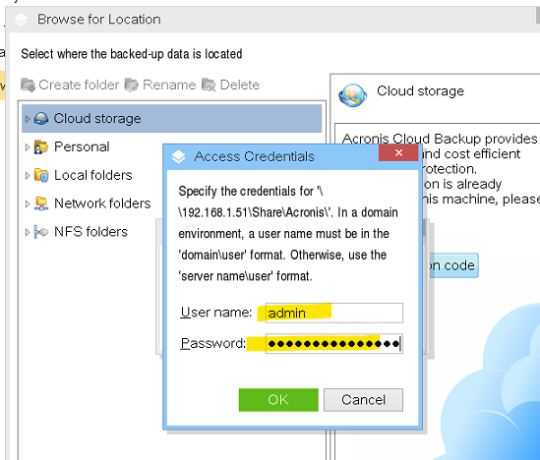

15. Once the credentials are provided choose the disk which needs to be recovered and start the recovery.

Ex (C:\ drive)

16. check the recovery status.

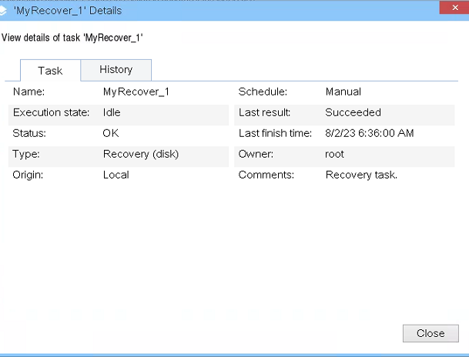

**IMPORTANT:**

**(a). Once the revery is completed make sure to remove the Network adapter from VM to avoid any issue on the production server.**

**(b). Make sure to remove the boot_media. iso from the dvd drive before booting the recovered VM.**

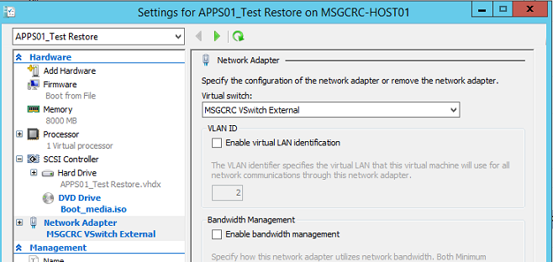

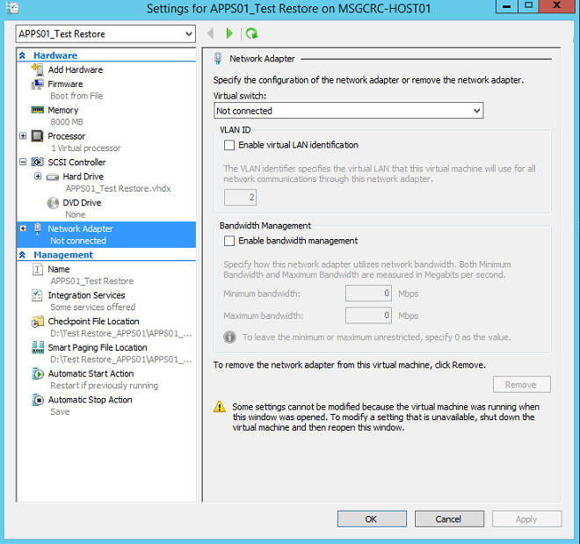

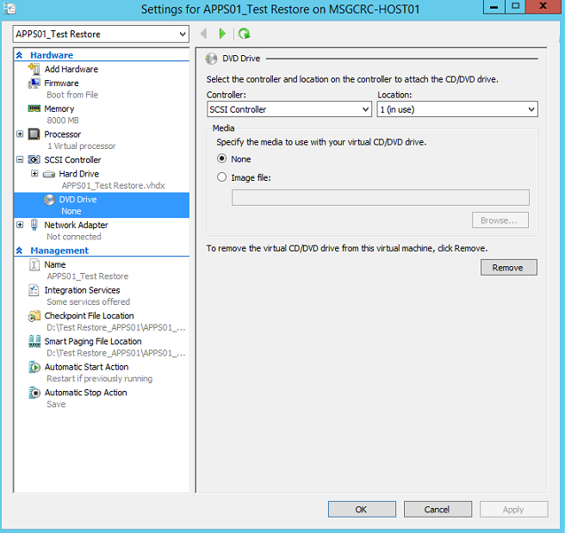

17. After removing the network adapter and iso file boot the VM.

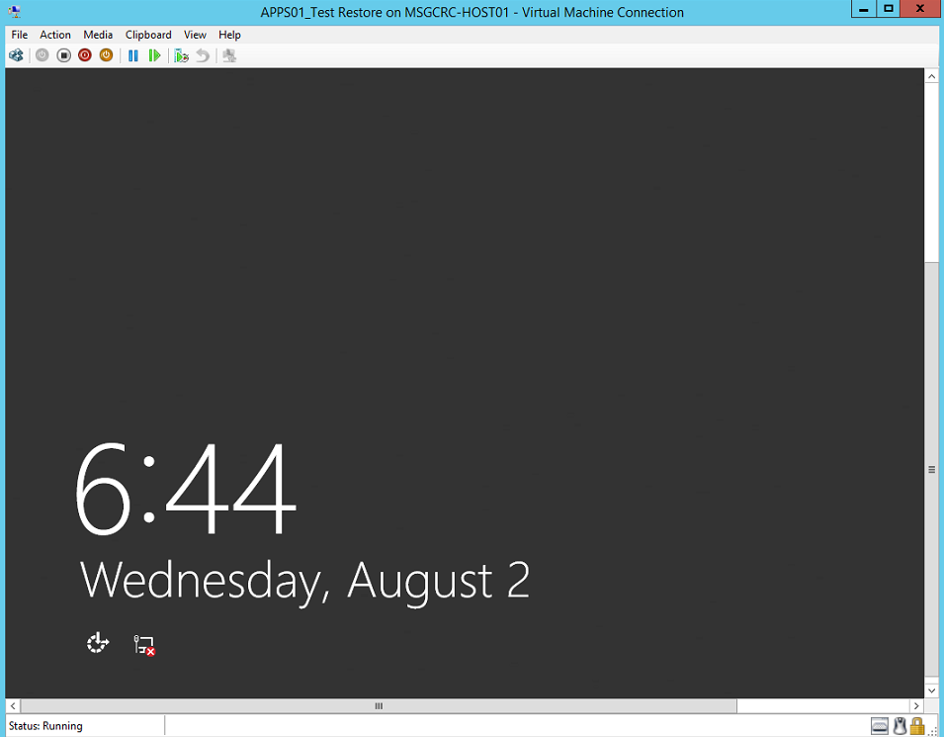

18. After successfully boot turn off the VM.

