**Acronis Backup Testing (Screenshot Validation)**

**About Screenshot Validation:**

* With this validation method, the agent runs a virtual machine from the backup, and while the virtual machine is booting, screenshots are made. A machine intelligence (MI) module checks the screenshots and if there is a login screen on them, it marks the backup as validated.
* The screenshot is attached to the recovery point, and you can download it in the Cyber Protect console within one year of the validation. For more information on how to check the screenshot, refer to [Checking the validation status of a backup](https://www.acronis.com/en-us/support/documentation/CyberProtectionService/checking-validation-status.html).
* If notifications are enabled for your user account, you will receive an email about the validation status of the backup, in which the screenshot is attached. For more information about the notifications, refer to [Changing the notification settings for a user](https://dl.managed-protection.com/u/baas/help/24.03/partner/en-US/index.html#changing-notification-settings-for-user.html).
* Select the Site from the Acronis portal and go to the Management tab.

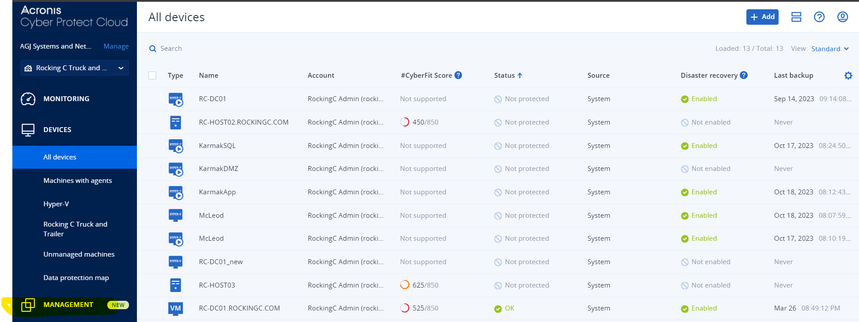

* Choose the Validation tab.

* On the Validation tab click on the Create plan



* Specify the details on the validation plan.

* Choose the **specify** option to select the backup file to validate.

* Selcect the Backups option and then click on Add

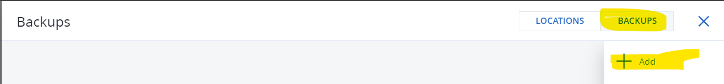

Choose the backup target from which we will opt the backup file.

* Once the backup file is selected, click on Done.

* Choose the option as per the need if we want to validate all the backups or only Last backup.

* Choose the Validation method.

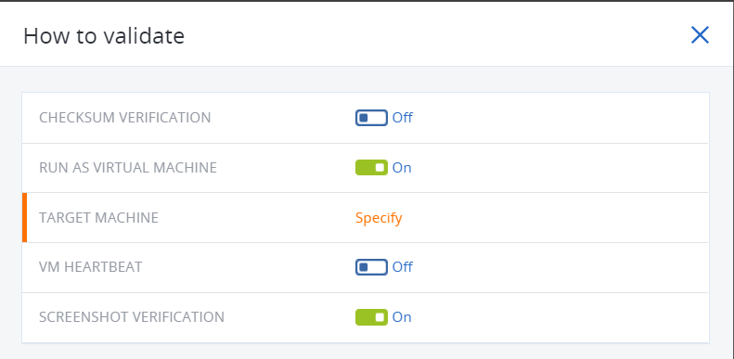

* Select the Host where the Screenshot validation will run and specify the machine name

* Choose the specific path to where the machine will be stored temporarily.

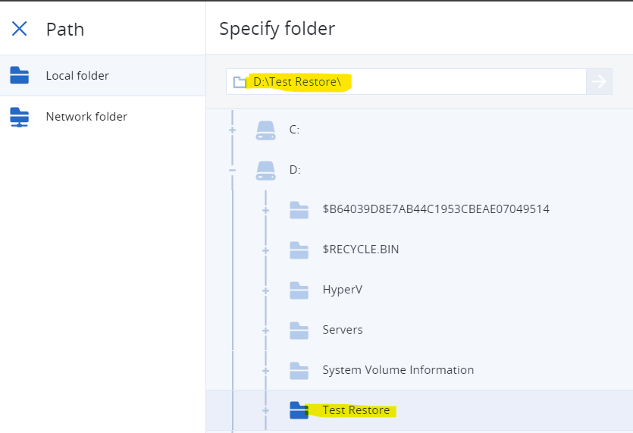

* Now click on VM settings to allocate the Memory and Network adapters.

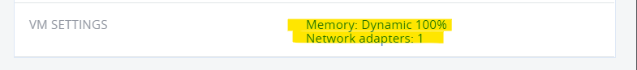

* Choose the Fixed memory option to allocate the memory option to avoid any resource issue.
* And remove the network adapter.

* Once all the options are selected click on Done.

* Click on the schedule to adjust the schedule as pe the requirement.



* Now provide the Encryption key and click on Create to complete the configuration of the validation plan.

* Now the Screenshot validation plan is configured.

