A picture containing clipart

Description generated with high confidence

Backup Radar HandBook

Asif Jilani

VER No. (1.0)

iNITIAL DRAFT / Review Date (19th July 2024)

2024

Contents

**How to Activate Backup Radar Policies**: 2

**Templates to Auto Activate Backups**: 3

**Creating Customized Backup Radar Schedules**: 5

**Backup Radar Dashboard** 7

**Backup Radar Dashboard Access Restriction:** 8

**Retiring the Backup Radar policies:** 9

**Backup Radar IP Address Allow Lists:** 10

**Setting up Scheduled Reporting:** 11

**Backup Radar API INTEGRATIONS** 14

**Acronis API Integration** 14

**Veeam VSPC Portal API Integration** 14

**Axcient x360 API Integration** 15

**Azure API Integration Manually** 15

**Datto BCDR API Integration** 15

**MSP360 API Integration** 15

**N-Able Cove Portal API Integration** 15

**ConnectWise PSA Integration** 16

**Generating API Keys from ConnectWise** 16

**ConnectWise PSA Integration with Backup Radar** 17

**Deleting a PSA Integration** 21

*Backup Radar Handbook*

# **How to Activate Backup Radar Policies**:

**Step 1:**

Go to Manage Activate Backups. Select the backup you want to activate by checking the box and selecting Bulk Activate.

**Step 2:**

**Device Information:** While activating a backup job there are a few mandatory parameters, which we’ll focus on here. The required fields to activate, and the tabs in which they can be found are:

1. Backup Type – Alerts/Backup
2. Device Company – Assign the company that needs to be assigned
3. Ticketing Company – Assign the required company that needs to be assigned

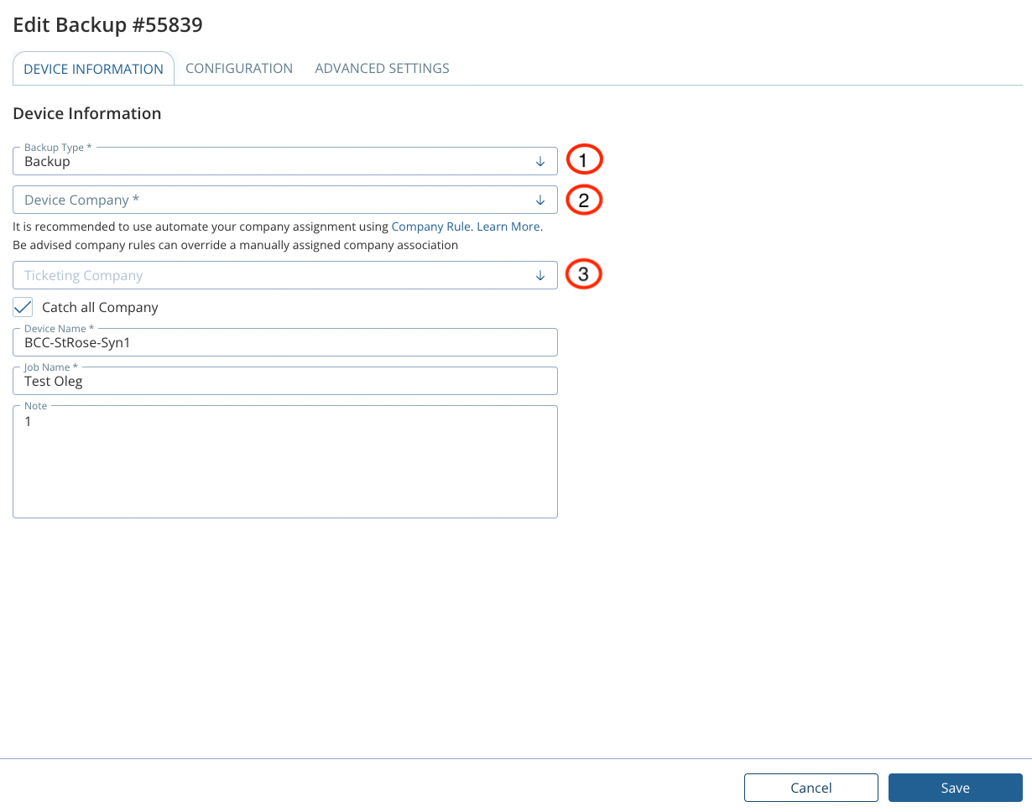

**Step 3:**

**Configuration:** Below details needs to be updated:

1. Schedule: Daily/Weekly/Monthly as per the backup schedule
2. Device Type: Server/Workstation/O365/Mailbox (Chose the options accordingly since the license is consumed accordingly)
3. Status Calculation: Select Last Status Received/Warning if Mixed
4. No Result Threshold: 0 for daily jobs, 6 for Weekly jobs, 30 for Monthly jobs

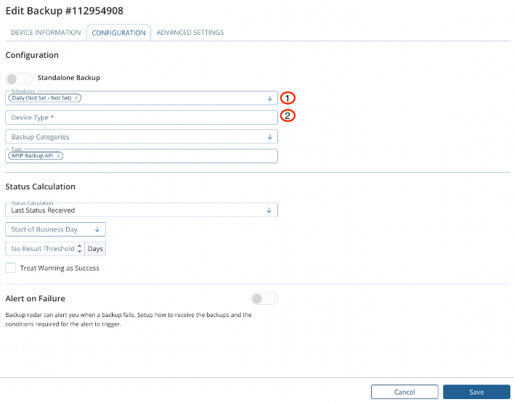

**Once all the details are updated click save and the policy will start reflecting under Edit Backups Tab**

# **Templates to Auto Activate Backups**:

**Step 1:**

Go to Manage Template and click Add Template to create a new autoactivation template

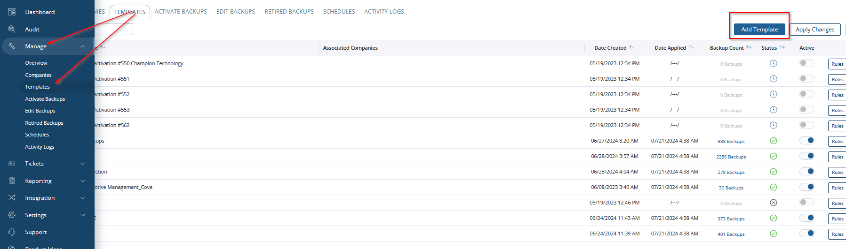

**Step 2:**

Define the standard template name as required, e.g. **“Veeam Onsite”**

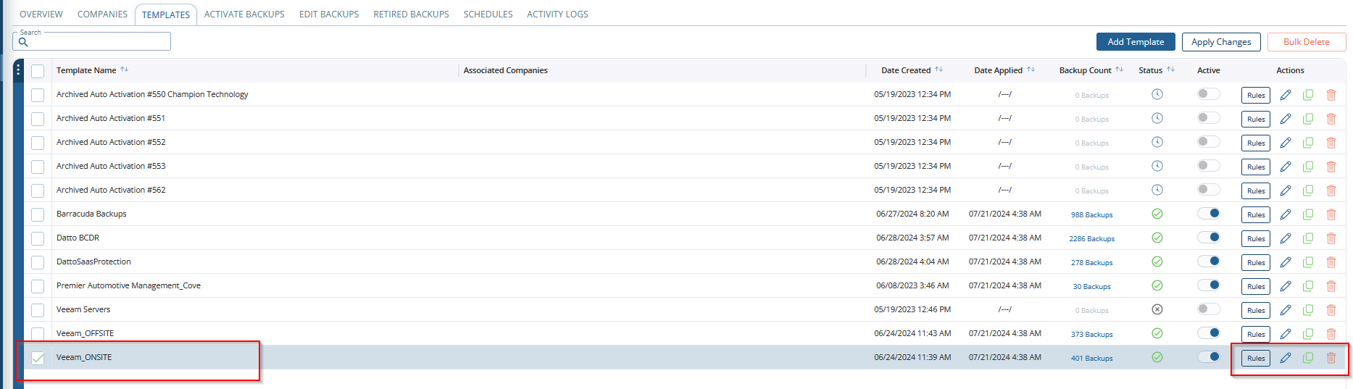

**Step 3:**

Once the Template is created, define the rules for Auto-activation by clicking on Rules and click Save.

***Note: The below screenshot defines the Auto-activation rule for Veeam Onsite Jobs. You can create as per your requirements. It needs to be created using the logical switches available in Backup Radar***

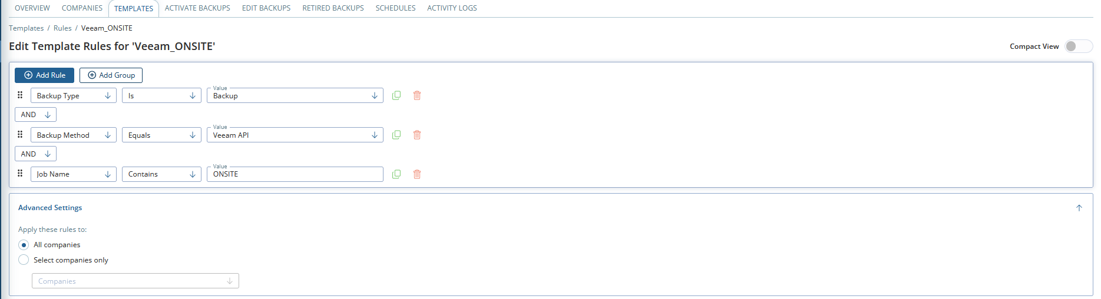

**Step 4:**

Once Rules are created, click on edit on the Right and Specify all configuration details for the specific Backup Radar policy.

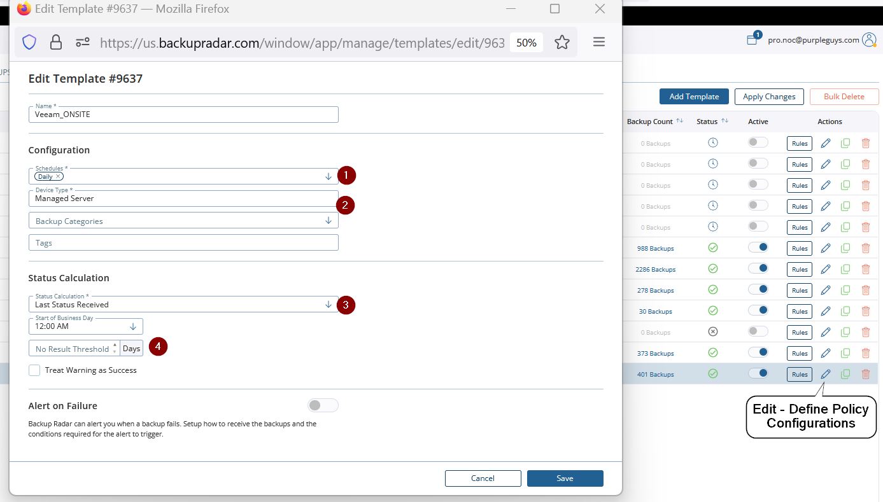

**Step 5:**

Once the Template is created, Activation Rules are defined. Enable the Active Switch on the Right and Click Apply Changes. All the policies will move to the templates and will be standardized.

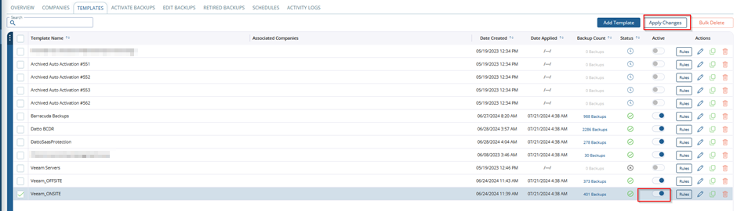

# **Creating Customized Backup Radar Schedules**:

Setting a schedule for your backup is a crucial component, as the schedule tells Backup Radar when to expect the report or notification for a specific backup job. This allows you to identify when a backup is missing (also known as a No Result).

**Step 1:**

Under Backup Radar account, click **Manage > Schedules**

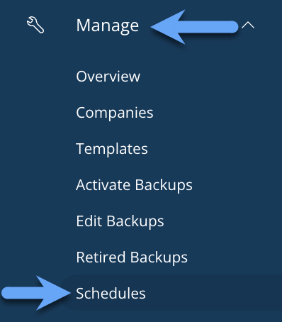

**Step 2:**

Click the **Create Schedule** button.

**Step 3:**

Configure the following fields (your schedule details should match the days on which your backup runs):

1. **Name** (required).
2. **Description** (required).
3. **Days of Week** (if applicable).
4. **Months** (if applicable).
5. **Days of Month** (if applicable).
6. **Every 'x' days** (if applicable).

***Note: If you would like Backup Radar to assume all possible options in a field are selected, you can do this by either leaving the field blank (which can be done for all fields except the Months field) or clicking the check box to the right of the field***

# **Backup Radar Dashboard**

The Dashboard is the homepage for all Backup Radar users and should be used to convey your most vital data quickly and efficiently

***There are 5 tile types to choose from, all of which can be created, arranged, enlarged/shrunk, and edited as you see fit***

* Histogram
* Pie Chart
* Count
* Horizontal Bar Charts
* Vertical Bar Charts

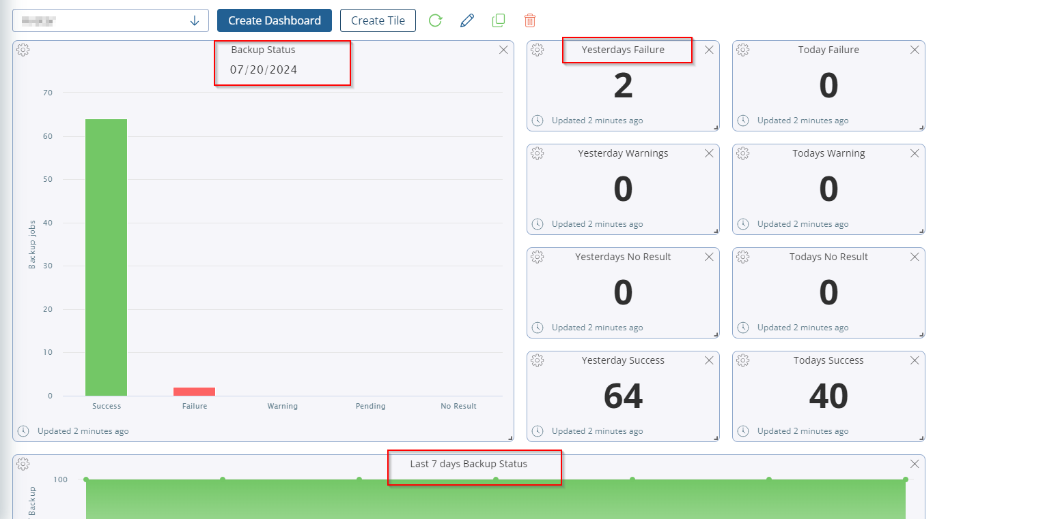

**Below are some key points on how to create the Dashboard**

* By clicking on the Create Dashboard tab you can Create & Name your Dashboard
* Once named you’ll want to start adding tiles.
  + First, we will create the Counts on the left.
  + Select Create Tile. Then when the new tile appears click on the center (+). Set the parameters to match below and click save.
* Now repeat these steps but instead of Failure, try creating one for No Results and another for Warnings.

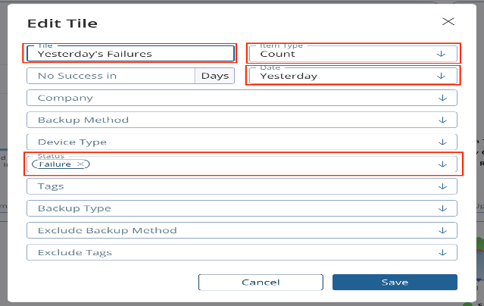

# **Backup Radar Dashboard Access Restriction:**

By default, all dashboards created are set to general access, meaning they can be viewed and edited by anyone logged in. Using the Share, Backup Radar offers the ability to share your dashboard via URL or restrict internal access to a select user or users, assigning them one of three available roles.

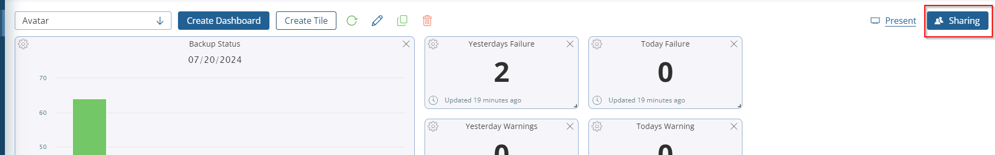

To restrict dashboard access, use the toggle **or "Turn off general access"** button. This will trigger a pop-up asking you to confirm the action.

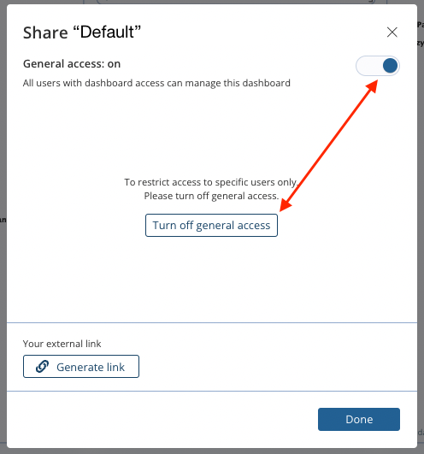

Choose to proceed, and you can add users with the drop-down. You can add multiple users at a time, providing they will all be given the same access level, and you can even choose to notify them of the change by email.

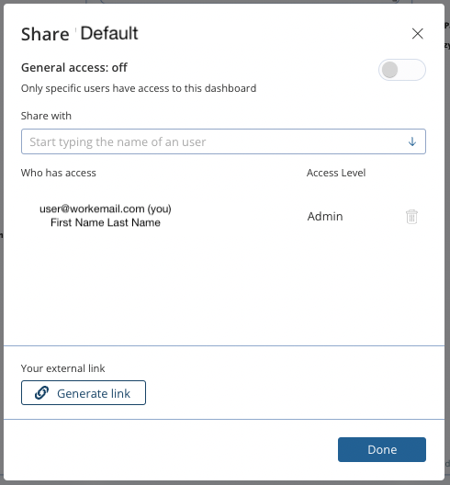

**There are three levels to choose from when granting a user access to a private dashboard:**

* **Viewer**: View only
* **Editor:** Able to make changes to the dashboard tiles & layout but cannot grant/remove access to other users
* **Admin:** Full read & write capabilities

***Restricted Dashboards will be shown in the dashboard drop-down list with a lock next to their name to those with access and will not appear at all for others.***

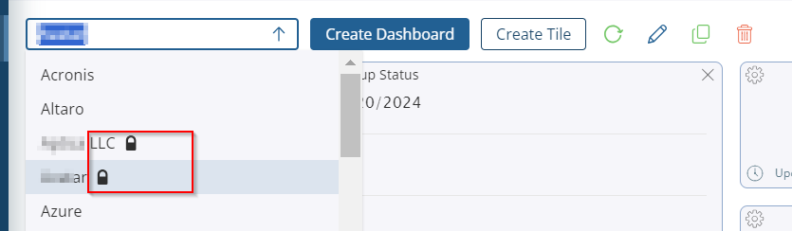

# **Retiring the Backup Radar policies:**

Retire Backups is a helpful feature for when you no longer need a backup (for example, when a customer moves on, or you retire a device).

**Below are the steps to retire the BR policies**

**Step 1:**

Under **Manage**, select **Edit Backups**.

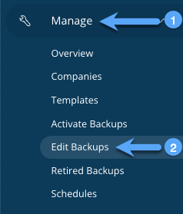

**Step 2:**

Select the backup you would like to retire and click **Bulk Retire**.

**Step 3:**

Add a **reason for retiring** and click **Retire**.

*Once your backup has been retired successfully, you can find it in your****Manage****>****Retired Backups****screen. It will no longer be displayed in the Dashboard, Audit, or Active Reports screens. Results will continue to parse, and history will be saved*

# **Backup Radar IP Address Allow Lists:**

**US Hosted Partners**

* *20.98.189.147*
* *20.106.27.138*
* *20.157.88.41*
* *35.162.64.210*

For the updated list, use these link: [https://help.backupradar.com/hc/en-us/articles/16883910454555-IP-Address-Allow-Lists#heading-1](https://help.backupradar.com/hc/en-us/articles/16883910454555-IP-Address-Allow-Lists%23heading-1)

# **Setting up Scheduled Reporting:**

Reports help share backup data either internally or externally (with your customers).

**Step 1:**

Under the Backup Radar account, navigate to**Reporting** > **Scheduled Reports**.

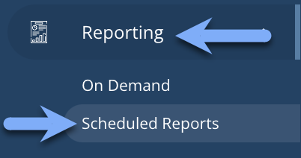

**Step 2:**

In the top right corner, click **Create New Scheduled Report**.

**Step 3:**

Configure your scheduled report and, when finished, click the**Filters**tab:

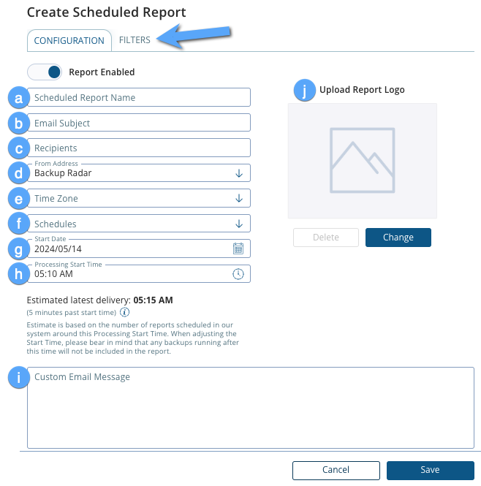

|  |
| --- |
| 1. **Scheduled Report Name**: Enter your preferred Report Name for this report. 2. **Email Subject**: Enter your preferred email subject line for this report. 3. **Recipients**: Enter the email address(es) you would like this report to be sent to. 4. **From Address**: By default, your Backup Radar account will send scheduled reports or email notifications from [noreply@backupradar.com](mailto:noreply@backupradar.com). 5. **Time Zone**: Set your time zone. 6. **Schedules**: Choose one of the schedule options from the drop-down menu:   • Daily: Report will be sent once each day. • Weekly: Report will be sent once each week. • Monthly: Report will be sent for the entire previous month. • Last 30 Days: Report will be sent for the entire previous 30 days. • Weekdays: When you choose this option, a new field will appear called Days of Week. In this field, select each day of the week that you would like your report to be sent on.  A white and blue line  Description automatically generated |

1. **Start Date**: Select the first date the report should begin sending.
2. **Processing Start Time**: Select the time that you would like the report to start compiling data.
3. **Custom Email Message**: This is an optional field where you can enter any custom message of your choice for the body of the email.
4. **Upload Report Logo**: You can optionally add a logo to this scheduled report.

**Step 4:**

Customize your Filters tab and **click Save**:

You can select the Report that needs to be scheduled. (Weekly/Monthly backup help to get the backup status.

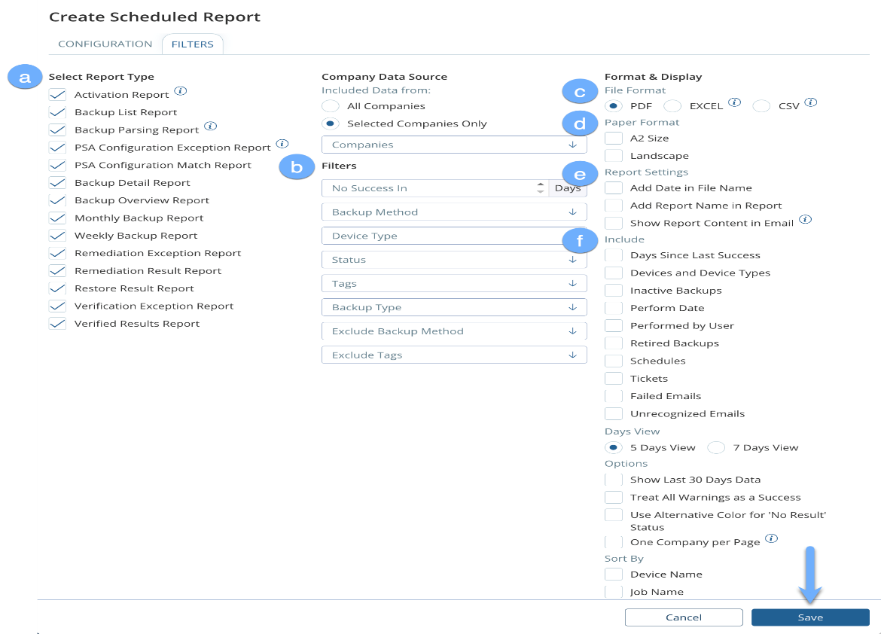

* Your scheduled report should start working its magic for you on the **Start Date** you selected. You can also test it immediately from the Scheduled Reporting page by clicking the **Run Now** button under the **Actions** column.

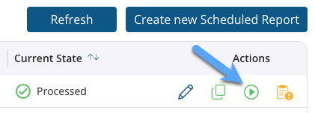

* If you'd like to create a copy of a scheduled report, navigate to the Scheduled Reports tab and click the **Copy from a copy** button next to the report. This can be useful if you need to create multiple customer reports with the same settings.

# **Backup Radar API INTEGRATIONS**

# **Acronis API Integration**

Use this link for integrating Acronis portal with the Backup Radar: <https://help.backupradar.com/hc/en-us/articles/16883907100571-Integrating-with-Acronis-API>

# **Veeam VSPC Portal API Integration**

Use this link for integrating VSPC portal with the Backup Radar: <https://help.backupradar.com/hc/en-us/articles/22211563781787-Integrating-with-Veeam-Service-Provider-Console-VSPC-API>

# **Axcient x360 API Integration**

Use this link for integrating Axcient x360 portal with the Backup Radar: <https://help.backupradar.com/hc/en-us/articles/26959353353243-Integrating-with-Axcient-x360Recover-API>

# **Azure API Integration Manually**

Use this link for integrating Azure portal Manually with the Backup Radar: <https://help.backupradar.com/hc/en-us/articles/16883915404571-Integrating-with-Azure-API-Manually>

# **Datto BCDR API Integration**

Use this link for integrating Datto BCDR portal with the Backup Radar: <https://help.backupradar.com/hc/en-us/articles/16883918598043-Integrating-with-Datto-BCDR-API>

# **MSP360 API Integration**

Use this link for integrating MSP360 portal with the Backup Radar: <https://help.backupradar.com/hc/en-us/articles/16883900754587-Integrating-with-MSP360-formerly-Cloudberry-Lab-API>

# **N-Able Cove Portal API Integration**

Use this link for integrating Cove portal with the Backup Radar: <https://help.backupradar.com/hc/en-us/articles/16883900898075-Integrating-with-N-able-Cove-formerly-MaxBackup-API>

# **ConnectWise PSA Integration**

# **Generating API Keys from ConnectWise**

**Step 1:**

In your ConnectWise account, click **System** > **Members**, then select the **API Members** tab and click the **+ button**.

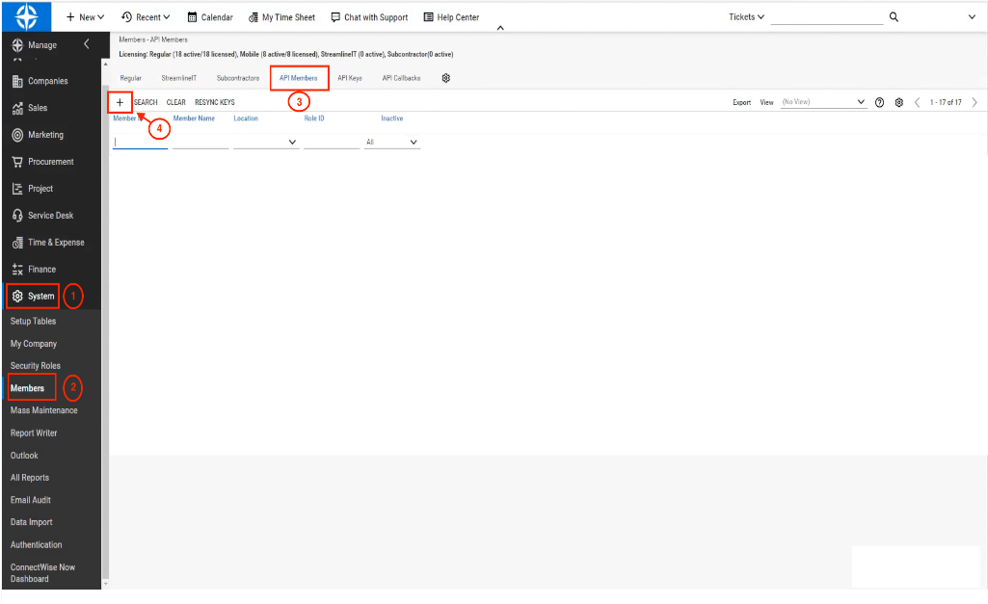

**Step 2:**

Enter the following information and click **Save**:

1. **Member ID**: This can be anything you like (for example, "BackupRadar").
2. **Member Name**: This can be anything you like (for example, "BackupRadar").
3. **Role ID**: Set this to the highest level available.
4. **Level**: Set this to the highest level available.
5. **Name**: Set this to the highest level available.
6. **Location**: Set this to the highest level available.
7. **Business Unit**: Set this to the highest level available.
8. **Default Territory**: Set this to the highest level available.

**Step 3:**

Select the **API Keys** tab and create an API Key by giving it a **description** (for example, "Backup Radar") and clicking **Save**. Make a note of the public and private keys that you receive in the next screen.

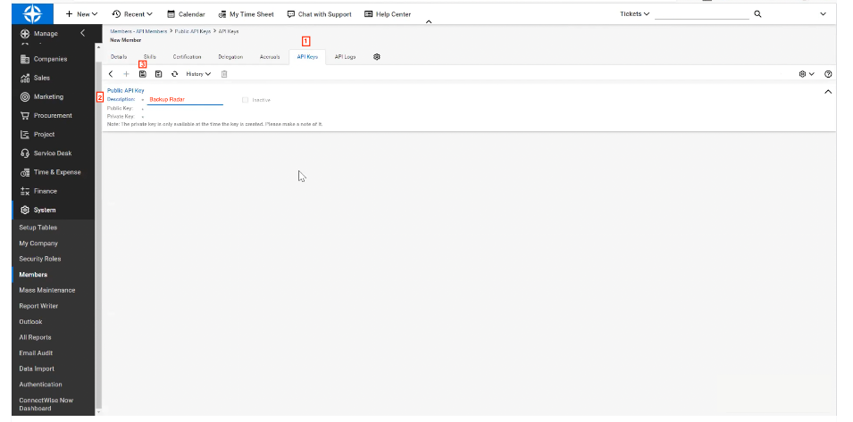

# **ConnectWise PSA Integration with Backup Radar**

**Step 1.**

In Backup Radar, click **Integration > PSA Integration**.

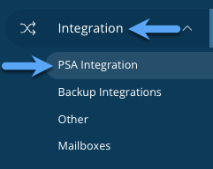

**Step 2.**

Under the **PSA Integration** tab, click **Configure**.

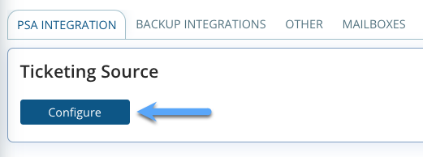

**Step 3:**

From the **PSA Integration** drop-down menu, select **ConnectWise**.

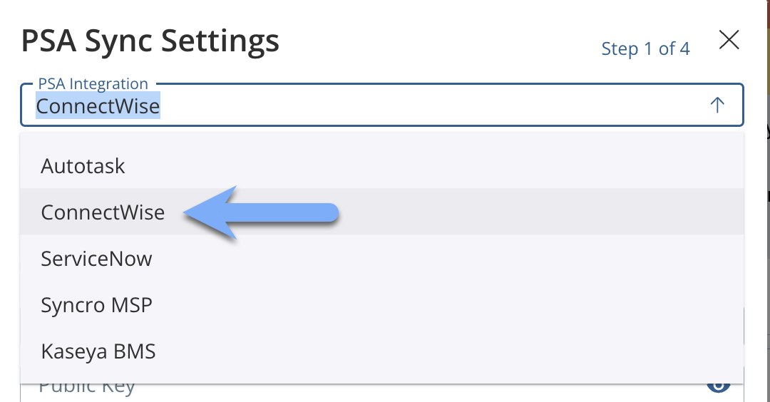

**Step 4:**

Enter the following information and click **Next Step**:

1. **Site** (CWM URL).
2. **Public Key** (the public key you received in ConnectWise).
3. **Private Key** (the private key you received in ConnectWise).
4. **Company Name** (matches your login ID for CWM).

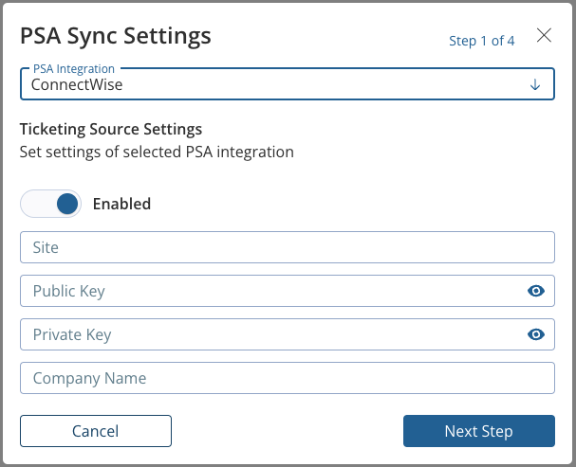

**Step 5:**

Select the **Company Types** and **Company Statuses** for the company names you wish to sync to Backup Radar and click **Next Step.**

These settings can be changed at any time.

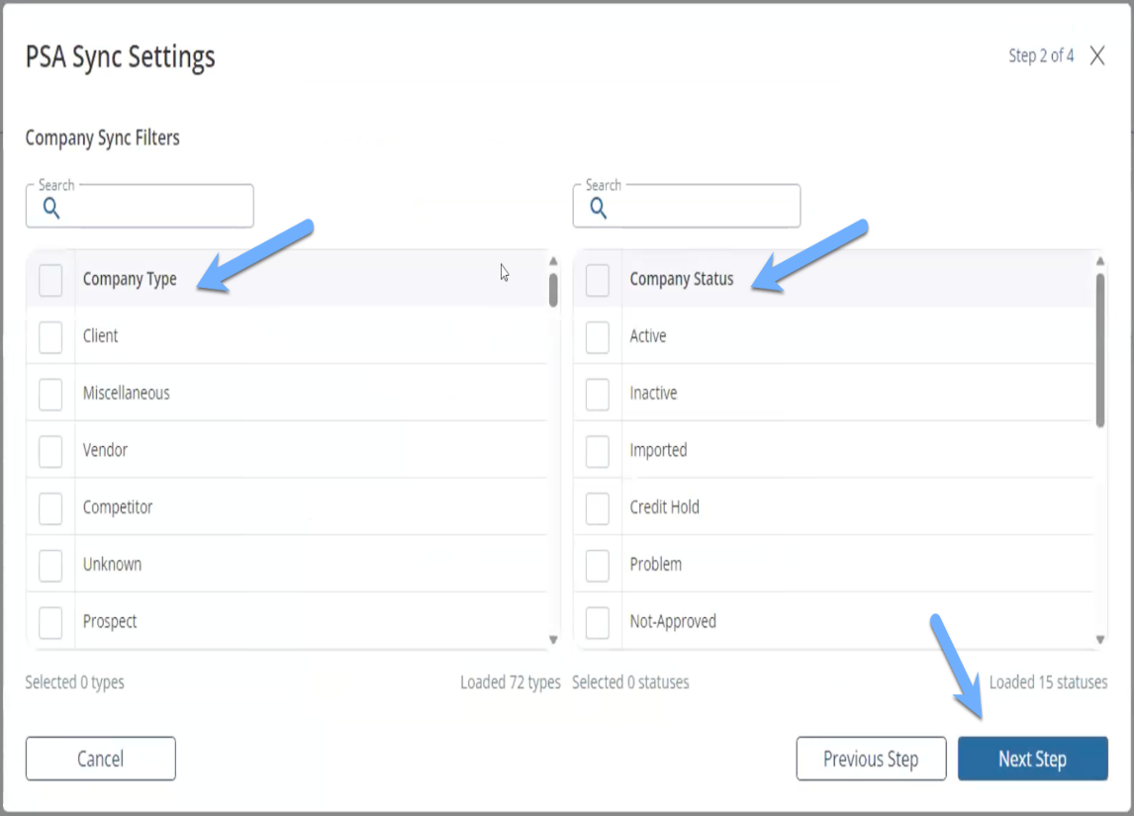

**Step 6:**

Configure your sync settings and click **Next Step**.

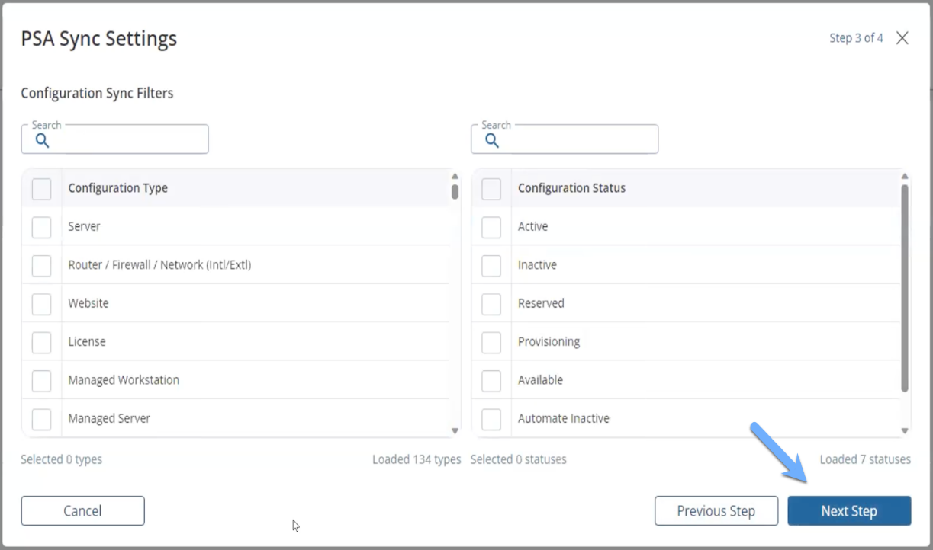

**Step 7:**

The final step allows you to preview which of your ConnectWise companies will be imported. Select **Get Companies** to see this list.

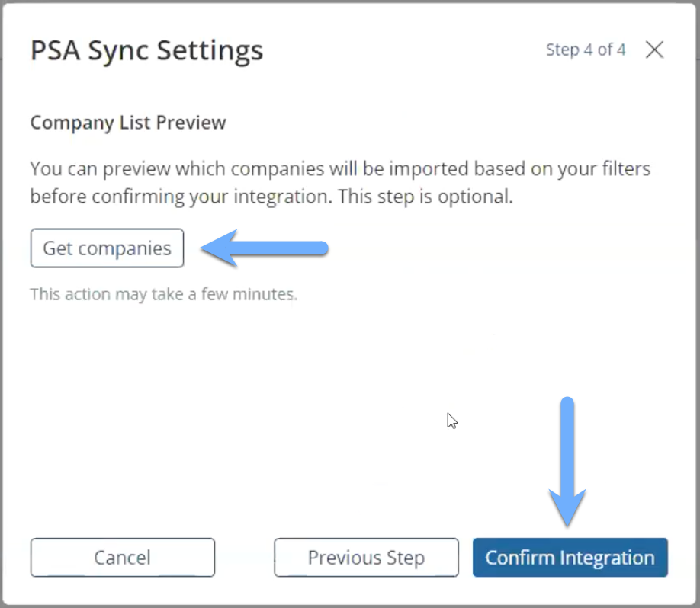

You're done! When you see  next to the Ticketing Source section, this indicates that your company sync has been completed and your PSA has been integrated successfully

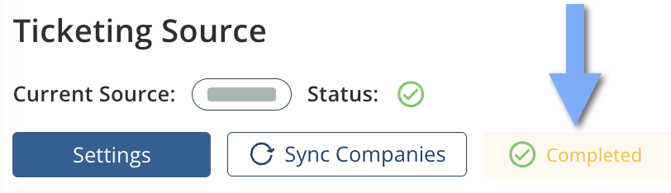

# **Deleting a PSA Integration**

Use this link for removing PSA integration from Backup Radar: <https://help.backupradar.com/hc/en-us/articles/18531651216667>