**Daily Snapshot SOP**

**Daily Snapshot Report:**

**Objective**: Ensure a daily snapshot report is sent to relevant Partners to monitor backup activities and identify any issues promptly.

**Snapshot Contents :**

* Include all tickets worked on the Day
* Include all Previously Escalated tickets
* Ticket status (Resolved, failed, in-progress and Assigned to MSP).
* Assign to MSP (Inputs / Approval required form Client)
* Follow the Default snapshot template as given below:



Daily Snapshot **Sample** Autotask reference ticket: **T20230823.0014.199**

**Report Delivery:**

Recurring email Configured on Auto Test. Once daily work is completed tech will send Daily Snapshot to Partners.



**Follow-Up:** If any report is not sent, an email is sent to the Tech lead using workflow.

**How to share the Daily Snapshot Email:**

1. Login into the Autotask
2. Go to the recurring ticket queue
3. Open the Daily Snapshot ticket for the required project
4. Click New Time Entry
5. Draft an email under the Summary Notes tab.

-------------------------------------------------------------------------

“Hello Team,

Greetings!!

Please find the daily backup report for the work performed and all open items.

Please feel free to respond to us for any additional queries.

Thanks & Regards,

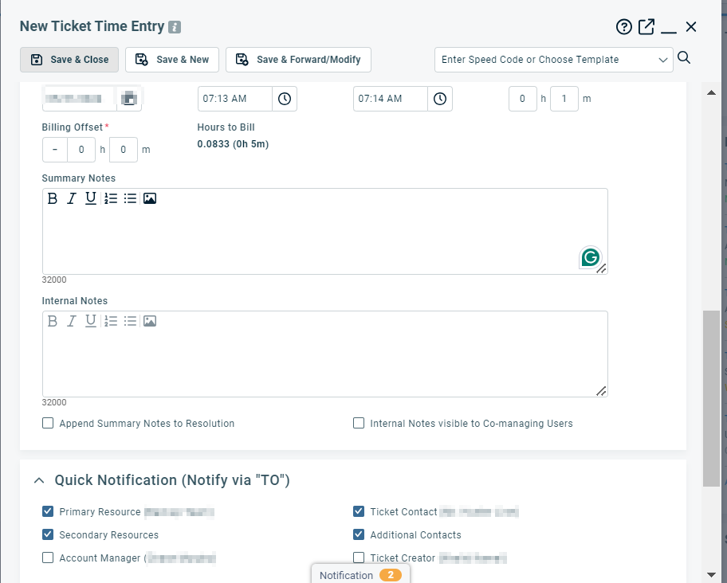

1. Attach the Daily snapshot snip/sheet to the ticket.

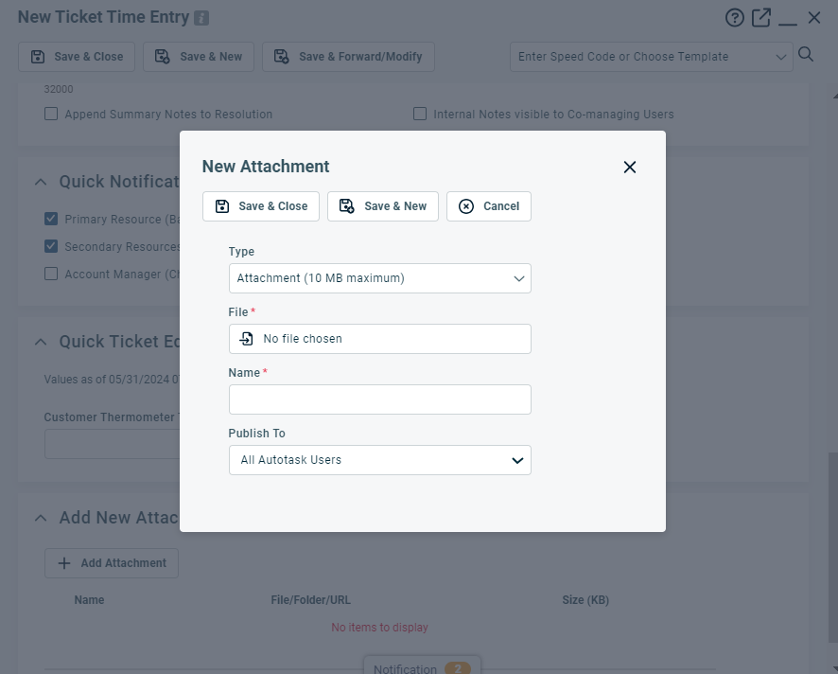

1. Make sure the Ticket Contact/Additional Contact/Primary Contact/Secondary Contact are checked.