Elasticity lab

Physics 110 at Olympic College

# Overview

We know that energy can be stored in springs. Ideally, any spring follows a rule known as Hooke’s law. Hooke’s law gives a relationship between the distance a spring is stretched from equilibrium, and the force required to hold it at that position:

$F^{sp}=kx$

The spring constant *k* is a measurement of how “stiff” the spring is, and is measured in newtons per meter (N/m)—how many newtons of force are required to stretch the spring by one meter. (Another way of expressing this is J/m2, which we have been using in the context of energy.)

If you make a plot of the force of the spring vs. the distance stretched from equilibrium, you would see a *linear* relationship, as shown below. The slope of this line gives the spring constant.

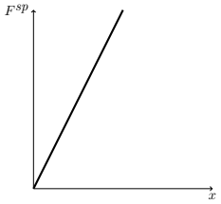

Many objects that are not springs—such as plastic cutlery—behave like springs; you need to apply some force to bend a plastic spoon, and you can store energy in the bent spoon. *Elastic* materials follow Hooke’s law for a certain range of displacements.

The next graph is an example of data on the elasticity of a plastic knife, taken by a Physics 110 student. Note how there are three distinct regions that each follow a linear trend. Hooke’s law is valid separately in each of those regions; the knife has a different spring constant depending on how much it is bent. This is typical of objects that are “springy,” but not ideal springs.

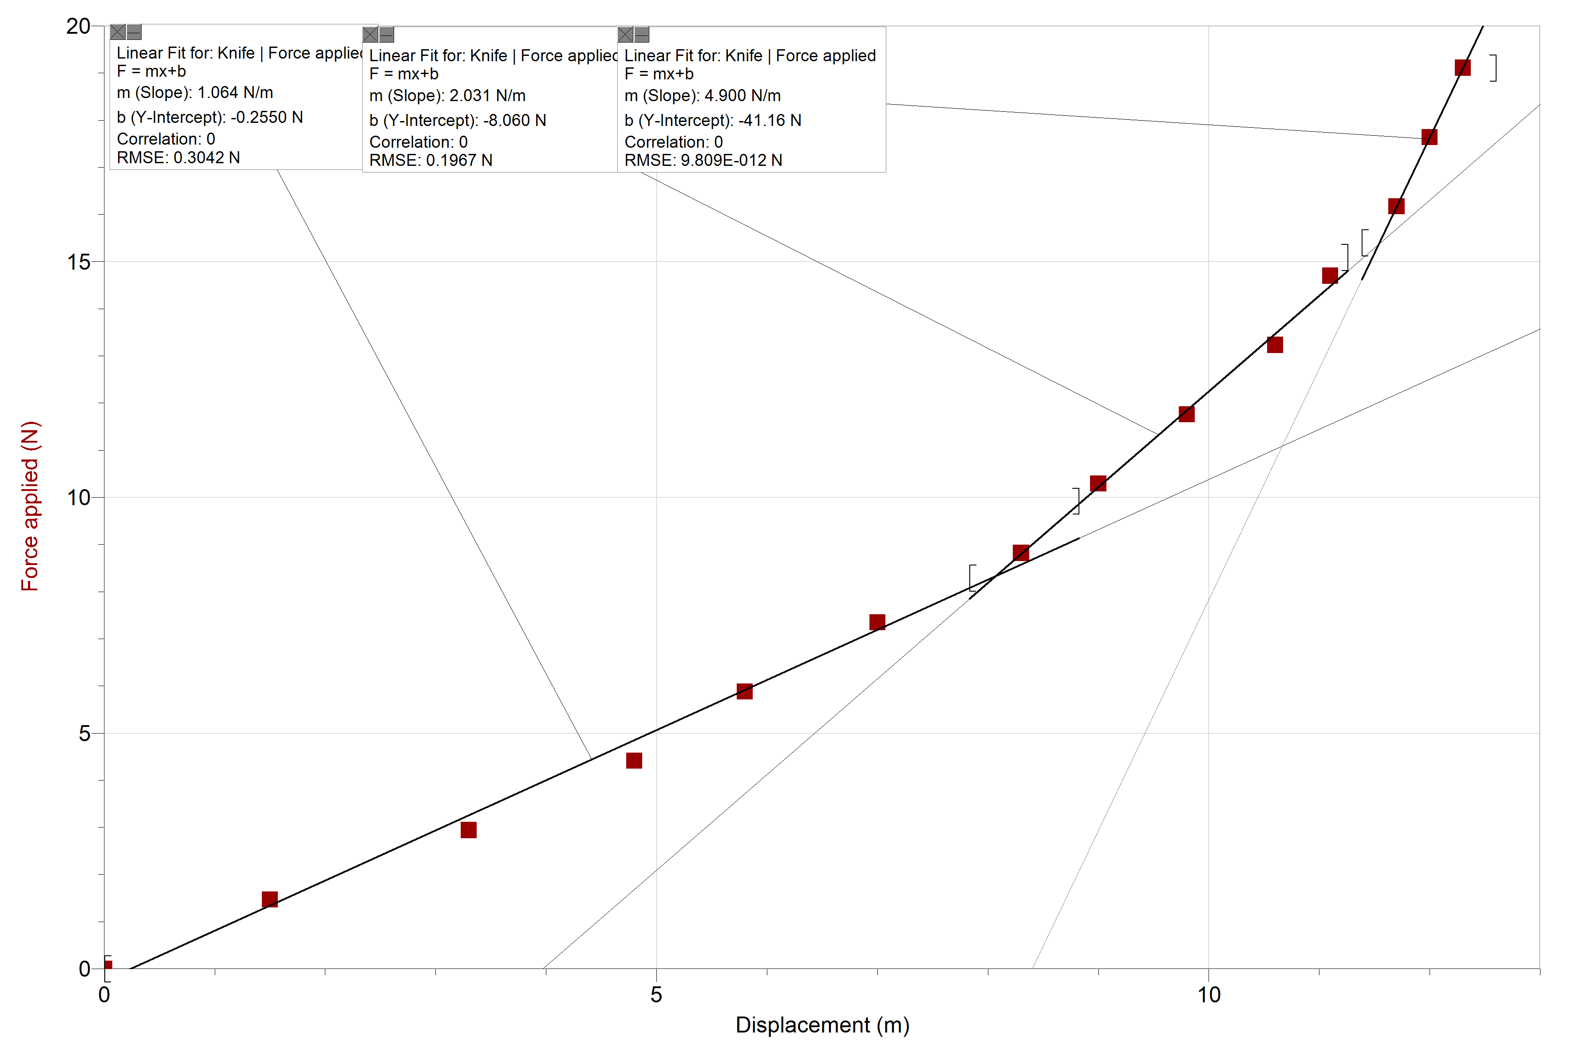

Force vs. displacement for a plastic knife. Note: the horizontal axis should be labeled with units of cm

In this lab, you will investigate Hooke’s law with a simulation and also with a real object from your home.

# Simulation

## Procedure

Go to <http://phet.colorado.edu/en/simulation/mass-spring-lab> and click the play button to launch the simulation, which can run in your web browser. When it opens, click the **Lab** tile. Play around with it a little bit to see how the simulation works.

1. Hang a mass a spring and measure how far the spring is stretched from it’s “natural position” once the spring has stopped bouncing
2. Record the distance stretched and the hanging mass
   1. Pay attention to units: the mass in the simulation is given in grams, but you need to record the mass in kilograms on the data table
3. Continue until you have at least five data points.

## Data

Fill in the following table. To find how much force a hanging mass is exerting on the spring, multiply the mass (in kilograms) by *g* (9.81 m/s2). This gives you the force in newtons.

|  |  |  |
| --- | --- | --- |
| Distance from equilibrium position (cm) | Hanging mass (kg) | Force applied (N) |
|  |  |  |
|  |  |  |
|  |  |  |
|  |  |  |
|  |  |  |

# Real object

## Materials

Find an object from your home that is “springy” (if you bend or stretch the object, it will return to its starting point when you let go). Some examples: plastic fork, thin piece of cardboard (e.g. a strip cut out from a cereal box), rubber band.

You will also need some small objects with weights that you measure using a scale. Some examples: a variety of rocks with different sizes, nuts, washers. It will be easiest if you have a small kitchen scale (or something similar), but a bathroom scale should work alright.

## Procedure

1. Attach the object to a support, such as a table or counter. The object’s equilibrium position is the position it is in now, before you add any weigh to it.
2. Pull the object a little bit from equilibrium by applying hanging some weight on it. Carefully measure the distance from the new location of the object to it’s equilibrium position.
3. Add a little more weight, and measure it’s position again.
4. Continue until you have at least five data points.

## Tips and tricks

* Attach a bag or pouch to your object to place your weights in, instead of attaching weights directly.
* Do something to mark the equilibrium position. For example, if you have a plastic fork extending from the edge of a table, lay a ruler down next to the fork; the ruler will stay in place as the fork bends, and you can measure from the tip of the fork to the ruler.
* It is OK to use non-SI units, but make sure you’re consistent.
  + If you use a bathroom scale, it will probably read in pounds—this is a unit of force! Ounces, which a standard kitchen scale will probably read in, are also a unit of force.
  + If you use a scale that gives you a reading in grams, then you’ll need to convert to kilograms and multiply by *g* (9.81 m/s2) to get a force in newtons.
* If your objects are too light for your scale, then weigh a group of similar objects (e.g. a bag full of washers). If you divide this weight by the number of objects, you will have a good approximation for the weight of each object by itself.

## Data

Fill in the following table. Be sure to indicate the units you use to measure distance and mass.

Object used: *(Write what object you used here)*

| Distance from equilibrium position | Force applied |
| --- | --- |
|  |  |
|  |  |
|  |  |
|  |  |
|  |  |

*Insert a picture of two of your experimental setup below:*

# Analysis

For both the simulation and real object, make a plot of force applied (vertical axis) vs. distance from equilibrium (horizontal axis). Plot a linear trendline, and display the equation on the graph. *Insert both graphs below:*

# Questions

1. Using the trendlines from your graphs, report the following:
   1. Spring constant of the simulation spring:
   2. Spring constant of the real object:
2. How well does the real object follow Hooke’s law? Explain your reasoning; referring to the graphs may be useful.
3. What challenges did you run into while taking data on the real object? How did you overcome these challenges? What would you do differently next time?