Energy and kinematics

Olympic College, Phys 110

# Overview

This is a “verification” lab; you will be comparing experimental reality to theoretical predictions of a ball’s launch speed after it has rolled down a ramp.

## Setup

Set up a ramp on a table. You’ll be rolling a ball down this ramp. You’ll get the best results if you arrange it so that the ball travels straight off the side of the table. See the figure below:

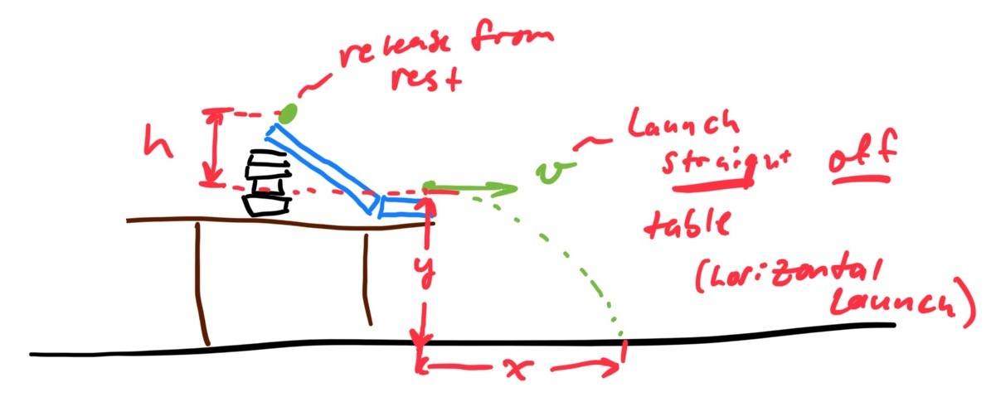

Books, notebooks, and binders all work very well, though if you have scrap wood laying around that is usually best.

*Take a picture of your setup and insert it here.*

# Procedure

1. Apply conservation of energy to *theoretically predict* the speed of the ball when it reaches the end of the track. Pay particular attention to how you measure the starting height (see diagram above). Record all data and show all your work in the space below.
2. Measure how far the ball lands from the track, and how far it fell vertically after leaving the track (see diagram above). Use this data to *experimentally determine* the launch speed. It is highly recommended that you run many trials. Record all data and show all your work in the space below.

# Analysis

1. Which gave a larger value for launch speed: the theoretical calculation applying energy conservation, or the calculation with kinematics using experimental data? What factors might cause this to be larger?
2. The percent difference between two quantities is given by their difference divided by their average. What is the percent difference between your theoretical (energy) and experimental (kinematics) calculations?
3. Considering the percent difference between your two calculations, what can you say about your experiment and the results? Do you think your conservation of energy calculation accurately predicted the ball’s speed? Do you think the kinematics calculation accurately determined the ball’s speed? Explain your reasoning.