Phys 256 gas properties lab

# Overview

In this lab, you’ll use a simulation to investigate an ideal gas. The simulation should run in your web browser, and can be found here: <https://phet.colorado.edu/sims/html/gas-properties/latest/gas-properties_en.html>. Select the “Ideal” tile once the simulation loads:

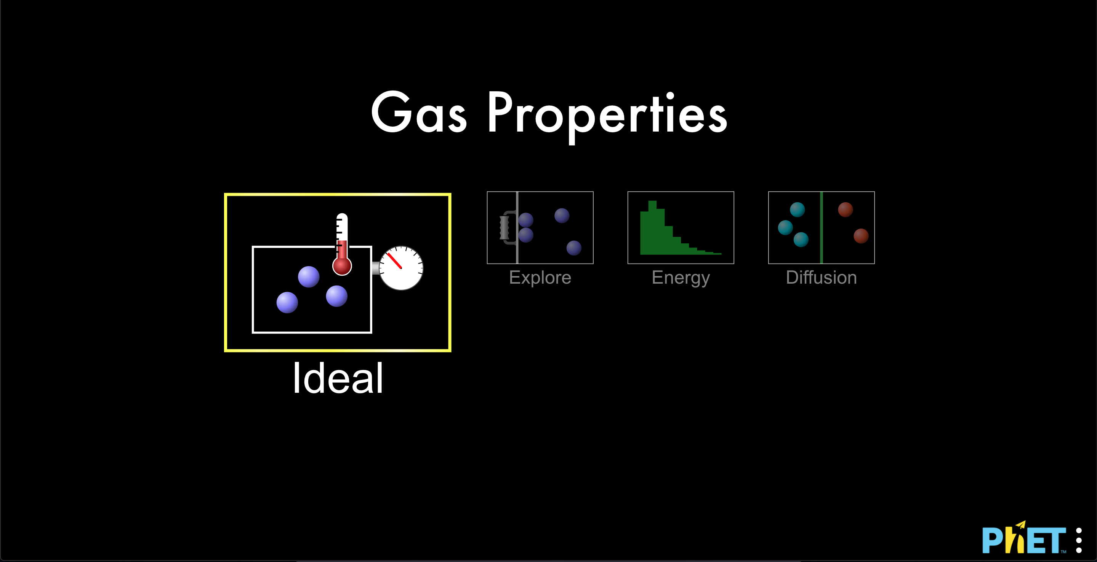

## Some notes on the simulation

* The molecules are modeled as hard spheres that only interact via elastic collisions
* The height of the container is 8.75 nm, and the depth is 4 nm. These are both constant.
* For any given measurement in the simulation (temperature, pressure, or width of the container), take the uncertainty as plus or minus one smallest increment. For example, the width is given to one decimal place, so the uncertainty in that measurement would be ±0.1 nm.
  + You can take the height and width as exact values
* The light particles have a mass of 4 u, and the heavy particles have a mass of 28 u. These may be taken as exact values.

# Tasks

You are to determine mathematical relationships between the following quantities:

1. P and V
2. P and T
3. V and T
4. V and N

## Notes and suggestions

* You’ll want to make graphs relating the two quantities; analyze the graphs to find precise mathematical relationships between the two. I recommend using Logger Pro over Excel—Logger Pro is designed specifically for data analysis in intro-level science labs, so it is generally a better tool.
* Getting a nice relationship means controlling your variables: you want as much to remain constant as possible.
* Be sure to include error bars on the data points on your graph.
* You do not need to include *materials* in your lab report—your “materials” are the simulation.
* In the *methods* section of your lab report, give brief explanation of what you did for each of the four relationships. Be sure to identify what was kept constant, and how you did that. (It will be more straightforward for some of these relationships than for others.)