Standing Waves

Olympic College, Phys 256

# Overview

In some labs in this class, you design and carry out your own experiment. This helps you develop the skills of an experimenter, and the focus is more on the process than the results (though certainly the results are important!)

In this lab, however, the focus is on the interpretation and analysis of data. It is set up to be like you “see” through the eyes of someone carrying out the experiment, and you are tasked with interpreting the results and analyzing the data.

## Setup

A string hangs over a pulley, weighed down by some mass. The other end of the string is attached to a vibrator whose frequency can be controlled. See the diagram below:

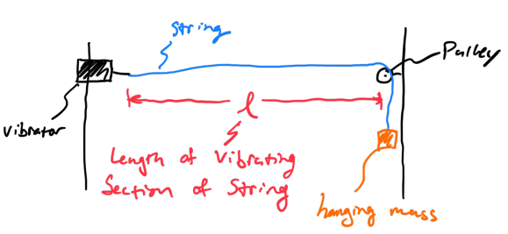

Lab setup

With a given mass and vibrator frequency, you will see standing waves form in the section of string between the vibrator and pulley. For example, here’s what the second harmonic would look like:

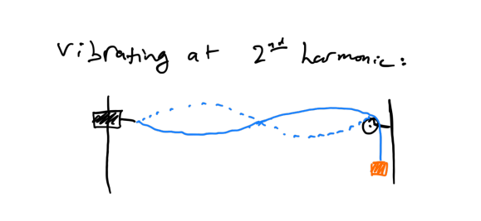

Second harmonic

In the video, the vibrator frequency is fixed at 120 Hz ±1%. The string is held under tension by a series of five different hanging masses. Where the video says “estimated resonance uncertainty” on the masses, that means that the experimenter was able to go about that many grams above and below and still have what looked like a standing wave in the string.

For example, if the hanging mass was 500 g, with a “resonance uncertainty” of ±2 grams, that would mean the experimenter observed a standing wave for the range of 498–502 g.

## Calculating wave speed

A standing wave is made of two traveling waves of an appropriate frequency that results in the standing wave pattern. One of the waves is traveling to the right (driven by the vibrator) and the other is traveling to the left (reflected where the string meets the pulley). There are two methods of determining the speed that these waves are traveling:

1. Measuring the frequency and wavelength, and calculating $v=fλ$
2. Measuring the tension and linear mass density, and calculating $v=\sqrt{\frac{F^{T}}{μ}}$

The linear mass density $μ$ is the mass per unit length of string (note: this involves the *total* length of the string, not just the vibrating segment).

# Tasks

For three different harmonics (there are five shown to choose from), you will calculate the wave speed using *both* methods mentioned in the previous section. For each wave speed, calculate the associated uncertainty by propagation of error. (Hint: determine a symbolic expression for the uncertainty from each wave speed calculation method, so you only need to do all partial derivatives and algebra one time for each method.)

For each of the three harmonics, compare your results: were both calculations within the bounds of uncertainty of each other?

*The video mentions finding the percent difference between the two;* ***we are not doing that***. Instead, we are comparing with uncertainties.

# What to turn in

You are not writing a full lab report. Instead, think of your report like a deep dive into the data/results section of a full report.

You will turn in a document with the following information:

* All the data you are using, with measurement uncertainties, including the information that is given directly in the video.
  + Your data must be clearly organized.
* Your calculation for the linear mass density and associated propagation of error.
* Your calculations for the wave speed and associated propagation of error.
  + For this you will have two calculations for each of the three harmonics you chose to use.
  + Your calculations must be clearly organized.
* An explanation of how you determined which harmonic was which.
* A brief analysis of experimental errors, and what you would have done if you were there doing the lab.
  + Was there any time you were watching the video and thought “I wish they did…”?
  + “Brief” means a paragraph or so. If you feel yourself wanting to write more than two paragraphs, go back and revise your writing. Brevity is a skill that is worth developing and this *will* be part of the grading.

Any writing needs to be typed. Calculations etc. may be done by hand and inserted into the document. If you choose to type calculations, you must use the equation editor of your word processor.

## Recommended organization

Organizing data is a lab skill in and of itself. There may be multiple ways to logically organize your data and calculations. Here’s what I recommend for this lab:

* A section (with appropriate heading) for data that is common to all harmonics.
  + For example, the mass and total length of the string, the vibrator frequency, how you determined which harmonic was which, etc.
* Separate sections (with appropriate headings) for *each* harmonic you chose to analyze.
  + Include the relevant data and calculations for that particular harmonic.
* A section comparing each set of wave speed calculations.
  + Include each calculation, with associated uncertainty, as well as a statement of whether or not the two methods agree within each other’s uncertainty.
* A section for the brief experimental analysis.