When Pigs Fly: Circular motion lab

Olympic College, Phys 110

# Overview

In this lab you will use two different methods to determine the speed of a flying pig, and compare the two results. The pig flies in a circle, and you will do some video analysis to collect your data.

The videos show two different views of the flying pig: one from directly above, and one from the pig’s level. They represent two different trials. The metal yardstick is placed with one end directly below the center of the path the pig is flying around. The larger markings are in inches, and the wooden meter stick is placed at the edge of the circular path. Even though you cannot clearly read the markings on the metal yardstick, you can still use it to estimate the radius of the pig’s circular path.

## Measuring speed as distance divided by time

First, you’ll do a more-or-less direct measurement of speed.

For an object traveling around a circular path at a constant speed, the speed can be found by



where $r$ is the radius of the path (so the numerator of the fraction is the circumference of the path) and $T$ is the *period*: the time it takes to make one complete revolution. You can determine the period by counting how many times the pig goes around in set amount of time, and dividing to find the time to make one revolution.

## Measuring speed by analyzing forces

This requires a little more analysis, which the next section will walk you through. Refer to the images below.

Flying pig schematic:

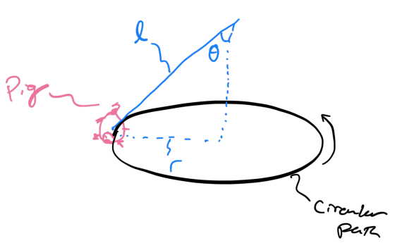

Flying pig free body diagram:

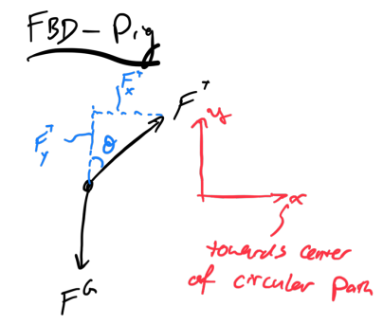

The angle the string makes with the vertical (labeled as $θ$ in the images above) is 42°.

# Procedure

These steps will walk you through the data collection and analysis. Throughout, there are questions for you to answer about the process.

**For all calculations, you need to show your work.** You can do so by embedding an image of handwritten work, or by using the equation editor in your word processor.

## Direct measurement

1. For each video, count the number of times the pig goes around a complete circle, and the amount of time it took. Record your data below:
   1. *Trial 1, number of revolutions:*
   2. *Trial 1, time:*
   3. *Trial 2, number of revolutions:*
   4. *Trial 2, time:*
2. Now, calculate the period (the time it took to make one revolution) for each trial:
   1. *Trial 1, period:*
   2. *Trial 2, period:*
   3. *How well do these two measurements agree with each other? What could cause any differences?*
3. We’ll use the average of these two to calculate the speed:
   1. *Average period:*
4. Pause the video, and use the metal yardstick to measure the radius of the pig’s circular path. The yardstick measures in inches, so you’ll need to convert this to meters
   1. *Radius in meters:*
   2. *Describe any of the difficulties in making this measurement.*
5. Finally, with the radius and average period, calculate the speed of the pig:
   1. *Pig’s speed:*

## Force analysis

Refer to the free body diagram in the Overview section of this handout.

1. The pig may bob up and down a little but, but there is virtually no motion in the vertical direction. So, we can say the $y$ component of the acceleration is zero. Using this information, apply Newton’s second law ($F=ma$) to the $y$ components of the forces and find an expression for the tension in the string $F^{T}$. Your expression will be in terms of mass $m$, the constant $g$, and the angle $θ$. *Show your work in the space below:*
2. In the $x$ direction, the pig has centripetal acceleration. Using this information, apply Newton’s second law to the $x$ components of the forces and find an expression for the tension in the string $F^{T}$. Your expression will be in terms of mass $m$, speed $v$, radius $r$, and the angle $θ$. *Show your work in the space* below:
3. You now have two different expressions for the tension in the string. Set them equal to each other and solve for the speed $v$. Your expression should be in terms of radius $r$, the constant $g$, and the angle $θ$. (Notice how the mass divides out! Neat!) *Show your work in the space below:*
4. Finally, calculate the speed:
   1. *Pig’s speed:*

# Synthesis

1. The *percent difference* between two experimentally-determined values is their difference divided by their average. Determine the percent difference between the two speeds you calculated. You may leave your result as a decimal, or multiply by 100 to represent it as a percent.
   1. *Percent difference:*
2. *How would you compare the two calculations? Would you say they are very close? Very different?*
3. *What could account for the differences?*