Fuzzy Logic versus simple Rules Based system for controlling an AI video game car

Jay Bretherton 1800231 Report for MAT301

# Introduction

## Overview

This project aims to evaluate the performance of a fuzzy logic system in solving a simple video-game-oriented problem. To achieve this, an implementation of a fuzzy logic system that was written by this author was tested against a very simple control class which implements a rules-based solution to the same problem.

The aim is to prove if a more complex fuzzy inference system out-performs a more simple rules based solution. The devised test is to drive a Kart around a lap of a track in the fastest time, while avoiding crashing.

## Techniques

The solution, naturally, implements a fuzzy logic inference system as this is the system this experiment aims to test, and it implements a very simple rules based inference system as a baseline comparison.

The fuzzy system defines fuzzy numbers as being in a combination of five states (Tutorials Point, n.d.): Large negative, Medium negative, Close to zero, Medium positive, and Large positive. It then uses these fuzzy numbers to allow the construction of logical statements that do not need precise “crisp” values in their antecedent and consequent phrases. This means logical rules can be built up without having to define exact scenarios where they would come into effect. Furthermore, it contains systems for taking in crisp input data and converting it into fuzzy numbers (fuzzifying) and taking fuzzy output numbers and turning them back into crisp numbers that can be used by the rest of the solution (de-fuzzifying). This allows the system to be integrated into the solution in exactly the same way as the rules based system.

By comparison, the rules based system that is implemented to be a comparison, is intentionally far simpler. It consists of a series of evaluations comparing the data to exact numerical values and a list of Boolean logical rules. It then evaluates those rules and returns an output for the system. An RBS was chosen as the control it has the closest mapping onto a fuzzy rules system, with the main difference being the lack of fuzzy numbers – the key characteristic of fuzzy systems.

## Description of Solution

The solution implements an example microgame developed by (Unity Technologies, 2021) in which each AI controls a kart and attempts to drive it round a course. There is a sensor class which gathers information about the current state of the kart, and a controller class for each AI system. Each controller class takes data from the sensor and formats it before it is used as the input for its AI system. It then takes the suggested output given by its AI and validates it before passing this to the class which controls the Kart.

The example includes a countdown timer, but there are several “checkpoints” throughout the course which add time on to this. For this reason, each solutions’ time performance is recoded externally. The number of wall collisions will be counted manually by the individual carrying out the test.

## Hypothesis

The hypothesis held is that the fuzzy system will outperform the rules based system in both the time-to-complete of the lap, and in the number of collisions.

# Background

## Fuzzy Logic

Fuzzy logic is built off fuzzy set theory first proposed by (Zadeh, 1965). This model attempts to emulate the way natural logic is performed by people, where strict and exact values are not used but instead they use “fuzzy” values such as “tall, large, cold, or few”. It is particularly useful whenever discussing systems where statements can have degrees of truth and the system’s state can be in more than one form at once (Cintula, 2017). Because of this, fuzzy logic can be used in very complex systems so long as each attribute of the system is expressible on a scale of large negative to large positive These are then used to build up a rules base which is used by the fuzzy logic inference engine to determine the behaviour of the system for a given input.

Fuzzy systems implement logic through fuzzy sets logic rules which are different from their Boolean counterparts. Logical “And” is represented as a Minimum function of its two arguments. Logical “Or” is represented as a Maximum function. Logical Not is gained by taking 1 – value. (Guru99, n.d.).

An idealised fuzzy logic system is outlined below.

Crisp Input

Rules

Inference Engine

Fuzzifier

De-Fuzzifier

Fuzzy Input

Fuzzy Output

Crisp Output

Figure 1

As can be seen in Figure 1 here, crisp input is passes to the Fuzzifier which produces a fuzzy input. This is then passed to the inference engine which uses the rules set and fuzzy logic to produce Fuzzy output. This is then passed to the De-Fuzzifier which produces a crisp output.

## Simple Rules Based System

Rules based systems are in many ways identical to fuzzy rules based systems, as fuzzy logic systems are a subset of rule based systems. RBS use a list of rules in much the way a fuzzy logic system would but uses crisp numbers throughout. This means that each logical statement must be made with exact values for each rule (Deep AI, n.d.).

# Methodology

## Unity Setup and Integration

### Kart Controller

The kart controller implements (Unity Technologies, 2021)’s KartGame.KartSystems.BaseInput interface which KartGame.KartSystems.ArcadeKart (the class that moves the kart) uses to gather its commands. The Kart controller can change which if the AI systems it uses at any time and switches between them in order to test both systems.

### Kart Sensor

The kart sensor class can be queried to discover the current state of the kart. It returns the Karts current speed, but also fires out raycasts forward, left, and right. The sensor returns if it hit a wall (implicitly), the distance to the wall it hit, and the surface normal of that wall. This information communicates all the AI would need to know to keep the car driving on the track and turn if there is a bend in the road coming up.

### Fuzzy Kart Control

The fuzzy kart control class is used by the kart controller when it is in the mode to test the fuzzy AI. This class is responsible for taking data from the sensor and normalising it into a form the fuzzy AI will accept as crisp input. This means taking the speed; forward, left, and right raycast distances; and the forward raycast surface normal and normalising them to a [-1, 1] scale.

The speed (which can never be negative or invalid) was mapped 0 to 0 and 10 (the max speed) to 1, with all negative values being unused.

The forward distance was mapped 0 to 0, 10 (the max length of the ray) to 1, and the state where the ray hit nothing was encoded as -1.

The same for the left and right rays as forward, except their max length is 5 so this was mapped to 1 instead.

For the surface normal, the signed angle difference between the surface normal and the negative forward of the kart was taken. As this angle cannot have a larger magnitude than 90°, this value was mapped to 1 and -90° to -1. In the event that the ray hit noting, this event was encoded as 0 as this would represent no action.

All intermediate values were linearly interpolated between the maximum, neutral and minimum.

When the fuzzy system does not have any rules at all that apply to the given inputs, it returns an (ISO, 2020) NaN representing no suggestion for the output value. In this case the fuzzy kart control ignores the output and does the safest option of not driving or turning.

## Rule based system Kart Control

The rules based system kart control class is used by the kart controller when it is in the mode to test the RBS AI. This class also takes in data from the sensor and evaluates it based on its hard coded rules.

This class implements a rules based system AI. As it exists to compare the fuzzy solution to, it was not made to be flexible or expandable, but instead implements the same rules that the fuzzy system does, but with hard coded explicit values. This allowed the entire system to be implemented very quickly. Below is an illustrative code snippet from (RBSKartController.cs, line 90). *[Some rules have been omitted for brevity]*



Figure 2

As can be seen, this system is very simple when compared to the several classes required to implement the fuzzy solution.

## Fuzzy Rules

For ease of use of the system, a unity scriptable object with a custom editor UI was developed for use when tuning the fuzzy rules.

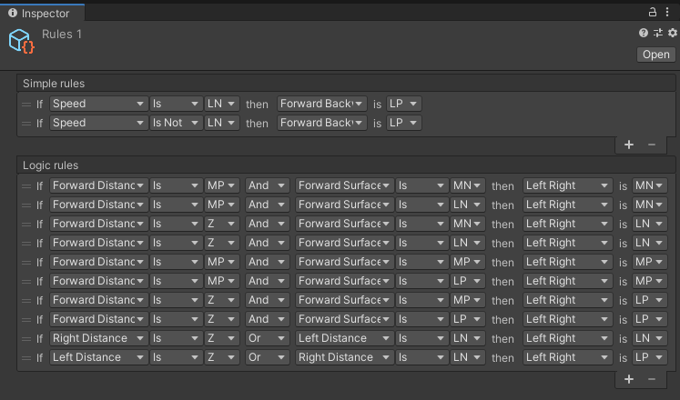

Figure 3

The simple rules consist only of antecedent and consequent whereas the logical rules represent rules that have a logical (and / or) relationship between the who antecedent statements. These statements can be made up of “is” statements or “is not” statements, where the fuzzy logical Not of the input is taken.

The values LN, MN, Z, MP, and LP represent Large Negative, Medium Negative, Close to Zero, Medium Positive, and Large Positive, respectively.

### Rules Chosen

The rules chosen are as follows

#### Forward and Backward output

Rules all:

* If speed is large negative then forward is large positive
* If speed is not large negative then forward is large positive

This has the effect of instructing the car to drive forward at all times as this encompasses the entire possibility space of the input

#### Left and Right output

Rules distant left turn:

* If forward distance is medium positive and forward surface normal is medium negative then left/right is medium negative
* If forward distance is medium positive and forward surface normal is large negative then left/right is medium negative

These cover the event that there is a left turn in the distance and result in a slight argument for turning left

Rules close left turn:

* If forward distance is small and forward surface normal is medium negative then left/right is large negative
* If forward distance is small and forward surface normal is large negative then left/right is large negative

These cover the event that there is a left turn in the kart’s immediate vicinity and result in a strong argument for turning left

Rules turn right:

* If forward distance is medium positive and forward surface normal is medium positive then left/right is medium positive
* If forward distance is medium positive and forward surface normal is large positive then left/right is medium positive
* If forward distance is small and forward surface normal is medium positive then left/right is large positive
* If forward distance is small and forward surface normal is large positive then left/right is large positive

The same as above but for the right instead

Rules right sensor:

* If right distance is small or left distance is large negative then left/right is large negative

This rule takes the state that there is a wall very close to the right or if there is no wall anywhere near the left and gives a strong argument for turning left

Rules left sensor:

* If left distance is small or right distance is large negative then left/right is large positive

Again, if there is a wall very close to the left or if there is no wall anywhere near the right then give a strong argument for turning right

### Simplified Rules

These last two rules are omitted to produce a second simplified ruleset. This is because this ruleset would require a defuzzification method that converges in order for them to produce stable output instructions, and not all defuzzification methods would do this.

## Defuzzification

Upon initial research, the most popular method for defuzzification seemed to involve finding the centroid of the area under the output graph. This method seemed overly complex, involving expressing the output data as a mathematical function curve followed by the summation of several integrals (Topperly, 2020). This was deemed too complex a solution to implement and therefore out of scope, so alternative methods were devised.

An excel spreadsheet prototype[1] was created to test different defuzzification algorithms. The devised algorithms were as follows.

#### Clamped weighted sum

This method takes the input values and multiplies them by the value of their membership category   
(-1, -0.5, 0, 0.5, 1) for (LN, ML, Z, MP, LP) respectively to get a weighted sum.

It then clamps this between [-1, 1].

#### Weighted average

This method takes a weighted sum (as described above) then takes the mean average of these values.

#### Weighted average Cutoff

This method takes a weighted average but only of the values that are above a threshold (0.5) the rest of which are ignored.

#### Exact value from biggest input

Simply take the value of the category that has the maximum input value.

#### Weighted sum by input magnitude

Weighted sum divided by Pythagorean magnitude of the input values.

#### Weighted sum by input sum

Also known as centre of mass formula for point masses (isaacphysics, n.d.). This formula takes the weighed sum of the inputs and divides them by the unweighted sum of the inputs.

### Prototype results and method chosen

Here is shown each defuzzification method plotted on the same diagram as the input, which is shown as the blue curve.

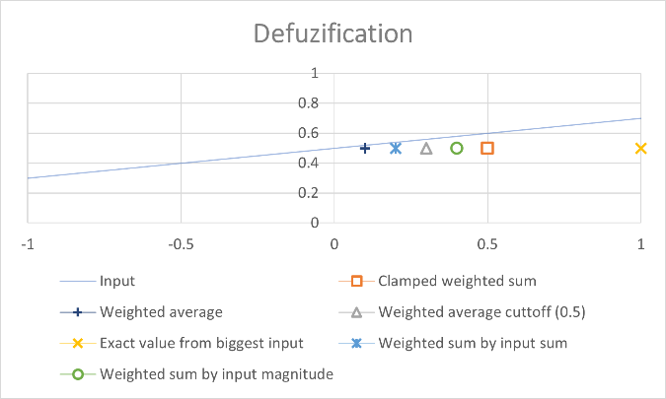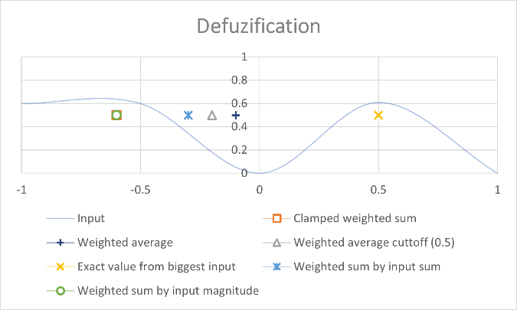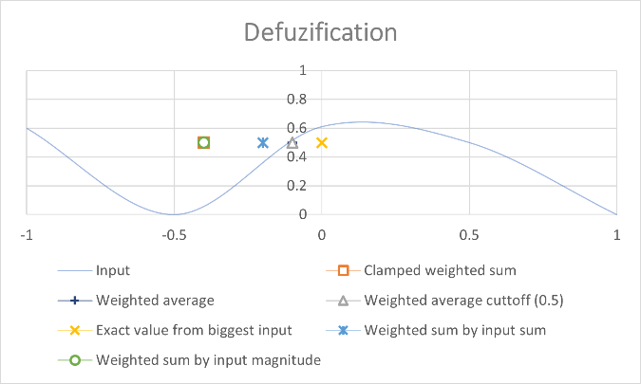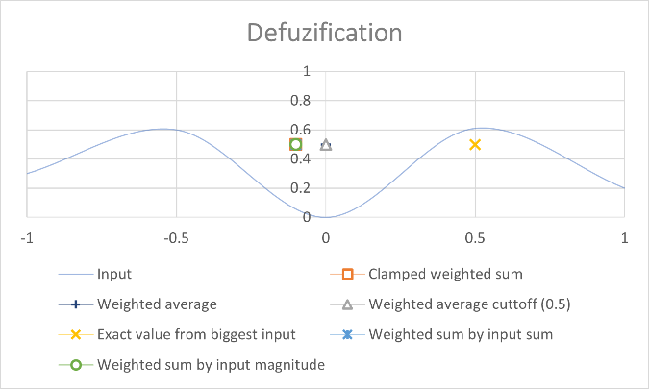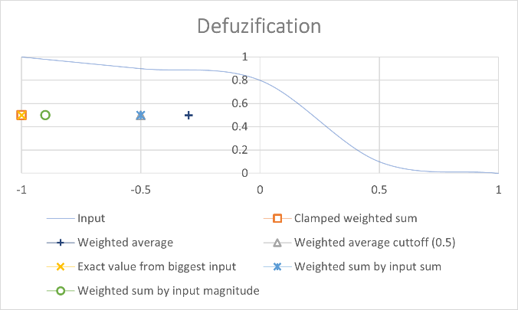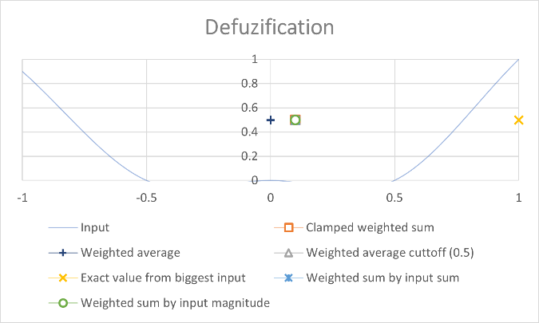

Figure 4

Based on this data it was decided that the two strongest candidates were the exact category value from maximum input “maximum” (the yellow cross) as it was guaranteed to give a value that was strongly aligned with at least some of the rules at the cost of being unstable, and the weighted sum by input sum “centre of mass” (the blue six-point star) as it gave a strong compromise between all inputs while remaining highly stable.

As both of these methods seemed viable in different ways they were both implemented and tested separately.

### Amendments

After preliminary testing it was discovered that the maximum method did not reliably complete the course, therefore the simplified rules mentioned above were given to this system and also tested.

## Fuzzy system

The fuzzy logic class contains three classes responsible for evaluating the fuzzy data. The fuzzifier, Inference engine, and the defuzzifier.

The fuzzifier takes in crisp input and uses the function curve class to fuzzify these values into the categories large negative, medium negative, near zero, medium positive, and large positive. It then returns the fuzzy input.

The inference engine takes the list of rules and applies them to each variable in the fuzzy input. It negates any “not” rules and applies any “and” / “or” rules thought the use of the Minimum and Maximum functions. It then returns this fuzzy output.

The defuzzifier finally is responsible for taking this fuzzy output and returning a crisp output through its defuzzification method, either centre of mass or maximum input.

# Results

## Experiment Overview

In addition to testing between the fuzzy and rules based systems, there was also the question of which method of defuzzification would perform the best. Therefore, four test cases were devised:

* Fuzzy system centre of mass
* Fuzzy system maximum with the same ruleset as the COM method
* Fuzzy system maximum with the simplified rules
* Rules based system

Each of these cases were set up to be tested independently. Two criteria were measured to determine the overall performance of the system. These were the time taken to complete a lap, and the number of times the kart crashed into a wall.

Timings began as the word “Go” appeared and ended as the kart crossed the finish line.

## Data

The raw data gathered as the average of three single lap trials is shown below.

|  |  |  |  |
| --- | --- | --- | --- |
| Mode | Time to complete | | Crashes |
| Fuzzy system centre of mass | | 29.80 seconds | 0 |
| Fuzzy system maximum (default rules) | | 58.32[2] seconds | 24 |
| Fuzzy system maximum (simplified rules) | | 32.25 seconds | 2 |
| Rules based system | | 30.02 seconds | 0 |

The default rules on the “maximum” defuzzification method produced highly erratic results and the cart often did not complete the course. This timing is taken from when the kart managed to complete a lap.

# Discussion

## Results Overveiw

Overall, the performance of the rules based system kept up with the fuzzy system centre off mass approach, and significantly outperformed both maximum fuzzy methods.

The centre of mass method is significantly more performant than the maximum defuzzification mode. This remained true even when simplifying the rules used for the maximum, although the difference here was less dramatic.

## Exploration of results

Quantitively, the fuzzy COM performed equally as well as the rules based solution. However, the quality of the driving was marginally better from the fuzzy COM which stayed locked in the middle of the road and tuned a lot more smoothly.

### Best performing fuzzy system vs rules based system

The smoothness of the fuzzy COM is likely due to the nature of fuzzy systems having more than one binary state. This defuzzification method is quite stable and coherent over subtle input changes so slight variations in the data from the sensors would not result in a sudden change in behaviour.

In contrast to this, the RBS has binary states and thresholds that when crossed would alter the behaviour suddenly. When the rules are well set up this can still lead to convergent behaviour, but the output will never be completely smooth in the way a fuzzy system can be.

### Defuzzification methods

The COM system did not always pick an output that had high confidence, but this ended up working to its favour as when two contradictory inputs were given it could make a compromise between them.

This was not the case with the maximum system. This system would erratically switch between extremes with no care for what the rest of the inputs looked like. This led to a highly unstable function where slight alterations to the input could drastically alter the output.

It did not become clear until running the tests that situations like shown in Figure 5 below where there is no clear correct answer, but two opposed options, that choosing the intermediate value is preferable in most situations. Despite the actual value chosen having very little confidence.

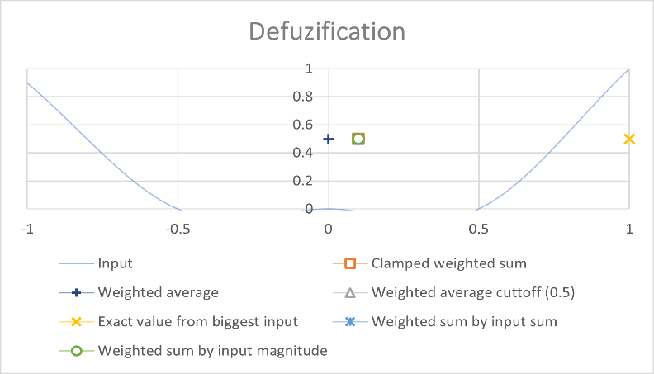

Figure 5

Simplifying the ruleset by removing the rules at conflict with each other did improve performance of the maximum mode, but still left a system incapable of nuance that appeared more stochastic than the even the rules based system.

## Critique

It is worth stating that this data was gathered from a fairly small sample and was generated by a fairly simple challenge. It is possible that it would have created more significant results created had the experiment used a more complex test. Increasing the track size, adding more obstacles, or making the AI perform more laps would have been desirable in improving the quality of the data.

# Conclusion

## Hypothesis

To restate the hypothesis of this paper: “The hypothesis held is that the fuzzy system will outperform the rules based system in both the time-to-complete of the lap, and in the number of collisions”.

It can quite definitively be said that this hypothesis has not been proven.

In fact, for one of the defuzzification methods chosen the RBS was significantly more performant.

As the best of the fuzzy system and the rules based system both completed the track with no crashes, and they both completed the lap within 0.7% of each other’s time, it is fair to conclude that their performances were equal.

## Critical Analysis

It could be argued that the RBS performing as well as the fuzzy system is due to the task being overly simple. It would follow that as it is possible to express more in fuzzy systems than classical RBSs there should in theory be a class of problems that fuzzy systems will outperform rule based systems in. A possible limitation of this experiment was its simplicity did not allow the fuzzy system to express its full capability. A response to this critique would be that while fuzzy systems allow the simpler expression of rules, they do not necessarily have a better ability to solve a problem, and a more complex challenge for the AIs would not have necessarily garnered different results.

## Closing thoughts

The fuzzy system did not outperform the rules based in the test. It was however, as a system, far more maintainable and better organised than the rules based. If these systems were to grow and become more complex, it would be significantly easier to expand the fuzzy system. Fuzzy rules provide a significantly more manageable way of expressing behaviour than classical Boolean logic. If one were to implement a large complex system using only a rules-based system it would quickly grow to an unmanageable number of variables to keep track of when comparing different states. This really is the power of fuzzy systems: even if they do not always perform strictly better than alternatives, they do allow the expression of instructions in a form which is profoundly simple, intuitive, and elegant.

# References

Cintula, P. C. G. F. a. C. N., 2017. *Fuzzy Logic.* [Online]   
Available at: https://plato.stanford.edu/archives/fall2017/entries/logic-fuzzy  
[Accessed 2021].

Deep AI, n.d. *Rule Based System.* [Online]   
Available at: https://deepai.org/machine-learning-glossary-and-terms/rule-based-system  
[Accessed 2021].

Guru99, n.d. *Fuzzy Logic Tutorial: What is, Architecture, Application, Example.* [Online]   
Available at: https://www.guru99.com/what-is-fuzzy-logic.html#:~:text=The%20term%20fuzzy%20logic%20was,from%20control%20theory%20to%20AI.  
[Accessed 2021].

isaacphysics, n.d. *Centre of Mass.* [Online]   
Available at: https://isaacphysics.org/concepts/cp_centre_mass  
[Accessed 2021].

ISO, 2020. ISO/IEC/IEEE International Standard - Floating-point arithmetic. *ISO/IEC 60559:2020(E) IEEE Std 754-2019,* pp. 1-86.

Topperly, 2020. *Solved Examples - Defuzzification Method | Fuzzy Logic.* [Online]   
Available at: https://www.youtube.com/watch?v=jhCFouPg3SA  
[Accessed 2021].

Tutorials Point, n.d. *Artificial Intelligence - Fuzzy Logic Systems.* [Online]   
Available at: https://www.tutorialspoint.com/artificial_intelligence/artificial_intelligence_fuzzy_logic_systems.htm  
[Accessed 2021].

Unity Technologies, 2021. *Karting Microgame.* [Online]   
Available at: https://assetstore.unity.com/packages/templates/karting-microgame-150956  
[Accessed 2021].

Zadeh, L., 1965. Fuzzy sets. *Information and Control,* 8(3), pp. 338-353.

1. See “Defuzzification Methods Experimentation.xlsx” included with this submission
2. Completed track times only