HAProxy Architeture Test results and pricing

- Haproxy Architecture
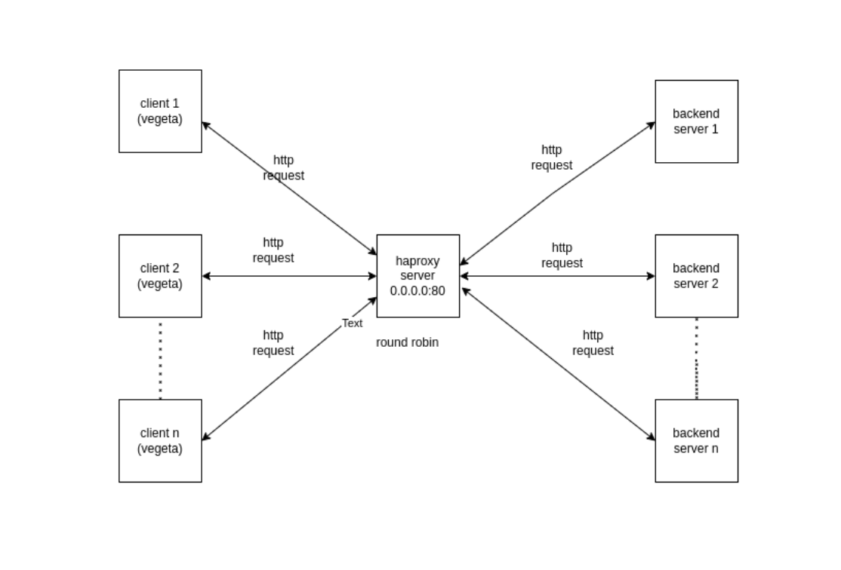

- Local setup Configuration

- Connected over Netgear switch

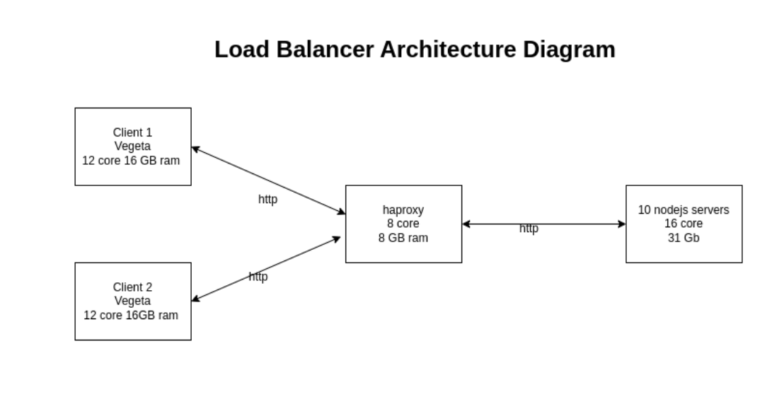

- Test Results

- 80000 request from 2 clients

*Success rate 3 in 5 times
Duration : 10m
RPS: 80000

Client No 1 192.168.2.1

echo "GET http://192.168.2.4/" | vegeta -cpus=12 attack -duration=10m -rate=40000 | vegeta report --type=text
Requests [total, rate, throughput] 23999998, 39998.97, 39978.91
Duration [total, attack, wait] 10m0s, 10m0s, 301.03ms
Latencies [min, mean, 50, 90, 95, 99, max] 259.438µs, 16.894ms, 1.505ms, 10.465ms, 210.698ms, 228.283ms, 3.355s
Bytes In [total, mean] 95999992, 4.00
Bytes Out [total, mean] 0, 0.00
Success [ratio] 100.00%
Status Codes [code:count] 200:23999998

Client No 2 192.168.2.3

echo "GET http://192.168.2.4/" | vegeta -cpus=12 attack -duration=10m -rate=40000 | vegeta report --type=text
Requests [total, rate, throughput] 23999999, 40000.01, 39983.30
Duration [total, attack, wait] 10m0s, 10m0s, 250.701ms
Latencies [min, mean, 50, 90, 95, 99, max] 247.885µs, 18.334ms, 1.519ms, 10.658ms, 212.227ms, 228.874ms, 5.001s
Bytes In [total, mean] 95999996, 4.00
Bytes Out [total, mean] 0, 0.00
Success [ratio] 100.00%
Status Codes [code:count] 200:23999999
Error Set:

- 60000 request from 2 clients

Duration : 10m
RPS: 60000

Client No 1 192.168.2.1

echo "GET http://192.168.2.4/" | vegeta -cpus=12 attack -duration=10m -rate=30000 -timeout=60s | vegeta report --type=text
Requests [total, rate, throughput] 18000180, 30000.30, 29999.99
Duration [total, attack, wait] 10m0s, 10m0s, 6.208ms
Latencies [min, mean, 50, 90, 95, 99, max] 401.315µs, 8.685ms, 6.282ms, 13.889ms, 21.438ms, 40.135ms, 1.034s
Bytes In [total, mean] 72000720, 4.00
Bytes Out [total, mean] 0, 0.00
Success [ratio] 100.00%
Status Codes [code:count] 200:18000180

Client No 2 192.168.2.3

echo "GET http://192.168.2.4/" | vegeta -cpus=12 attack -duration=10m -rate=30000 -timeout=60s | vegeta report --type=text
Requests [total, rate, throughput] 17999916, 29999.62, 29988.90
Duration [total, attack, wait] 10m0s, 10m0s, 214.545ms
Latencies [min, mean, 50, 90, 95, 99, max] 394.662µs, 8.598ms, 6.283ms, 13.418ms, 20.956ms, 40.137ms, 1.244s
Bytes In [total, mean] 71999664, 4.00
Bytes Out [total, mean] 0, 0.00
Success [ratio] 100.00%
Status Codes [code:count] 200:17999916
Error Set:

- Pricing

Local setup implementation in AWS

Instance type | Instance specification | Number of instance | Pricing per month(USD) | Total(USD)
c5a.2xlarge | 8 Core ,16Gb,  100 GB EBS volume, | 1 | 183.8
c6g.4xlarge | 16 Core, 16Gb,  100 GB EBS volume, | 3 | 872.35
 |  |  |  | 1056.15

Haproxy enterprice pricing

EC2 Instance type | Software/hr | EC2/hr | Total/hr
m4.2xlarge | $0.35 | $0.42 | $0.77

Application load balancer

For Application Load Balancers in the AWS Region:
- $0.0239 per Application Load Balancer-hour (or partial hour)
- $0.008 per LCU-hour (or partial hour
An LCU contains:
25 new connections per second.
- 3,000 active connections per minute.
- 1 GB per hour for Amazon Elastic Compute Cloud (EC2) instances, containers, and IP addresses as targets, and 0.4 GB per hour for Lambda functions as targets.
- 1,000 rule evaluations per second

Network Load Balancer

- $0.0239 per Network Load Balancer-hour (or partial hour)
- $0.006 per NLCU-hour (or partial hour)

An LCU contains:
• 800 new TCP connections per second.
• 100,000 active TCP connections (sampled per minute).
• 1 GB per hour for Amazon Elastic Compute Cloud (EC2) instances, containers, IP addresses, and Application Load Balancers as targets.

