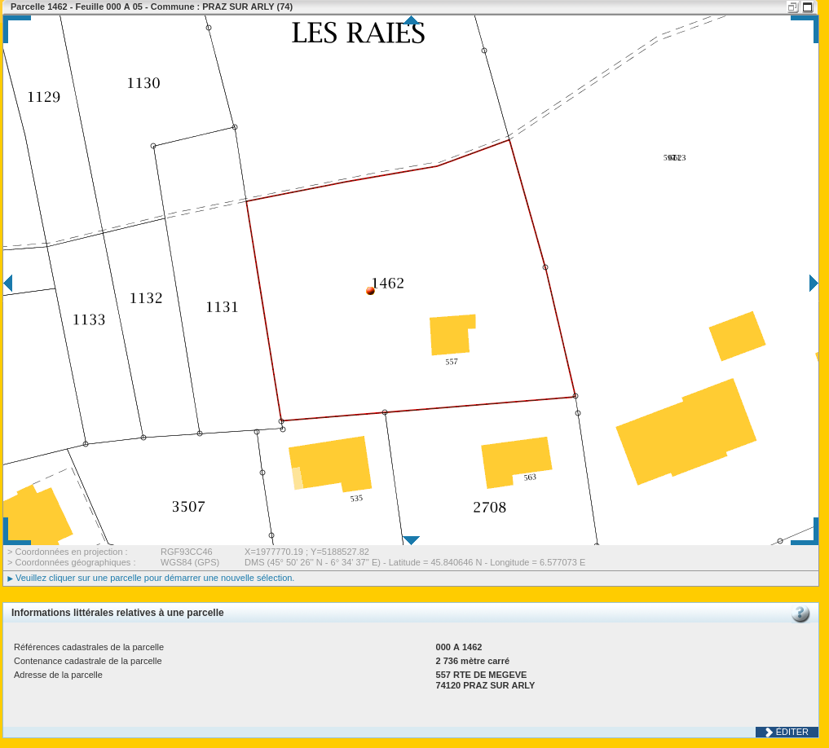

$Nom $prenon
est heureux

qsdqsdqsdqsd
qs
d
qsdqsd

aaatab1 | bbbb
Mon $cell1 | $cell2 dsgdsgdfgf

Erg | $var1 | Efjizgf
$var2 | E,fef, | Zpkgioajrg
Zeg,kozjego | Ijombniubhgui | $var3

kmlkmlkkm mlmkm

$signature

