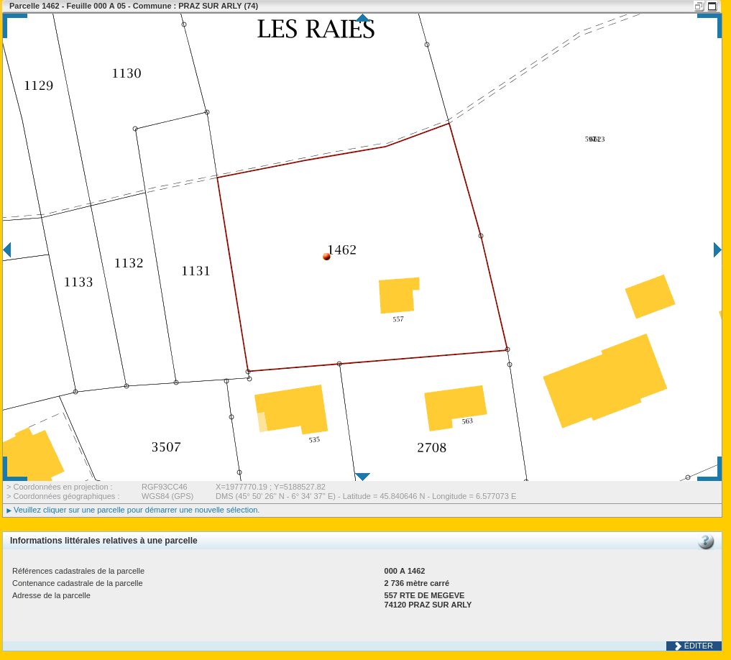

$Nom $prenon

est heureux

qsdqsdqsdqsd

qs

d

qsdqsd

|  |  |
| --- | --- |
| aaatab1 | bbbb |
| Mon $cell1 | **$cell2 dsgdsgdfgf** |

kmlkmlkkm mlmkm

$signature