Practical-1

## AIM: Usage of cables and channels in various types of networks.

Refer these links for better understanding of the same:

1. <https://www.wikihow.com/Create-an-Ethernet-Cable>
2. https://[www.cnet.com/how-to/how-to-make-your-own-ethernet-cable/](http://www.cnet.com/how-to/how-to-make-your-own-ethernet-cable/)
3. <https://www.ertyu.org/steven_nikkel/ethernetcables.html>
4. <https://www.youtube.com/watch?v=lullzS740wI&t=148s>
5. <https://www.youtube.com/watch?v=NmtMPSu--q0>
6. **Cabling:** [https://www.youtube.com/watch?v=KfhVrivvL7E&list=PLcxPetO_cDzvtZpI-](https://www.youtube.com/watch?v=KfhVrivvL7E&list=PLcxPetO_cDzvtZpI-zjKKsc1LZ7K_fDuC&index=14) [zjKKsc1LZ7K_fDuC&index=14](https://www.youtube.com/watch?v=KfhVrivvL7E&list=PLcxPetO_cDzvtZpI-zjKKsc1LZ7K_fDuC&index=14)
7. **Crossover**

**cable:** [https://www.youtube.com/watch?v=Xc4fWgNDniQ&list=PLcxPetO_cDzvtZpI-](https://www.youtube.com/watch?v=Xc4fWgNDniQ&list=PLcxPetO_cDzvtZpI-zjKKsc1LZ7K_fDuC&index=15) [zjKKsc1LZ7K_fDuC&index=15](https://www.youtube.com/watch?v=Xc4fWgNDniQ&list=PLcxPetO_cDzvtZpI-zjKKsc1LZ7K_fDuC&index=15)

1. **UTP Vs**

**STP:** [https://www.youtube.com/watch?v=4cgzuvaukVY&list=PLEWX0h0oWdl0GcSwE3Cs_U](https://www.youtube.com/watch?v=4cgzuvaukVY&list=PLEWX0h0oWdl0GcSwE3Cs_Uz-EgKVe84Fn) [z-EgKVe84Fn](https://www.youtube.com/watch?v=4cgzuvaukVY&list=PLEWX0h0oWdl0GcSwE3Cs_Uz-EgKVe84Fn)

**Submission**: After writing an answer into this word document, Student needs to change name to his ID followed by practical number. Ex 21ce005_Pr1.docx. Upload on assignment segment. Take the speed as your student ID. Ex. 21ce005, speed would be 5 Mbps.

**Rubrics**: Nicely drafted document with clarity in answers leads to full marks. Otherwise, submission carries proportional marks.

## Refer the following Transmission Modes - Modes of Communication and based on that perform the following case study and write down proper answers of it.

In **Scenario - 1,** as shown in figure 1.1, Let’s assume that a car (4-seater Inline) with the constant speed of 60Km/h issues a ticket from the Toll booth to go to its destination. Before the destination there is another Toll Booth which checks the ticket of the car. There is a 120km one way road of 120Km between the two Toll Booths. (Simplex)

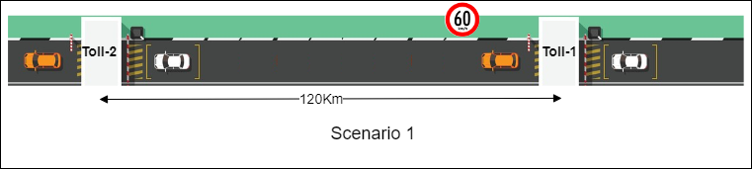

Figure 1.1 Scenario 1

Analogy with computer network

Table 1.2 Simplex Communication

|  |  |  |
| --- | --- | --- |
| **Parameters** | **Road Transport** | **Network** |
| **Distance** | Road Length 120KM | Length of Wire/Channel 120KM |
| **Direction** | **One Way**  ( Either way Both the way ) | Simplex**,** Half Duplex Full Duplex |
| **Speed** | Car speed 60 km/hr | Link Speed 2.8*108m/s (10 Mbps) |
| **Toll Booth-1** | Toll point issue tickets | Transmission Hardware (NIC Card) |
| **Toll Booth-2** | Toll point checks tickets | Receiving Hardware (NIC Card) |
| **Time to reach from Toll-1 to Toll-2** | 2 Hours | 428.6 ms |
| **Road** | Damar Road | Channel (Signal carries data) |
| **Number of Lane/Road** | **Single Lane** | **Single Channel** |
| **Injection** | Number of Passengers in Car: 4, they seat back-to- back. | Number of chunks /signals  /data |
| **number of deck on car** | **Single car** | **Without Multiplexing**\* |

*Multiplexing: combining together

In **Scenario - 2,** as shown in figure 1.2, Let’s assume that a car (4-seater Inline) with the constant speed of 60Km/h issues a ticket from the Toll booth to go to its destination. Before the destination there is another Toll Booth which checks the ticket of the car. Both the Stations are connected with a single one-way bridge. (Half Duplex)

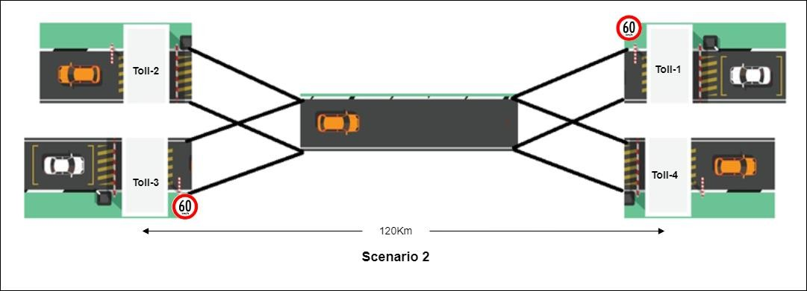

Figure 1.2 Scenario 2

## Analogy with computer network: Fill the rows

Table 1.2 Half Duplex Communication

|  |  |  |
| --- | --- | --- |
| **Parameters** | **Road Transport** | **Network** |
| **Distance** | Road Length 120km | Length of Wire/Channel  120KM |
| **Direction** | One Way | Simplex, Half Duplex |
| **Speed** | Car speed 60 km/hr | Link Speed 2.8*108m/s (10 Mbps) |
| **Toll Booth-1** | Toll point issue tickets | Transmission Hardware (NIC Card) |
| **Toll Booth-2** | Toll point checks tickets | Receiving Hardware (NIC Card) |
| **Toll Booth-3** | Toll point issue tickets | Transmission Hardware (NIC Card) |
| **Toll Booth-4** | Toll point checks tickets | Receiving Hardware (NIC Card) |
| **Time to reach from Toll-1 to Toll-2** | 2 Hours | 428.6 ms |
| **Time to reach from Toll-3 to Toll-4** | 2 Hours | 428.6 ms |
| **Road** | Damar Road | Channel (Signal carries data) |

|  |  |  |
| --- | --- | --- |
| **Width of Lane/Road** | 3.7 m | - |
| **Number of Lane/Road** | Single Lane | Single Channel |
| **Injection** | Number of Passengers in Car:4, they seat back-to- back. | Number of chunks /signals  /data |
| **Number of deck on car** | Single Car | - |

In **Scenario - 3,** as shown in figure 1.3, Let’s assume that a car (4 seater Inline) with the constant speed of 60Km/h issuing a ticket from the Toll booth to go to its destination. Before the destination there is another Toll Booth which checks the ticket of the car. There is a two way road of 120Km between the two Toll Booths. One road to go from toll-1 to toll-2 and second is to go from toll-3 to toll-4. (Full duplex)

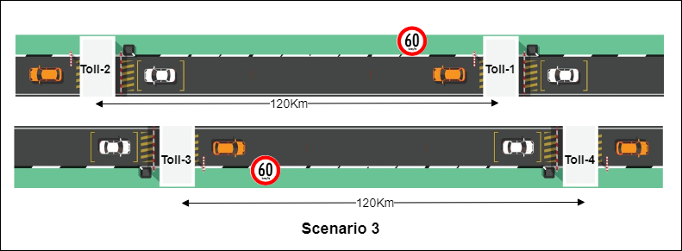

Figure 1.3 Scenario 3

## Analogy with computer network: Fill the rows

Table 1.3 Full Duplex Communication

|  |  |  |
| --- | --- | --- |
| **Parameters** | **Road Transport** | **Network** |
| **Distance** | Road Length 120km | Length of Wire/Channel 120KM |
| **Direction** | Both the Way | Full Duplex |
| **Speed** | Car speed 60 km/hr | Link Speed 2.8*108m/s (10 Mbps) |

|  |  |  |
| --- | --- | --- |
| **Toll Booth-1** | Toll point issue tickets | Transmission Hardware (NIC Card) |
| **Toll Booth-2** | Toll point checks tickets | Receiving Hardware (NIC Card) |
| **Toll Booth-3** | Toll point issue tickets | Transmission Hardware (NIC Card) |
| **Toll Booth-4** | Toll point checks tickets | Receiving Hardware (NIC Card) |
| **Time to reach from Toll-1 to Toll-2** | 2 Hours | 428.6 ms |
| **Time to reach from Toll-3 to Toll-4** | 2 Hours | 428.6 ms |
| **Road** | Damar Road | Channel (Signal carries data) |
| **Width of Lane/Road** | 7.5 m | - |
| **Number of Lane/Road** | Multiple Lane | Multiple Channel |
| **Injection** | Number of Passengers in Car:4, they seat back-to- back. | Number of chunks /signals  /data |
| **Number of deck on car** | Single Car | - |

## Simplex:

* Simplex channel operation
* one way only
* one person talks and other listens

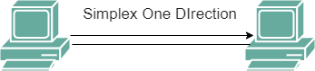

## Half Duplex:

* Two-way communication
* Two people can talk but one at a time

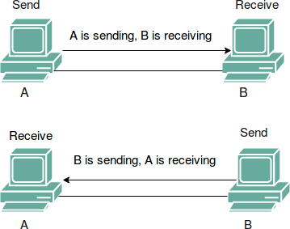

## Full Duplex:

* Both ways of communication.
* Two people can talk simultaneously.

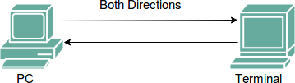

**Exercise:** Calculate the cost of the Network 100 metre network of 2 Machines. Also write a list of equipment required for each type and medium of network.

Table 1.4 Exercise

|  |  |  |  |
| --- | --- | --- | --- |
|  | **Wired** | **Wireless** | **Fiber Optic Cable** |
| **Simplex** | Requires a | Requires a | Requires an optical |
|  | transmitter and a | transmitter and a | transmitter and an |
|  | receiver. Examples | receiver. Examples | optical receiver. |
|  | include one-way | include one-way |  |
|  | cable TV | radio broadcast. |  |
|  | transmission. |  |  |
| **Half Duplex** | Requires devices | Requires devices | Requires devices |
|  | capable of | capable of switching | capable of alternating |
|  | alternating between | between | between transmitting |
|  | transmitting and | transmitting and | and receiving optical |
|  | receiving, such as | receiving, such as | signals, such as |
|  | network interface | wireless routers, | transceivers and optical |
|  | cards (NICs) | access points, and | fiber cables. |
|  | supporting half- | wireless network |  |
|  | duplex mode, and | cards. |  |
|  | network cables. |  |  |
| **Full Duplex** | Requires devices | Requires devices | Requires devices |
|  | capable of | and protocols that | capable of |
|  | simultaneous | support | simultaneous |
|  | bidirectional | simultaneous | bidirectional |
|  | communication, such | bidirectional | communication over |
|  | as NICs supporting | communication, | optical fiber, such as |
|  | full-duplex mode, | such as Wi-Fi 6 | full-duplex transceivers |
|  | and network cables. | (802.11ax) or newer | and optical fiber cables. |
|  |  | standards. |  |

**Cost Calculation:** The cost of the network will vary depending on the specific equipment chosen, brand preferences, and installation requirements. Here are some general cost estimates for the equipment:

## Equipment Cost:

* + Wired: Cost of NICs, network cables, and any additional networking hardware (e.g., switches or hubs).
  + Wireless: Cost of wireless routers, access points, wireless network cards, and any additional hardware (e.g., antennas or repeaters).
  + Optical Fiber: Cost of optical transceivers, optical fiber cables, and any additional equipment (e.g., media converters or switches with fiber ports).

## Installation Cost:

* + Wiring and Cable Installation: Cost of labor for cable installation, termination, and testing.
  + Wireless Network Setup: Cost of configuring wireless routers, access points, and security settings.
  + Optical Fiber Installation: Cost of fiber optic cable installation, splicing, and termination.

In **Scenario - 4,** Let’s assume that a car (4-seater Inline) with the constant speed of 60Km/h issues a ticket from the Toll booth to go to its destination. Before the destination there is another Toll Booth which checks the ticket of the car. There are two lane roads to go from Toll-1 to Toll-2 and Toll-3 to Toll-4. By Two roads the capacity of the road increases the number of cars which can travel through. (Full Duplex with Improved bandwidth)

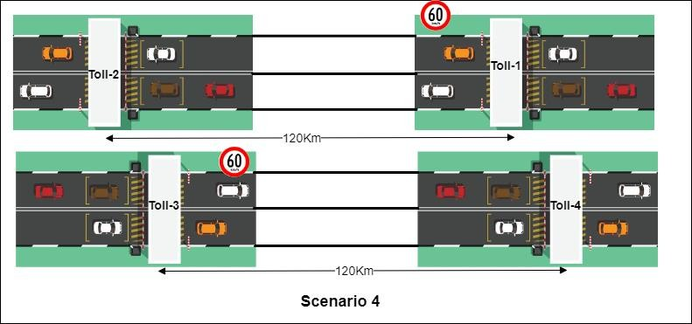

Figure 1.4 Scenario 4

## Analogy with computer network

Table 1.5 Full Duplex with Improved bandwidth Communication

|  |  |  |
| --- | --- | --- |
| **Parameters** | **Road Transport** | **Network** |
| **Distance** | Road Length 120km | Length of Wire/Channel 120KM |
| **Direction** | Two Way | **Full Duplex**  with Improved bandwidth |
| **Speed** | Car speed 60 km/hr | Link Speed 2.8*108m/s (10 Mbps) |
| **Toll Booth-1** | Toll point issue tickets | Transmission Hardware (NIC Card) |
| **Toll Booth-2** | Toll point checks tickets | Receiving Hardware (NIC Card) |
| **Toll Booth-3** | Toll point issue tickets | Transmission Hardware (NIC Card) |

|  |  |  |
| --- | --- | --- |
| **Toll Booth-4** | Toll point checks tickets | Receiving Hardware (NIC Card) |
| **Time to reach from Toll-1 to Toll-2** | 2 Hours | 428.6 ms |
| **Time to reach from Toll-3 to Toll-4** | 2 Hours | 428.6 ms |
| **Road** | Damar Road | Channel (Signal carries data) |
| **Width of Lane/Road** | 15m | - |
| **Number of Lane/Road** | Multiple Lane | Multiple Channel |
| **Injection** | Number of Passengers in Car:4, they seat back-to- back. | Number of chunks /signals  /data |
| **Number of deck on car** | **Single car** | With multiplexing |

In **Scenario -5**, Let’s assume that a Double Decker car (4-seater Inline, 2 floors) with the constant speed of 60Km/h issuing a ticket from Toll booth to go to its destination. Before the destination there is another Toll Booth which checks the ticket of the car. Both the Stations are connected with a single one-way bridge. Only one double decker car can go through. **(Multiplexing)**

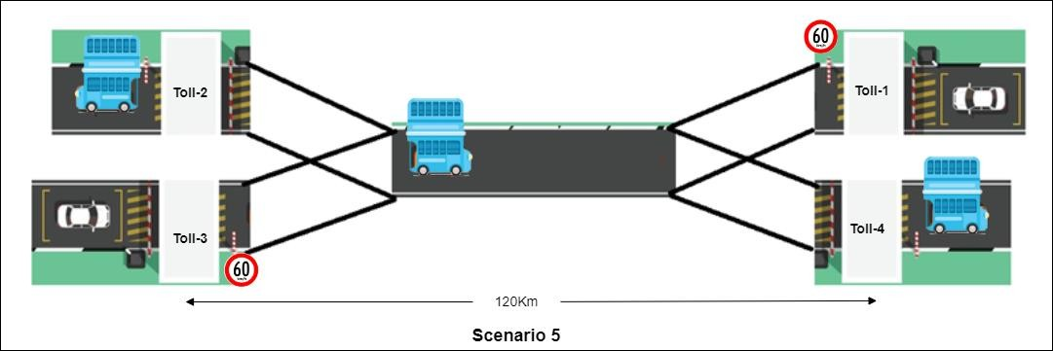

Figure 1.5 Scenario 5 Analogy with computer network: Fill the rows

Table 1.6 Multiplex Communication

|  |  |  |
| --- | --- | --- |
| **Parameters** | **Road Transport** | **Network** |
| **Distance** | Road Length 120km | Length of Wire/Channel 120KM |
| **Direction** | One Way | Half Duplex |
| **Speed** | Car speed 60 km/hr | Link Speed 2.8*108m/s (10 Mbps) |
| **Toll Booth-1** | Toll point issue tickets | Transmission Hardware (NIC Card) |
| **Toll Booth-2** | Toll point checks tickets | Receiving Hardware (NIC Card) |
| **Toll Booth-3** | Toll point issue tickets | Transmission Hardware (NIC Card) |
| **Toll Booth-4** | Toll point checks tickets | Receiving Hardware (NIC Card) |
| **Time to reach from Toll-1 to Toll-2** | 2 Hours | 428.6 ms |
| **Time to reach from Toll-3 to Toll-4** | 2 Hours | 428.6 ms |
| **Road** | Damar Road | Channel (Signal carries data) |
| **Width of Lane/Road** | 3.75m |  |
| **Number of Lane/Road** | **Single Lane** | **Single Channel** |
| **Injection** | Number of Passengers in Car: 4, 2 floors | Number of chunks /signals  /data |
| **Number of deck on car** | **Double Decker car** | **With Multiplexing** |

**Scenario 6,** as shown in figure 1.6, Let’s say we want to travel from Ahmedabad to Surat. In this first we go through Express Highway till Vadodara after that we route for National Highway. Ahmedabad to Vadodara takes less time as cars can speed up to 100Km/h. Vadodara to Surat takes much time as cars can speed only up to 60Km/h. (Data Rate Changes with respect to link speed)

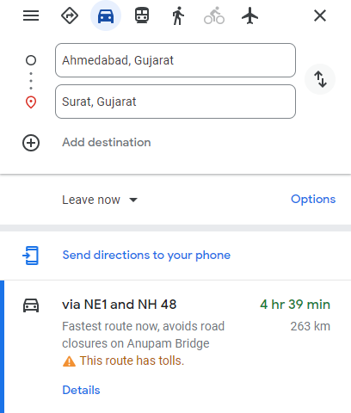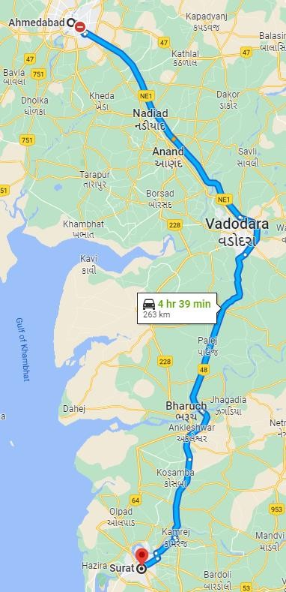

Figure 1.6 Different speed on different type of road

## Write conclusion with respect to computer networks:

Ans:

The scenario you've described with the travel from Ahmedabad to Surat using both an Express Highway and a National Highway can be metaphorically related to computer networks in terms of data transfer rates and network performance. Let's draw some conclusions based on this analogy:

1. Express Highway as High-Speed Link:
   * The portion of the journey from Ahmedabad to Vadodara on the Express Highway, where cars can speed up to 100 km/h, can be equated to a high- speed link in a computer network.
   * In computer networks, high-speed links or connections with greater bandwidth allow for faster data transfer rates. This could be analogous to a network segment with high data rate capabilities, such as a fiber-optic connection or a high-speed wired network.
2. National Highway as Low-Speed Link:
   * The segment from Vadodara to Surat on the National Highway, where cars can only travel at 60 km/h, represents a slower link in the journey.
   * In computer networks, this could be analogous to a network segment with a lower data transfer rate, such as a connection with limited bandwidth or slower wireless connectivity.
3. Data Rate Changes and Link Speed:
   * The scenario highlights a change in data rate as the journey progresses, transitioning from a high-speed link to a lower-speed link.
   * In computer networks, data rate changes can occur between different segments of a network. For instance, within a network, data might move at different speeds depending on the type of connection, the technology used, or the network infrastructure.

## Types of Delay:

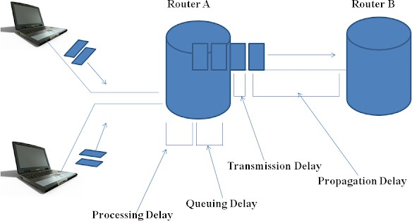

Figure 1.9 Scenario 5

In Scenario -1**,** different cars coming from each direction have to wait for the signal to cross the road as the road is busy because other cars are crossing through the same cross road.

**Exercise:** Write down transmission delay, queueing delay of computer network with respect to following cross road analogy.

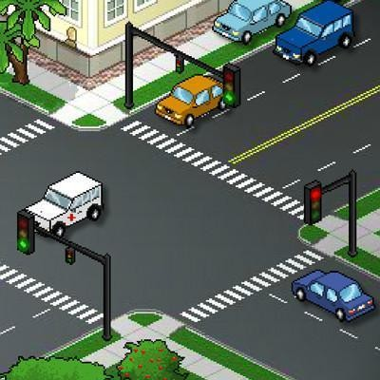

Figure 1.8 Scenario 5

In the crossroad analogy, transmission delay is represented by the time it takes for a car to cross the road after the signal changes, and queueing delay is illustrated by the time cars spend waiting in a queue before being allowed to proceed. These analogies help to visualize and understand the concepts of transmission delay and queueing delay in the context of computer networks.

## Propagation Delay:

* + Propagation delay is the time it takes for a signal to travel from the source to the destination. It is influenced by the physical distance between the sender and receiver and the speed of the medium (such as copper wire, fiber-optic cable, or wireless).

## Transmission Delay:

* + Transmission delay is the time it takes to push all the bits of a packet onto the network medium. It depends on the size of the data packet and the data rate

of the link. The formula for transmission delay is given by

Transmission Delay=Packet SizeLink BandwidthTransmission Delay=Link Band widthPacket Size.

## Processing Delay:

* + Processing delay is the time it takes for a router or a host to process the incoming data. This includes tasks such as packet header processing, error checking, and making routing decisions.

## Queueing Delay:

* + Queueing delay occurs when a packet has to wait in a queue before it can be transmitted. This delay is influenced by the congestion level of the network and the queuing algorithms in use.

# Case Study:

## Refer to the following diagram and identify which mode of communication happens.

1. Refer to the following two scenarios and identify which type of communication is done. **Scenario 1:** Can different radio stations work at the same time using the same frequency. Ans:

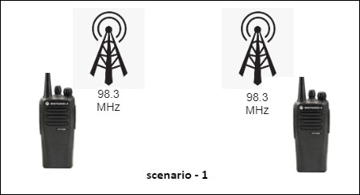

Figure 1.10 Scenario 5

**Scenario 2:** Can different radio stations work at the same time using different frequencies.

Ans: Yes, different radio stations can work at the same time using different frequencies, and this concept is based on Frequency Division Multiplexing (FDM). FDM is a multiplexing

technique that allows multiple signals to share the same communication channel without interfering with each other by assigning distinct frequency bands to each signal.

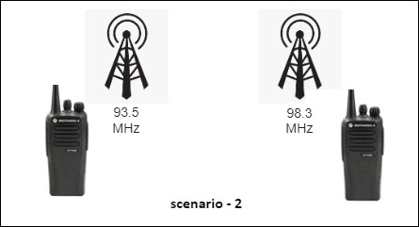

Figure 1.11 Scenario 5

1. Refer to the following diagram and identify which type of communication is done.

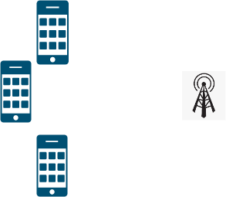

Figure 1.12 Scenario 5

## Ans: Metropolitan Area Network (MAN)

1. Refer to the following diagram and identify which type of communication is done.



Figure 1.13 Scenario 5 Ans: **Metropolitan Area Network (MAN)**

1. Refer to the following diagram, figure 1.14, and identify which type of communication is done.

Different radio stations in different cities and they are communicating to each other so which type of communication is happen between this radio stations.

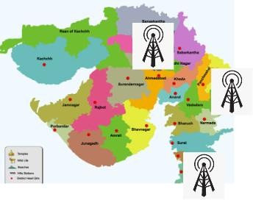

Figure 1.14 Scenario 5

## Ans: Wide Area Network (WAN)

1. Refer to the following diagram and identify which type of communication is done.



Figure 1.15 Scenario 5

## Ans: Personal Area Network (PAN)

1. Refer to the following diagram and identify which type of communication is done.



Figure 1.16 Scenario 5

## Ans: Wide Area Network (WAN)

**Study the different types of Cables in Networking and based on that perform the following case study.**

## Refer to the following link. https://fcit.usf.edu/network/chap4/chap4.htm

When it comes to connecting the networks, we can connect them in two different ways

* 1. Wired Connection
  2. Wireless connection

## Different types of Networking Cables:

1. Unshielded Twisted Pair (UTP) Cable
2. Shielded Twisted Pair (STP) Cable
3. Coaxial Cable
4. Fiber Optic Cable
5. Cable Installation Guides
6. Wireless LANs
7. Unshielded Twisted Pair (UTP) Cable

# Case Study:

1. Refer to the following Linear Bus Topology and make the connection using appropriate cables.

Link: https://fcit.usf.edu/network/chap5/chap5.htm

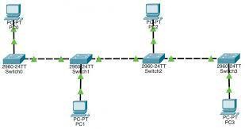

Figure 1.17 Scenario 5

1. 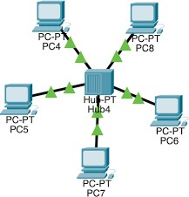Refer to the following Star Topology and make the connection using appropriate cables.

Figure 1.18 Scenario 5

1. Refer to the following Tree Topology and make the connection using appropriate cables.

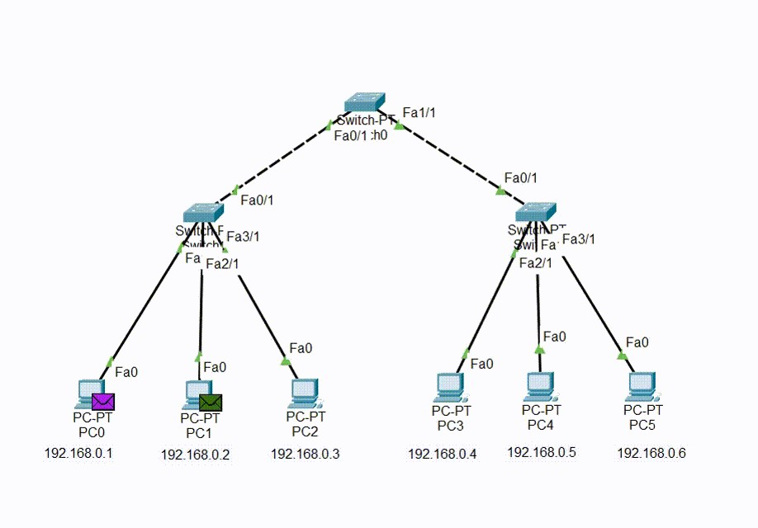

Figure 1.19 Scenario 5

Refer to the following Network Diagram - Typical Simple Home Network

## https://fcit.usf.edu/network/chap4/chap4.htm

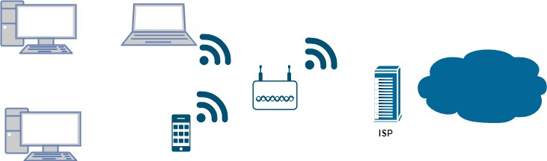

Figure 1.20 Scenario 5

## Refer to the following images and based on that let’s understand the concept of

**Multiplexing and Demultiplexing.**

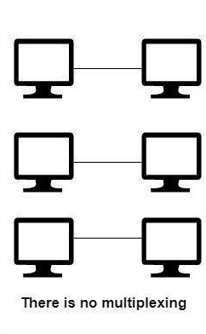

Figure 1.21 Scenario 5

In above point to point topology, all the nodes can send and receive data but with their own channels. so required three own channels.

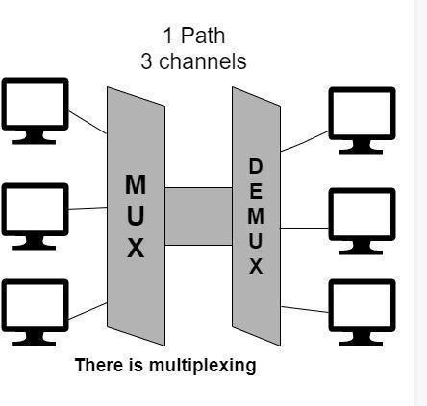

Figure 1.22 Scenario 5

In the above diagram, With the help of multiplexing, more than one signal can be sent easily over a single medium or link. Multiplexing helps in the effective utilization of the bandwidth of the medium.

**Questions**

Students are advised to give answers to following questions after going through in-depth study of all above references:

1. What is the significance of Braided Shield in Shielded Twisted Pair (STP) cable?

Answer: the significance of the braided shield in Shielded Twisted Pair (STP) cables includes:

* 1. Protection against electromagnetic interference (EMI) and radio frequency interference (RFI).
  2. Grounding to dissipate induced electrical charges.
  3. Mechanical protection for internal components.
  4. Flexibility for versatile installation and usage.

1. List down various network cables in markets other than UTP and STP.

Answer: Various types of network cables available in the market other than UTP and STP:

* 1. Coaxial Cable (Coax)
  2. Fiber Optic Cable
  3. Twisted Pair Cable Categories (e.g., Cat6a, Cat7)
  4. Power over Ethernet (PoE) Cable
  5. Plenum Cable
  6. Direct Burial Cable
  7. Ethernet Crossover Cable

1. Where UTP and STP cables are used? Answer:
2. UTP (Unshielded Twisted Pair) Cables:
   * Used extensively in Ethernet networks, including LAN (Local Area Network) environments such as offices, homes, and schools.
   * Commonly employed for telephone lines, broadband internet connections, and home networking applications.
   * Preferred choice for short to medium distance data transmissions due to its cost- effectiveness and ease of installation.
3. STP (Shielded Twisted Pair) Cables:
   * Employed in environments with higher levels of electromagnetic interference (EMI), such as industrial settings, manufacturing plants, and areas with electrical machinery.
   * Utilized in environments where data integrity and reliability are critical, such as data centers, server rooms, and high-security installations.
   * Offers superior protection against EMI and RFI (Radio Frequency Interference), making it suitable for applications where signal integrity is paramount.
4. List down the four parameters, on which the UTP cables are categorised.

Answer: Unshielded Twisted Pair (UTP) cables are categorized based on the following four parameters:

* 1. **Category (Cat):**
     + Indicates the performance specifications of the cable, including data transmission speed and bandwidth capacity. Common categories include Cat5e, Cat6, Cat6a, and Cat7.
  2. **Bandwidth:**
     + Refers to the maximum frequency range over which the cable can transmit data. Higher bandwidth cables support faster data transmission rates and can handle larger amounts of data.
  3. **Frequency:**
     + Specifies the frequency range over which the cable is tested for performance. Higher frequencies correspond to higher data transmission speeds.
  4. **Twists per Inch (TPI):**
     + Indicates the number of twists in the cable's twisted pairs per inch of cable length. A higher TPI value typically results in better noise immunity and signal quality.
  5. What is the difference in pin architecture of Cross-over cable and straight through cable? Answer: the main difference in pin architecture between a crossover cable and a straight-through cable is the arrangement of wires at the connectors:

1. **Straight-Through Cable:**
   * Both ends of the cable have the same pin configuration, meaning that the wires are connected straight through from one end to the other.
   * In Ethernet cables, the pinouts are typically aligned such that the transmit (TX) pins on one end connect to the receive (RX) pins on the other end.
2. **Crossover Cable:**
   * The pin configuration at one end of the cable is reversed compared to the other end.
   * In Ethernet cables, this means that the transmit (TX) pins on one end connect to the transmit (TX) pins on the other end, and the receive (RX) pins connect to the receive (RX) pins. This configuration allows for direct communication between similar devices without the need for a network switch or hub.
   1. Why is twisted pair used in network cable?

Answer: twisted pair cables are used in network cables because:

1. **Reduced Electromagnetic Interference (EMI):**
   * Twisting the pairs of wires helps cancel out electromagnetic interference (EMI) from external sources, such as power lines or electronic devices, resulting in clearer transmission signals.
2. **Minimized Crosstalk:**
   * Twisting the pairs also reduces crosstalk, which is interference caused by adjacent wire pairs in the cable. This ensures that data signals remain distinct and do not interfere with each other.
3. **Cost-Effectiveness:**
   * Twisted pair cables are relatively inexpensive to manufacture, making them a cost- effective choice for networking applications.
4. **Versatility:**
   * Twisted pair cables can support various data transmission speeds and are suitable for both short and long-distance connections, making them versatile for different network environments.
   1. Why do we require two wires for signal transmission in cable and one wire in optic transmission in fibre optic?

Answer: the difference in the number of wires required for signal transmission between cable (such as twisted pair) and fiber optic transmission is due to the nature of the mediums:

1. **Cable (Twisted Pair):**
   * In cable transmission, such as twisted pair cables, two wires are used for signal transmission because electrical signals require a complete circuit to flow. One wire carries the signal (transmit), and the other acts as a reference (ground or return path), completing the circuit.
2. **Fiber Optic Transmission:**
   * In fiber optic transmission, only one wire (fiber optic strand) is needed because data is transmitted using light signals instead of electrical signals. The light travels through the core of the fiber optic strand, and there is no need for a return path as in electrical transmission. Therefore, only one strand is required for bidirectional communication, allowing for simpler and more efficient transmission.
   1. Write down in 2nd column (which cable to use) below:

|  |  |
| --- | --- |
| **Connection Scenario** | **Cable Type**  **(Cross Over or straight Through)** |
| Computer to Computer | crossover Ethernet cable |
| Cable modem to Router | straight-through Ethernet cable |
| Computer to Cable modem | straight-through Ethernet cable |
| Computer to Switch | straight-through Ethernet cable |
| Computer to Hub | straight-through Ethernet cable |

* 1. What is the full form of RJ-45? Answer: Registered Jack-45
  2. List down various RJ connectors with their usage.

Answer: Here's a list of various RJ connectors with their common usage:

1. **RJ-11:**

* + - Commonly used for telephone and analog modem connections. 2. **RJ-45:**
    - Used for Ethernet networking connections, including Cat5e, Cat6, and Cat6a cables.

3. **RJ-12:**

* + - Similar to RJ-11 but with additional pins. Used for telephone and some data communications.

4. **RJ-48:**

* + - Used for T1 and ISDN connections, often found in telecom and networking equipment.

5. **RJ-14:**

* + - A combination of RJ-11 and RJ-12, typically used for two-line telephone connections.
  1. What signal is used for wireline, wireless and fibre communication? Give example how data is transmitted in simplex, half-duplex and full duplex communication with respect to above cables.

Answer: In wireline, wireless, and fiber communication, different signals are used for data transmission:

## Wireline Communication:

* + Signal: Electrical signals are commonly used for wireline communication.
  + Example: Ethernet cables (UTP or STP) use electrical signals for data transmission.

## Wireless Communication:

* + Signal: Electromagnetic waves, such as radio frequencies or microwaves, are used for wireless communication.
  + Example: Wi-Fi routers transmit data using radio frequency signals.

## Fiber Communication:

* + Signal: Light signals (optical signals) are used for fiber communication.
  + Example: Fiber optic cables transmit data using light signals through the fiber optic strands.

Now, let's look at how data is transmitted in simplex, half-duplex, and full-duplex communication with respect to the above cables:

## Simplex Communication:

* + Simplex communication involves one-way data transmission.
  + Example: In a simplex communication scenario, data flows only in one direction. For instance, a sensor sending data to a central monitoring system over a fiber optic cable in a one-way manner.

## Half-Duplex Communication:

* + Half-duplex communication allows data transmission in both directions, but not simultaneously.
  + Example: In a half-duplex communication scenario, devices take turns sending and receiving data. For example, two-way radio communication or walkie- talkies operate in half-duplex mode.

## Full-Duplex Communication:

* + Full-duplex communication enables simultaneous two-way data transmission.
  + Example: In a full-duplex communication scenario, data can be transmitted and received simultaneously. For instance, Ethernet connections using twisted pair cables (UTP/STP) or fiber optic cables support full-duplex communication, allowing devices to transmit and receive data at the same time, enhancing communication efficiency.
  1. What are tools used to make network cable with CAT-6 cable? Also write its usage. Answer: Tools used to make network cables with CAT-6 cable include:

## Cable Crimper:

* + Usage: Used to attach RJ-45 connectors to the ends of CAT-6 cables.

## Cable Tester:

* + Usage: Used to verify the integrity and functionality of the completed CAT-6 cable connections.

These tools are essential for properly terminating CAT-6 cables and ensuring reliable network connections.

* 1. Mention the companies who are making the cables. Answer:
  2. What is delay and loss in the network? Answer:

## Delay (Latency):

* + Time taken for data to travel from source to destination.
  + Types include transmission, propagation, processing, and queuing delays.
  + High delays can slow down network performance and response times.

## Loss (Packet Loss):

* + Occurs when packets fail to reach their destination.
  + Reasons include congestion and transmission errors.
  + Can degrade network quality, leading to retransmissions and performance issues.
  1. How long does a 10Mbps channel take to transmit 1 bit ?

To calculate the time taken to transmit 1 bit on a 10 Mbps channel, you can use the formula:

Time=1/Data Rate where:

* Time is the time taken to transmit 1 bit,
* Data Rate is the channel's speed in bits per second (bps). Using this formula:

Time=1/10 Mbps=110×106 bits/secondTime=10 Mbps1=10×106 bits/second1

Time=1×10−7 secondsTime=1×10−7 seconds

So, it takes 1×10−71×10−7 seconds to transmit 1 bit on a 10 Mbps channel.

* 1. Mention the companies who are making the following specific cables.

|  |  |
| --- | --- |
| **Name of the Cables** | **Companies who are making the cables.** |
| Unshielded Twisted Pair (UTP) Cable | CommScope , Belden ,Panduit ,Siemon  , Nexans |
| Shielded Twisted Pair (STP) Cable | CommScope, Belden , Panduit , Siemon  ,Nexans |
| Coaxial Cable | CommScope, Belden ,Times Microwave Systems , Amphenol ,L-com |
| Fiber Optic Cable | Corning Incorporated ,Prysmian Group  ,CommScope ,OFS (Furukawa Electric)  ,AFL Telecommunications |

## Gate Question:

1. **Calculate the number of cables used for 4 Nodes in mesh topology ?**

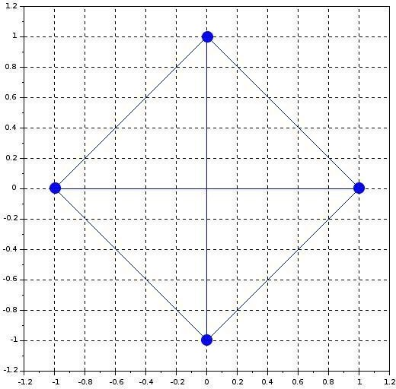

Ans : 6

## Calculate the number of cables used for 16 Nodes in mesh topology ?

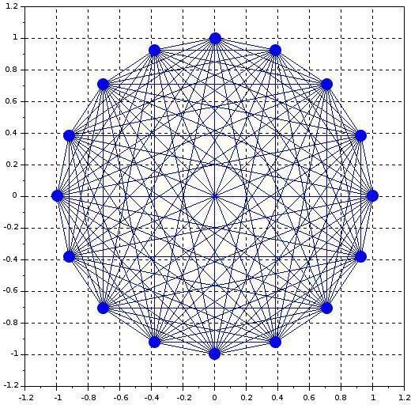

Ans: 120

## In a fully-connected mesh network with 10 computers, a total number of

**cables are required and number of ports are required for each device.**

## [UGC-NET | UGC NET CS 2016 July]

A) 40,9

B) 45,10

C) 45,9

D) 50,10

## Determine the maximum length of the cable (in km) for transmitting data at a rate of 500 Mbps in an Ethernet LAN with frames of size 10,000 bits. Assume the signal speed in the cable to be 2,00,000 km/s. [GATE | GATE CS 2013]

* 1. 1
  2. 2 C) 2.5

D) 5

## Consider a source computer transmitting a file of size 106 bits to a destination computer (D) over a network of two routers (R1 and R2) and three links (L1, L2 and L3). L1 connects to S to R1; L2 connects to R1 to R2; and L3 connects to R2 to D. Let each link be of length 100 km. Assume signals travel over each link at a speed of 108 meters per second. Assume that the link bandwidth on each link is 1Mbps. Let the file be broken down into 1000 packets each of size 1000 bits. Find the total sum of transmission and propagation delays in transmitting the file from S to D?

1) 1005 ms

2) 1010 ms

3) 3000 ms

4) 3003 ms

## Let us consider a statistical time division multiplexing of packets. The number of sources is 10. In a time unit, a source transmits a packet of 1000 bits. The number of sources sending data for the first 20 time units is 6, 9, 3, 7, 2, 2, 2, 3, 4, 6, 1, 10, 7, 5, 8, 3, 6, 2, 9, 5 respectively. The output capacity of multiplexer is 5000 bits per time unit. Then the average number of backlogged of packets per time unit during the given period is

* 1. 5

B) 4.45

C) 3.45

D) 0

## A broadcast channel has 10 nodes and total capacity of 10 Mbps. It uses polling for medium access. Once a node finishes transmission, there is a polling delay of 80 μs to poll the next node. Whenever a node is polled, it is allowed to transmit a maximum of 1000 bytes. The maximum throughput of the broadcast channel is:

* 1. 1 Mbps
  2. 100/11 Mbps
  3. 10 Mbps
  4. 100 Mbps

## Consider a CSMA/CD network that transmits data at a rate of 100 Mbps (108 bits per second) over a 1 km (kilometre) cable with no repeaters. If the minimum frame size required for this network is 1250 bytes, What is the signal speed (km/sec) in the cable?

1) 8000

2) 10000

3) 16000

4) 20000

## A network has a data transmission bandwidth of 20 × 106 bits per second. It uses CSMA/CD in the MAC layer. The maximum signal propagation time from one node to another node is 40 microseconds. The minimum size of a frame in the network is 3200 bytes.

1. **Which of the following statements is TRUE about CSMA/CD:**
   1. IEEE 802.11 wireless LAN runs CSMA/CD protocol
   2. Ethernet is not based on CSMA/CD protocol
   3. CSMA/CD is not suitable for a high propagation delay network like satellite network

## A network with CSMA/CD protocol in the MAC layer is running at 1Gbps over a 1km cable with no repeaters. The signal speed in the cable is 2 × 108m/sec . The minimum frame size for this network should be:

* + 1. 10000bits
    2. 10000bytes
    3. 5000 bits D) 5000bytes

## Determine the maximum length of the cable (in km) for transmitting data at a rate of 500 Mbps in an Ethernet LAN with frames of size 10, 000 bits. Assume the signal speed in the cable to be 2, 00, 000 km/s.

* 1. 1
  2. 2 C) 2.5

D) 5

## In an Ethernet local area network, which one of the following statements is TRUE?

* 1. A station stops to sense the channel once it starts transmitting a frame.
  2. The purpose of the jamming signal is to pad the frames that are smaller than the minimum frame size.
  3. A station continues to transmit the packet even after the collision is detected.
  4. The exponential back off mechanism reduces the probability of collision on retransmissions.

## Consider two hosts X and Y , connected by a single direct link of rate 106 bits/sec. The distance between the two hosts is 10, 000 km and the propagation speed along the link is 2 × 108 m/sec . Host X sends a file of 50, 000 bytes as one large message to host Y continuously. Let the transmission and propagation delays be p milliseconds and q milliseconds respectively. Then the value of p and q are

* 1. p = 50 and q = 100
  2. p = 50 and q = 400
  3. p = 100 and q = 50 D) p = 400 and q = 50

## Consider the store and forward packet switched network given below. Assume that the bandwidth of each link is 106 bytes /sec. A user on host A sends a file of size 103 bytes to host B through routers R1 and R2 in three different ways. In the first case a single packet containing the complete file is transmitted from A to B. In the second case, the file is split into 10 equal parts, and these packets are transmitted from A to B. In the third case, the file is split into 20 equal parts and these packets are sent from A to B. Each packet contains 100 bytes of header information along with the user data. Consider only transmission time and ignore processing, queuing and propagation delays. Also assume that there are no errors during transmission. Let T 1, T 2 and T 3 be the times taken to transmit the file in the first, second and third case respectively. Which one of the following is CORRECT?

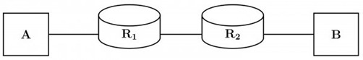

* 1. T 1 < T 2 < T 3
  2. T 1 > T 2 > T 3

C) T 2 = T 3, T 3 < T 1 D) T 1 = T 3, T 3 > T 2

## Two hosts are connected via a packet switch with 107 bits per second links. Each link has a propagation delay of 20 microseconds. The switch begins forwarding a packet 35 microseconds after it receives the same. If 10000 bits of data are to be transmitted between the two hosts using a packet size of 5000 bits, the time elapsed between the transmission of the first bit of data and the reception of the last bit of the data in microseconds is 145.

1. **Frames of 1000 bits are sent over a 106 bps duplex link between two hosts. The propagation time is 25 ms. Frames are to be transmitted into this link to maximally pack them in transit (within the link).**

## What is the minimum number of bits (I) that will be required to represent the sequence numbers distinctly? Assume that no time gap needs to be given between transmission of two frames.

* 1. I = 2
  2. I = 3
  3. I = 4 D) I = 5

## A channel has a bit rate of 4 kbps and one-way propagation delay of 20 ms. The channel uses stop and wait protocol. The transmission time of the acknowledgment frame is negligible. To get a channel efficiency of at least 50%, the minimum frame size should be

* + 1. 80 bytes
    2. 80 bits
    3. 160 bytes
    4. 160 bits