Practical-4

# AIM: Understand and identify Layer-2 functionality.

### ---------------------------------------------------------------------------------------------------------------------------

Tools required:

1. Desktop Computer
2. Cisco Packet Tracer

Simulate different scenarios given below in Cisco packet tracker and fill up table.

**Note:** While applying IP address, student need to allocate IP address as per his/her student ID. For Example, if student ID is 20ce005 then IP address allocation for first network should start with 5.0.0.0. For subsequent network, it should start with ID+1 i.e. 6.0.0.0, 7.0.0.0. and so on.

**Submission**: After writing answer into this word document, Student need to change name to his ID followed by practical number. Ex 20ce005_Pr1.docx. Upload on assignment segment.

**Rubrics**: Nicely drafted document with clarity in answers leads to full marks. Otherwise, submission carries proportional mark.

**Recommended** to type, avoid copy-past to increase your typing skill.

**Scenario 1:** Let’s assume that there are three PCs in network. All are connected with layer 2 device switch. All are assigned with the shown IP Addresses in the figure 4.1. All ARP tables are empty. Now, PC0 wants to send some data to PC2. How communication will do?

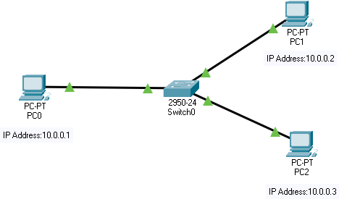

Figure 4.1 Scenario 1

Conclusion: The sender is a host and wants to send a packet to another host on the same network.

* Uses ARP to find another host’s physical address

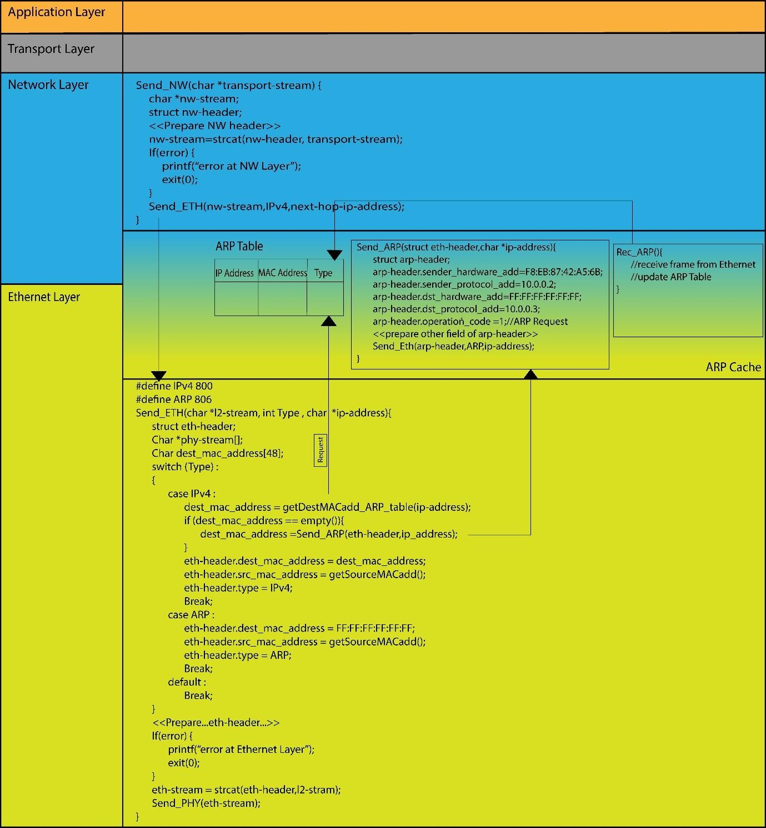

Figure 4.2 TCP/IP stack

# Address Resolution Protocol (ARP):

Most of the computer programs/applications use logical address (IP address) to send/receive messages, however, the actual communication happens over the physical address (MAC address) i.e., from layer 2 of the TCP/IP model. So, our mission is to get the destination MAC address which helps in communicating with other devices. This is where ARP comes into the picture, its functionality is to translate IP address to physical addresses.

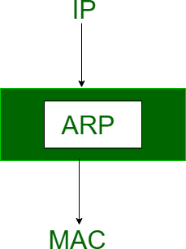



ARP Request ARP Reply ARP Table

Figure 4.3 ARP Maps IP address to MAC address

The acronym ARP stands for Address Resolution Protocol which is one of the most important protocols of the Network layer in the OSI model.

ARP finds the hardware address, also known as Media Access Control (MAC) address, of a host from its known IP address.

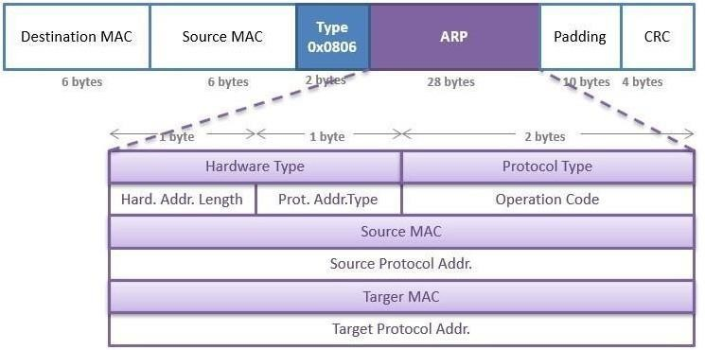

Figure 4.4 ARP header

**Scenario 2:** With respect to given topology shown in figure 4.5, IP addresses are assigned to all the PCs. Initial ARP tables are empty. Now, PC0 wants to send data to PC3. Write down the step how communication will take place.

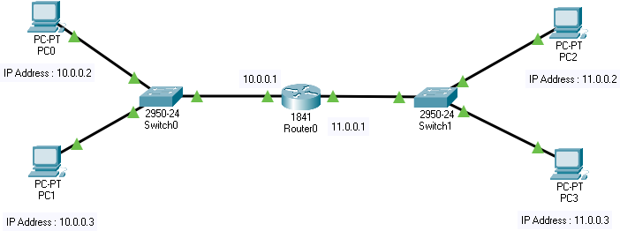

Figure 4.5 Scenario 2

Conclusion: The sender is a host and wants to send a packet to another host on another network.

* The sender looks at its routing table.
* Find the IP address of the next-hop (router) for this destination.
* Use ARP to find the router’s physical address

**Scenario 3:** With respect to given topology shown in figure 4.6, IP addresses are assigned to all the PCs. Initial ARP tables are empty. Now, Packet is received by router 1 with destination IP address 12.0.0.2. Write down the step how communication will take place.

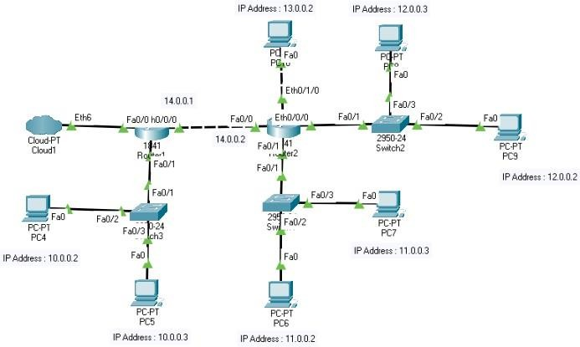

Figure 4.6 Scenario 3

Conclusion: the sender is a router and received a datagram destined for a host on another network.

* The router checks its routing table.
* Find the IP address of the next router.
* Use ARP to find the next router’s physical address.

Question 1: List out Different network devices and give a small introduction of the same. Ans. Router: Routes data between different networks at the network layer (Layer 3).

* 1. **Switch**: Connects devices within a local area network (LAN) at the data link layer (Layer 2), forwarding data based on MAC addresses.
  2. **Hub**: Simple device that connects multiple devices in a LAN but broadcasts data to all connected devices, operating at the physical layer (Layer 1).
  3. **Modem**: Converts digital data from a computer into analog signals for transmission over communication lines, and vice versa, enabling internet connectivity.
  4. **Access Point (AP)**: Provides Wi-Fi connectivity, allowing wireless devices to connect to a wired network.

Question 2: write down difference between HUB and SWITCH. Ans. Here are the key differences between a hub and a switch:

### Functionality:

* + Hub: Operates at the physical layer (Layer 1) of the OSI model and simply forwards data to all connected devices without any intelligence. It broadcasts data to all ports.
  + Switch: Operates at the data link layer (Layer 2) of the OSI model and intelligently forwards data to the specific device it is intended for based on the device's MAC address. It creates a dedicated connection between the sender and receiver, reducing unnecessary traffic.

### Broadcasting:

* + Hub: Broadcasts data to all connected devices, causing network congestion and reducing overall network efficiency.
  + Switch: Forwards data only to the specific device it is intended for, eliminating unnecessary broadcasting and improving network performance.

### Bandwidth Management:

* + Hub: Shares available bandwidth among all connected devices, leading to potential bandwidth bottlenecks and slower network speeds.
  + Switch: Provides dedicated bandwidth to each port, allowing devices to communicate simultaneously without sharing bandwidth. This results in faster and more efficient data transfer.

### Collision Domain:

* + Hub: All devices connected to a hub belong to a single collision domain, meaning that data collisions can occur when multiple devices attempt to transmit data simultaneously.
  + Switch: Each port on a switch is in its own collision domain, significantly reducing the likelihood of data collisions and improving network reliability.

### Security:

* + Hub: Lacks security features and does not provide any means of controlling or securing data transmission.
  + Switch: Offers better security by isolating traffic between devices and preventing unauthorized access to data transmitted between them.

# Exercise-1

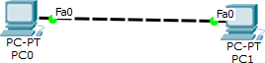

Redraw above diagram which includes IP address and MAC address. Take IP address and MAC address as per your knowledge.

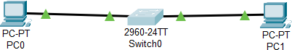

Ping from PC0 to PC1 and vice versa and insert snap of output here.

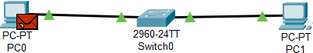

Write down ARP table of PC0 and PC1. Fill ARP table entry of PC0

|  |  |
| --- | --- |
| **IP address** | **MAC Address** |
| 121.127.1.1 | 0003.e49b.c8ca |

Fill ARP table entry of PC1

|  |  |
| --- | --- |
| **IP address** | **MAC Address** |
| 121.127.1.2 | 00e0.8fb6.b613 |

### Questions:

1. What does ARP table contain?

Ans :The ARP (Address Resolution Protocol) table contains mappings between IP addresses and corresponding MAC (Media Access Control) addresses on a local network. It essentially acts as a cache that helps devices on a network quickly determine the MAC address associated with a particular IP address.

1. Why there is need of ARP table?

Ans :The ARP table is needed because it allows devices on a network to efficiently communicate with each other. When a device wants to send data to another device on the same network, it needs to know the MAC address of the recipient. The ARP table helps in quickly resolving IP addresses to MAC addresses, reducing the need for constant broadcasting of ARP requests.

1. What is topology name of exercise-1? Ans: Star Topology
2. What is relation of IP address with MAC address?

Ans :The IP address (Internet Protocol address) and MAC address (Media Access Control address) are both used in network communication, but they serve different purposes. An IP address is a logical address assigned to a device for communication within an IP network, while a MAC address is a unique identifier assigned to network interfaces for communication on the physical network. The relation between them is that ARP (Address Resolution Protocol) is used to map IP addresses to MAC addresses on a local network.

1. Can we change MAC Address of machine?

Ans: Yes, it is possible to change the MAC address of a machine. This process is known as MAC address spoofing. However, it's worth noting that MAC addresses are typically hardcoded into network interface hardware and changing them may violate network policies or cause network connectivity issues.

1. Can we change IP address of machine?

Ans: Yes, it is possible to change the IP address of a machine. IP addresses can be assigned statically or dynamically, and in either case, they can be changed by network administrators or users with appropriate permissions. However, changing the IP address may require reconfiguring network settings and could potentially disrupt network connectivity until the new address is properly propagated and recognized by other devices on the network.

# Exercise-2 :



Redraw above diagram which includes IP address and MAC address. Take IP address and MAC address as per your knowledge.

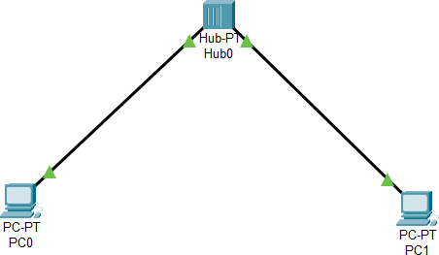

Ping from PC0 to PC1 and vice versa and insert snap of output here.

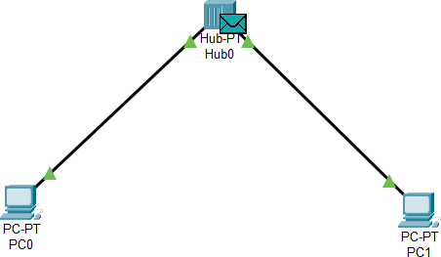

Write down ARP table of PC0 and PC1. Write down switch table of Hub0. Fill ARP table entry of PC0

|  |  |
| --- | --- |
| **IP address** | **MAC Address** |
| 121.127.1.1 | 0007.ecb4.12b8 |

Fill ARP table entry of PC1

|  |  |
| --- | --- |
| **IP address** | **MAC Address** |
| 121.127.1.2 | 0010.114b.c508 |

Questions:

1. What is functionality of Hub?

Ans :A hub operates at the physical layer (Layer 1) of the OSI model and functions as a central connection point for multiple devices in a network. Its primary functionality is to receive data from one device connected to its port and broadcast it to all other devices connected to its other ports. Essentially, it blindly forwards data packets without any intelligence or processing, leading to inefficient use of network bandwidth.

1. Does hub have IP address?

Ans: No, a hub does not have its own IP address. Hubs operate at the physical layer of the OSI model and do not have the capability to understand or process IP addresses. They simply pass along data frames based on the MAC addresses of connected devices without any knowledge of IP addresses.

1. Does hub have switch (ARP) table?

Ans: No, hubs do not have a switch table or an ARP (Address Resolution Protocol) table. Unlike switches, which operate at the data link layer (Layer 2) and maintain tables for mapping MAC addresses to port locations, hubs do not perform any intelligent forwarding or address resolution. They simply broadcast incoming data packets to all connected devices.

1. What is topology of exercise-2? Ans: Star Topology

# Exercise-3

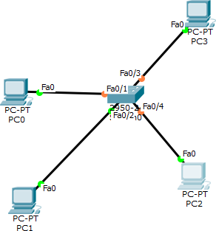

Redraw above diagram which includes IP address and MAC address. Take IP address and MAC address as per your knowledge.

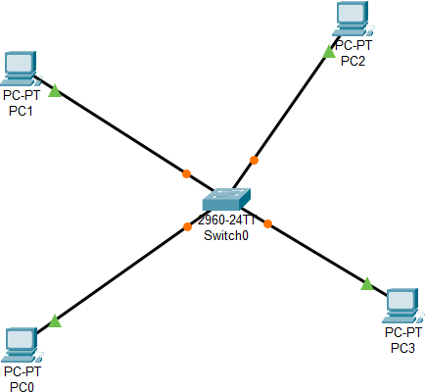

Ping from PC0,PC1,PC2 and PC3 respectively and insert snap of output here.

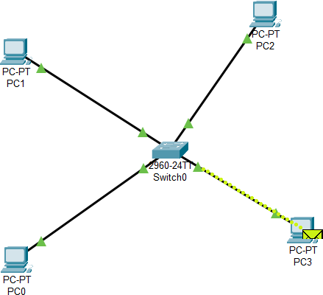

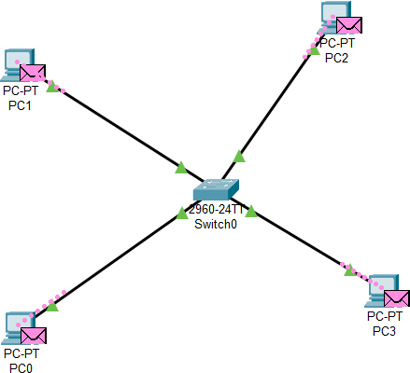

11

Write down ARP tables of PC0,PC1,PC2 and PC3. Write down switch table of Switch0. Fill ARP table entry of PC0

|  |  |
| --- | --- |
| **IP address** | **MAC Address** |
| 121.127.1.1 | 000b.be79.8c3a |

Fill ARP table entry of PC1

|  |  |
| --- | --- |
| **IP address** | **MAC Address** |

|  |  |
| --- | --- |
| 121.127.1.3 | 0030.f26e.b2e9 |

Fill ARP table entry of PC2

|  |  |
| --- | --- |
| **IP address** | **MAC Address** |
| 121.127.1.2 | 00e0.f70c.b947 |

Fill ARP table entry of PC3

|  |  |
| --- | --- |
| **IP address** | **MAC Address** |
| 11.127.1.1 | 0050.0fe1.9b6a |

Fill Switch table entry of Switch0

|  |  |
| --- | --- |
| **MAC Address** | **Ethernet port no** |
| 00:09:7c:75:6B:25 | 26 |

Questions:

1. What is functionality of switch?

Ans: A switch operates at the data link layer (Layer 2) of the OSI model and functions as a central connection point for devices within a local area network (LAN). Its primary functionality is to receive data frames from connected devices and intelligently forward them to their intended destination based on the destination MAC address. Switches maintain a MAC address table, also known as a switch table, to facilitate efficient data forwarding, leading to better network performance and reduced collisions compared to hubs.

1. Does switch have IP address?

Ans: Yes, switches can have IP addresses, particularly if they are managed switches. Managed switches often include features such as remote management, VLAN configuration, and network monitoring, which require an IP address for configuration and access purposes. Unmanaged switches typically do not have their own IP addresses and operate in a plug-and- play fashion.

1. Does switch have switch (ARP) table?

Ans:Yes , switches maintain a switch table, sometimes referred to as a MAC address table or ARP table. This table maps MAC addresses to the physical ports on the switch. When a switch receives a data frame, it checks the destination MAC address against its switch table to determine the outgoing port. If the MAC address is not found in the table, the switch may use ARP (Address Resolution Protocol) to discover the MAC address associated with the destination IP address.

1. What is topology name of exercise-3? Ans: Star Topology

# Exercise-4

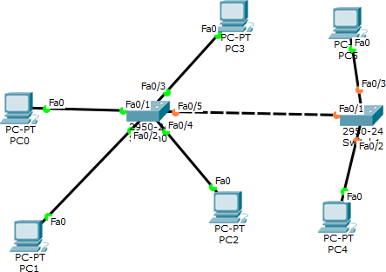

Redraw above diagram which includes IP address and MAC address. Take IP address and MAC address as per your knowledge.

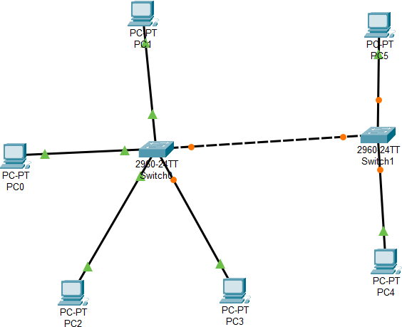

Ping from all given PCs respectively and insert snap of output here.

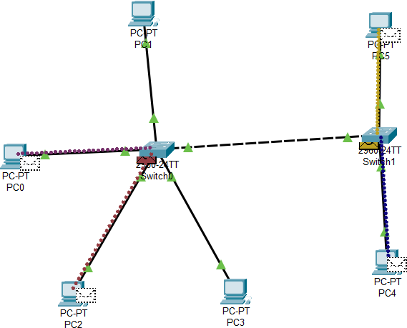

Write down ARP table of all given PCs. Write down switch table of Switch0 and Switch1. ARP table entry of PC0

|  |  |
| --- | --- |
| **IP address** | **MAC Address** |
| 10.10.1.4 | 0050.0f78.b73d |
| 10.11.1.2 | 0001.96b9.c3ea |

ARP table entry of PC1

|  |  |
| --- | --- |
| **IP address** | **MAC Address** |
| 10.10.1.3 | 0002.1747.d70c |

ARP table entry of PC2

|  |  |
| --- | --- |
| **IP address** | **MAC Address** |
| 10.10.1.2 | 0005.5e74.200d |

ARP table entry of PC3

|  |  |
| --- | --- |
| **IP address** | **MAC Address** |
| 10.10.1.1 | 0002.17bb.2975 |

ARP table entry of PC4

|  |  |
| --- | --- |
| **IP address** | **MAC Address** |
| 10.10.1.1 | 0002.17bb.2975 |

ARP table entry of PC5

|  |  |
| --- | --- |
| **IP address** | **MAC Address** |
| 10.11.1.2 | 0001.96b9.c3ea |

Switch table entry of Switch0

|  |  |
| --- | --- |
| **MAC Address** | **Ethernet port no** |
| 00:90:0c:13:69:ID | 26 |

Switch table entry of Switch1

|  |  |
| --- | --- |
| **MAC Address** | **Ethernet port no** |
| 00:D0:D3:A4:37:BD | 26 |

Questions

1. Does both the switch will have identical switching table?

Ans: No, the switching tables on two different switches may not be identical. Switching tables are dynamically built based on the MAC addresses observed on each switch's ports. They reflect the devices connected to each switch and their corresponding MAC addresses. While switches in the same network may have some overlap in their switching tables, they can differ due to variations in connected devices, network traffic patterns, and the timing of MAC address learning.

1. In Exercise-4, why does PC0 contain IP MAC address of PC4? Ans : As it sends packets from pc0 to pc4.
2. What is topology name of exercise-4? Ans: Hybrid Topology

# GATE Questions:

### Consider the diagram shown below where a number of LANs are connected by (transparent) bridges. In order to avoid packets looping through circuits in the graph, the bridges organize themselves in a spanning tree. First, the root bridge is identified as the bridge with the least serial number. Next, the root sends out (one or more) data units to enable the setting up of the spanning tree of shortest paths from the root bridge to each bridge.

**Each bridge identifies a port (the root port) through which it will forward frames to the root bridge. Port conflicts are always resolved in favour of the port with the lower index value. When there is a possibility of multiple bridges forwarding to the same LAN (but not through the root port), ties are broken as follows: bridges closest to the root get preference and between such bridges, the one with the lowest serial number is preferred.**

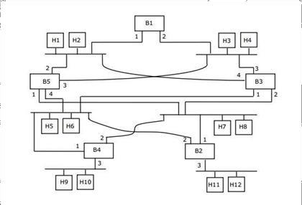

**For the given connection of LANs by bridges, which one of the following choices represents the depth first traversal of the spanning tree of bridges?**

A) B1, B5, B3, B4, B2

B) B1, B3, B5, B2, B4

C) B1, B5, B2, B3, B4

D) B1, B3, B4, B5, B2

Ans.

## Consider the diagram shown below where a number of LANs are connected by (transparent) bridges. In order to avoid packets looping through circuits in the graph, the bridges organize themselves in a spanning tree. First, the root bridge is identified as the bridge with the least serial number. Next, the root sends out (one or more) data units to enable the setting up of the spanning tree of shortest paths from the root bridge to each bridge. Each bridge identifies a port (the root port) through which it will forward frames to the root bridge. Port conflicts are always resolved in favour of the port with the lower index value. When there is a possibility of multiple bridges forwarding to the same LAN (but not through the root port), ties are broken as follows: bridges closest to the root get preference and between such bridges, the one with the lowest serial number is preferred.

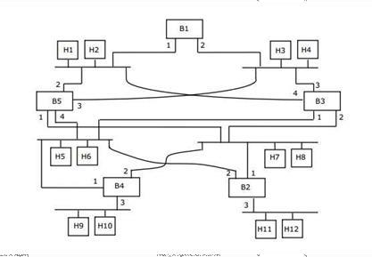

**Consider the spanning tree B1, B5, B3, B4, B2 for the given connection of LANs by bridges that represents the depth first traversal of the spanning tree of bridges. Let host H1 send out a broadcast ping packet. Which of the following options represents the correct forwarding table on B3?**

|  |  |  |
| --- | --- | --- |
| **A)** | **Hosts** | **Port** |
| H1, H2, H3, H4 | 3 |
| H5, H6, H9, H10 | 1 |
| H7, H8, H11, H12 | 2 |
|  | | |
| **B)** | **Hosts** | **Port** |
| H1, H2 | 4 |
| H3, H4 | 3 |
| H5, H6 | 1 |
| H7, H8, H9, H10, H11, H12 | 2 |
|  | | |
| **C)** | **Hosts** | **Port** |
| H3, H4 | 3 |
| H5, H6, H9, H10 | 1 |
| H1, H2 | 4 |
| H7, H8, H11, H12 | 2 |
|  | | |
| **D)** | **Hosts** | **Port** |
| H1, H2, H3, H4 | 3 |
| H5, H7, H9, H10 | 1 |
| H7, H8, H11, H12 | 4 |

* 1. A
  2. B
  3. C
  4. D Ans.

## Consider a simple communication system where multiple nodes are connected by a shared broadcast medium (like Ethernet or wireless). The nodes in the system use the following carrier-sense based medium access protocol. A node that receives a packet to transmit will carrier-sense the medium for 5 units of time. If the node does not detect any other transmission, it starts transmitting its packet in the next time unit. If the node detects another transmission, it waits until this other transmission finishes, and then begins to carrier-sense for 5 time units again. Once they start to transmit, nodes do not perform any collision detection and continue transmission even if a collision occurs. All transmissions last for 20 units of time. Assume that the transmission signal travels at the speed of 10 meters per unit time in the medium.

**Assume that the system has two nodes P and Q, located at a distance d meters from each other. P start transmitting a packet at time t = 0 after successfully completing its carrier-sense phase. Node Q has a packet to transmit at time t = 0 and begins to carrier- sense the medium.**

## The maximum distance d (in meters, rounded to the closest integer) that allows Q to successfully avoid a collision between its proposed transmission and P ’s ongoing transmission is .

Ans.

## A and B are the only two stations on an Ethernet. Each has a steady queue of frames to send. Both A and B attempt to transmit a frame, collide, and A wins the first backoff race. At the end of this successful transmission by A, both A and B attempt to transmit and collide. The probability that A wins the second backoff race is:

A) 0.5

B) 0.625

C) 0.75

D) 1.0

Ans.

## Which of the following statements is TRUE?

* 1. Both Ethernet frame and IP packet include checksum fields
  2. Ethernet frame includes a checksum field and IP packet includes a CRC field
  3. Ethernet frame includes a CRC field and IP packet includes a checksum field
  4. Both Ethernet frame and IP packet include CRC fields Ans.

## Consider three IP networks A, B and C. Host HA in network A sends messages each containing 180 bytes of application data to a host HC in network C. The TCP layer prefixes 20 byte header to the message.

**This passes through an intermediate network B.The maximum packet size, including 20 byte IP header, in each network is:**

## A: 1000 bytes

**B: 100 bytes**

## C: 1000 bytes

**The network A and B are connected through a 1 Mbps link, while B and C are connected by a 512 Kbps link (bps = bits per second).**

## Assuming that the packets are correctly delivered, how many bytes, including headers, are delivered to the IP layer at the destination for one application message, in the best case? Consider only data packets.

A) 200

B) 220

C) 240

D) 260

Ans.

## Consider three IP networks A, B and C. Host HA in network A sends messages each containing 180 bytes of application data to a host HC in network C. The TCP layer prefixes 20 byte header to the message. This passes through an intermediate network B. The maximum packet size, including 20 byte IP header, in each network, is:

**A : 1000 bytes B : 100 bytes C : 1000 bytes**

## The network A and B are connected through a 1 Mbps link, while B and C are connected by a 512 Kbps link (bps = bits per second).

**What is the rate at which application data is transferred to host HC? Ignore errors, acknowledgments, and other overheads.**

* 1. 325.5 Kbps
  2. 354.5 Kbps
  3. 409.6 Kbps
  4. 512.0 Kbps Ans.

## A 2 km long broadcast LAN has 107 bps bandwidth and uses CSMA/CD. The signal travels along the wire at 2 × 108 m/s. What is the minimum packet size that can be used on this network?

* 1. 50 bytes
  2. 100 bytes
  3. 200 bytes
  4. None of the above Ans.

## Consider that 15 machines need to be connected in a LAN using 8-port Ethernet switches. Assume that these switches do not have any separate uplink ports. The minimum number of switches needed is .

Ans.

## A host is connected to a Department network which is part of a University network. The University network, in turn, is part of the Internet. The largest network in which the Ethernet address of the host is unique is:

* 1. the subnet to which the host belongs
  2. the Department network
  3. the University network
  4. the Internet Ans.

## Which of the following statements is FALSE regarding a bridge?

* 1. Bridge is a layer 2 device
  2. Bridge reduces collision domain
  3. Bridge is used to connect two or more LAN segments
  4. Bridge reduces broadcast domain Ans.

### Suppose the round trip propagation delay for a 10 Mbps Ethernet having 48-bit jamming signal is 46.4 μs. The minimum frame size is:

* 1. 94

B) 416

C) 464

D) 512

Ans.

## A link has transmission speed of 106 bits/sec. It uses data packets of size 1000 bytes each. Assume that the acknowledgment has negligible transmission delay and that its propagation delay is the same as the data propagation delay. Also, assume that the processing delays at nodes are negligible. The efficiency of the stop-and-wait protocol in this setup is exactly 25%. The value of the one way propagation delay (in milliseconds) is .

Ans.

## Consider a simplified time slotted MAC protocol, where each host always has data to send and transmits with probability p = 0.2 in every slot. There is no backoff and one frame can be transmitted in one slot. If more than one host transmits in the same slot, then the transmissions are unsuccessful due to collision. What is the maximum number of hosts which this protocol can support if each host has to be provided a minimum throughput of 0.16 frames per time slot?

* 1. 1
  2. 2
  3. 3
  4. 4 Ans.

## In a TDM medium access control bus LAN, each station is assigned one time slot per cycle for transmission. Assume that the length of each time slot is the time to transmit 100 bitsplus the end-to-end propagation delay. Assume a propagation speed of 2 × 108m/sec. The length of the LAN is 1 km with a bandwidth of 10 Mbps. The maximum number of stations that can be allowed in the LAN so that the throughput of each station can be 2/3 Mbpsis

* 1. 3
  2. 5
  3. 10
  4. 20 Ans.

## The address resolution protocol (ARP) is used for:

* 1. Finding the IP address from the DNS
  2. Finding the IP address of the default gateway
  3. Finding the IP address that corresponds to a MAC address
  4. Finding the MAC address that corresponds to an IP address

Ans.

## Suppose that in an IP-over-Ethernet network, a machine X wishes to find the MAC address of another machine Y in its subnet. Which one of the following techniques can be used for this?

* 1. X sends an ARP request packet to the local gateway’s IP address which then finds the MAC address of Y and sends to X
  2. X sends an ARP request packet to the local gateway’s MAC address which then finds the MAC address of Y and sends to X
  3. X sends an ARP request packet with broadcast MAC address in its local subnet
  4. X sends an ARP request packet with broadcast IP address in its local subnet Ans.

1. **Consider the following two statements.**

## S1: Destination MAC address of an ARP reply is a broadcast address. S2: Destination MAC address of an ARP request is a broadcast address.

**Which one of the following choices is correct?**

1. Both S1 and S2 are true
2. S1 is true and S2 is false
3. S1 is false and S2 is true
4. Both S1 and S2 are false Ans.

### Consider the following clauses:

1. **Not inherently suitable for client authentication.**
2. **Not a state sensitive protocol.**

## Must be operated with more than one server.

1. **Suitable for structured message organization.**

## May need two ports on the serve side for proper operation. The option that has the maximum number of correct matches is

* 1. IMAP-i; FTP-ii; HTTP-iii; DNS-iv; POP3-v
  2. FTP-i; POP3-ii; SMTP-iii; HTTP-iv; IMAP-v
  3. POP3-i; SMTP-ii; DNS-iii; IMAP-iv; HTTP-v
  4. SMTP-i; HTTP-ii; IMAP-iii; DNS-iv; FTP-v Ans.

## In a packet switching network, packets are routed from source to destination along a single path having two intermediate nodes. If the message size is 24 bytes and each packet contains a header of 3 bytes, then the optimum packet size is:

* 1. 4
  2. 6
  3. 7
  4. 9 Ans.

## Which one of the following statements is FALSE?

* 1. Packet switching leads to better utilization of bandwidth resources than circuit switching
  2. Packet switching results in less variation in delay than circuit switching
  3. Packet switching requires more per-packet processing than circuit switching
  4. Packet switching can lead to reordering unlike in circuit switching Ans.

## Consider a network using the pure ALOHA medium access control protocol, where each frame is of length 1, 000 bits. The channel transmission rate is 1 Mbps (= 106 bits per second). The aggregate number of transmissions across all the nodes (including new frame transmissions and retransmitted frames due to collisions) is modelled as a Poisson process with a rate of 1, 000 frames per second. Throughput is defined as the average number of frames successfully transmitted per second. The throughput of the network (rounded to the nearest integer) is .

Ans.

## For the IEEE 802.11 MAC protocol for wireless communication, which of the following statements is/are TRUE?

1. **At least three non-overlapping channels are available for transmissions.**

## The RTS-CTS mechanism is used for collision detection.

1. **Unicast frames are ACKed.**
   1. I, II, and III
   2. I and III only
   3. II and III only
   4. II only Ans.

## The minimum frame size required for a CSMA/CD based computer network running at 1Gbps on a 200m cable with a link speed of 2 × 108m/sec is:

* 1. 125bytes
  2. 250bytes
  3. 500bytes
  4. None of the above Ans.