**Practical-5**

**AIM: Understand and identify Layer-3 functionality.**

**Tools required:**

1. Desktop Computer
2. Cisco Packet Tracer

**Time distribution**

|  |  |
| --- | --- |
| Exercise-1 | 30 minutes |
| Exercise-2 | 30 minutes |
| Exercise-3 | 45 minutes |
| Questions and answer | 15 minutes |

Simulate different scenarios (Exercises-1 to 3) given below in Cisco packet tracker. Fill up respective tables, justify statements and write conclusion in your words.

**Routing**

* A Router is a process of selecting path along which the data can be transferred from source to the destination. Routing is performed by a special device known as a router.
* A Router works at the network layer in the OSI model and internet layer in TCP/IP model
* A router is a networking device that forwards the packet based on the information available in the packet header and forwarding table.
* The routing algorithms are used for routing the packets. The routing algorithm is nothing but a software responsible for deciding the optimal path through which packet can be transmitted.
* The routing protocols use the metric to determine the best path for the packet delivery. The metric is the standard of measurement such as hop count, bandwidth, delay, current load on the path, etc. used by the routing algorithm to determine the optimal path to the destination.
* The routing algorithm initializes and maintains the routing table for the process of path determination.

**Types of routing**

There are three types of routing as shown in figure 5.1.

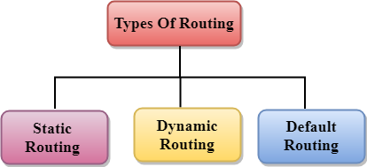

Figure 5.1

**Static routing:**

* Static Routing is also known as Nonadaptive Routing.
* It is a technique in which the administrator manually adds the routes in a routing table.

**Dynamic routing:**

* It is also known as Adaptive Routing.
* It is a technique in which a router adds a new route in the routing table for each packet in response to the changes in the condition or topology of the network.
* Dynamic protocols are used to discover the new routes to reach the destination.

**Default routing:**

* Default Routing is a technique in which a router is configured to send all the packets to the same hop device, and it doesn't matter whether it belongs to a particular network or not. A Packet is transmitted to the device for which it is configured in default routing.

**Routing Protocols**

Routing protocols can be either an interior protocol or an exterior protocol. An interior protocol handles intradomain routing; an exterior protocol handles interdomain routing.

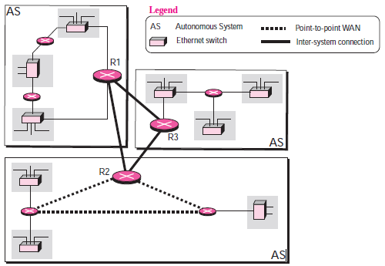

Figure 5.2 Intra domain and Inter domain routing protocol

Several intra-domain and inter-domain routing protocols are in use. We discuss two intra-domain routing protocols: distance vector and link state. We also introduce one inter-domain routing protocol: path vector.

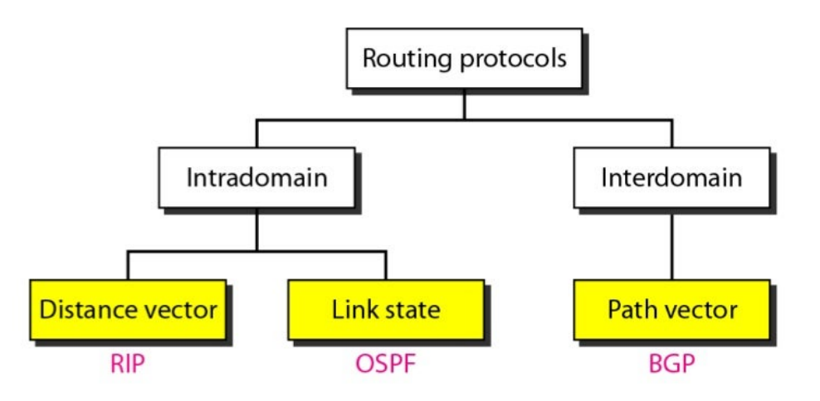

Figure 5.3 Routing Protocols

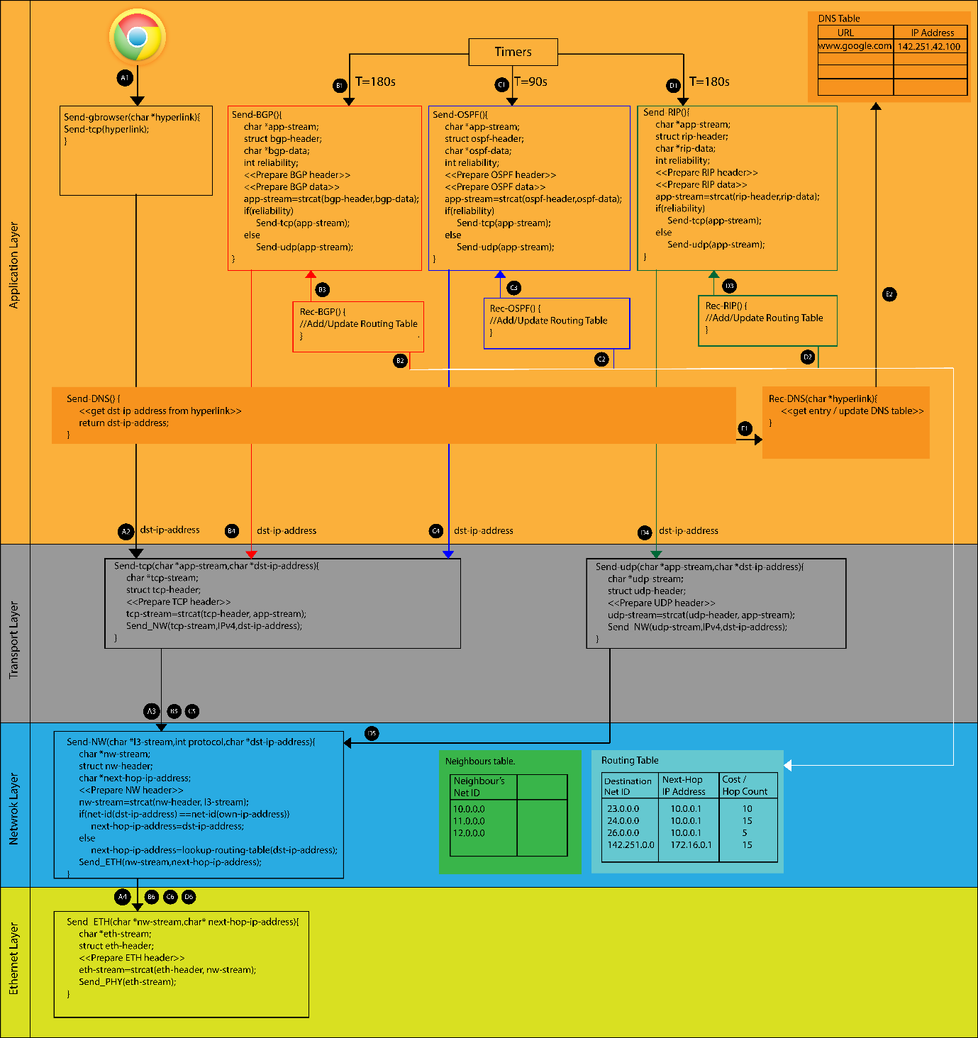

Figure 5.4 Demonstration of routing protocols in TCP/IP stack

1. How do DNS work?

Ans. The Domain Name System (DNS) is a hierarchical and decentralized naming system for computers, services, or other resources connected to the Internet or a private network.

1. What is the significance of the routing table?

Ans. The routing table is a database that contains information about the paths between different networks. It is used by routers to determine how to forward packets to their destinations.

1. What is the next hop IP address?

Ans. The next hop IP address is the IP address of the next router on the path to a destination network.

1. What is the significance of routing protocols?

Ans. Routing protocols are an essential part of the internet infrastructure. They allow routers to efficiently route packets to their destination networks, which ensures that the internet is fast, reliable, and scalable.

**Exercise-1**

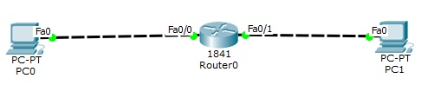

Redraw above diagram which includes IP address and MAC address. Take IP address and MAC address as per your knowledge.

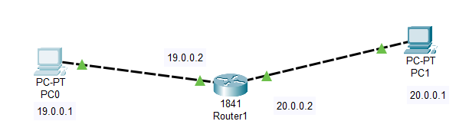

Ping from PC0 to PC1 and vice versa and get the output here.

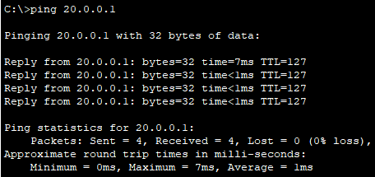

Write down the ARP table of PC0 and PC1. Write down Routing table Router0.

ARP table entry of PC0



ARP table entry of PC1



Routing table of Router0:

|  |  |  |
| --- | --- | --- |
| Destination Network ID | Next Hop IP address | Hop Count along a path |
| 10.0.0.0 | -- | 0 |
| 11.0.0.0 | -- | 0 |

Which are the following statements correct? Also justify each statement.

1. Is PC0 having Ethernet Card?

Ans. Yes

Justification: Because if we need to connect more ethernet we can insert it.

1. PC1 is having Ethernet Card.

Ans. Yes

Justification: Because if we need to connect more ethernet we can insert it.

1. Router0 is having two NIC card.

Ans. Yes

Justification: Because there are two fast ethernet ports.

1. Router 0 is having two Mac address

Ans. Yes

Justification: Because there are two fast ethernet ports.

1. Router0 is having TWO IP address

Ans. Yes

Justification: Because there are two fast ethernet ports.

1. MAC address pair on link 0(between PC0 and Router0) is different than MAC address pair in link 1(between Router0 and PC1) for message transfer.

Ans. Yes

Justification: Because MAC address of each device is unique.

1. Router0 is having switching table

Ans. Yes

Justification: To switch data within the network.

1. Speed of Link 0 is 10 Mbps.

Ans. Yes

Justification: There is more speed of link 1.

1. Speed of Link1 is 100 Mbps.

Ans. Yes

Justification: Because there is less speed of link0.

1. Router0 takes decision based on MAC address.

Ans. Yes

Justification: To reach to proper destination.

1. PC0 and PC1 can communicate because they are having same Ethernet cards i.e. Fa0.

Ans. No

Justification: Because they are in same network.

1. PC1 and Router0 cannot communicate as they are having different Ethernet cards.

Ans. No.

Justification: They cannot be ping to eachother.

**Exercise-2**

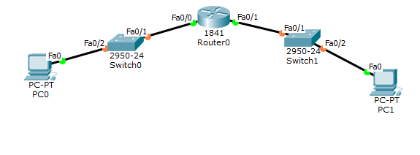

Redraw above diagram which includes IP address and MAC address. Take IP address and MAC address as per your knowledge.

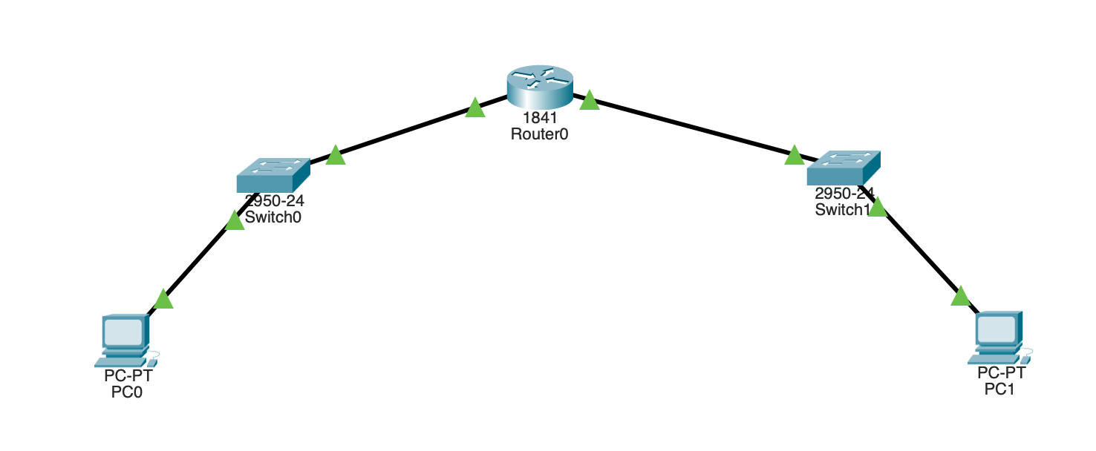

Ping from PC0 to PC1 and vice versa and get the output here.

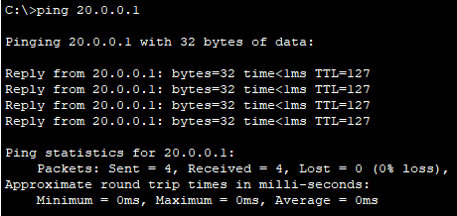

Write down ARP table of PC0 and PC1. Write down switch table of switches. Write down Routing table of routers.

ARP table entry of PC0



ARP table entry of PC1



Switch table entry of Switch0:

|  |  |
| --- | --- |
| **MAC Address** | **Ethernet port no** |
| 0090.2B0A.1168 | 1 |
| 0060.4766.0E01 | 2 |

Switch table entry of Switch1:

|  |  |
| --- | --- |
| **MAC Address** | **Ethernet port no** |
| 00D0.971E.02D8 | 1 |
| 0060.4766.0E01 | 2 |

Routing table of Router0:

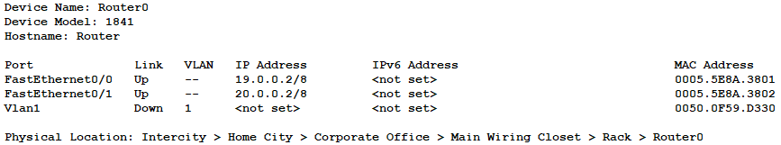

Which are the following statements correct? Also justify each statement.

1. Switch0 contains MAC address of PC1 in their switching table.

Ans. Yes

Justification: Because they have to communicate.

1. Switch1 contains MAC address of PC1 in their switching table.

Ans. Yes

Justification: Because they have to communicate.

1. Any computer or device can be Router if it has two NIC cards.

Ans. Yes

Justification: Because it is connected to different device.

1. Switch0 and Switch1 may take decision based on IP address.

Ans. Yes

Justification: The nearest IP through them they send to it.

1. Router0 works at layer 3, while switches work at layer 2.

Ans. Yes

Justification: Router do data communication.

1. By default, Network ID of NIC cards are routing table entries.

Ans. Yes

Justification: By default, the routing table of a device will include a route for each network that the device is directly attached to.

1. MAC address pair on link 0(between PC0 and Router0) is different than MAC address pair in link 1(between Router0 and PC1) for message transfer.

Ans. Yes

Justification: Due to there MAC address and same network.

**Exercise-3**

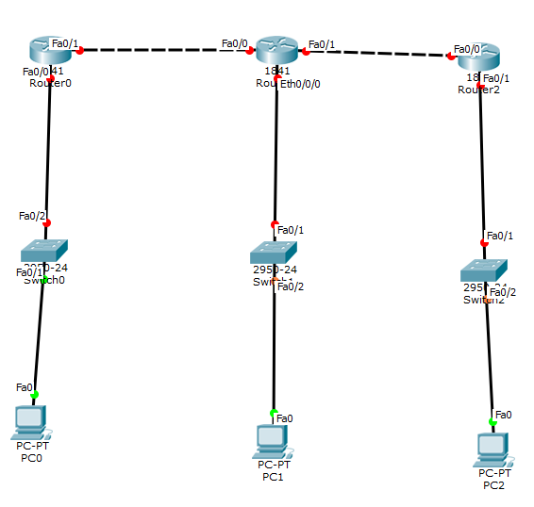

Redraw above diagram which includes IP address and MAC address. Take IP address and MAC address as per your knowledge.

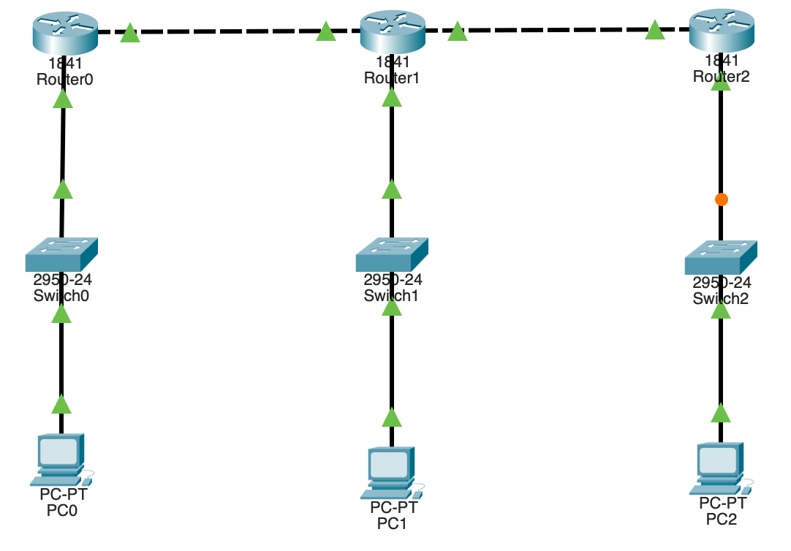

Ping all PCs respectively and get the output here.

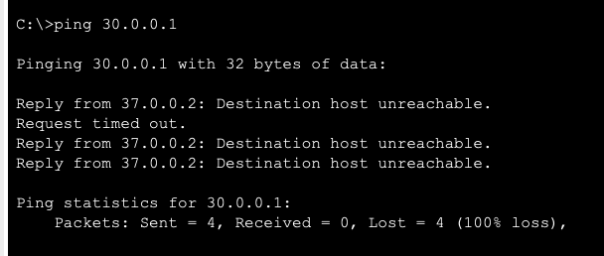

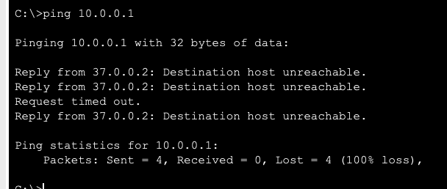

Write down ARP table of PC0, PC1 and PC3 after successful ping. Write down switch table of switches. Write down Routing table of routers.

ARP table entry of PC0

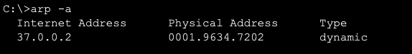

ARP table entry of PC1

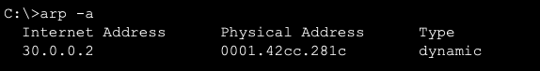

ARP table entry of PC2

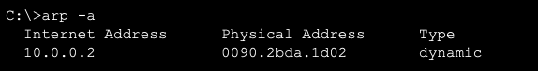

Switch table entry of Switch0:

|  |  |
| --- | --- |
| **MAC Address** | **Ethernet port no** |
| 0009.7C73.ACC3 | 2 |
| 0001.9634.7202 | 1 |

Switch table entry of Switch1:

|  |  |
| --- | --- |
| **MAC Address** | **Ethernet port no** |
| 0007.EC59.7543 | 2 |
| 0001.42CC.281C | 1 |

Routing table of Router0:

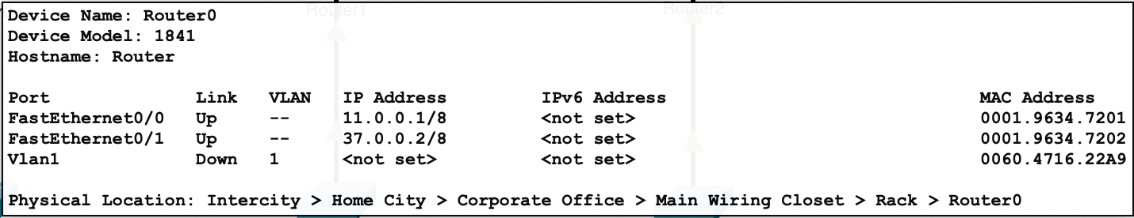

Routing table of Router1:

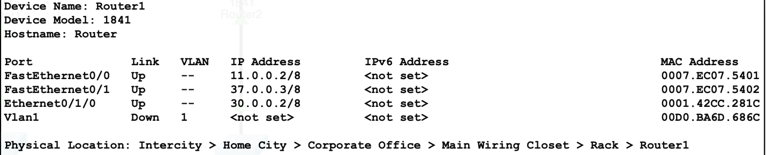

Routing table of Router2:

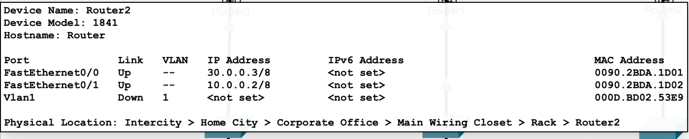

Conclusions (Inference):

1. We learned how to connect switch and routers together
2. We also learned how the network topology works.

**GATE Questions:**

1. **Consider a network with 6 routers R1 to R6 connected with links having weights as shown in the following diagram.**

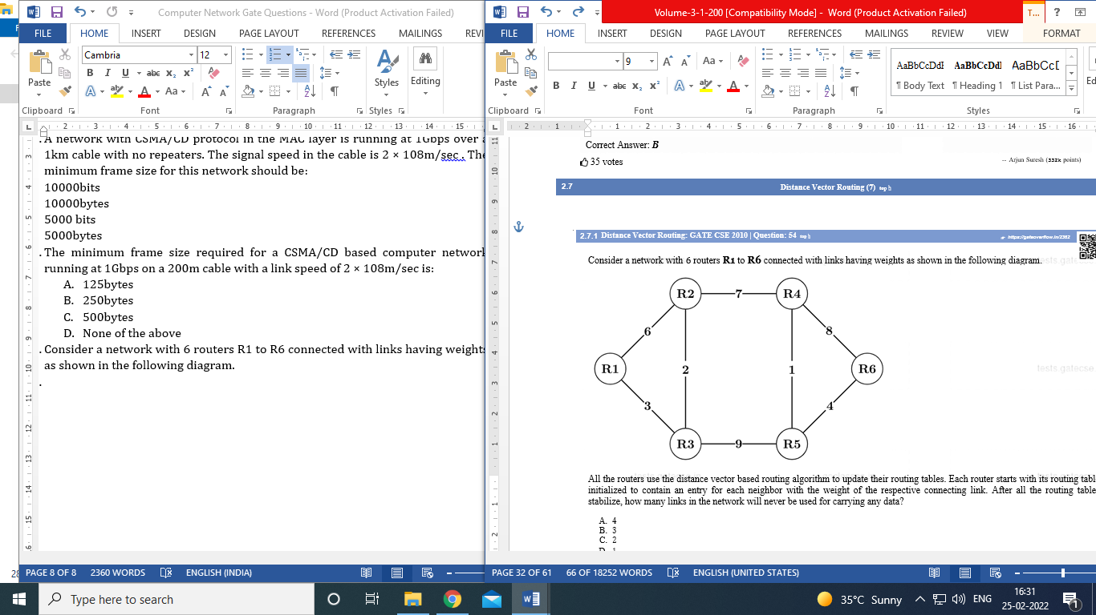

**All the routers use the distance vector-based routing algorithm to update their routing tables. Each router starts with its routing table initialized to contain an entry for each neighbor with the weight of the respective connecting link. After all the routing tables stabilize, how many links in the network will never be used for carrying any data?**

1. 4
2. 3
3. 2
4. 1
5. **Consider a network with 6 routers R1 to R6 connected with links having weights as shown in the following diagram.**



**Suppose the weights of all unused links are changed to 2 and the distance vector algorithm is used again until all routing tables stabilize. How many links will now remain unused?**

1. 0
2. 1
3. 2
4. 3
5. **Consider a network with five nodes, N1 to N5, as shown as below.**

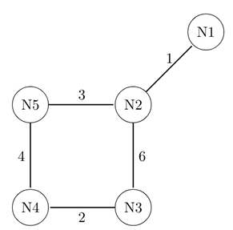

**The network uses a Distance Vector Routing protocol. Once the routes have been stabilized, the distance vectors at different nodes are as follows.**

**N1: (0, 1, 7, 8, 4)**

**N2: (1, 0, 6, 7, 3)**

**N3: (7, 6, 0, 2, 6)**

**N4: (8, 7, 2, 0, 4)**

**N5: (4, 3, 6, 4, 0)**

**Each distance vector is the distance of the best known path at that instance to nodes, N1 to N5, where the distance to itself is 0. Also, all links are symmetric and the cost is identical in both directions. In each round, all nodes exchange their distance vectors with their respective neighbors. Then all nodes update their distance vectors. In between two rounds, any change in cost of a link will cause the two incident nodes to change only that entry in their distance vectors.**

**The cost of link N2 − N3 reduces to 2 (in both directions). After the next round of updates, what will be the new distance vector at node, N3?**

1. (3, 2, 0, 2, 5)
2. (3, 2, 0, 2, 6)
3. (7, 2, 0, 2, 5)
4. (7, 2, 0, 2, 6)
5. **Consider a network with five nodes, N1 to N5, as shown as below.**



**The network uses a Distance Vector Routing protocol. Once the routes have been stabilized, the distance vectors at different nodes are as follows.**

**N1: (0, 1, 7, 8, 4)**

**N2: (1, 0, 6, 7, 3)**

**N3: (7, 6, 0, 2, 6)**

**N4: (8, 7, 2, 0,**

**N5: (4, 3, 6, 4, 0)**

**Each distance vector is the distance of the best known path at that instance to nodes, N1 to N5, where the distance to itself is 0. Also, all links are symmetric and the cost is identical in both directions. In each round, all nodes exchange their distance vectors with their respective neighbors. Then all nodes update their distance vectors. In between two rounds, any change in cost of a link will cause the two incident nodes to change only that entry in their distance vectors.**

**The cost of link N2 − N3 reduces to 2 (in both directions). After the next round of updates, the link N1 − N2 goes down. N2 will reflect this change immediately in its distance vector as cost, ∞. After the NEXT ROUND of update, what will be the cost to N1 in the distance vector of N3 ?**

1. 3
2. 9
3. 10
4. ∞
5. **Consider a computer network using the distance vector routing algorithm in its network layer. The partial topology of the network is shown below.**

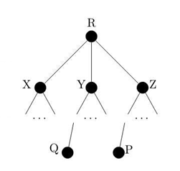

**The objective is to find the shortest-cost path from the router R to routers P and Q. Assume that R does not initially know the**

**shortest routes to P and Q. Assume that R has three neighbouring routers denoted as X, Y and Z. During one iteration, R measures its distance to its neighbours X, Y , and Z as 3, 2 and 5, respectively. Router R gets routing vectors from its neighbours that indicate that the distance to router P from routers X, Y and Z are 7, 6 and 5, respectively. The routing vector also indicates that the distance to router Q from routers X, Y and Z are 4, 6 and 8 respectively. Which of the following statement(s) is/are correct with respect to the new routing table o R, after updation during this iteration?**

1. The distance from R to P will be stored as 10
2. The distance from R to Q will be stored as 7
3. The next hop router for a packet from R to P is Y
4. The next hop router for a packet from R to Q is Z.
5. **For the network given in the figure below, the routing tables of the four nodes A, E, D and G are shown. Suppose that F has estimated its delay to its neighbors, A, E, D and G as 8, 10, 12 and 6 msecs respectively and updates its routing table using distance vector routing technique.**

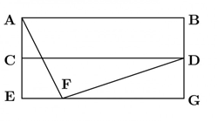

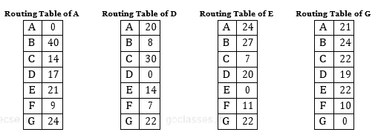

A) 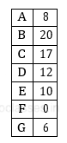

B)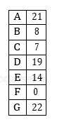

C)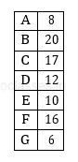

D)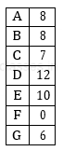

1. **Consider the following three statements about link state and distance vector routing protocols, for a large network with 500 network nodes and 4000 links.**

**[S1]: The computational overhead in link state protocols is higher than in distance vector protocols.**

**[S2]: A distance vector protocol (with split horizon) avoids persistent routing loops, but not a link state protocol.**

**[S3]: After a topology change, a link state protocol will converge faster than a distance vector protocol.**

**Which one of the following is correct about S1, S2, and S3?**

1. S1, S2, and S3 are all true.
2. S1, S2, and S3 are all false.
3. S1 and S2 are true, but S3 is false.
4. S1 and S3 are true, but S2 is false.