**Practical-6**

Date: 29-03-2024

**AIM: Understand & identify Packet(L3) & frame(L2) content detail.**

Tools required:

1. Desktop Computer
2. Cisco Packet Tracer

**Note:** While applying IP address, student need to allocate IP address as per his/her student ID. For Example, if student ID is 20ce005 then IP address allocation for first network should start with 5.0.0.0. For subsequent network, it should start with ID+1 i.e. 6.0.0.0, 7.0.0.0. and so on.

**Submission**: After writing answer into this word document, Student need to change name to his ID followed by practical number. Ex 20ce005_Pr1.docx. Upload on assignment segment.

**Rubrics**: Nicely drafted document with clarity in answers leads to full marks. Otherwise, submission carries proportional mark.

copy-past from cisco packet tracker is permitted.

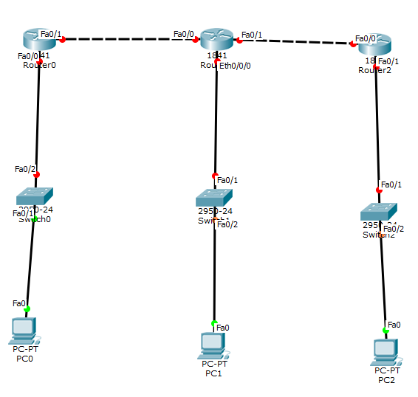

Topology for the consideration

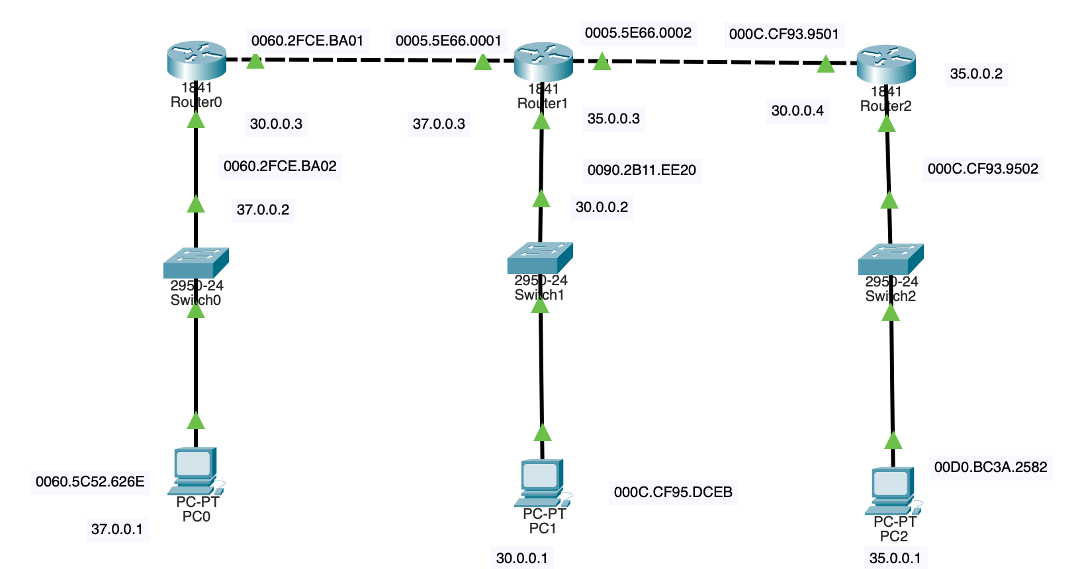**Steps:**

1. Create topology in Realtime mode
2. Configure IP address
3. Configure Static Routing in Each routers
4. Ping from PC0 to rest other PCs and all interface of routers and fill success table
5. Go to Simulation mode
6. Prepare MAC and IP address Table.
7. Prepare ARP table for all PCs
8. Prepare Routing tables for Router0, Router1 and Router2
9. Prepare ARP tables for Router0, Router1 and Router2
10. Prepare MAC table of all switches
11. In simulation mode follow instructions as given in exercise and write answer of questions.

|  |  |  |  |
| --- | --- | --- | --- |
| **Destination machine** | **Destination IP address** | **Command** | **Success/Fail** |
| FE0/0 of Router0 | 30.0.0.3 | Ping 30.0.0.3 | Success |
| FE0/1 of Router0 | 37.0.0.2 | Ping 37.0.0.2 | Success |
| FE0/0 of Router1 | 37.0.0.3 | Ping 37.0.0.3 | Success |
| FE0/1 of Router1 | 35.0.0.3 | Ping 35.0.0.3 | Success |
| FE0/0/0 of Router1 | 30.0.0.2 | Ping 30.0.0.2 | Success |
| PC1 | 30.0.0.1 | Ping 30.0.0.1 | Success |
| FE0/0 of Router2 | 30.0.0.4 | Ping 30.0.0.4 | Success |
| FE0/1 of Router2 | 35.0.0.2 | Ping 35.0.0.2 | Success |
| PC2 | 35.0.0.1 | Ping 35.0.0.1 | Success |

Ping Success table

Ping from PC0 to PC2 and attach a snapshot for the same.

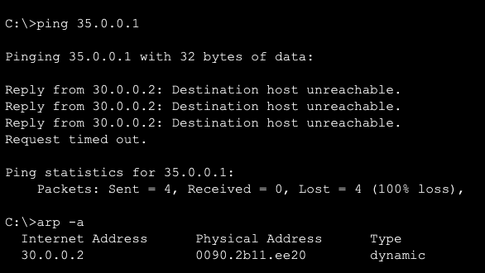

|  |  |  |
| --- | --- | --- |
| **Computer/Router Interface** | **MAC address** | **IP address** |
| PC0 | 0060.5C52.626E | 37.0.0.1 |
| Router0 FE0/0 | 0060.2FCE.BA02 | 10.0.0.1 |
| Router0 FE0/1 | 0060.2FCE.BA01 | 37.0.0.2 |
| Router1 FE0/0 | 0005.5E66.0001 | 10.0.0.2 |
| Router1 FE0/1 | 0005.5E66.0002 | 11.0.0.1 |
| Router1 ETH0/0/0 | 0090.2B11.EE20 | 30.0.0.2 |
| PC1 | 000C.CF95.DCEB | 30.0.0.1 |
| Router2 FE0/0 | 000C.CF93.9501 | 11.0.0.2 |
| Router2 FE0/1 | 000C.CF93.9502 | 35.0.0.2 |
| PC2 | 00D0.BC3A.2582 | 35.0.0.1 |

MAC and IP address Table

ARP Table for PC0

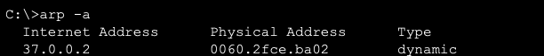

ARP Table for PC1

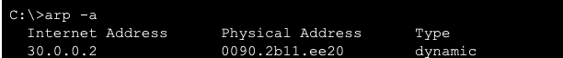

ARP Table for PC2

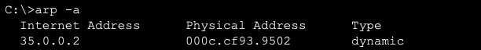

Routing table for Router0

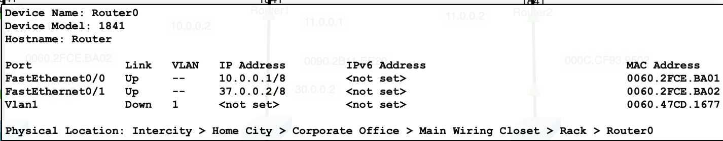

Routing table for Router1

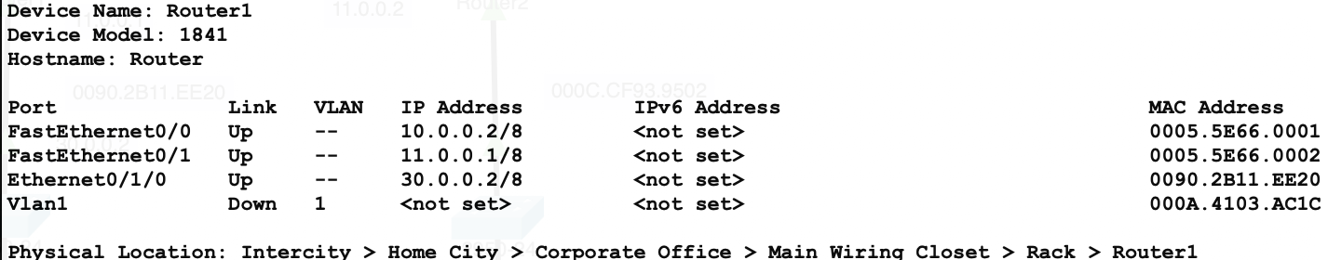

Routing table for Router2

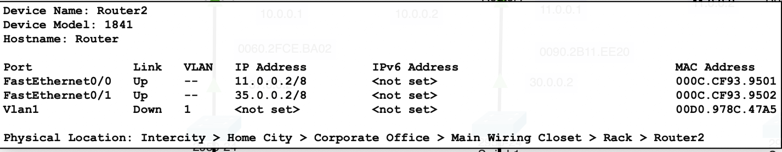

|  |  |  |
| --- | --- | --- |
| **IP Address** | **MAC Address** | **Interface** |
| 37.0.0.2 | 0060.2FCE.BA01 | Dynamic |
| 10.0.0.1 | 0060.2FCE.BA02 | Dynamic |

ARP Table for Router0

|  |  |  |
| --- | --- | --- |
| **IP Address** | **MAC Address** | **Interface** |
| 10.0.0.2 | 0005.5E66.0001 | Dynamic |
| 11.0.0.1 | 0005.5E66.0002 | Dynamic |

ARP Table for Router1

|  |  |  |
| --- | --- | --- |
| **IP Address** | **MAC Address** | **Interface** |
| 11.0.0.2 | 000C.CF93.9501 | 000C.CF93.9501 |
| 35.0.0.2 | 000C.CF93.9502 | 000C.CF93.9502 |

ARP Table for Router2

Switching table for Switch0

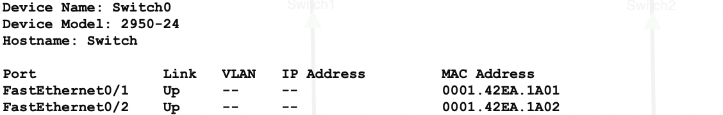

Switching table for Switch1

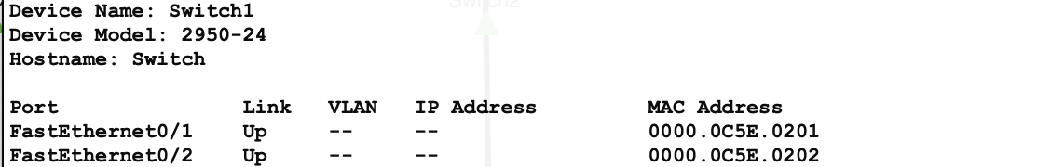

Switching table for Switch2

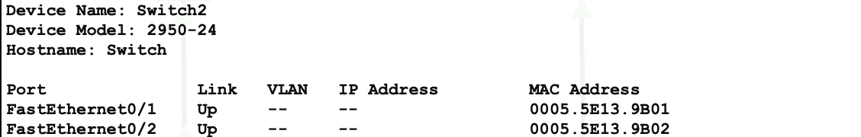

**In simulation mode**

**Exercise-1**: Ping from PC0 to FE0/0 of Router0

click on capture forward once so packet goes to switch, Inspect& write Inbound and Outbound PDU and fill following table

|  |  |  |
| --- | --- | --- |
|  | **In Bound** | **Out Bound** |
| Source MAC Address | 0060.5C52.626E | 0060.5C52.626E |
| Destination MAC address | 0060.2FCE.BA02 | 0060.2FCE.BA02 |
| Source IP Address | 37.0.0.1 | 37.0.0.1 |
| Destination IP address | 10.0.0.1 | 10.0.0.1 |

Question: What decision will be taken by switch?

Answer: It will send packet to given MAC Address.

**Exercise-2**: Ping from PC0 to FE0/1 of Router0

Click on capture forward once so packet goes to switch, Inspect& write Inbound and Outbound PDU and fill following table

|  |  |  |
| --- | --- | --- |
|  | **In Bound** | **Out Bound** |
| Source MAC Address | 0060.5C52.626E | 0060.5C52.626E |
| Destination MAC address | 0060.2FCE.BA01 | 0060.2FCE.BA01 |
| Source IP Address | 37.0.0.1 | 37.0.0.1 |
| Destination IP address | 37.0.0.2 | 37.0.0.2 |

Question: Is there any difference between table content of exercise-1 and 2? Why?

Answer: No, Because the destination is Same.

**Exercise-3**: Ping from PC0 to FE0/0 of Router1

Click on capture forward once so packet goes to switch, Inspect & write Inbound and Outbound PDU and fill following table

|  |  |  |
| --- | --- | --- |
|  | **In Bound** | **Out Bound** |
| Source MAC Address | 0060.5C52.626E | 0060.5C52.626E |
| Destination MAC address | 0005.5E66.0001 | 0005.5E66.0001 |
| Source IP Address | 37.0.0.1 | 37.0.0.1 |
| Destination IP address | 10.0.0.2 | 10.0.0.2 |

Question: What decision will be taken by Router0?

Answer: Router0 will forward the msg.

Question: Is Inbound and outbound PDU detail remain same? If not why?

Answer: Yes.

**Exercise-4**: Ping form PC0 to PC1 (For even roll number of student PC0 to PC2)

Click on capture forward so packet goes to switch0, Inspect & write Inbound and Outbound PDU and fill following table

|  |  |  |
| --- | --- | --- |
|  | **In Bound** | **Out Bound** |
| Source MAC Address | 0060.5C52.626E | 0060.5C52.626E |
| Destination MAC address | 000C.CF95.DCEB | 000C.CF95.DCEB |
| Source IP Address | 37.0.0.1 | 37.0.0.1 |
| Destination IP address | 30.0.0.1 | 30.0.0.1 |

Click on capture forward so packet goes to Router0, Inspect & write Inbound and Outbound PDU and fill following table

|  |  |  |
| --- | --- | --- |
|  | **In Bound** | **Out Bound** |
| Source MAC Address | 0060.5C52.626E | 0060.5C52.626E |
| Destination MAC address | 0060.2FCE.BA02 | 0060.2FCE.BA02 |
| Source IP Address | 37.0.0.1 | 37.0.0.1 |
| Destination IP address | 10.0.0.1 | 10.0.0.1 |

Click on capture forward so packet goes to Router1, Inspect & write Inbound and Outbound PDU and fill following table

|  |  |  |
| --- | --- | --- |
|  | **In Bound** | **Out Bound** |
| Source MAC Address | 0060.5C52.626E | 0060.5C52.626E |
| Destination MAC address | 0005.5E66.0001 | 0005.5E66.0001 |
| Source IP Address | 37.0.0.1 | 37.0.0.1 |
| Destination IP address | 10.0.0.2 | 10.0.0.2 |

Click on capture forward so packet goes to switch1, Inspect & write Inbound and Outbound PDU and fill following table

|  |  |  |
| --- | --- | --- |
|  | **In Bound** | **Out Bound** |
| Source MAC Address | 0005.5E66.0001 | 0005.5E66.0001 |
| Destination MAC address | 0000.0C5E.0201 | 0000.0C5E.0201 |
| Source IP Address | 10.0.0.2 | 10.0.0.2 |
| Destination IP address | 30.0.0.1 | 30.0.0.1 |

Click on capture forward so packet goes to PC1, Inspect & write Inbound and Outbound PDU and fill following table

|  |  |  |
| --- | --- | --- |
|  | **In Bound** | **Out Bound** |
| Source MAC Address | 0060.5C52.626E | 0060.5C52.626E |
| Destination MAC address | 0060.2FCE.BA01 | 0060.2FCE.BA01 |
| Source IP Address | 30.0.0.1 | 30.0.0.1 |
| Destination IP address | 30.0.0.2 | 30.0.0.2 |

Click on capture forward so packet goes to switch1, Inspect & write Inbound and Outbound PDU and fill following table

|  |  |  |
| --- | --- | --- |
|  | **In Bound** | **Out Bound** |
| Source MAC Address | 0060.5C52.626E | 0060.5C52.626E |
| Destination MAC address | 0005.5E66.0001 | 0005.5E66.0001 |
| Source IP Address | 37.0.0.1 | 37.0.0.1 |
| Destination IP address | 10.0.0.2 | 10.0.0.2 |

Click on capture forward so packet goes to Router1, Inspect & write Inbound and Outbound PDU and fill following table

|  |  |  |
| --- | --- | --- |
|  | **In Bound** | **Out Bound** |
| Source MAC Address | 0005.5E66.0001 | 0005.5E66.0001 |
| Destination MAC address | 0000.0C5E.0201 | 0000.0C5E.0201 |
| Source IP Address | 10.0.0.2 | 10.0.0.2 |
| Destination IP address | 30.0.0.1 | 30.0.0.1 |

Click on capture forward so packet goes to router0, Inspect & write Inbound and Outbound PDU and fill following table

|  |  |  |
| --- | --- | --- |
|  | **In Bound** | **Out Bound** |
| Source MAC Address | 0060.5C52.626E | 0060.5C52.626E |
| Destination MAC address | 0060.2FCE.BA02 | 0060.2FCE.BA02 |
| Source IP Address | 37.0.0.1 | 37.0.0.1 |
| Destination IP address | 10.0.0.1 | 10.0.0.1 |

Click on capture forward so packet goes to switch0, Inspect & write Inbound and Outbound PDU and fill following table

|  |  |  |
| --- | --- | --- |
|  | **In Bound** | **Out Bound** |
| Source MAC Address | 0060.5C52.626E | 0060.5C52.626E |
| Destination MAC address | 0005.5E66.0001 | 0005.5E66.0001 |
| Source IP Address | 37.0.0.1 | 37.0.0.1 |
| Destination IP address | 10.0.0.2 | 10.0.0.2 |

Click on capture forward so packet goes to PC0, Inspect & write Inbound and Outbound PDU and fill following table

|  |  |  |
| --- | --- | --- |
|  | **In Bound** | **Out Bound** |
| Source MAC Address | 0005.5E66.0001 | 0005.5E66.0001 |
| Destination MAC address | 0000.0C5E.0201 | 0000.0C5E.0201 |
| Source IP Address | 10.0.0.2 | 10.0.0.2 |
| Destination IP address | 30.0.0.1 | 30.0.0.1 |

Observe/inspect values of above tables and answer following questions.

Question: Is Source IP and Destination IP remains same for one way of data transmission?

Answer: No, it changes.

Justify: In reverse direction, source IP and destination IP address gets changed.

Answer: Yes it get change.

=**Gate Questions :**

1. **Which of the following functionality must be implemented by a transport protocol over and above the network protocol?**
2. Recovery from packet losses
3. Detection of duplicate packets
4. Packet delivery in the correct order
5. End to end connectivity

Ans. **D) End to end connectivity**

1. **Choose the best matching between Group 1 and Group 2**

|  |  |
| --- | --- |
| **Group-1** | **Group-2** |
| P. Data link layer | 1.Ensures reliable transport of data over a physical point-to-point link |
| Q. Network layer | 2.Encodes/decodes data for physical transmission |
| R. Transport layer | 3.Allows end-to-end communication between two processes |
|  | 4. Routes data from one network node to the next |

1. P-1, Q-4, R-3
2. P-2, Q-4, R-1
3. P-2, Q-3, R-1
4. P-1, Q-3, R-2

Ans. **A) P-1, Q-4, R-3**

1. **Match the following:**

|  |  |
| --- | --- |
| 1. SMTP | 1. Application Layer |
| 1. BGP | 1. Transport Layer |
| 1. TCP | 1. Data Link Layer |
| 1. PPP | 1. Network Layer |
|  | 1. Physical Layer |

1. A - 2, B - 1, C - 3, D - 5
2. A - 1, B - 4, C - 2, D - 3
3. A - 1, B - 4, C - 2, D - 5
4. A - 2, B - 4, C - 1, D – 3

Ans. **B) A-1, B-4, C-2, D-3**

1. **Assume that source S and destination D are connected through two intermediate routers labeled R. Determine how many times each packet has to visit the network layer and the data link layer during a transmission from S to D.**
2. Network layer – 4 times and Data link layer – 4 times
3. Network layer – 4 times and Data link layer – 3 times
4. Network layer – 4 times and Data link layer – 6 times
5. Network layer – 2 times and Data link layer – 6 times

Ans. **C) Network layer – 4 times and Data link layer – 6 times**

1. **In the following pairs of OSI protocol layer/sub-layer and its functionality, the INCORRECT pair is**
2. Network layer and Routing
3. Data Link Layer and Bit synchronization
4. Transport layer and End-to-end process communication
5. Medium Access Control sub-layer and Channel sharing

Ans. **B) Data Link Layer and Bit synchoronization**

1. **Match the following:**

|  |  |
| --- | --- |
| **Field** | **Length in bits** |
| (P).UDP Header's Port Number  (Q).Ethernet MAC Address  (R).IPv6 Next Header  (S).TCP Header's Sequence Number | 1. 48 2. 8 3. 32 4. 16 |

1. P-III, Q-IV, R-II, S-I
2. P-II, Q-I, R-IV, S-III
3. P-IV, Q-I, R-II, S-III
4. P-IV, Q-I, R-III, S-II

Ans. **C) P-IV, Q-I, R-II, S-III**

1. **Which of the following is NOT true with respect to a transparent bridge and a router?**
2. Both bridge and router selectively forward data packets
3. A bridge uses IP addresses while a router uses MAC addresses
4. A bridge builds up its routing table by inspecting incoming packets
5. A router can connect between a LAN and a WAN

Ans. **B) A bridge uses IP addresses while a router uses MAC address.**

1. **Which of the following is TRUE about the interior gateway routing protocols − Routing Information Protocol (RIP) and Open Shortest Path First (OSPF)**
2. RIP uses distance vector routing and OSPF uses link state routing
3. OSPF uses distance vector routing and RIP uses link state routing
4. Both RIP and OSPF use link state routing
5. Both RIP and OSPF use distance vector routing

Ans. **A) RIP uses distance vector routing and OSPF uses link state routing**

1. **An IP router implementing Classless Inter-domain Routing (CIDR) receives a packet with address 131.23.151.76 . The router's routing table has the following entries:**

|  |  |
| --- | --- |
| **Prefix** | **Outer Interface Identifier** |
| 131.16.0.0/12 | 3 |
| 131.28.0.0/14 | 5 |
| 131.19.0.0/16 | 2 |
| 131.22.0.0/15 | 1 |

**The identifier of the output interface on which this packet will be forwarded is ___________.**

Ans. 1

1. **Consider the following statements about the routing protocols. Routing Information Protocol (RIP) and Open Shortest Path First (OSPF) in an IPv4 network.**
2. RIP uses distance vector routing
3. RIP packets are sent using UDP
4. OSPF packets are sent using TCP
5. OSPF operation is based on link-state routing

**Which of the above statements are CORRECT?**

1. I and IV only
2. I, II and III only
3. I, II and IV only
4. II, III and IV only

Ans. **C) I, II and IV only**

1. **Consider the following statements about the functionality of an IP based router.**
2. A router does not modify the IP packets during forwarding.
3. It is not necessary for a router to implement any routing protocol.
4. A router should reassemble IP fragments if the MTU of the outgoing link is larger than the size of the incoming IP packet.

**Which of the above statements is/are TRUE?**

1. I and II only
2. I only
3. II and III only
4. II only

Ans. **II only**

1. **Consider a simple graph with unit edge costs. Each node in the graph represents a router. Each node maintains a routing table indicating the next hop router to be used to relay a packet to its destination and the cost of the path to the destination through that router. Initially, the routing table is empty. The routing table is synchronously updated as follows. In each updated interval, three tasks are performed.**
2. A node determines whether its neighbours in the graph are accessible. If so, it sets the tentative cost to each accessible neighbour as 1. Otherwise, the cost is set to ∞.
3. From each accessible neighbour, it gets the costs to relay to other nodes via that neighbour (as the next hop).
4. Each node updates its routing table based on the information received in the previous two steps by choosing the minimum cost.

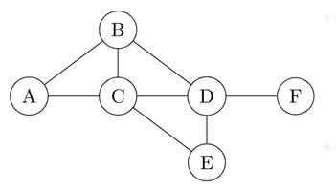

**For the graph given above, possible routing tables for various nodes after they have stabilized, are shown in the following options. Identify the correct table.**

|  |  |  |  |
| --- | --- | --- | --- |
| A. | A | - | - |
| B | B | 1 |
| C | C | 1 |
| D | B | 3 |
| E | C | 3 |
| F | C | 4 |
|  | Table for node A | | |

|  |  |  |  |
| --- | --- | --- | --- |
| B. | A | A | 1 |
| B | B | 1 |
| C | - | - |
| D | D | 1 |
| E | E | 1 |
| F | E | 3 |
|  | Table for node C | | |

|  |  |  |  |
| --- | --- | --- | --- |
| C. | A | A | 1 |
| B | - | - |
| C | C | 1 |
| D | D | 1 |
| E | C | 2 |
| F | D | 2 |
|  | Table for node B | | |

|  |  |  |  |
| --- | --- | --- | --- |
| D. | A | B | 3 |
| B | B | 1 |
| C | C | 1 |
| D | - | - |
| E | E | 1 |
| F | F | 1 |
|  | Table for node D | | |

Ans. **A)**

1. **A group of 15 routers is interconnected in a centralized complete binary tree with a router at each tree node. Router i communicates with router j by sending a message to the root of the tree. The root then sends the message back down to router j. The mean number of hops per message, assuming all possible router pairs are equally likely is**
2. 3
3. 4.26
4. 4.53
5. 5.26

Ans. **C)5.26**

1. **Two popular routing algorithms are Distance Vector(DV) and Link State (LS) routing. Which of the following are true?**

**(S1): Count to infinity is a problem only with DV and not LS routing**

**(S2): In LS, the shortest path algorithm is run only at one node**

**(S3): In DV, the shortest path algorithm is run only at one node**

**(S4): DV requires lesser number of network messages than LS**

1. S1, S2 and S4 only
2. S1, S3 and S4 only
3. S2 and S3 only
4. S1 and S4 only

Ans.  **D) S1 and S4 only**